Week 4 Performance Assessment: Outer Joins Part 1
The following questions come from the Check your understanding examples of each section of chapter 14 in your textbook.
After you are finished, please submit the Microsoft Word file that contains screenshots of the SQL script and the resulting tables. Your document should be named W4_PA_OuterJoins1_Lastname.docx.

(14-3) Question 1:
The following select statement shows all the employees who are in each department. First run this code as it is—as an inner join. Then change it to a left outer join. What is the difference in the result tables?
select a.department_name,
b.first_name,
b.last_name
from L_DEPARTMENTS a,
L_EMPLOYEES b
where a.dept_code = b.dept_code;

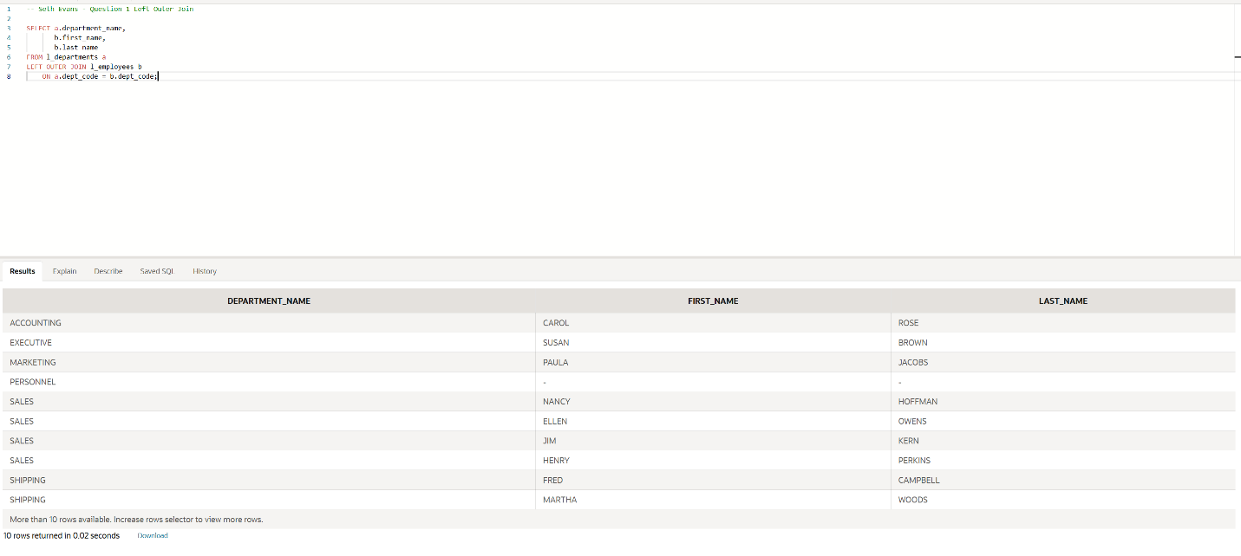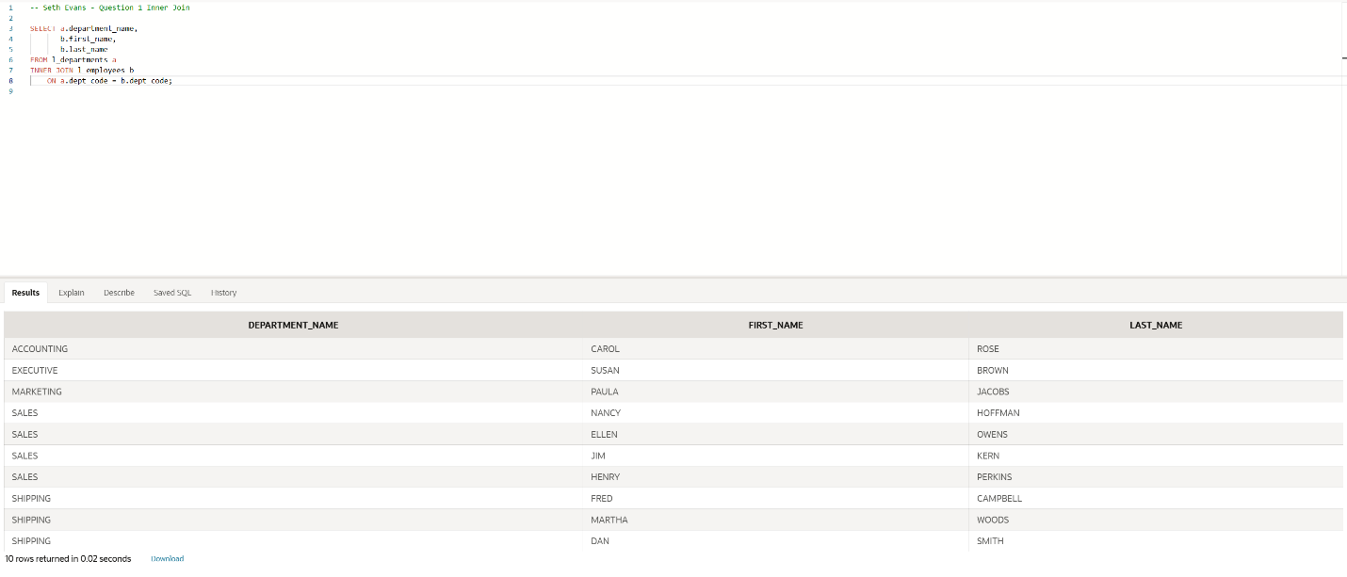
The inner join only displays departments that have matching employees. The left outer join displays all departments, including departments that do not have a matching employee. For a department without an employee, the employee columns contain NULL values.

(14-4) Question 2:
This is a modification of the exercise in section 14-3. The only thing that has been changed is the order of the tables in the from clause. First run this code as it is—as an inner join. Then change this select statement to a right outer join. What is the difference in the result tables?
select a.department_name,
b.first_name,
b.last_name
from L_EMPLOYEES b,
L_DEPARTMENTS a
where a.dept_code = b.dept_code;

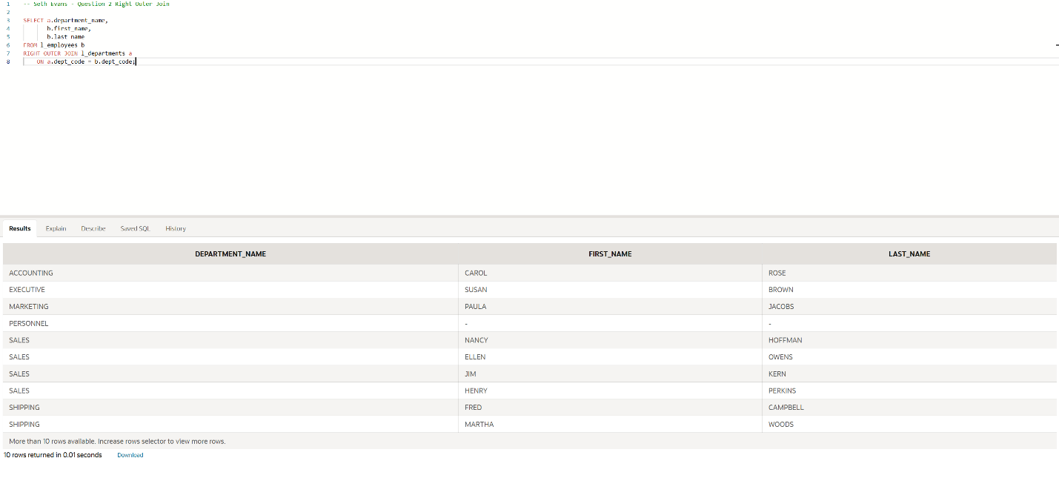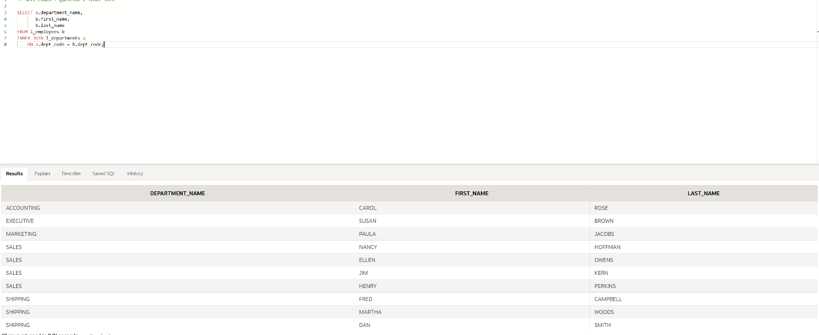
The inner join only displays departments that have matching employees. The right outer join displays all departments, including departments that do not have a matching employee. Unmatched departments have NULL values in the employee columns.

(14-5) Question 3:
This is a modification of the exercise in section 14-3. The only thing that has changed is that table sec1405_employees replaces table L_EMPLOYEES. The new table contains one new employee who has not been assigned to any department yet. First run this code as it is—as an inner join. Then change this select statement to a full outer join. What is the difference in the result tables?

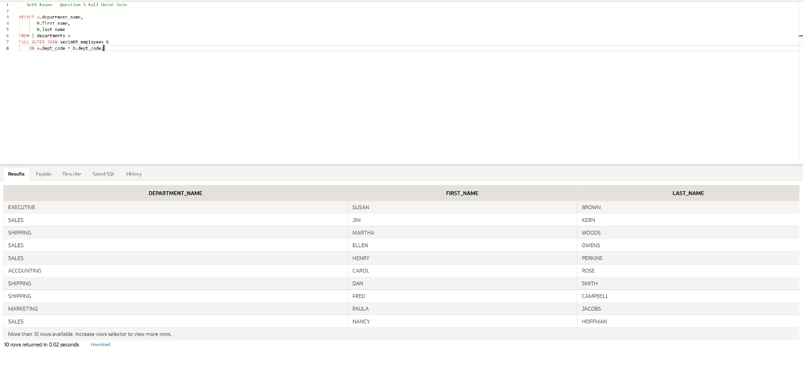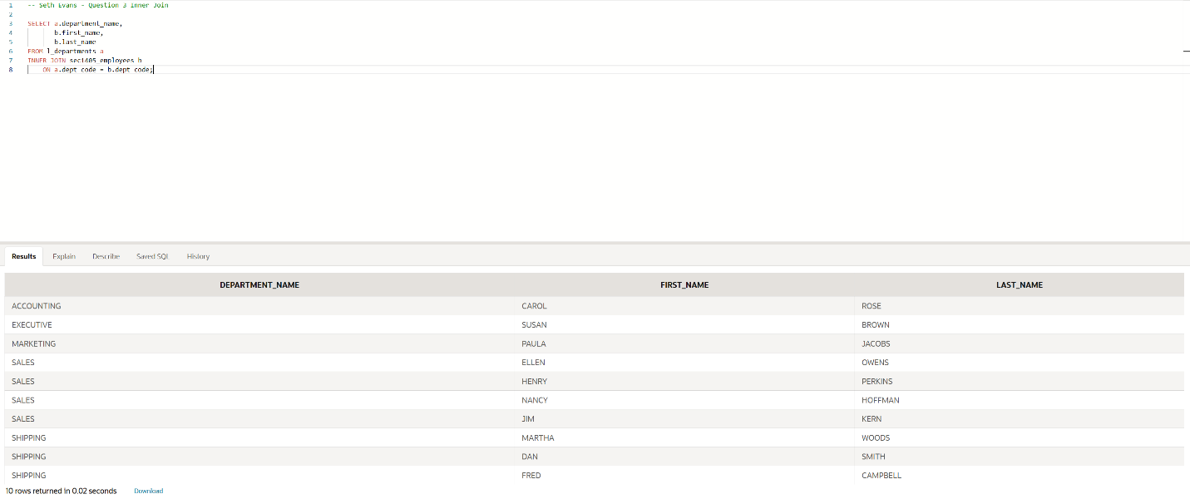
The inner join only displays rows where an employee matches a department. The full outer join displays all matching rows as well as unmatched rows from both tables. This includes departments without employees and the new employee who has not been assigned to a department.

(14-7) Question 4:
The table sec1407_departments has the same format as the L_DEPARTMENTS table. Write a select statement that shows the union of the two tables.
