NALYSIS SCIENTIFIC LTD
Rocklands 9 Rockcliffe Villas Bacup Lancs OL13 8JG UK
Tel: 01706 871700 www.analysis-scientific.co.uk
Email: brenda.peters@analysis-scientific.co.uk

Report prepared for: Little Greene Paint Company

Subject: Toy Regulations EN71-3:2019+ A1:2021

Intelligent ASP (AD/091120)
Report no. 91003/21
Date: 22 February 2021

Specification: BS EN 71-3:2019+A1:2021
Acid extraction method was used and migration elements content were determined by Inductively Coupled Plasma-ICP-MS

CONCLUSION: The results of the tests carried out MEET the requirements of the
Standard Toy Regulations EN71-3:2019+A1:2021 Category II Liquid/Sticky

Element | EN71-3: 2019 Limits Category II | Intelligent ASP (AD/091120)
Element | mg/kg
Aluminium | 1406 | 953.3
Antimony | 11.3 | <0.2
Arsenic | 0.9 | <0.1
Barium | 375 | <100
Boron | 300 | <100
Cadmium | 0.3 | <0.125
Chromium (III) | 9.4 | <0.004
Chromium (VI) | 0.005 | <0.004
Cobalt | 2.6 | <0.5
Copper | 156 | <50
Lead | 0.5 | 0.21
Manganese | 300 | <100
Mercury | 1.9 | <0.05
Nickel | 18.8 | <6
Selenium | 9.4 | <3
Strontium | 1125 | <250
Tin | 3750 | <0.2
Organic Tin | 0.2 | <0.2
Zinc | 938 | 305.4
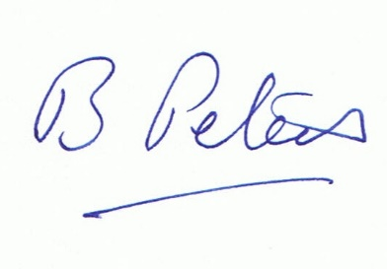
Brenda Peters FTSC FIMF FICorr CSci

Company No 11282709
VAT No GB508 2760 50

