**Background and aims**

The Corona virus disease (COVID-19) in Wuhan, China, became a pandemic after its outbreak in January 2020. Countries one after the other are witnessing peak effects of the disease, and they need to learn from the experience of others already affected or peaked countries. Thus, this paper aims to analyse the effect of the COVID-19 pandemic on different countries that resulting in deaths and recoveries.

**Methods**

This study analyses quantitatively the lethal effects of the pandemic through the study of infections, deaths, and recoveries affected COVID-19 countries . The daily change in cases, deaths, and recoveries for all the countries were considered. Combined analysis for comparison and separate analysis for the detailed study were both taken for every country. All the graphs were made in Power BI as it is best for statistical analysis.

**Research and processed .**

We need to understand the effect of COVID-19 pandemic on human life. This pandemic is travelling worldwide across different countries. It started in China but has taken over the globe. However, there is not a complete analysis available. So, we need to analyse country-wise response and effect because this will help us in understanding what has ensued in other countries.

This data analyses the datasets of the COVID-19 hit countries across the globe. The focus was to consider the affected countries with the highest number of COVID-19 cases . However, we have also considered China in our study as it was the first country where corona virus emerged. The number of cases, deaths and recoveries were taken into account. We have analyzed the performance curves of various countries in fighting this pandemic. From the mistakes of these countries, we can learn to improve our methods in containing.

**Charts and Analyse.**

Those numbers below shows that total active cases ,rate of deaths and rate of recovery between years 2020 to 2023 in different countries.

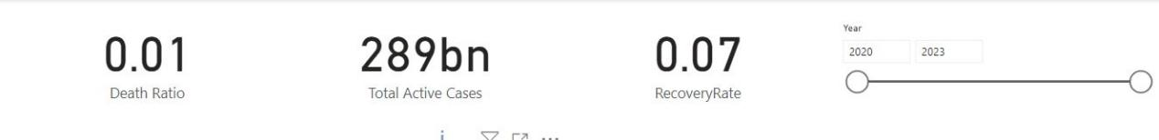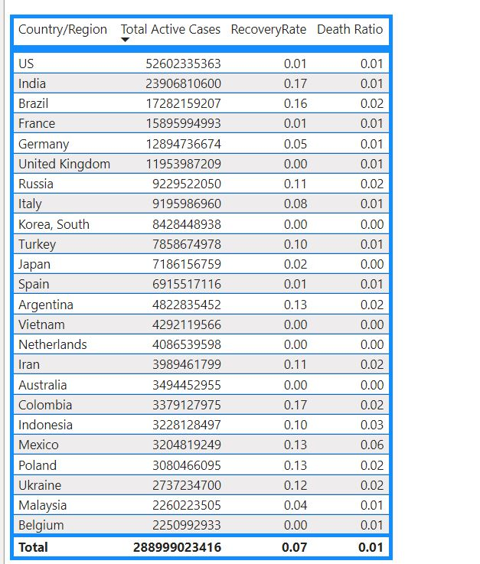

### Total confirmed cases .

It is clearly in this chart that USA is the most affected country with corona virus . The initially unaffected countries experienced an exponential rise in the corona positive cases almost after two months of the pandemic. China which was the epicentre of this disease, was somewhat successful in handling the pandemic. Countries like Brazil, Russia, India, Peru, and Turkey experienced a major hike in cases quite late. Iran, Italy, Germany, Spain were better at handling the pandemic as the cases did not have a major hike in the latter section of the graph. France, United Kingdom have not been efficient in their way of handling the situation as they were initially hit and are still on the most affected countries list.

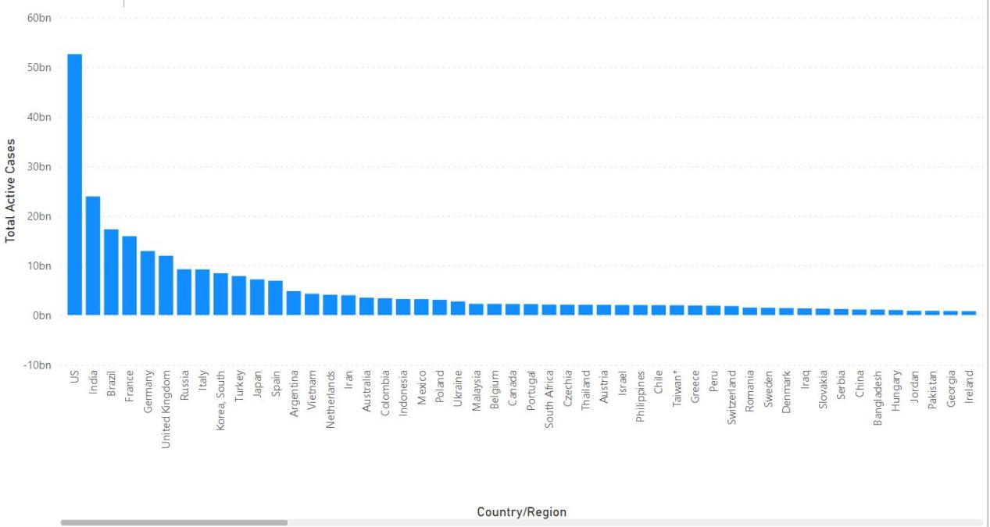

### Total deaths .

It is clearly in this line chart depicted that the Argentina is the most affected country with more than 130000 cumulative corona deaths. Excluding the Argentina , the Austria is worst affected, and the least number of deaths among them is in Antigua and Barbuda .

### deaths

### Average recoveries.

It is clearly in this line chart that even though the Argentina is the most affected country with more than 130000 cumulative corona deaths, it is also the country having the most recoveries in July 2021. After that Austria, Azerbaijan, Armenia, Albania and Algeria has most recoveries in Jul 2021.

On the other hand we can see the least number of recoveries among them is in Bahamas until 2023 .

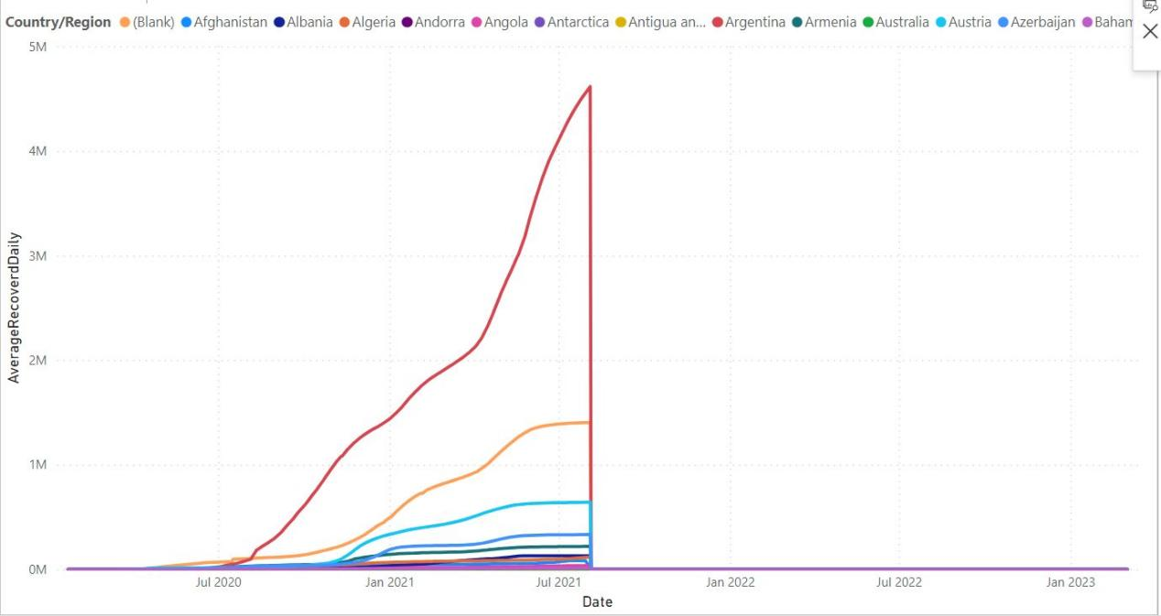

**Conlusion.**

### From this analysis, we understood the impact of lockdown and the implementation of government policies in various countries is different for every country. It can be concluded that countries having high corona positive cases do not necessarily have a high death rate, as the death rate depends on the immunity of people and the healthcare facilities.Through the assessment of these graphs, one can learn lessons especially in terms of countrywide health with global perspective and can gear up its facilities to fight any new upcoming similar pandemic.

### 