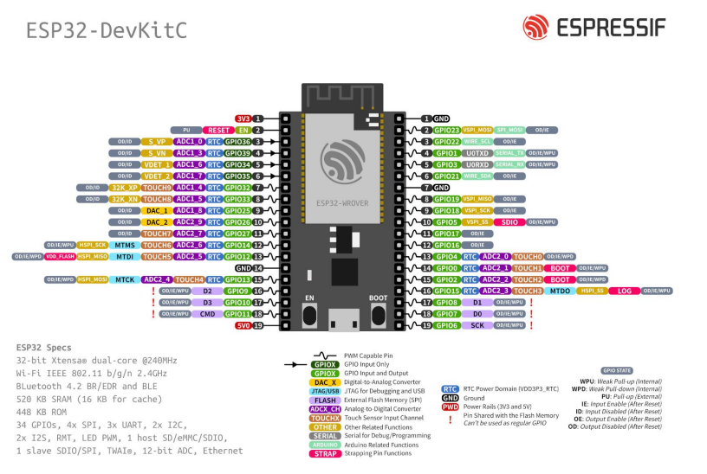Links
Esp-Now: sending data - link
Esp-Now: peer to peer - link
Esp-Now: multiple - link

