Name: Seif Elmughrabi

Metric Number: 2219120e

*Assessed exercise 1*

**Lillybank Wine Merchants**



Assumptions:

* Wine name text field is 15 characters long.
* Wine quantity and price text fields are 6 digits long.
* Transaction and balance text fields are 10 digits long.

Deficiency:

* Upon testing, sometimes a wide space appears between the decimal dot and the two decimal digits. It might be solved with special tweaking to String Format.

Example: when initial balance is £1 and we apply a return for: quantity=1, price £1.



Test Data:

* Screen dump for initial input data.

Customer name: **Jane Smith**, initial balance: £**100.236**

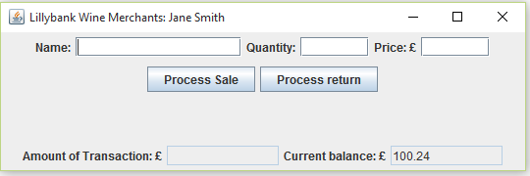

* Screen dump for number input validation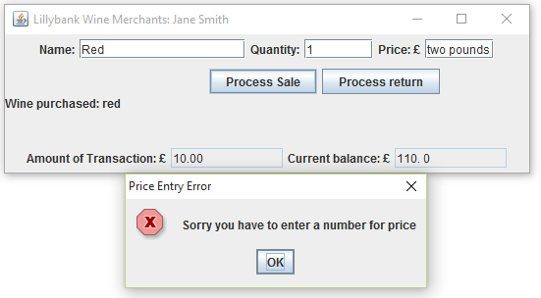
* Screen dump of positive balance after a sale.

Initial balance = -17.49, quantity = 15, price = 18.99 pounds.

Result:

Transaction amount: 18.99*15 = £**284.85**

Current balance: 284.85-17.49 = £**267.36**

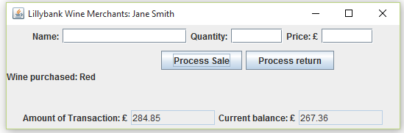

* Screen dump of negative balance after a return.

Initial balance = 0, quantity = 1, price = £3.97.

Result:

Transaction amount: 3.97*1*.8 = £**3.176 (rounded to 3.18)**

Current balance: 284.85-17.49 = £-**3.18**

