CodePlay

The place for games

**Group - 4**

**Advance Web Application - COMP229-005**

**Team Members:**

Seth Kaminski

Shivam Patel

Jason Huang

**Scope & Target Audience**

CodePlay is an e-commerce website. The website is intended to sell the pc games online. In the user will be able to select the games to be bought from a huge range of categories. Users will also be able to add reviews about the product.

The target audience for the website are mostly the youngsters who are attracted towards playing games. There are two options provided for the products. One is to get the product in the form of a CD/DVD and the other is to get it as a downloadable code. So people who do not want to wait for the product CD to arrive, they can directly buy the Setup files online via the website.

**Diagrams**

**ERD**

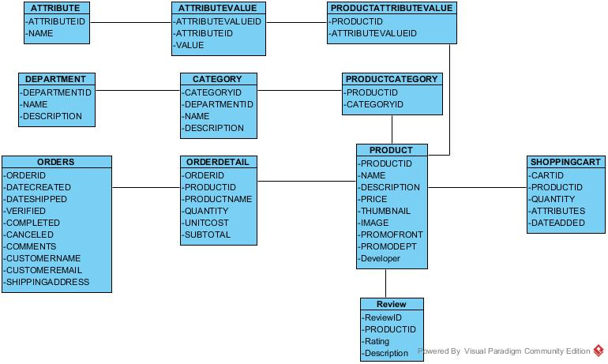

**Site Diagram**

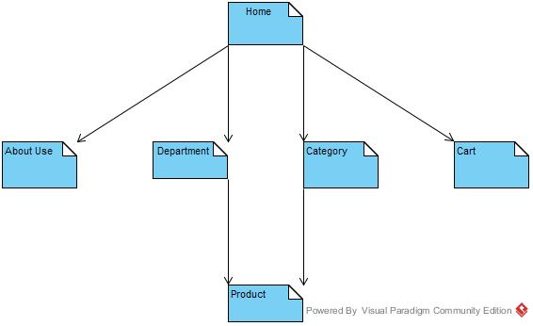

**Additional Features**

* Promotional Bar
  + This would be at the homepage of the website. It will randomly display the games and their prices in order to attract the random user with the random game.
* Reviews
  + This is the feature that is implemented in order to make the users aware about the quality of the product they are buying. On the viewpoints of the other users, who have already bought the games, they can decide on whether to take the particular stuff or not.

**Analysis**

First of all, we started looking into the already existing stuffs that matched our problem definition. Things like Ebgames, Stream helped us to begin with head start. Then the Ballonshop template was helpful in understanding how will the website work all together with the database.

**Challenges**

1. Understanding how the database and the website works together.
2. Using the bootstrap and converting it into the respective ASP control.

**Conclusion**

For a website to work according to what it is thought at first, one has to plan and meet the deadlines accordingly.

**Whom did what?**

**Seth (CodeBase Manager)** - Transformed the designed html pages into aspx, connect the database to the website, Music & Party and Sports category.

**Jason (Analyst and Production)** - Product page, Search page, connect the database to the website, Action and Strategy category.

**Shivam(Designer)** - Homepage, AboutUs, Categories, Search, Product page design. Cart page. Puzzle and RPG category.