Budopolis

Founder’s Note:

Ink is weird. Words are weird. Words written in ink even more so, but I digress. I HAVE A KINGDOM NOW! Sort of. They are kinda eating each other as I write this, but they seem like cool peeps. Not to mention they treat me as a god. TAKE THAT JEFF! WHO’S DOING STUFF NOW!? Wait… who’s Jeff?.. Anyway, it’s weird being king, but I plan to try to help them not eat each other as much, and maybe other stuff. Once we get that figured out, we’ll TOTALLY build this place into party central. All the greenery and drink one could hope for. Oh yeah, and the people not starving… that’d be cool too. I’m gonna go do stuff now before I forget. I end this with a quote from a like-minded canine bard, “Bitches ain’t shit but hoes and tricks.”

~Bud~

Changes I submit for DM approval:

It’s been a few sessions since taking over the kingdom so I offer the below as to what happened (or what I would like to think happened) in the time since.

-Initial Changes-

As established previously, from the inception of the new kingdom there has been one main export to bring in revenue; KUSH. Using this revenue, the initial focus would be to have the people farm crops and livestock to reach a point of having enough in the kingdom reserves to avoid them eating each other as much. This would also add variety to what the kingdom and the respective famers are able to trade resulting in further stimulus to the Budopolean economy and to the farmer’s own pockets. Also this should help boost the population of the guys who have been being eaten by the other guys, nah mean?

Once food stability is achieved, an order is sent to spread seeds and random shiny stuffs in the more or less abandoned area for the Aaracrockas to hopefully have them return and rejoin the newly formed government and have all 7 races/clans united under the throne.

-Government Structure-

The new Budopolis is a militant theocratic monarchy with Bud as the godhead. Under him is the Overseers’ Court established of the leaders of each clan of the Kingdom and the head of the Brotherhood. Each member is knighted with the title of Overseer and acts as a form of governor over their clan’s province.

Each clan is given a responsibility to the kingdom based on their skills (and what I randomly came up with).

~Bloodfin~

Bloodfin clan is given the responsibility to ensure the kingdom’s strength and defense in the water. The majority of the bloodfin form the naval forces for the nation and train to focus their natural bloodlust in service to the kingdom.

~Aarakocra~

Aarakocra clan is given the responsibility to ensure the kingdom’s strength and defense in the sky. The majority of the aarakocra form the airforce for the nation and use their natural affinity for flight in service to the kingdom.

~Crocfolk~

Crocfolk clan is given the responsibility to ensure the kingdom’s strength and defense on the ground. This clan form the majority of the kingdom’s army.

Cont.

~Kenku~

Kenku clan is given the responsibility of ensuring the kingdom’s strength and defense in the shadows. Known for stealth, they train for stealth to conduct black ops within our kingdom and others.

~Tortle~

Tortle clan is given the responsibility of ensuring the protection and safety of the people. Their clan forms the majority of the policing force found throughout the kingdom.

~Fishfolk & Grung~

Fishfolk & Grung clans are giving the ensuring stability and growth through the kingdom. As they are less geared toward combat, these clans take their place in the bureaucracy of managing resources and resource production throughout the kingdom, as well as maintaining and commissioning construction projects. These guys also do a lot of the farming (livestock, crops, kush).

The agencies for each clan are not restricted by race. The majority will stay with their clan’s duty but there are some that will work in different sections of the government as it is not restricted. This is especially apparent in the police force and the F&G construction and farming forces.

-Laws-

* Worship who you want as long as you accept and worship Bud as godking and overall dope entity.
* Partying a MINIMUM of once a year is required, and you must smoke one for Bud.
* Anyone responsible for party fouls is to leave theirself open to be slapped in the back of the head by any citizen of the kingdom who is not under the same punishment. They cannot retaliate, and must suffer this fate for 24hrs.
* If a ball is too big for your mouth, it is not your ball.
* Stealing is not cool bro. Unless you don’t get caught. If you do you can be sentenced to indentured servitude the length of which can vary depending on what was stolen.
* Killing innocent people, or eating them, is not cool. Can be sentenced to indentured servitude or DEATH. Public death. Which is kinda cool.
* Disputes can be settled in duels as long as there are at minimum 2 witnesses. This can be to the death w/o punishment. Cheating in a duel can result in punishment. Disputes can also be settled in court if you a bitch.
* He who smelt it, dealt it.
* Non-citizens can become citizens by pledging loyalty to bud and smoking a whole joint.
* Try to be chill with people. Just in general.
* Party on.

-The Brotherhood-

Founded after Bud’s escalation to godhood, the Brotherhood is the fraternity of priests who follow the teachings of the Bud. This organization is tasked with maintaining services at the temples of Bud and spreading the word of the Bud to the ends of the earth. This is exactly what you think. With an OHH YEAHHH attitude, these guys keep the party alive where they go and convert many to the way of Bud. These guys also tend to the Holy Garden in the top floors of the main palace where the stronger and rare strains of kush are brought to life.

PARTYY ONN BRRROOOTHERRRR!!

~A note on the temples. ~

Each has a larger room often closer to the center of the structure that is perpetually hot boxed. Each template has a large shrine to the bud, and can have smaller shrines to the other gods in the building as well. Let’s not forget that the Nilbog has his own small shrine in the maine temple/palace as promised.

-Layout of the Kingdom-

A few changes to the lay out.

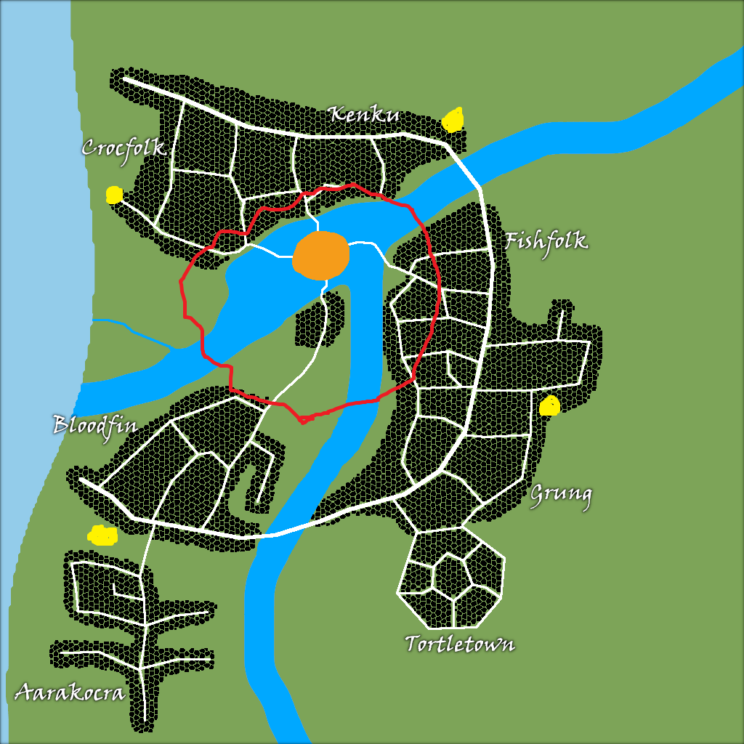

* The yellow dots are to be temples erected closer to the individual districts.
* The area close to the palace inside the red circle is to be a shared area for all of the races where they can live and be close to the main temple. The individual districts outside the red circle are less diverse.