**Each person to add graphs and describe trends, correlation, statistical analysis, etc. about their code and part of the project.**

**Analysis and Conclusion (20 points)**

* Write-up summarizes major findings and implications at a professional level (5 points)
* Each question in the project proposal is answered with precise descriptions and findings (5 points)
* Findings are strongly supported with numbers and visualizations (5 points)
* Each question response is supported with a well-discerned statistical analysis from lessons (e.g., aggregation, correlation, comparison, summary statistics, sentiment analysis, and time series analysis) (5 points)

**Household Income + Inflation (Amy):**

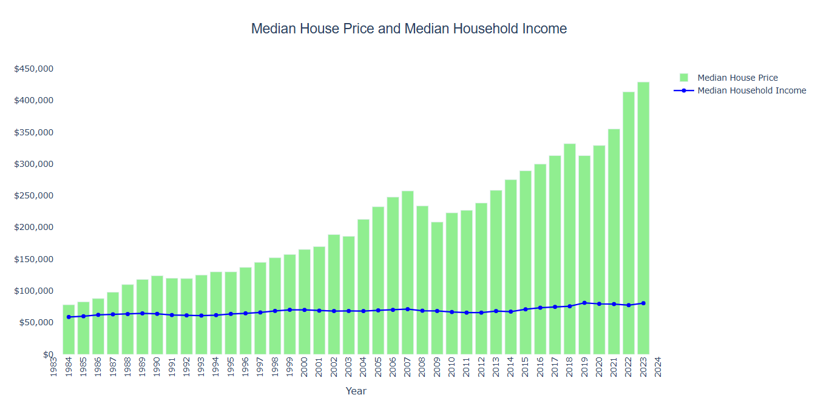

* Median Household Income does not increase at the same rate as Median House Price in the United States year over year
* Median House Prices may dip slightly from time to time, but looking at the greater picture overall, it always trends upwards
* Median Home Prices increase year or year and then dip a bit just for a couple of years like in years 2008-2009 and 2018-2019
* It seems that we may be seeing that same trend in 2023-2024 since Median House Prices dipped from 2022
* Seeing how that trend has repeated itself, I'd guess that in 2024-2025 would be a good time to buy a house
* There is a very large variance with the Median House Price compared to the Median Household Income
* The range for Median House Price is $361,600 versus the range for Median Household Income is $22,280

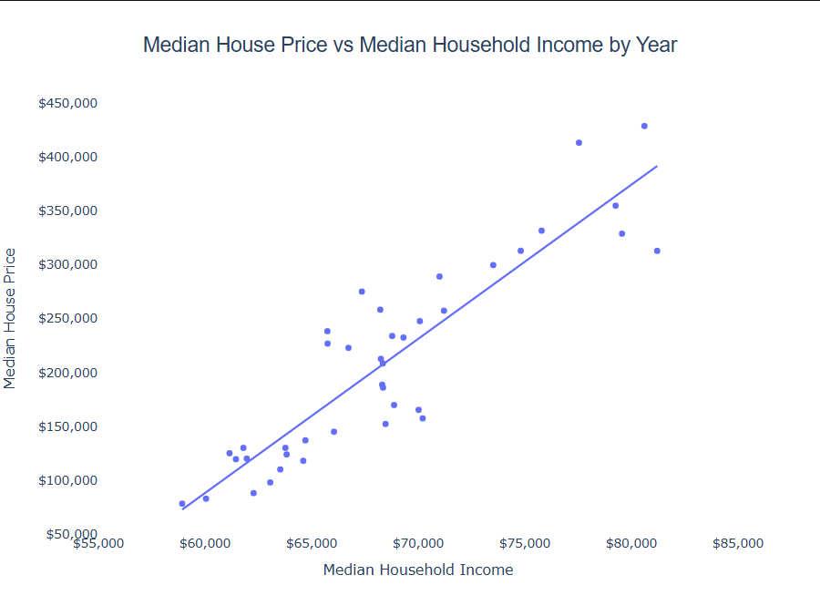

* There is a positive relationship with Median House Price and Median Household Income in the United States.
* As Median House Price increases, so does the Median Household Income year over year.

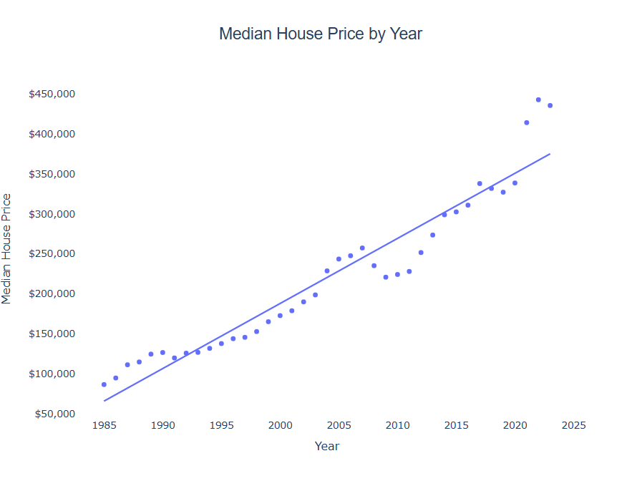

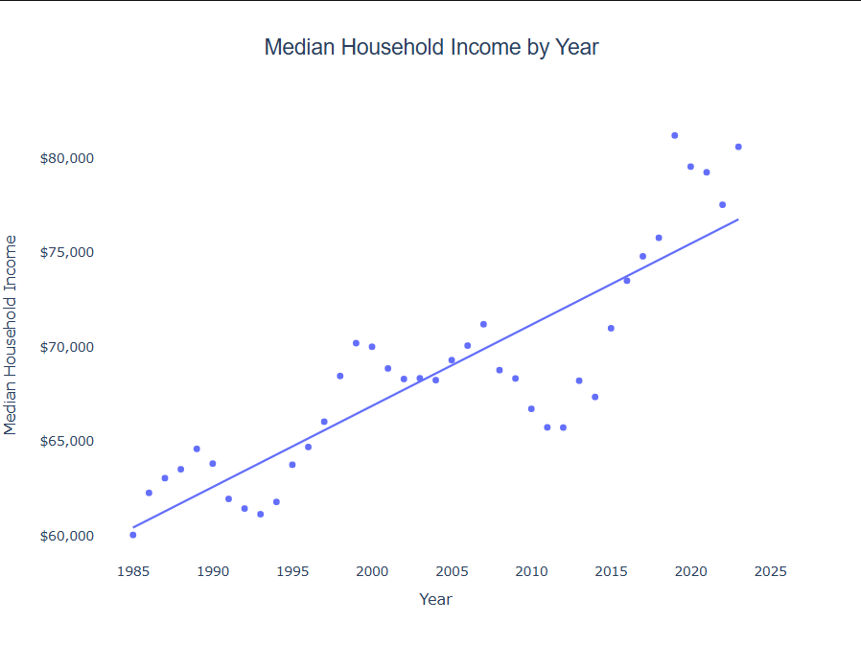

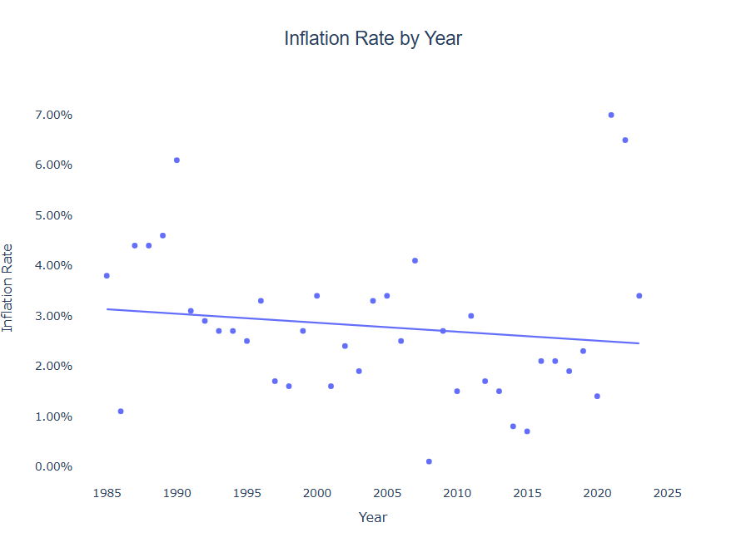

* There is a VERY strong analysis with Median House Price and Year and a slight ongoing pattern of increasing for a few years and then decreasing the following years before increasing again
* Median Household Income by Year also shows a similar trend, but not as strong
* There is actually a slight negative relationship with Inflation Rate and Year, but not very strong and quite a few outliers

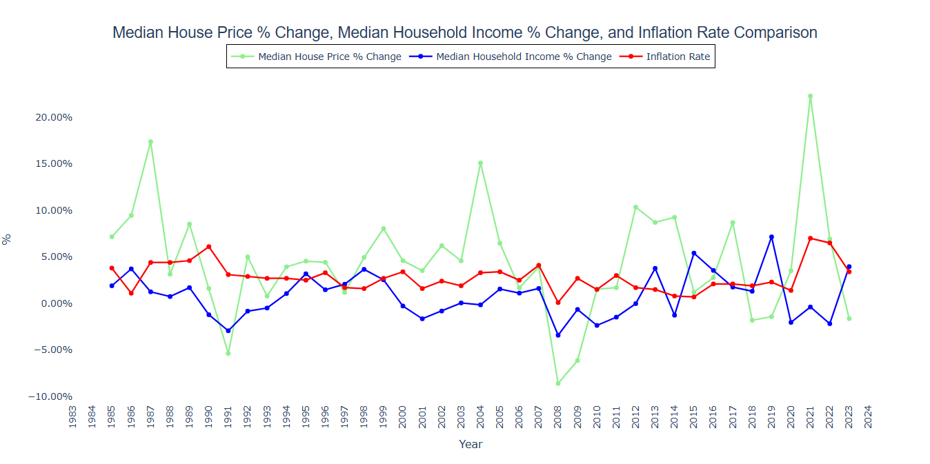

* Median House Price and Household Income % Change shows the change in house price and household income year to year.
* Median House Price % Change fluctuates quite a bit year to year, majority of the time still a positive % increase.
  + There were four years that had a 10%+ increase in house price, 1987-1988 with a 17.37% increase, 2004-2005 with a 15.09% increase, 2012-2013 with a 10.35% increase, and 2021-2022 with the highest increase of them all at 22.27%.
  + A few years later on those high % increases were pretty low % decreases with 1991-1992 with a -5.36% decrease, 2008-2009 and 2009-2010 with -8.59% and -6.12% decreases, respectively, 2018-2019 and 2019-2020 with -1.81% and -1.42% decreases, respectively, and 2023-2024 with a -1.63% decrease.
* Median Household Income % Change also fluctuates a bit, but has more minimal change year to year than Median House Price.
  + There were a lot more years where the Median Household Income decreased from the previous year than compared to the Median House Price which tells us that even though the Household Income went down, House Prices still increased in many years.
    - For example, between the years 2020-2021, the Median Household Income decreased -2.03%, but Median House Prices increased 3.52%.
  + However, both follow the same positive or negative trend majority of the time.

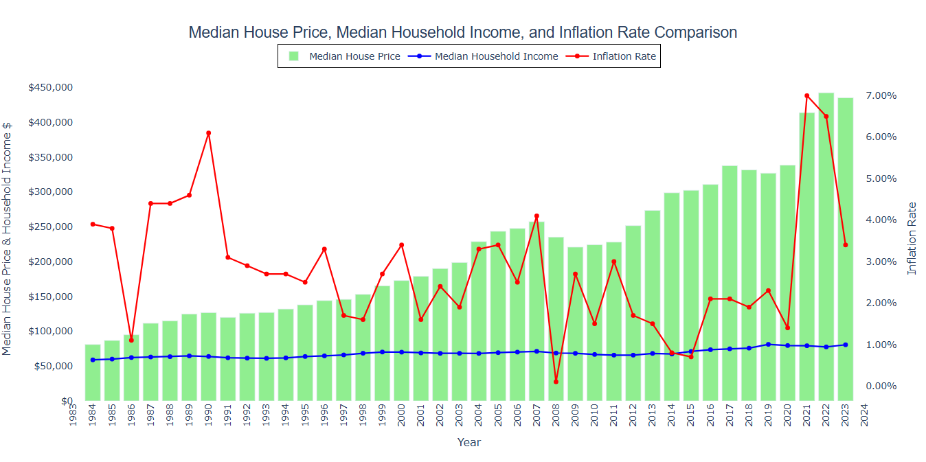

* This graph is the same as the graph showing the trend in Median House Price and Median Household Income year over year, but each year's inflation rate is added
* Inflation rate varies significantly from year to year and there is no pattern with the trend like there is for Median House Price and Median Household Income
* The lowest the inflation rate has ever been was 0.10% in 2008 and the highest was 7.00% in 2021 with an average from 1984-2023 of 2.82%.

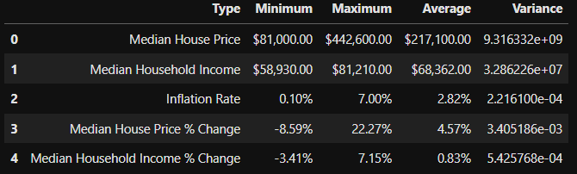

**Interest Rates (Eduardo):**

The major findings and implications I have gathered from the data, is that today is a great time to buy a home. Based on the data gathered, homes have been climbing in prices since 1971 to 2024. Comparing the average home interest rate date with the average median home price data, interest rates began to play a pivotal role in about the year 2000. Based on my observation every time the interest rate would lower the housing prices would respond by rising and when the interest rates would rise the home prices would respond by lowering the next year. For example, in 2000 to 2003 the interest rates drop from an average of 8.05% to 5.8% and held for 3 years at that rate and the rates rose to 6.4% in 2006. Home prices increase from an average of $165k in 2000 to $244k in 2007. And responded to drop again with the increase of interest rate in 2006 from $244k to $215k in 2009. This trend repeated in 2019 but in a more aggressive manner. From 2017 to 2020 the average median home price was set between $322k to $328k. In 2018 the average home interest rate was at 4.54% which had increase from 3.98% from 2017. From 2018 the rates drop to an all time low to 2.95% in 2021. The housing market then responded, and the average median home prices climbed from $328k in 2020 to $432K in 2022. After the rates drop to an all time low in 2021 the rates increase to 5.34% in 2022 and continue to increase to 6.71% in 2024. Now with the interest rate increase the home priced did have a decrease in pricing going from an all time high $432k in 2022 to $420K in 2024. This helps me prove that home prices are effect by home interest rates.

I think this current home market is a great time to buy a home because median home prices are trending downwards and are slowly trending downwards as well.

**Population Growth (Seth):**

**Unemployment Rate (Rafa):**