DID and DID Document
Document is based on:
How to generate did and its document
How to add, revoke the user and generate owner How and why we generate jwt
How to verify that jwt Discuss on different libraries

How to generate did and its document

  - How to generate did:-

did stands for decentralize identifier. did has three parts. First is did:. Second is its method.we can create our own method in did.Third is account address or wallet address

ex.did:bdid:0x058c31036ef5da74516308d13aa4959669e344e1 Here bdid is our method name which stands for blockchain did
you can create did by calling the default method of the server.ts file you can call this function with two way
- with the use of your wallet address,like,

bDid=newBDID({
provider,
address:identity
})

with the use of these method you are not able to generate the jwt
for generating the jwt you need to generate first signing designate with use of

vargenerateSigningDesignate= (awaitbDid.generateSigningDesignate()).kp

if you use this function then it adds another designate in to your publickey for signing Designate.

- with the use of generate random keypair

const kp = await BDID.generateAddressPrivateKey()
plainDid = new BDID({ ...kp, provider, registry: registry.address })

here first you need to generate the key value pair with any random number and then you need to call the default method of server.ts file

if we use this method to generate did then it automatically creates signing user for you. this function returns the did and all the functionality of the server file.
After calling this function you need to call
register({provider,registry: registry.address})
this is set your ethereum address in to your did document

And before generating the document you must call
registerResolver.default()
because, this function will call the default method of our b-did-resolver file.(more description is given below for this file)

How to generate did document
after getting the did you can generate its document. Like,
awaitresolve(bDid.did)
when you create your did at that time smart contract save your information on-chain and off-chain with ipfs(event).And save your event and function detail.

And when you call the resolve function it take the data from your smart contracts with the fromBlocks to toBlocks(previous change of the event) and generate the document for you

It generate the document for you like this,
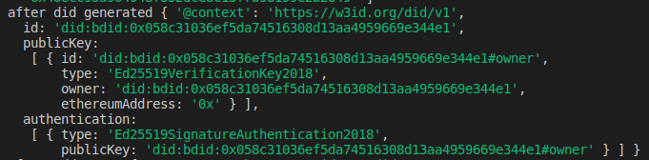

here we just create identity of this document. Identity is an account identifier.

How to add, revoke the user and generate owner
  - Verify Owner:- Each identity has a single address which maintains ultimate control over
it.
By default,each identity is controlled by itself.

Ownership of identity is verified by calling thebDid.lookupOwner()function.

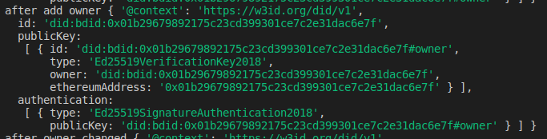

  - Change Owner:- The account Owner can replace themselves at any time,by callingawaitbDid.changeOwner(owner)

After Owner is changed your did document look like this
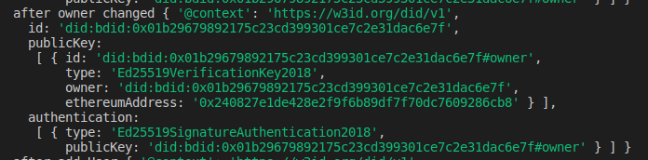

  - Add Simple Designate:- Add this Simple Designate to perform a function on behalf of an identity for specific time. LikeawaitbDid.addDesignate(designate1, {expiresIn:2})

here you need to pass the ethereum address as a designate1 and your expiration time in milisecond

An identity can add multiple delegates.
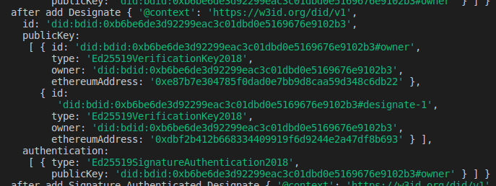

These designate is expired after 2 milliseconds.

  - Add Authenticated Designate:- An identity can assign signing authority to designate using this,
awaitbDid.addDesignate(designate2, {designateType:Ed25519SignatureAuthentication2018,expiresIn:10})

After give it to authority our document add it in to the authentication section with its signature type.

Our Document look like,
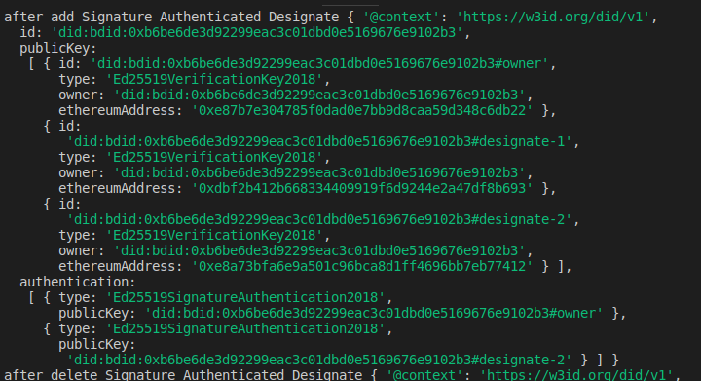

this authenticated designate will automatically expire after 10 milliseconds.

  - Revoke Simple Designate:- If you want to revoke the designate manually then you use this,awaitbDid.revokeDesignate(designate2)

  - Revoke Authenticated Designate:-you can also revoke the authenticated designate like this,awaitbDid.revokeDesignate(designate2, {designateType: Ed25519SignatureAuthentication2018})

It deletes the designate from public key and authentication in our did document.

  - Set Attribute:- An identity may need to publish some information that is only needed off-chain but still requires the security benefits of using a block-chain.

We can set the attribute with three method, pub, auth, svc
If you use pub means it saves your data in public key.It add the publickeyBase64 instead of ethereum address in did document.
Ex, var setAttribute = await bDid.setAttribute(
'did/pub/Ed25519/veriKey/base64',
'Arl8MN52fwhM4wgBaO4pMFO6M7I11xFqMmPSnxRQk2tx',
10
)
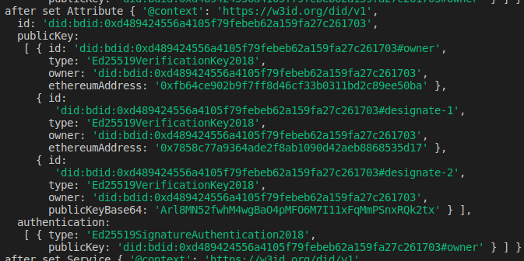

If you use auth means it saves your data in to public key as well as in authentication.
If you use svc means service, like await bDid.setAttribute(
'did/svc/HubService',
'https://hubs.uport.me',
10
)
It add your service in to the document like this,
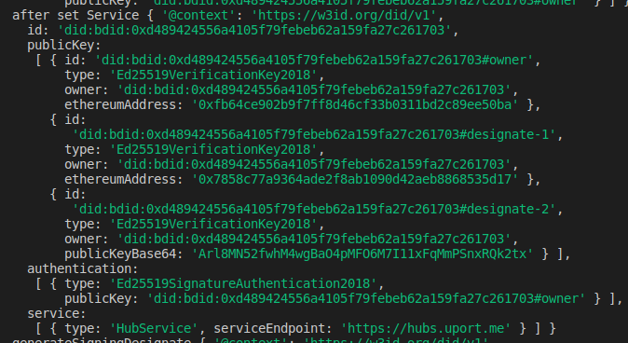
here type is the name of your service and serviceEndPoint is type url of your service.

How and why we generate jwt
  - Why we generate jwt:- When we want to pass any message like {hello:’world’} from block-chain with secure manner then it generates the jwt for that message using below process and pass it. You pass your message in this way,
awaitbDid.signJWT({hello:'world'})
  - How we generate jwt:- Our jwt looks like
eyJ0eXAiOiJKV1QiLCJhbGciOiJFZDI1NTE5In0.eyJpYXQiOjE1NjAyNTIxNTcsImhlbGxvIjoid2 9ybGQiLCJpc3MiOiJkaWQ6YmRpZDoweGQ0ODk0MjQ1NTZhNDEwNWY3OWZlYmViNjJh MTU5ZmEyN2MyNjE3MDMifQ.XuCTqQmGW_sA02ZrObrMKiUHg_ZTCixPJCiZ- GdpqawEdo_7Gm8om8De_tyhh2G_iRumIi0u9ZcMHOhKE0XbCQ
When you watch the jwt carefully it is divided with three dots
first part of that jwt is header,header includes type of token like jwt and algorithm name(here we use ed25519 algorithm)
second part of jwt denotes expiration time of that jwt, your payload(you can say that your message),and your issuer(means your did)
third part of jwt is signature. Signature is generated with the use of first and second part of jwt and your signer.
Basically signer is generated with the use of your private key, when you call the generateSigningDesignate function.

How to verify that jwt

when receiver receive this jwt, he/she calls the checkJwt function like,

awaitbDid.checkJWT(signJWT,publicKeyBuffer)

here signJWT is your jwt, and publicKeyBuffer is the publickey in buffer which is generated at the time of generateSigningDesignate.

This function returns to you the payload,your did document,issuer,signer, and jwt. It looks like,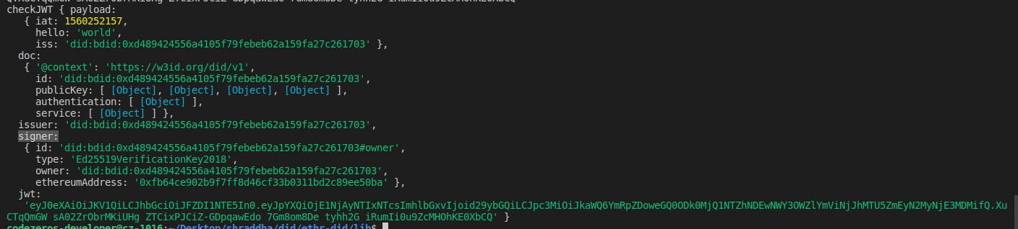

5. Discuss on different libraries

5.1 b-did-resolver --> contracts --> b-did-registry.json :- This library is just the abi of our smart contract. Our smart contract has all the function which we discuss above and all function of smart contract is emit on events.

5.2 b-did-resolver --> src --> bdid-resolver.ts :- this library is connected with our smart contract with abi.logDecoder(DidRegistryContract,false) line of code. All emitted event is store in to logDecoder.

When you perform any event of the smart contract its emitted event directly calls default function of this file and prepare the did document for you. And when you fire resolve function it generates did document for you.

Its default function first match your did and then fetch the owner of the document from your contract, after fetching owner calls the change log function for getting the all event history of that particular owner. And then lastly it calls the encloseDidDocument function which creates the structure of did document.

It has two more function bytes32toString and stringToBytes32. This is basically used to encrypt and decrypt the authentication key and verification key.

5.3 bdid-jwt --> digest.ts :- this library is only used to convert our public address into EthereumAddress.

5.4 bdid-jwt --> ed25519Signer.ts :- this library is used to create signer. It takes your private key and generates the signer function using ed25519 algorithm

5.5 bdid-jwt --> JWT.ts :- this library generates jwt, verifies your jwt and checks your did. It also checks your did method is right or not. resolveAuthenticator will check your did and the designate is authorized or not.

5.6 bdid-jwt --> signerAlgorithm.ts :- this file is used to check the algorithm is supported or not, and it also generates the signature for you by calling the signer function.

5.7 bdid-jwt --> verifierAlgorithm.ts :- this file is used for verify our signer with the use of ed25519 algorithm.

