Name: Taylor Stewart Mark _____________________/50

## Brief introduction __/3

My feature is level management which includes two main tasks: Creating the scenes which will make up the levels of our game, and managing the systems that allow us to load and trigger new levels.

## Use case diagram with scenario __14

### Use Case Diagrams

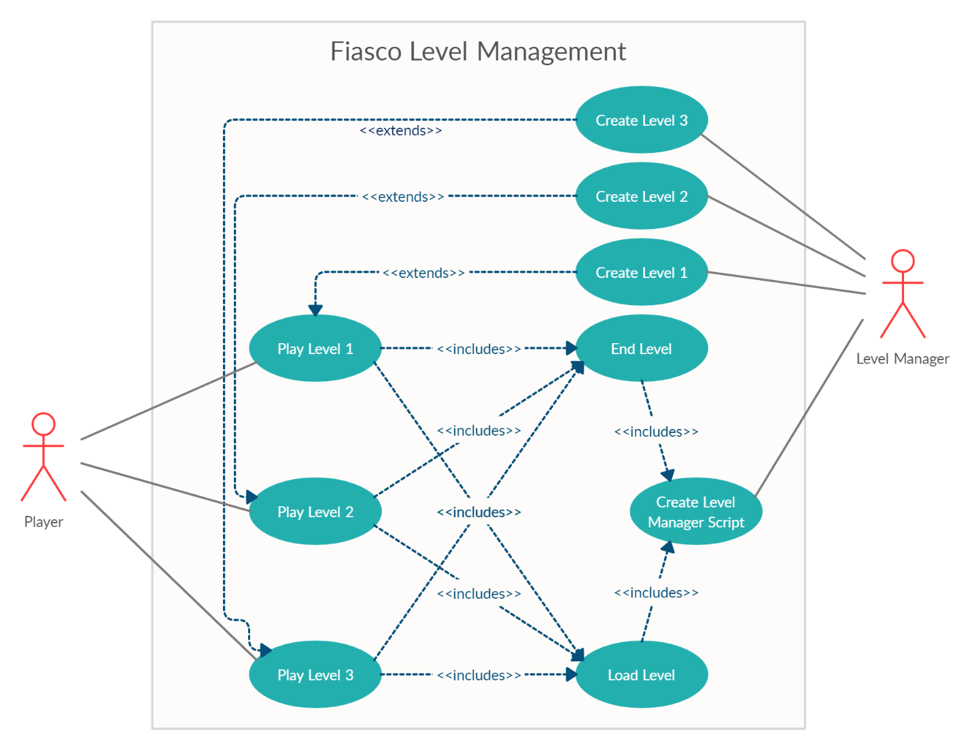

### Scenarios

**Name:** Play Level 1

**Summary:** The player loads into level 1 and can start playing through it.

**Actors:** The player of the game

**Preconditions:** Level 1 and the Level Manager script have been created by the Level Manager, and the Main Menu is able to use the load level method.

**Basic sequence:**

**Step 1:** The player presses “Start Game” on the main menu.

**Step 2:** The UI uses the Level Manager’s “Load Level” method.

**Step 3:** The Level Manager loads the level 1.

**Post conditions:** The player is now able to play the loaded level.

**Priority:** 1

**ID:** TS1

*The priorities are 1 = must have, 2 = essential, 3 = nice to have.

**Name:** Play Level 2

**Summary:** The player loads into level 2 and can start playing through it.

**Actors:** The player of the Game

**Preconditions:** Level 2 and the Level Manager script have been created by the Level Manager, and the player has beaten level 1.

**Basic sequence:**

**Step 1:** Player triggers “End Level” from level 1.

**Step 2:** The Level Manger loads level 2.

**Post conditions:** The player is now able to play the loaded level

**Priority:** 1

**ID:** TS2

*The priorities are 1 = must have, 2 = essential, 3 = nice to have.

**Name:** Play Level 3

**Summary:** The player loads into level 3 and can start playing through it.

**Actors:** The player of the Game.

**Preconditions:** Level 3 and the Level Manager script have been created by the Level Manager, and the player has beaten level 2.

**Basic sequence:**

**Step 1:** Player triggers “End Level from level 2.

**Step 2:** The Level Manager loads level 3

**Post conditions:** The player is now able to play the loaded level.

**Priority:** 1

**ID:** TS3

*The priorities are 1 = must have, 2 = essential, 3 = nice to have.

**Name:** End Level

**Summary:** Player reaches the end of a level, triggering the next one to be loaded.

**Actors:** NA

**Preconditions:** The player has successfully loaded into and played through a level.

**Basic sequence:**

**Step 1:** The player triggers a collider which signifies a door to the next level.

**Step 2:** The Load Level method is called for the next level.

**Exceptions:**

**Step 2:** If the player has just beaten level 3, this loads a victory scene rather than a new level.

**Post conditions:** The next level is loaded

**Priority:** 1

**ID:** TS4

*The priorities are 1 = must have, 2 = essential, 3 = nice to have.

**Name:** Load Level

**Summary:** Loads a unity scene

**Actors:** NA

**Preconditions:** The Level Manager Script, and the desired level to be loaded have been created.

**Basic sequence:**

**Step 1:** The Load Level command is called

**Exceptions:**

**Step 1:** The desired level may not exist; the level is not loaded.

**Post conditions:** The level is loaded.

**Priority:** 1

**ID:** TS5

*The priorities are 1 = must have, 2 = essential, 3 = nice to have.

**Name:** Create Level Manager Script

**Summary:** Create a script which has a method to load Unity scenes and monitors the player position to adjust the camera and trigger the end of a level.

**Actors:** Level Manager

**Preconditions:** NA

**Basic sequence:**

**Step 1:** Read the player’s position

**Step 2:** Create a method which adjust the camera based off the player’s position

**Step 3:** Create a method to load unity scenes from their build id.

**Step 4:** Create a method which monitors the player position and loads the next level on completion of the current level.

**Post conditions:** The camera is updated properly, and both the Load Level, and End Level use cases function as expected.

**Priority:** 1

**ID:** TS6

*The priorities are 1 = must have, 2 = essential, 3 = nice to have.

**Name:** Create Level 1

**Summary:** Create a beach themed unity scene for level 1.

**Actors:** Level Manager

**Preconditions:** Art assets have been obtained for this scene, and enemy prefabs are ready to place.

**Basic sequence:**

**Step 1:** Level Manager creates a level design on paper.

**Step 2:** Level background, and layers are placed.

**Step 3:** Walls and collision boxes placed.

**Step 4:** Enemies Placed.

**Post conditions:** Level 1 is created

**Priority:** 1

**ID:** TS7

*The priorities are 1 = must have, 2 = essential, 3 = nice to have.

**Name:** Create Level 2

**Summary:** Create a jungle themed unity scene for level 2.

**Actors:** Level Manager

**Preconditions:** Level 1 is created. Art assets have been obtained for this scene, and enemy prefabs are ready to place.

**Basic sequence:**

**Step 1:** Level Manager creates a level design on paper.

**Step 2:** Level background, and layers are placed.

**Step 3:** Walls and collision boxes placed.

**Step 4:** Enemies Placed.

**Post conditions:** Level 2 is created

**Priority:** 2

**ID:** TS8

*The priorities are 1 = must have, 2 = essential, 3 = nice to have.

**Name:** Create Level 3

**Summary:** Create a volcano themed unity scene for level 3.

**Actors:** Level Manager

**Preconditions:** Level 2 is created. Art assets have been obtained for this scene, and enemy prefabs are ready to place.

**Basic sequence:**

**Step 1:** Level Manager creates a level design on paper.

**Step 2:** Level background, and layers are placed.

**Step 3:** Walls and collision boxes placed.

**Step 4:** Enemies Placed.

**Post conditions:** Level 3 is created

**Priority:** 2

**ID:** TS9

*The priorities are 1 = must have, 2 = essential, 3 = nice to have.

## Data Flow diagram(s) from Level 0 to process description for your feature _______14

### Data Flow Diagrams

### Process Descriptions

Load Level Procedure:

IF load command input is received

IF desired build index is valid

Play level fade animation

Yield for transition time

Load scene from build index

ELSE

Do not attempt to load scene

ENDIF

ELSE

Wait for load command

ENDIF

End Level Procedure:

IF the player GameObject exist

IF the player triggers the End Door collider

IF the player is on Level 3

Load end of game scene

Else

Load the next level

ENDIF

ELSE

Wait for player to trigger collider

ENDIF

ELSE

Get player GameObject

ENDIF

Adjust Camera Procedure:

IF the player GameObject exist

Adjust camera position to center over player

ELSE

Get Player GameObject

ENDIF

## Acceptance Tests ________9

**End Level Process Test:**

On each level, pass multiple types of entities through the end level collider. Trigger a flag if the process has decided to load the next level. Each tag must be used on at least one entity for this test.

Expected Result:

Only entities using the “Player” tag should set the load level flag.

**Load Level Process Test:**

Use the load level process on all available build indexes, as well as some build indexes out of range. Trigger a flag indicating if the loader has rejected a build index due to bounds checking.

Expected Result:

All valid build indexes should load the level with all of its contents. The flag should be triggered in all other cases.

## Timeline _________/10

### Work items

|  |  |  |
| --- | --- | --- |
| Task | Duration (Hrs) | Predecessor Task(s) |
| 1. Create Level 1 | 5 | - |
| 2. Create Level 2 | 5 | 2 |
| 3. Create Level 3 | 5 | 1 |
| 4. Program Level Loader | 1 | 2, 5 |
| 5. Program Camera Adjustment | 1 | - |
| 6. Program End Level detection | 1 | 3, 4 |
| 7. Integrate Enemies | 3 | 6 |
| 8. Testing | 3 | 7 |

### Pert diagram

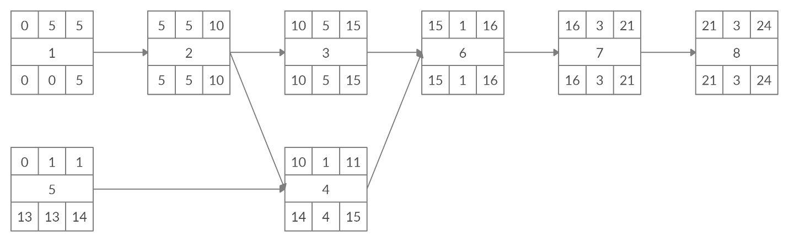

### Gantt timeline

|  |  |  |  |  |  |  |  |  |  |  |  |  |  |  |  |  |  |  |  |  |  |  |
| --- | --- | --- | --- | --- | --- | --- | --- | --- | --- | --- | --- | --- | --- | --- | --- | --- | --- | --- | --- | --- | --- | --- |
| 1 |  |  |  |  |  |  |  |  |  |  |  |  |  |  |  |  |  |  |  |  |  |  |
| 2 |  |  |  |  |  | 1 |  |  |  |  |  |  |  |  |  |  |  |  |  |  |  |  |
| 3 |  |  |  |  |  |  |  |  |  |  | 2 |  |  |  |  |  |  |  |  |  |  |  |
| 4 |  |  |  |  |  |  |  |  |  |  | 2 | 5 |  |  |  |  |  |  |  |  |  |  |
| 5 |  |  |  |  |  |  |  |  |  |  |  |  |  |  |  |  |  |  |  |  |  |  |
| 6 |  |  |  |  |  |  |  |  |  |  |  |  |  |  |  | 3 | 4 |  |  |  |  |  |
| 7 |  |  |  |  |  |  |  |  |  |  |  |  |  |  |  |  | 6 |  |  |  |  |  |
| 8 |  |  |  |  |  |  |  |  |  |  |  |  |  |  |  |  |  |  |  | 7 |  |  |
|  | 1 | 2 | 3 | 4 | 5 | 6 | 7 | 8 | 9 | 10 | 11 | 12 | 13 | 14 | 15 | 16 | 17 | 18 | 19 | 20 | 21 | 22 |