How to Setup Studio 5000

To Setup Communication to the controller using “FactoryTalk Linx”:
- Start > FactoryTalk Linx Network Browser
- Select “Ethernet, AB_ETH-1” > Select Driver Configuration (the wrench icon)
- Select Add New
- Enter A1 IP address (e.g., 10.22.166.242) > Select check icon
- Select Apply > Select OK
- Close “FactoryTalk Linx Network Browser”
(optional)To Check the Selected Communication Software:
- Open Studio 5000 > Logix
- Close the project: File > Close
- Select Communications > Select Communication Software…
  - Note which communication software is selected. “FactoryTalk Linx” is the default, but “RSLinx Classic” could be used instead.

To Create Logix program
- Start > Studio 5000
- Create > New Project
- Logix
  - CompactLogix 5380 Controller > 5069-L306ERM
  - Name: “Your name for the project”
  - Location: C:\Users\”your account”\Desktop\
  - Next
  - Revision: 35
  - Finish
- Select Communications > Who Active
  - Expand Ethernet, AB_ETH-1
  - Select “the ip address to the controller” (e.g. 10.22.166.242)
  - Select “Set Project Path”
  - Select Close
- Open MainRoutine
(Controller Organizer > Tasks > Main Task > MainProgram > MainRoutine)
- Delete the empty rung
- Select Communications > Download > Download
Now that Logix Designer is connected online to the controller:
- Right click on “5069 Backplane” > Discover Modules
(Controller Organizer > I/O Configuration > 5069 Backplane)
- For each of the 4 modules that are discovered:
  - Select Create > OK > Yes
- Select Close to close “Select Module Type” dialog box

To Explore I/O Modules:
- Select Communications > Run Mode > Yes
- Open “Controller Tags” in Controller Organizer
- Expand Local:1:I > Local:1:I.Pt00 > Local:1:I.Pt00.Data
  - Toggle Switch 1 on the PLC Trainer box and watch Local:1:I.Pt00.Data toggle between 0 and 1
- Expand Local:2:O > Local:2:O.Pt00 > Local:2:O.Pt00.Data
  - Change the value from 0 to 1 and verify that LED 1 lights up on the PLC Trainer box.

To Create Tags that are Aliased to the I/O Modules
- Expand Tasks > Main Task > MainProgram in the Controller Organizer.
- Double click “Parameters and Local Tags” for the MainProgram.
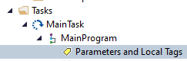
- Select Edit Tags at the bottom.
- Add two tags as shown:
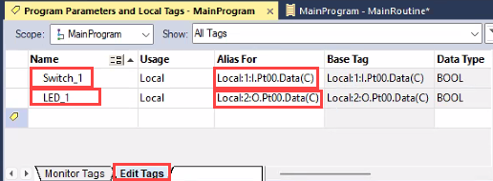
- Download the program, Go online, and select Run Mode.
  - Select Communications > Go Online.
  - Press Download in the Connected To Go Online window.
  - Press Download in the Download window.
  - Select Communications > Run Mode.
  - Select Yes to Change controller mode to Remote Run? window.
- Open “Parameters and Local Tags” for the MainProgram if it is not already open.
- Select the Monitor Tags tab at the bottom.
- Verify that the two tags are aliased to the Switch_1 and LED_1
  - Toggle Switch 1 on the PLC Trainer box and watch Switch_1 toggle between 0 and 1.
  - Change the value LED_1 from 0 to 1 and verify that LED 1 lights up on the PLC Trainer box.

To Create an LED Light Switch using Ladder Logic
- Open MainRoutine
(Controller Organizer > Tasks > Main Task > MainProgram > MainRoutine)
- Right click the last rung.
- Select Add Rung.
- Select Examine On, , in the Favorites tab on the Language Element Toolbar.
- Double click on the “?” above Examine On.
- Select the pulldown menu 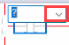.
- Uncheck “Show controller tags”.
- Select the Switch1 tag.
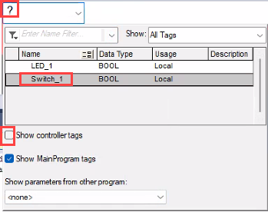
- Press Enter.

- Click and drag Output Energize, , command to the right side of rung 0.
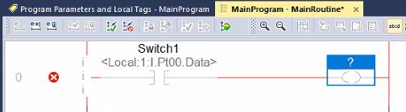
- Double click the “?” above the Output Energize command.
- Select the LED_1 tag.
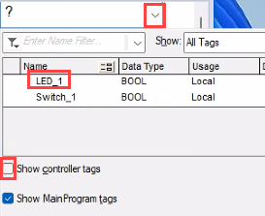
The rung should look like this:
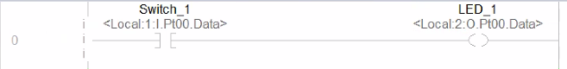
- Press Accept Pending Program Edits.
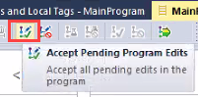
- Press Yes to “Accept the Pending Edits of program ‘MainProgram’?” pop up.
- Select 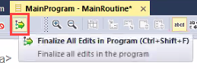 to Finalize All Edits in Program.
- Press Yes to confirm your selection.
The program should now look like this:
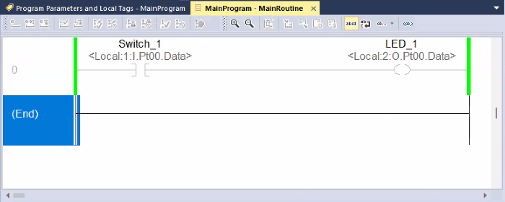
The green lines indicate that the program is running.
- Toggle Switch 1 on the PLC Trainer box and verify that LED 1 lights up on the PLC Trainer box.

Create Routines to Switch LED2, LED3, and LED4 using other Languages
- Go offline and modify your program to do the following.
  - Create a Structure Text routine to make Switch2 turn on and off LED2.
  - Create a Sequential Function Charge routine to make Switch3 turn on and off LED3.
  - Create a Function Block Diagram routine to make Switch4 turn on and off LED4.
  - Call all three of these routines from the MainRoutine.

Procedure
- Add new tags from the Switches and LEDs and alias them to the correct Controller Tags.
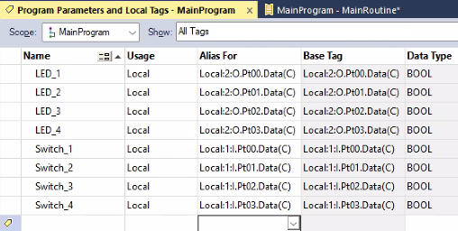
- Create Structured Text routine to switch LED_2 with Switch_2.
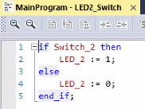
- Create a Sequential Function Chart routine to switch LED_3 with Switch_3.
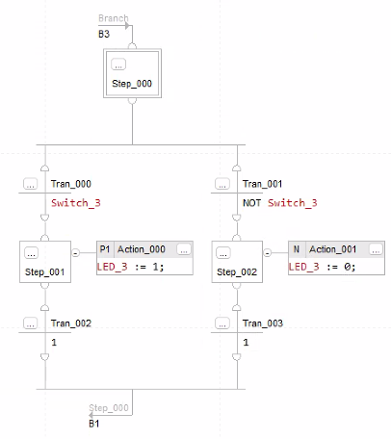
- Create a Function Chart routine to switch LED_4 with Switch_4.
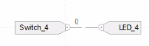
- Modify MainRoutine to call the other 3 routines
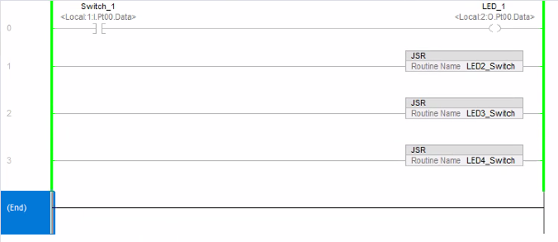

To Create a New Routing and Select its language type.
- Select Communications > Go Offline
- Right-Click on MainProgram > Add > New Routine…
  - Change Type to “Sequential Function Chart”
  - In Name field, enter desired routine name

To change which routine is called first
- Double-click MainProgram
- Select Configuration tab
- Change Assign routines: Main:
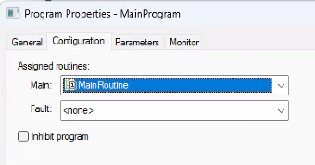
Note, the main routine cannot be a subroutine.
- Select OK

