5Lifeguards, 3Stations. How many ways to choose and order among stations?(5)(4)(3)=60
$$P\left(A | B\right)=\frac{P\left(A∩B\right)}{P\left(B\right)}$$
$$P\left(A∩B\right):if dep→=P\left(A\right)P\left(B | A\right);if indep→=P\left(A\right)P\left(B\right)…\left(works for any number\right)$$
Mutually exclusive- no overlap
Exhaustive- union covers whole sample space
Baye’s Rule: $P\left(A | B\right)=\frac{P\left(B | A\right) ∙P\left(A\right)}{P\left(B\right)}$
 | Repetition Allowed | Repetition Allowed
Order Matters | Perm. nPk | Neither ${(n}^{k})$
Order Doesn’t Matter | Comb. nCk | n flavs, pick k $\frac{\left(n+k-1\right)!}{\left(n-1\right)!k!}$

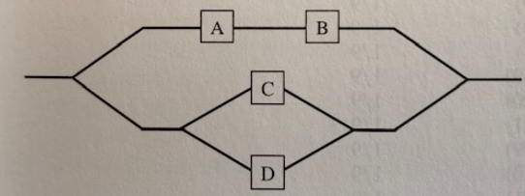
P(system failure) = A OR B AND C AND D

Random Var: prob. Dist. Fun.: p(x)=P(X=x)
$$\sum_{all x}{p\left(x\right)}=1$$
Expected value (mean) $→E\left(x\right)=\sum_{all x}{x*p\left(x\right)}=μ_{x}$
Variance: $var\left(x\right)=\sum_{all x}{{\left(x-μ_{x}\right)}^{2}p\left(x\right)}$
Cumulative Dist. Fun.: $F\left(X\right)=P(X≤x)$

