BJT is in saturation region if $V_{CE}≤0.3V\left(npn\right)$
If $V_{BE}<0.7V→cuttoff$
$$V_{BE}≥0.7V and V_{CE}>0.3V→active region$$
$$V_{BE}≥0.7Vand V_{CE}≤0.3V→saturation region$$
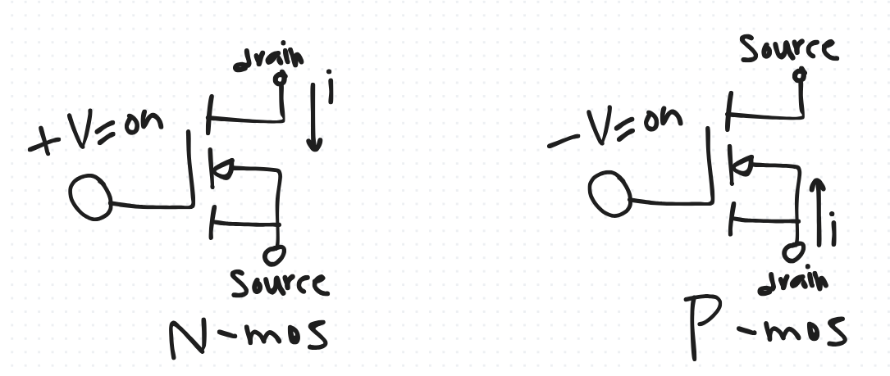
$$β_{n}-gain factor;μ_{n}-electron mobility;C_{OX}-oxide capacitance per unit area$$
$$W-width of MOSFET;l-length of MOSFET$$
Differential (Open-loop A_{D}) gain: gain when inputs are different(ideal=inf)
$$A_{CM}:common-mode gain:gain when both inputs are same\left(ideal=0\right)$$
$$CMRR=\frac{A_{0}}{A_{CM}};CMRR_{dB}=20log⁡(\frac{A_{D}}{A_{CM}})$$

