One factor ANOVA: Single Factor (F test)
Requirements for ANOVA: Random sample. Each sample comes from normal population, check w/ histogram for each sample. NO sample size requirements. Equal variances for the group, largest sample variance $≤$4x smallest sample variance, or 2x $S_{d}$ HYP $H_{0}: all groups means are same \left(μ_{1}=μ_{2}=μ_{n}\right)$ $H_{1}: at least 1 group mean differs$

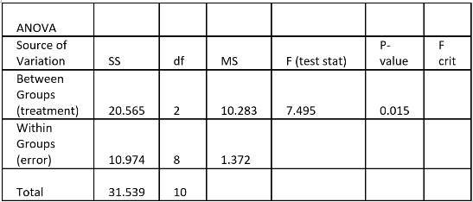
df above is (2,8)
$$F\left(test stat\right)=\frac{MST_{r}}{MSE}$$
p-val < $α→$ reject $H_{0}$, sufficient evidence $H_{1}$ is true
p-val > $α→$ fail to reject $H_{0}$, insufficient evidence $H_{1}$ is true
(statement always about alternative hypo)

Import[Filebrowser]
<< ANOVA’
ANOVA[paste w/ no outer brackets]

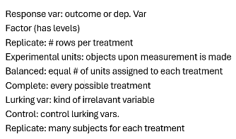
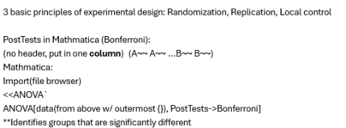
Anova two factor w/ replication:
Include row and column labels, not beyond.
$$I→\#rows, J→\#columns, K→\#replicates$$
Row (sample) df = I -1
Column def = J -1
Interaction df = (I-1)(J-1)
Error df = IJ(K-1)
Total def = IJK – 1

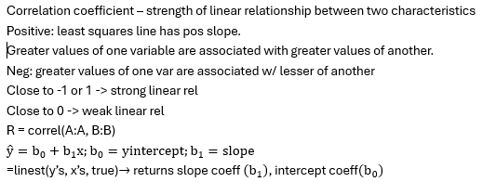
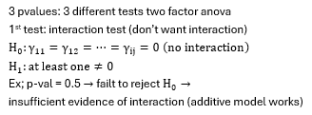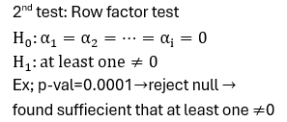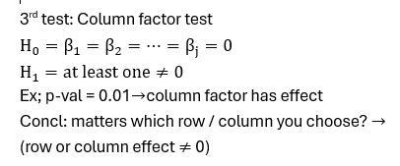
Requirements for 2-factor ANOVA:
Complete, balanced design
At least 2 replicates per treatment
Random sample from normal population for each treatment (Histogram / QQ Plot of residuals)
Equal variances for all treatments (Residual plot (different from above))
Histogram / QQ Plot: Residual = actual – avg, 1 for each replicate. Put all in one column.
Residual plot: Two rows, means first, residuals second. Do scatterplot. Absense of megaphone/tunnel.
Interaction Plot (Means plot) for a two factor experiment.
Copy treatment means, make a little table, insert line plot. If parallel-ish, no interaction.

