NAME: Seth Ricks Score: ________/ 38

ECEN 324
Homework #1 – Chapter 1 – A Tour of Computer Systems

- (9 points) Match the items, A, B, … J, in the diagram with their descriptions:

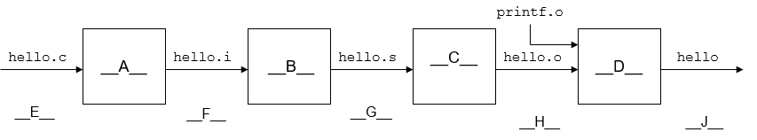

- Linker D
- Executable object program J
- Relocatable object program H
- Compiler B
- Source program E
- Assembly program G
- Pre-processor A
- Modified source program F
- Assembler C

- (2) Choose all of the following that are text files:

Source program, Assembly program, Relocatable object program, Executable object program.

- (7) True/False questions

T / F A system spends a lot of time moving information from one place to another.

T / F According to the textbook: application programmers who are aware of cache memories can exploit them to improve program performance by factors of 1,000.

T / F In a Unix type system, every I/O device is modeled as a file.

T / F Multi-core processors have several CPUs, or cores, integrated onto a single integrated-circuit (IC) chip.

T / F The principles of concurrency started being formulated when multi-core processors where introduced into desktop computers around 2002. (Has been around since 1960s)

T / F The advent of multi-core and hyperthreaded systems has greatly increased the desire to find ways to write application programs that can exploit the thread-level parallelism available with these systems.

T / F Taking advantage of computer level parallelism, a single-core modern processor can execute multiple instructions at one time.

- (10) Similar to Practice Problem 1.1

Suppose you work as a truck driver, and you have been hired to carry a load of potatoes from Rexburg, Idaho to Reno, Nevada, a total distance of 640 miles. You estimate you can average 64 miles/hr driving within the speed limits, requiring a total of 10 hours for the trip.

A. You hear on the news that Nevada has just abolished its speed limit, which constitutes 400 miles of the trip. Your truck can travel at 80 miles/hr. What will be your speedup for the trip?

$$S=\frac{1}{\left(1-α\right)+\left(\frac{α}{k}\right)}$$
$$α=\frac{400}{640}=0.625$$
$$k=\frac{NewSpeed}{OldSpeed}=\frac{80}{64}=1.25$$
$$S=\frac{1}{\left(1-0.625\right)+\left(\frac{0.625}{1.25}\right)}=1.14$$
$$S=1.14$$

B. You can buy a new turbocharger for your truck at www.fasttrucks.com. They stock a variety of models, but the faster you want to go, the more it will cost. How fast must you travel through Nevada to get an overall speedup for your trip of 4/3?

$$S=\frac{1}{\left(1-α\right)+\left(\frac{α}{k}\right)}$$
$$k=\frac{NewSpeed}{OldSpeed}$$
$$α=\frac{400}{640}=0.625$$
$NewSpeed =\frac{α}{\frac{1}{S}+α-1}*OldSpeed=\frac{0.625}{0.75+0.625-1}*64=106.67$ miles/hr
106.67 miles/hr

Homework continues on the next page.

- (10) Matching Definitions

D Instruction Set Arch.  E Microarchitecture  C CPU/Processor  G Process  F Operating system  I Kernel  H System call  J Cache memory  B Main memory  A Buses | - A collection of electrical conduits that carry bytes of information back and forth between components  - A temporary storage device that holds both a program and the data it manipulates while the processor is executing the program.  - The engine that interprets instructions stored in main memory. Appears to execute instructions in strict sequence, executing one after another.  - Describes the effect of each machine-code instruction.  - Describes how the processor is actually implemented.  - Provide applications with simple and uniform mechanisms for manipulating complicated and often wildly different low-level hardware devices.  - Operating system’s abstraction for a running program.  - Used by an application program to request some service from the operating system.  - The portion of the operating system code that is always resident in memory.  - Smaller, faster storage devices that serve as temporary staging areas for information that the processor is likely to need in the near future.

