NAME: Seth Ricks Score: ________/ 49

ECEN 324
Homework #4 – Integers

- (12 points) Similar to Practice Problem 2.16

Fill in the table below showing the effects of the different shift operations on single-byte quantities. The best way to think about shift operations is to work with binary representations. Convert the initial value in each row to binary, perform the shifts in that row using the initial value of x, and then convert the shifted value to hexadecimal. Give answers in both binary (8 bits) and hexadecimal (2 digits).

x | x << 3 | x >> 2  Logical | x >> 2  (Arithmetic)
Hex Binary | Binary Hex | Binary Hex | Binary Hex
0xF0--------1111 0000 | 1000 0000--------0x80 | 0011 1100--------0x3C | 1111 1100--------0xFC
0x0F--------0000 1111 | 0111 1000--------0x78 | 0000 0011--------0x03 | 0000 0011--------0x03
0xCC-------1100 1100 | 0110 0000--------0x60 | 0011 0011--------0x33 | 1111 0011--------0xF3
0x55--------0101 0101 | 1010 1000--------0xA8 | 0001 0101--------0x15 | 0001 0101--------0x15

- (6) Similar to Practice Problem 2.19

Fill in the following table describing the function T2U_{4.} Give answers in decimal, as the solutions to PP 2.19 show in the book. You might wish to review problem 2.17 in the book before doing this problem.

x | T2U₄(x)
-8 | $$1000→8_{10}$$
-6 | $$1010→{10}_{10}$$
-4 | $$1100→{12}_{10}$$
-1 | $$1111→{15}_{10}$$
0 | $$0000→0_{10}$$
3 | $$0011→3_{10}$$

- (10) The following table represents a small memory. Refer to this table for the following questions.
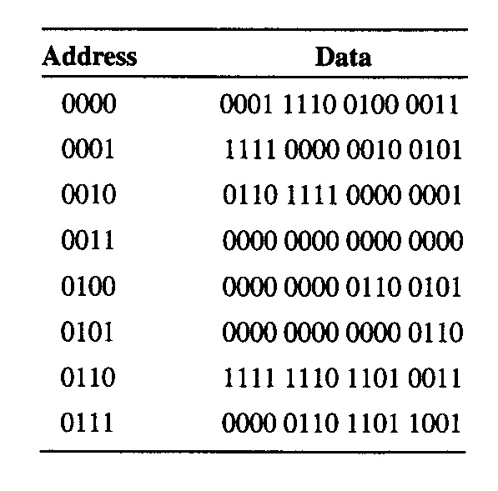
- What 16 bit binary value (write it in binary) does location 3 (0011₂) contain?
0000 0000 0000 0000

- What binary value (write it in binary) does location 6 contain?
1111 1110 1101 0011

The binary value within each location can be interpreted in many ways. We have seen that binary values can represent unsigned numbers, 2’s complement signed numbers, floating point numbers, and so forth. For example, the binary value of 0000 0110 1101 1001₂ in location 7 could be interpreted as the decimal value of 1,753.

C. Interpret location 0 as a 2’s complement integer:
$$0001 1110 0100 {0011}_{T}→{7747}_{10}$$
- Interpret location 1as a 2’s complement integer:
$$1111 0000 0010 {0101}_{T}→0000 1111 1101 {1011}_{U}→{-4059}_{10}$$

- Interpret the lower byte of location 4 (0100₂) as an ASCII character:
$$XXXX XXXX 0110 {0101}_{2}→{65}_{16}→"e"$$

- Interpret location 0 as an unsigned integer:
$$0001 1110 0100 {0011}_{U}→{7747}_{10}$$

- Interpret location 1 as an unsigned integer:
$$1111 0000 0010 {0101}_{U}→{61477}_{10}$$

- In the Von Neumann model, the contents of a memory location can also be an instruction. If the binary pattern in location 0 were interpreted as an LC-2 instruction, what type of instruction would it represent? [See “Basics of Computer Architecture” PowerPoint slide set for LC-2 information.]
ADD (opcode) | Dst | Src1 | 0 | 00 | Src2
0001 | 111 | 001 | 0 | 00 | 011
“Add the contents of register 1 to the contents of register 3, and store the result in register 7.”

- A binary value can also be interpreted as a memory address. Say the value stored in location 5 is a memory address. To which memory location does it refer? (Convert the binary value of the “address” stored in location 5 to decimal for your answer:
$0000 0000 0000 {0110}_{b}→\text{"address}\text{"}$6₁₀

- Express in hexadecimal the contents of the memory location that was the answer for the previous problem (part I). [This is the value of a memory location that is “pointed to” by the contents of memory address/location 5.] ???

R1: 1111 0000 0010 0101
R3: 0000 0000 0000 0000
R1 + R3 = 0xF025

- (10) Similar to Practice Problem 2.23

Consider the following C functions:

int fun1 (unsigned word)
{
return (int) ((word << 24) >> 24);
}

int fun2 (unsigned word)
{
return ((int) word << 24) >> 24;
}

Assume these are executed on a machine with a 32-bit word size that uses two’s complement arithmetic. Assume also that right sifts of unsigned values are performed logically.

A. (8) Fill in the following table showing the effect of these functions for several example arguments (the arguments shown are in decimal and hexadecimal; provide answers in both decimal and hexadecimal):

w | funl (w) | fun2 (w)
127 (0x7F) | 127  0x7f | 127  0x7f
128 (0x80) | 128  0x80 | -128  0xffffff80
255 (0xFF) | 255  0xff | -1  0xffffffff
256 (0x100) | 0  0x0 | 0  0x0

B. (2) Describe in words the useful computation each of these functions performs.

fun1: zero extends lower byte
fun2: sign extends lower byte

- (3) Practice Problem 2.25

Consider the following code, which attempts to sum the elements of an array a, where the number of elements is given by parameter length:

1 /* WARNING: This is buggy code */
2 float sum_elements (float a [], unsigned length)
3 {
4 int i;
5 float result = 0;
6
7 for (i = 0; i <= length-1; i++)
8 result += a [i];
9 return result;
10 }

When run with argument length equal to 0, this code should return 0.0. Instead, it encounters a memory error. Explain why this happens, and show how the code can be corrected.

The problem with this code is that the argument length is unsigned. It is fine for every list length greater than 0, but when it is zero, the for loop causes some issues. In unsigned, 0 minus 1 is equal to U_{max}, a very large number. If the array does not have U_{max} number of values in it, then it will be a memory issue, trying to access elements that don’t exist. The simplest fix would be to change the unsigned length to signed length. That way, 0-1 is now -1 instead of U_{max}. The loop condition will be automatically false, since 0 is not less than or equal to -1, and will return 0. I tried this change, and it worked.

- (7.5 + 0.5) Similar to Practice Problem 2.33 – [note that the order of the columns has changed]

We can represent a two’s complement number that has a bit pattern of length w = 4 with a single hex digit. Fill in the second column of the table below with the decimal values of the two’s complement hex values in the first column. In the third column, write the hex value that is the additive inverse of the hex value in the first column. In the fourth column, give the decimal value of the two’s complement number in the third column.

x |  | -tx  4
Hex | Decimal | Hex | Decimal
0 | 0_{d} | 0x0 | 0_{d}
3 | 3_{d} | -3_{d} = 1101_{T} = 0xD | -3_{d}
8 | -8_{d} | 0x8 | -8_{d}
A | 1010_{T} =0110_{U} = -6_{d} | 0x6 | 6_{d}
F | 1111_{T} = -1_{d} | 0x1 | 1_{d}

