Ex 2
Code and Screenshots:
i)Install dependencies
%pip install pandas numpy matplotlib seaborn kagglehub

ii)Load Dataset
import kagglehub
import pandas as pd
from kagglehub import KaggleDatasetAdapter

file_path = "data.csv"

df = kagglehub.load_dataset(
KaggleDatasetAdapter.PANDAS,
"shriyashjagtap/indian-personal-finance-and-spending-habits",
file_path,
)

df.head(5)

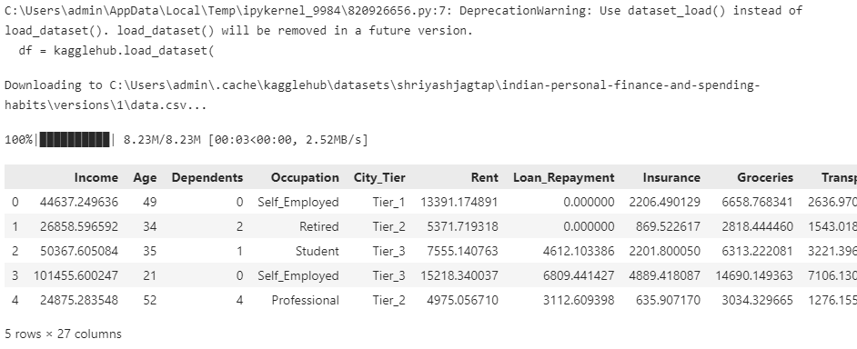

2a)Data Preprocessing:
i)Identifying missing values
df.isnull().sum()

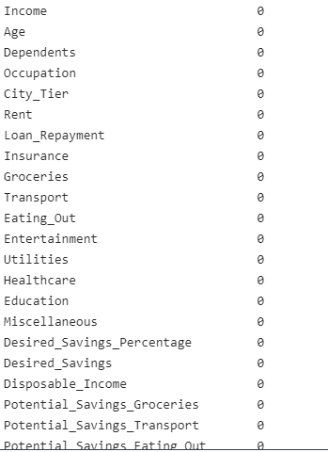

ii)Handling Missing datas with medians
df.fillna(df.median(numeric_only=True),inplace=True)

iii)Look for Dupes and Remove Duplicates
df.duplicated().sum
df.drop_duplicates(inplace=True)
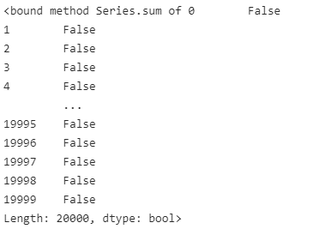
iv)Verify datatypes
df.dtypes
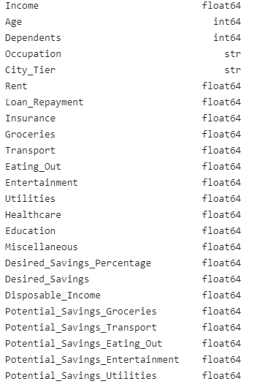
Feature Selection
num_df = df.select_dtypes(include=['int64','float64'])
num_df.head()

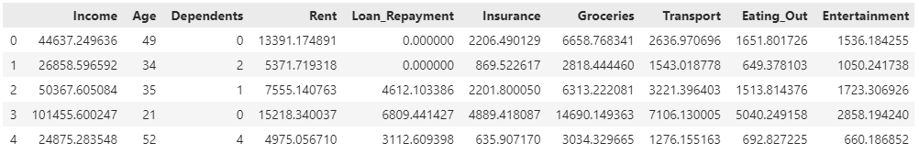
selected_features = [
'Income',
'Entertainment',
'Utilities',
'Healthcare',
'Education',
'Desired_Savings'
]

num_df = num_df[selected_features]
num_df.head()

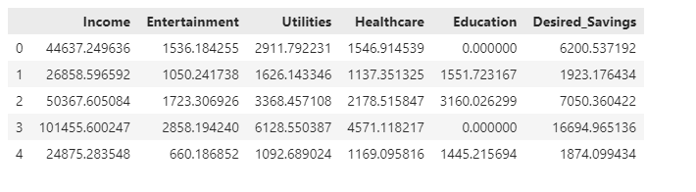

2b) Data Visualization
i)Import Libraries
import matplotlib.pyplot as plt
import seaborn as sns

ii)Plotting a Histogram
num_df.hist(figsize=(15,25))
plt.show()

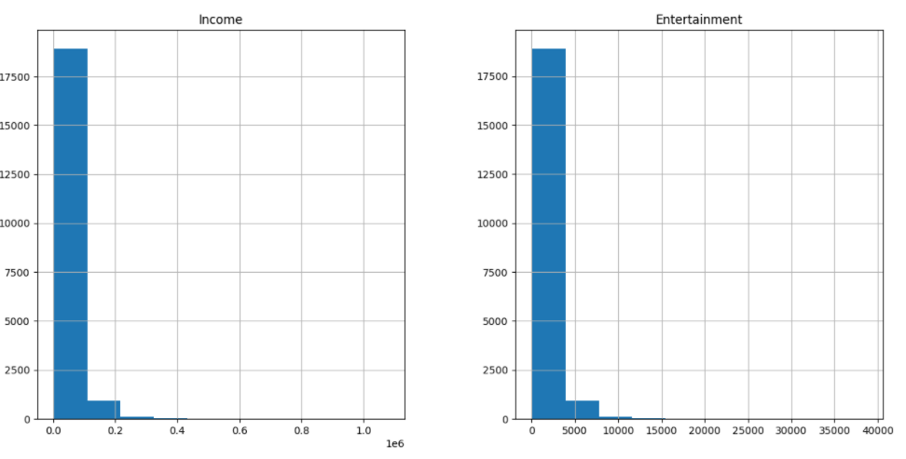

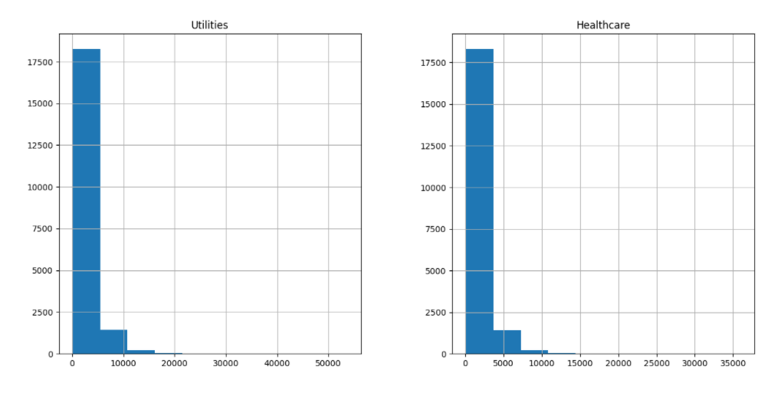

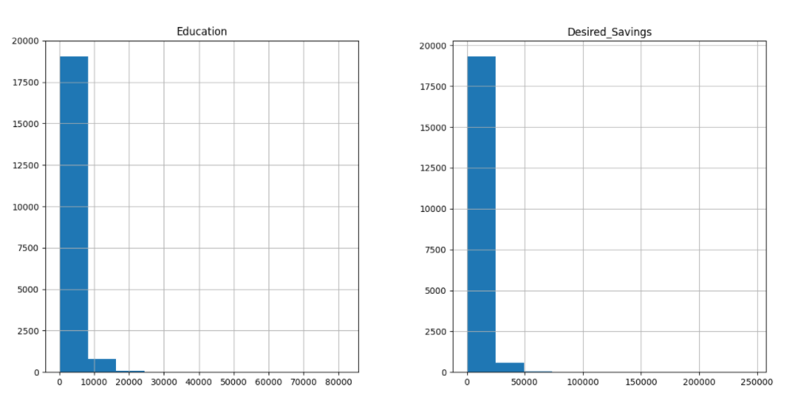

iii)Boxplot
plt.figure(figsize=(15,8))
sns.boxplot(data=num_df)
plt.show()
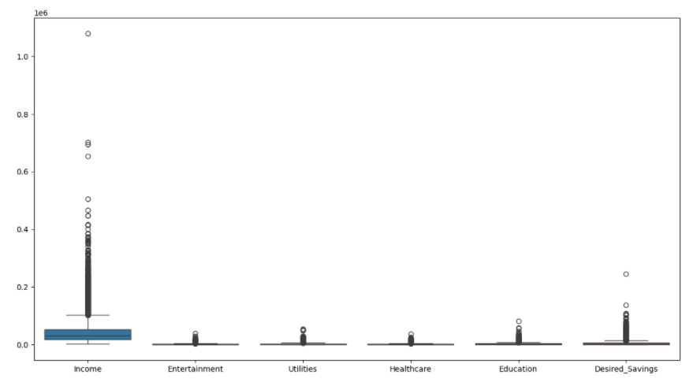

iii)Count Plot
plt.figure(figsize=(10,8))
sns.countplot(x='Occupation', data=df)
plt.show()
