Ex no:4
1.Data Preprocessing
df.isnull().sum()
df.duplicated().sum()

- Checking null and dupes

2.Defining the target variable

spending = np.array(df['Disposable_Income'])
spending

smin = min(spending)
smax = max(spending)

print(smin)
print(smax)

np.linspace(smin,smax,4)
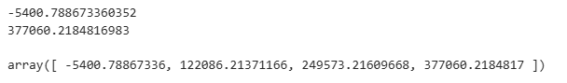

df['Spending_Class'] = pd.cut(
df['Disposable_Income'],
bins=[ -5400.78867337, 122086.21371166, 249573.21609668, 377060.2184817 ],
labels=['Overspender','Moderate','Saver']
)
df['Spending_Class'].value_counts()

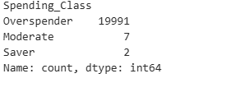

3.Encoding Categorical Data
df = pd.get_dummies(df, columns=['Occupation', 'City_Tier'], drop_first=True)

4.Defining Target Variables
X = df.drop(['Spending_Class','Disposable_Income'],axis=1)
Y = df['Spending_Class']

5.Train test split
from sklearn.model_selection import train_test_split

x_train,x_test,y_train,y_test = train_test_split(
X,Y,test_size=0.20,random_state=42
)

6.Feature Scaling
from sklearn.preprocessing import StandardScaler

scaler = StandardScaler()

x_train = scaler.fit_transform(x_train)
x_test = scaler.fit_transform(x_test)

7.Applying Classification

