Ex 3:
1.Load Dataset
import kagglehub
from kagglehub import KaggleDatasetAdapter

file_name = "data.csv"

df = kagglehub.load_dataset(
KaggleDatasetAdapter.PANDAS,
"shriyashjagtap/indian-personal-finance-and-spending-habits",
file_name,
)

df.head()

2.Feature Selection
selected_features = [
'Rent',
'Income',
'Entertainment',
'Utilities',
'Healthcare',
'Education',
'Desired_Savings'
]

num_df = num_df[selected_features]
num_df.head()

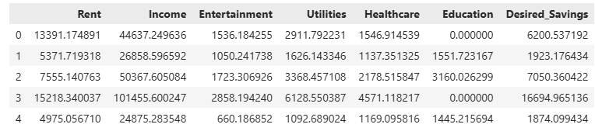

3.Created a Derived Attribute

num_df["Expenses"] = num_df["Entertainment"] + num_df["Utilities"] + num_df["Education"]
num_df.head()

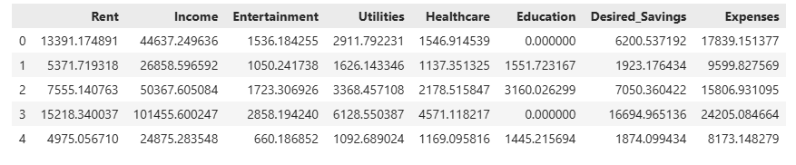

4.Calculate Covariance matrix
cov_matrix = num_df.cov()
cov_matrix

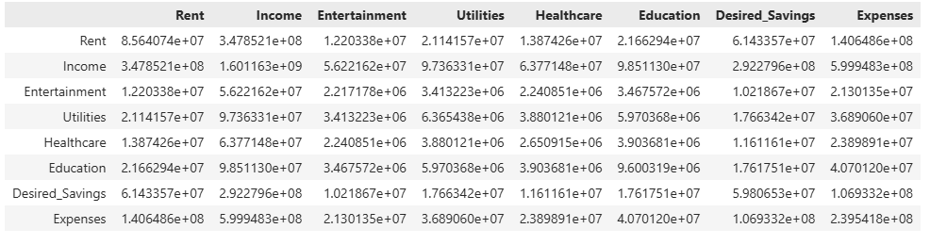
5.Calculate Covariance between Different Attributes
def define_covariance(cov):
if(cov > 0):
print("Positive Covariance")
elif(cov < 0):
print("Negative Covariance")
else:
print("Zero Covariance")

inc_sav_cov = cov_matrix.loc["Income","Desired_Savings"]
print(inc_sav_cov)
define_covariance(inc_sav_cov)

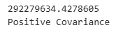

inc_exp_cov = cov_matrix.loc["Income","Expenses"]
print(inc_exp_cov)
define_covariance(inc_exp_cov)

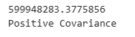

6.Calculate Correlation Matrix
corr_matrix = num_df.corr()
corr_matrix.head()
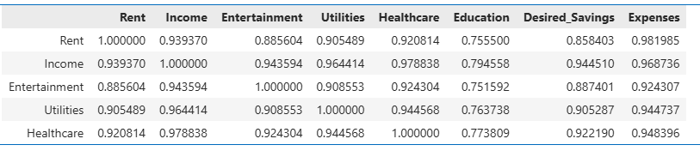

7.Calculated Correlation for two different Atributes
def define_correlation(corr):
if(corr > 0):
print("Positive Correlation")
elif(corr < 0):
print("Negative Correlation")
else:
print("Zero Correlation")

inc_sav_corr = corr_matrix.loc["Income","Desired_Savings"]
print(inc_sav_corr)
define_correlation(inc_sav_corr)

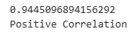
8.Plotting Heatmap showing Correlation
plt.figure(figsize=(10,6))
sns.heatmap(corr_matrix,annot=True,cmap='coolwarm')
plt.title("Heatmap")
plt.show()

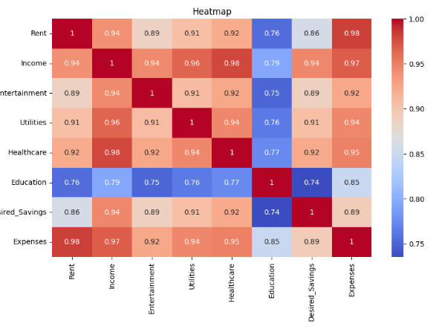

9.Plotting Pairplot to visualize the correlation line of all entries of Income and Expenses
sns.pairplot(num_df[['Income', 'Expenses']])
plt.show()

