
Learning Management System
Complete Project Guide & User Manual
What EduLearn does, what every type of user can do, and how to use, install and maintain the system — with step-by-step instructions and screenshots.
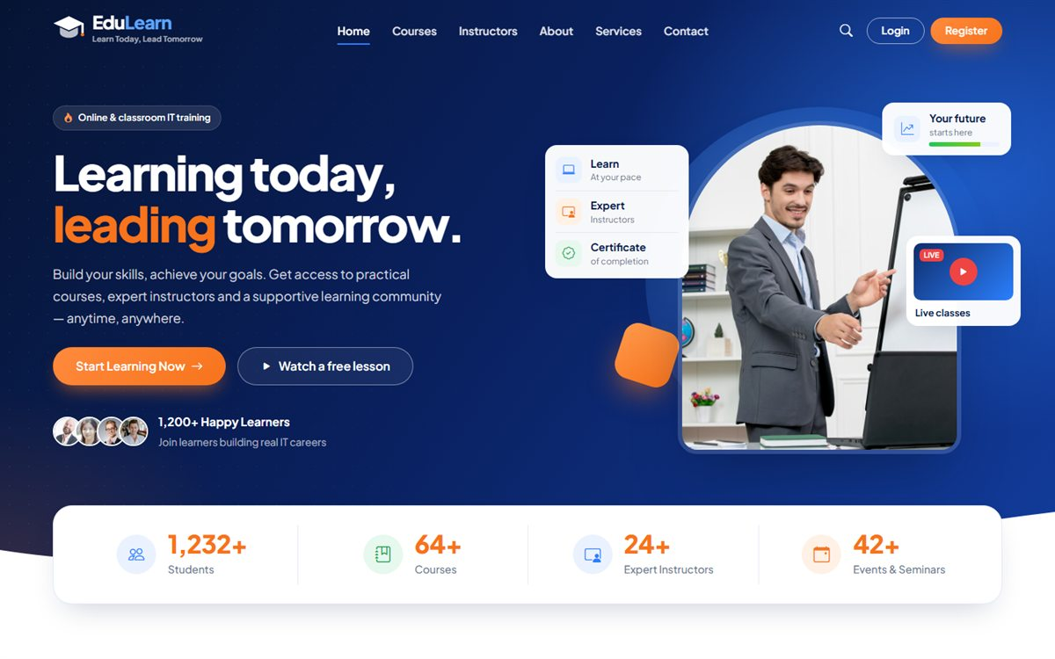
Version | 1.1 (adds batches)
Date | October 2026
Covers | Public website · Student, Teacher and Admin panels · Batches · Installation and customization
Platform | ASP.NET Core 9 MVC · Entity Framework Core · SQL Server

Contents
1. Introduction 1
1.1 What is EduLearn? 1
1.2 Who uses EduLearn? 1
1.3 Features at a glance 1
1.4 How everything fits together 2
2. User Roles and Permissions 3
2.1 Roles overview 3
2.2 Permission matrix 3
2.3 Default accounts 4
3. Getting Started (All Users) 5
3.1 Creating a student account 5
3.2 Logging in 5
3.3 Changing your password 6
3.4 Forgot password 6
3.5 Logging out 6
4. Public Website (Visitors) 7
4.1 Website pages 7
4.2 Finding a course 8
4.3 Course details page 8
4.4 Free seminar registration 10
4.5 Contact form and newsletter 10
4.6 Verifying a certificate 10
5. Student Guide 11
5.1 Student dashboard 11
5.2 Enrolling in a course 11
5.3 My Courses 13
5.4 Learning in the course player 13
5.5 Assignments 14
5.6 Quizzes 15
5.7 Grades 17
5.8 Class schedule and live classes 17
5.9 Announcements 18
5.10 Certificates 18
5.11 My profile 18
6. Teacher Guide 19
6.1 Teacher dashboard 19
6.2 My courses and student progress 19
6.3 Building the curriculum 20
6.4 Assignments 22
6.5 Quizzes 22
6.6 Live classes 23
6.7 Announcements 24
6.8 My profile 24
7. Admin Guide 25
7.1 Admin dashboard 25
7.2 Course categories 25
7.3 Courses 25
7.4 Batches 27
7.5 Enrollments and payment verification 30
7.6 Teachers 31
7.7 Students 32
7.8 Admin users 33
7.9 Website inquiries 33
7.10 Announcements 33
7.11 Payment methods 33
7.12 Reports 34
7.13 Managing course content as admin 35
8. Key Workflows (Step by Step) 36
8.1 Launching a new course 36
8.2 Paid enrollment: from payment to access 36
8.3 From first lesson to certificate 36
8.4 Assignment lifecycle 36
8.5 Quiz lifecycle 36
8.6 Running a new batch 37
8.7 Moving a student to another batch 37
9. Rules and Reference 38
9.1 Enrollment statuses 38
9.2 Course and enrollment rules 38
9.3 Quiz rules 38
9.4 Assignment rules 38
9.5 File upload limits 39
9.6 Deletion protection 39
9.7 Generated numbers 39
9.8 Batch rules 39
10. Security and Privacy 41
11. Technical Overview (for Developers) 42
11.1 Technology stack 42
11.2 Project structure 42
11.3 Main database tables 43
12. Installation and Deployment 44
12.1 Requirements 44
12.2 Running the project 44
12.3 Configuration 44
12.4 Database setup options 44
12.5 Going-live checklist 45
13. Customization 46
13.1 Contact details and site information 46
13.2 Branding 46
13.3 Content managed from the admin panel 46
14. Troubleshooting and FAQ 47
15. Current Limitations and Future Enhancements 48
Appendix A: Page Address Reference 49
Appendix B: Glossary 50

1. Introduction

1.1 What is EduLearn?
EduLearn is a complete online learning platform (Learning Management System, LMS) for an IT training institute. It combines a public marketing website with three private panels — for students, teachers and administrators — so the whole learning journey happens in one place: from a visitor discovering a course, to enrolling and paying, learning lesson by lesson, submitting assignments, taking quizzes, joining live classes and finally receiving a verifiable certificate.
The system is built with ASP.NET Core 9 (MVC) and SQL Server. It works on desktop, tablet and mobile browsers, and needs no software to be installed by students or teachers — a web browser is enough.

1.2 Who uses EduLearn?
User type | Description
Visitor | Anyone browsing the public website without logging in. Can explore courses and instructors, watch free preview lessons, register for a free seminar, send a message, subscribe to the newsletter and verify certificates.
Student | A learner with a student account (self-registered or created by the office). Enrolls in courses, learns in the course player, submits assignments, takes quizzes, joins live classes and earns certificates.
Teacher | An instructor account created by the admin. Builds the curriculum of the courses assigned to them, creates assignments and quizzes, grades students, schedules live classes and sends announcements.
Admin | Office staff / management. Manages categories, courses, teachers, students and admins, verifies payments and approves enrollments, handles website inquiries, payment methods, announcements and reports. Admins can also manage the content of every course.

1.3 Features at a glance
Area | What it provides
Public website | Modern responsive website: home page, course catalog with search and categories, course details with curriculum, instructors, about, services, products, reviews, contact page, privacy policy.
Accounts & security | Student self-registration, role-based login (Admin / Teacher / Student), change password, account activation and deactivation, secure password hashing.
Enrollment & payments | Free courses unlock instantly. Paid courses use manual payment (bKash, bank transfer, etc.): the student submits the transaction ID and the admin verifies and approves it. Seat limits and duplicate transaction checks are built in.
Batches | A course can run in batches, each with its own start date, class schedule, trainer and seats. Students choose a batch when they enroll; live classes, assignments and announcements can go to one batch; lists and reports can be viewed batch-wise.
Course content | Courses are organised into sections and lessons. Lesson types: video (YouTube, Vimeo, Google Drive or MP4), article, downloadable file and external link. Lessons can be marked as free previews.
Learning & progress | Course player with curriculum sidebar, "mark as complete", automatic progress tracking and course completion.
Assignments | Teachers publish assignments with due dates and marks; students submit text and/or files; teachers grade with feedback.
Quizzes | Multiple-choice quizzes with optional time limit, pass mark and maximum attempts; automatic marking and result review.
Live classes | Teachers schedule Zoom / Google Meet sessions; students see them on their dashboard and schedule with a Join button.
Announcements | Site-wide announcements from the admin and course announcements from teachers.
Certificates | A certificate is issued automatically when a student completes every lesson of a course. It can be printed or saved as PDF and verified publicly with its certificate number.
Website inquiries | Contact form messages, free seminar registrations and newsletter subscriptions are stored and managed in the admin panel.
Reports | Course performance (learners, completion rate, average progress, revenue) and payments received with a date filter.

1.4 How everything fits together
A typical cycle in EduLearn looks like this:
- The admin sets up course categories and payment methods, creates teacher accounts and creates a course (title, price, seats, thumbnail) assigned to a teacher.
- The teacher builds the course curriculum — sections and lessons — and adds assignments, quizzes and live classes.
- The admin publishes the course, so it appears on the public website, and opens a batch for it (start date, class times, trainer, seats).
- A visitor finds the course, registers as a student, clicks Enroll and chooses a batch. For a paid course, the student pays by bKash or bank and submits the transaction ID.
- The admin checks the payment and approves the enrollment. The course unlocks for the student.
- The student learns lesson by lesson, submits assignments, takes quizzes and joins live classes; the teacher grades work and follows progress.
- When every lesson is completed, the system issues a certificate with a unique number that anyone can verify on the website.

2. User Roles and Permissions

2.1 Roles overview
Role | How the account is created | After login goes to | Main menu
Student | Self-registration on the website (Register), or created by the admin (Students > Add student). | Student Panel (/Student) | Dashboard, My Courses, Browse Courses, Assignments, Quizzes, Grades, Class Schedule, Announcements, Certificates
Teacher | Created by the admin (Teachers > Add teacher). | Teacher Panel (/Teacher) | Dashboard, My Courses, Assignments, Quizzes, Live Classes, Announcements
Admin | The first admin is created automatically during installation; more admins are added in Admin Users. | Admin Panel (/Admin) | Dashboard, Categories, Courses, Batches, Enrollments, Assignments, Quizzes, Live Classes, Teachers, Students, Admin Users, Inquiries, Announcements, Payment Methods, Reports

Note: Every panel also has an Account menu with My Profile (students and teachers), Change Password and Logout. A deactivated account cannot log in until an admin activates it again.

2.2 Permission matrix
✔ = allowed, — = not available. "Own" means only for the courses the teacher is assigned to, as the course teacher or as the trainer of one of its batches.
Feature | Visitor | Student | Teacher | Admin
Browse website, courses, instructors | ✔ | ✔ | ✔ | ✔
Watch free preview lessons | ✔ | ✔ | ✔ | ✔
Register for free seminar / contact / newsletter | ✔ | ✔ | ✔ | ✔
Verify a certificate | ✔ | ✔ | ✔ | ✔
Register a student account | ✔ | — | — | —
Enroll in courses (choosing a batch) and pay | — | ✔ | — | —
Learn in the course player, track progress | — | ✔ (enrolled courses) | — | —
Submit assignments, take quizzes | — | ✔ | — | —
View grades, schedule, announcements, certificates | — | ✔ | — | —
Build curriculum (sections & lessons) | — | — | ✔ Own | ✔ All
Create assignments and grade submissions | — | — | ✔ Own | ✔ All
Create quizzes and view results | — | — | ✔ Own | ✔ All
Schedule live classes | — | — | ✔ Own | ✔ All
Send announcements | — | — | ✔ Own courses | ✔ Everyone or any course
View enrolled students and their progress | — | — | ✔ Own | ✔ All
Create / edit / publish / delete courses | — | — | — | ✔
Create batches, open / close admission, move students between batches | — | — | — | ✔
Send live classes, assignments and announcements to one batch | — | — | ✔ Own | ✔ All
Manage categories | — | — | — | ✔
Approve, reject, cancel enrollments; manual enrollment | — | — | — | ✔
Manage teachers, students and admin users | — | — | — | ✔
Manage payment methods | — | — | — | ✔
Website inquiries, reports | — | — | — | ✔
Edit own profile, change password | — | ✔ | ✔ | ✔ (password)

2.3 Default accounts
Account | Email | Password | When it exists
Administrator | admin@edulearn.com | Admin@123 | Always — created automatically on first run (or by the database script). Change this password immediately.
Demo teacher | teacher@edulearn.com | Teacher@123 | Only with demo data (development mode or the optional demo script).
Demo student | student@edulearn.com | Student@123 | Only with demo data (development mode or the optional demo script).

3. Getting Started (All Users)

3.1 Creating a student account
Anyone can create a free student account from the website.
- Click Register at the top right of the website (or Get Started Now in the banner).
- Enter your full name, mobile number, email address, a password (at least 6 characters) and confirm the password.
- Click Create account. You are logged in immediately and taken to your Student Dashboard. A message shows your new Student ID (for example ST26101234).

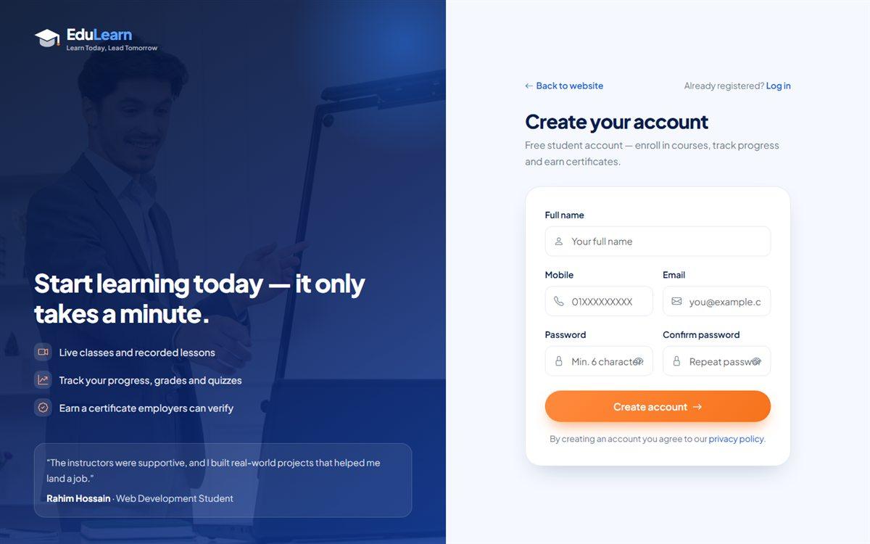
Figure 1: Create account page
Tip: If you clicked Enroll now on a course before registering, you are taken straight back to that course's enroll page after creating the account.

3.2 Logging in
- Click Login at the top right of the website.
- Enter your email and password and click Log in. Students, teachers and admins all use the same login page.
- You are taken to your own panel automatically: Admin Panel, Teacher Panel or Student Panel.

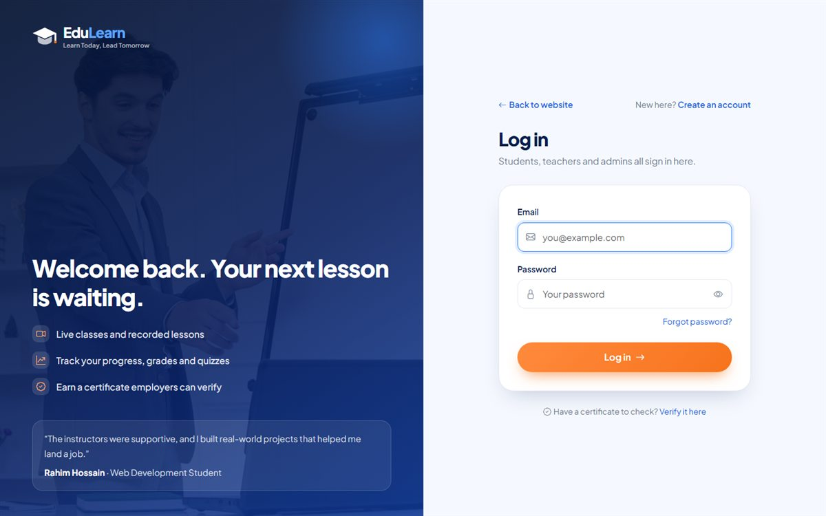
Figure 2: Login page
Message | Meaning
User not found. Please check your email. | No account exists with this email address.
Incorrect password. Please try again. | The password is wrong. Passwords are case-sensitive.
Your account has been deactivated. | An admin has switched the account off. Contact the office to reactivate it.

3.3 Changing your password
- Open the Account menu (left sidebar) or click your name at the top right and choose Change Password.
- Enter your current password, the new password (minimum 6 characters) and confirm it.
- Click Update password.

3.4 Forgot password
Click Forgot password? on the login page. It opens the Contact page with the subject "Password reset". The office can set a new password for the account: for students and teachers from Students / Teachers > Edit (New password field), and for admins from Admin Users > Set password.

3.5 Logging out
Choose Logout from the Account menu or from the drop-down under your name. On shared computers, always log out when you finish.

4. Public Website (Visitors)
The public website introduces EduLearn and turns visitors into students. The header shows the menu (Home, Courses, Instructors, About, Services, Contact), a course search button and the Login / Register buttons. When someone is logged in, the header shows their name with a link to their dashboard instead.
Figure 3: Home page

4.1 Website pages
Page | Address | What it shows
Home | / | Hero banner, key numbers, career categories, latest courses, why choose us, steps to a certificate, free seminar, instructors, student testimonials, call to action.
Courses | /Courses | All published courses with category filter and search.
Course details | /Courses/Details/{id} | Full course information, upcoming batches, curriculum, instructor, price, seats left and the Enroll button.
Free preview | /Courses/Preview/{id} | A lesson marked as "free preview" — visible to everyone.
Instructors | /Instructors | Profiles of active teachers with their number of courses and students.
About | /AboutUs | Who we are, mission, vision, values and leadership.
Services / Products | /Services, /Product | Software services and ready-made products offered by the company.
Reviews | /StudentsFeedback | Student testimonials and rating summary.
Contact | /ContactUs | Address, phones, emails, office hours, contact form, map and payment options.
Verify certificate | /Certificate/Verify | Public certificate verification by certificate number.
Privacy policy | /Home/Privacy | How personal information is used.

4.2 Finding a course
- Open Courses from the menu. Each card shows the thumbnail, category, title, number of students and lessons, level, price and an Enroll Now link.
- Use the category buttons to show only one category, or type in the search box (also available from the magnifier icon in the header). Search looks in course titles, short descriptions and category names.
- Badges on the thumbnails: Free (no fee), New (added in the last 45 days) and Popular (five or more students).

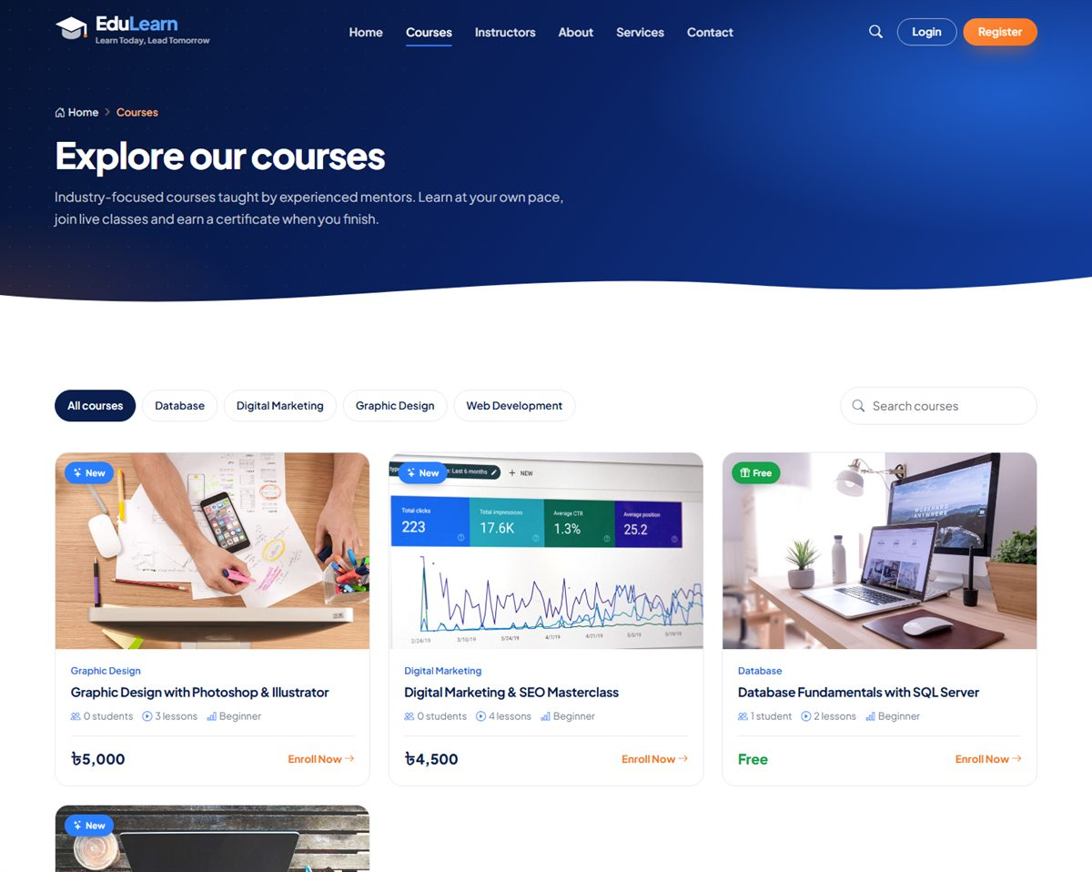
Figure 4: Course catalog with category filter and search

4.3 Course details page
The course page explains everything a student needs before enrolling:
- Header: title, short description, instructor, level, duration, number of lessons with total time.
- Enroll card (right side): price, seats left, the main button and a summary (next batch, trainer, schedule, duration, lessons, level, language). For a course with batches, the seats, trainer and schedule come from the next batch that still has room.
- Upcoming batches: every batch that is taking admission, with its dates, class schedule, trainer, seats left and an Enroll button for that batch.
- What's included, About this course, the full Curriculum (sections and lessons with durations) and Your instructor.
- Lessons marked Preview can be opened by anyone; other lessons show a lock icon.

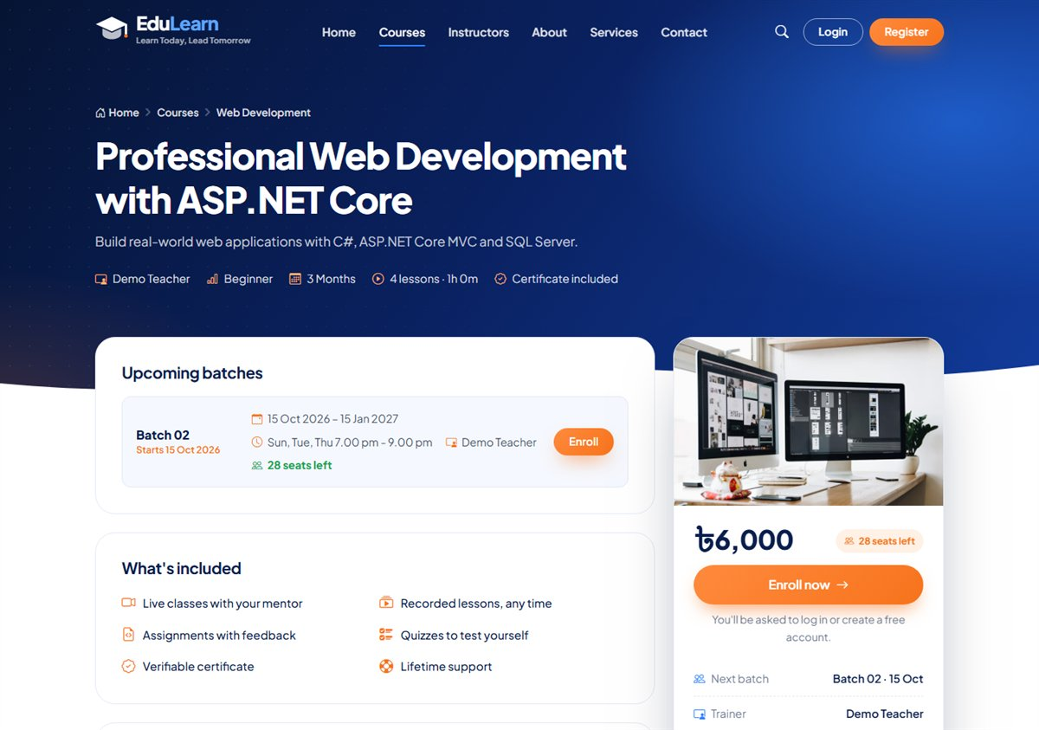
Figure 5: Course page with upcoming batches and the enroll card
The main button changes depending on who is looking:
Situation | Button shown
Visitor or student not yet enrolled | Enroll now (paid) or Enroll for free. Visitors are asked to log in or register first.
Student already enrolled | Continue learning — opens the course player.
Student waiting for payment approval | Waiting for payment verification (disabled).
All seats taken | This batch is full (course without batches) or All batches are full, plus Notify me about the next batch (opens the seminar form).
No batch is taking admission | Admission closed plus Notify me about the next batch.
Teacher or admin | Manage this course — opens the curriculum editor.

4.4 Free seminar registration
Buttons such as Join free seminar, Save Your Seat and the play button on the home page open the free seminar form. The visitor chooses the course they are interested in and enters their name, phone and email, then clicks Reserve my free seat. The registration appears in the admin panel under Inquiries > Seminar, so the office can call back with the date and time.

4.5 Contact form and newsletter
- Contact page: name, email, optional phone, subject and message. Messages whose subject mentions "feedback" are saved as Feedback, others as Contact.
- Newsletter: the email box in the footer. Each email is stored once.
- All three forms are protected against spam robots with a hidden field, and the visitor sees a confirmation message after sending.
- The Contact page also lists the payment options (bKash numbers, bank account) so people can pay before enrolling.

4.6 Verifying a certificate
Anyone (for example an employer) can check a certificate: open Verify certificate (footer, login page or /Certificate/Verify), type the certificate number such as EDU-2026-00001 and click Verify. A valid certificate shows the student's name, Student ID, course and completion date. An unknown number shows "Not found".
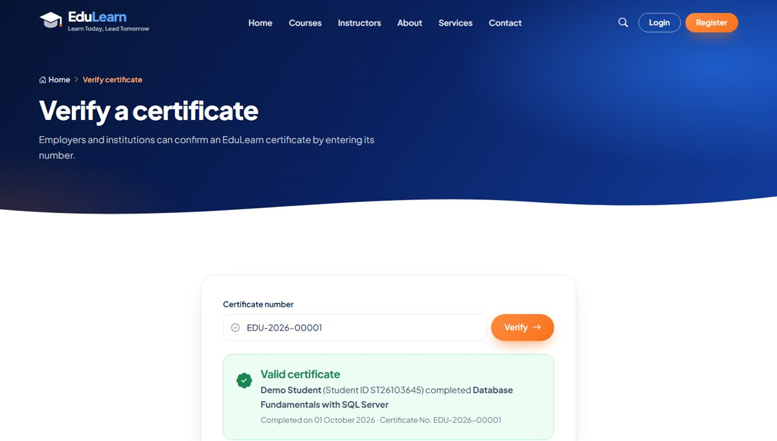
Figure 6: Public certificate verification

5. Student Guide

5.1 Student dashboard
After logging in, students land on their dashboard. It shows:
- A welcome banner with the Student ID and a Browse courses button.
- An alert when an enrollment request is waiting for payment verification.
- Four counters: courses in progress, assignments due, quiz average and certificates.
- Continue learning — up to four courses with progress bars and Start / Continue / Review buttons.
- Assignments due — upcoming assignments with a Submit button.
- Upcoming classes — live classes with a Join button (red and marked "Live" while the class is running).
- Announcements — the latest news from the office and teachers.

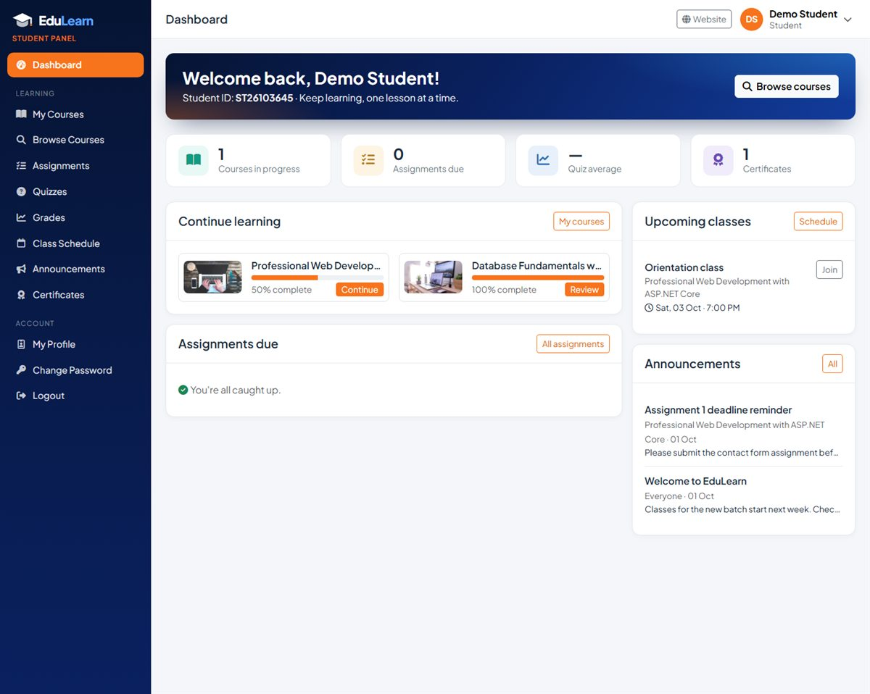
Figure 7: Student dashboard

5.2 Enrolling in a course
Many courses run in batches: groups of students who start on the same date and attend classes at the same times. On such a course the enroll page first asks you to choose your batch. Each batch shows its start and end date, class schedule, trainer and the seats left; a full batch cannot be chosen. Courses without batches skip this step.

Free courses
- Open the course (from the website or Browse Courses in the panel) and click Enroll for free.
- If the course has batches, choose one. Click Enroll for free. The course opens immediately in the course player.

Paid courses
- Open the course and click Enroll now (or Enroll next to a batch under Upcoming batches).
- If the course runs in batches, choose your batch.
- Pay the course fee to one of the accounts shown (for example bKash Merchant / Personal number or Sonali Bank). The copy button next to each number copies it.
- Select the payment method you used, enter your sender number (optional) and the Transaction ID from the confirmation SMS or deposit slip.
- Click Submit payment details. Your request is now Pending and appears under My Courses > Enrollment requests.
- The office checks the payment and approves it. The course then appears in My Courses and the Continue button works.

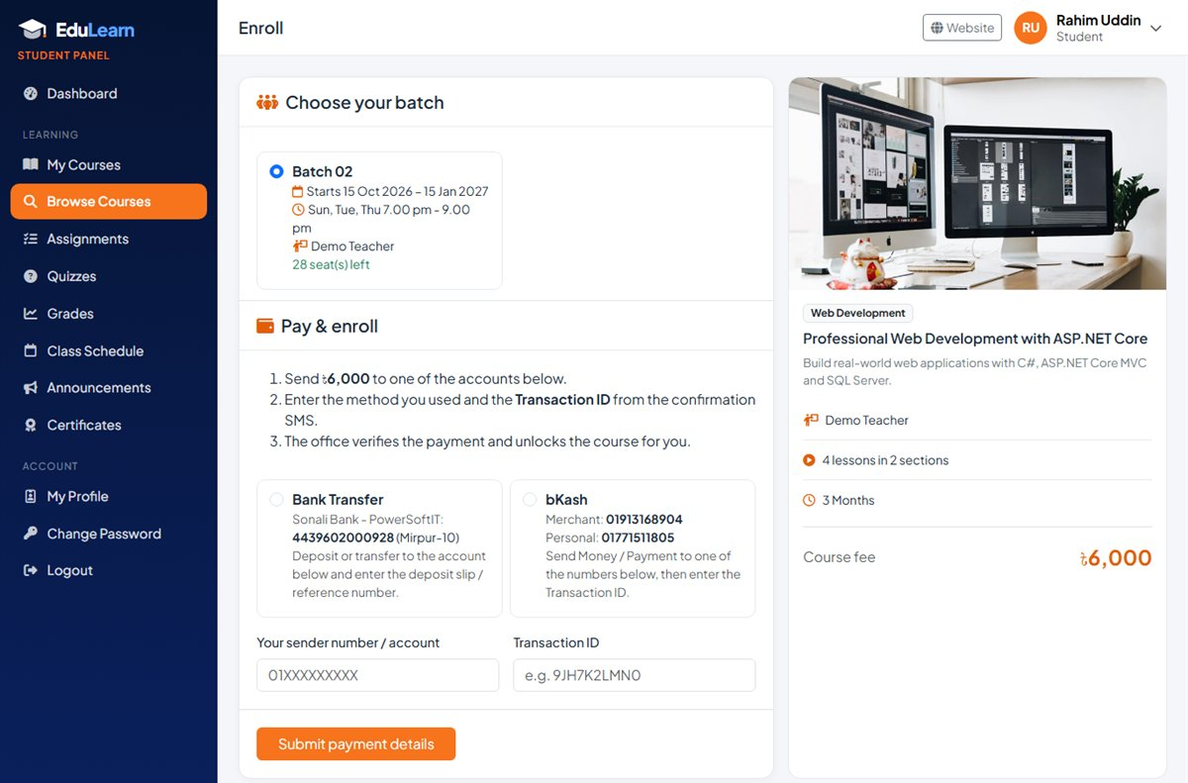
Figure 8: Enroll page: choose a batch, then pay and enter the transaction ID
Important: Each transaction ID can be used only once. If the course or batch has a seat limit, pending requests also hold a seat. If a request is rejected, the reason from the office is shown and you can submit the payment details again.

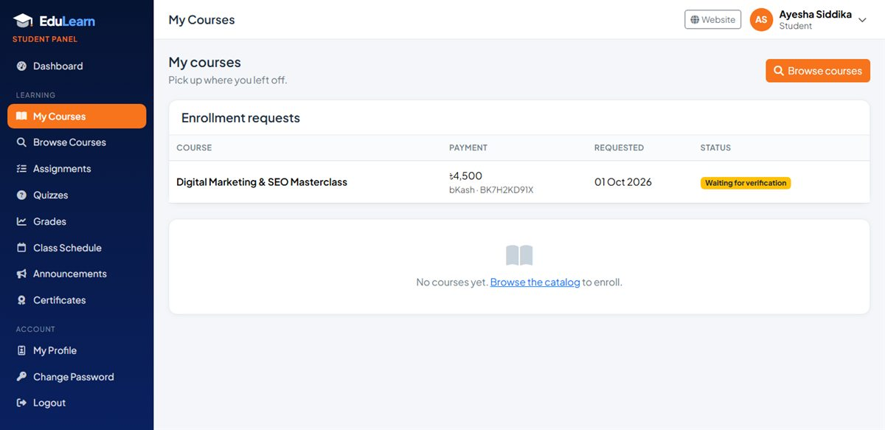
Figure 9: My Courses showing an enrollment request waiting for verification

5.3 My Courses
My Courses lists every course you have access to, with a progress bar (lessons completed / total). Buttons: Start course, Continue or Review course (after completion), plus a certificate button for completed courses. Courses that run in batches also show your batch and its class times. Enrollment requests that are pending, rejected or cancelled are listed in a table at the top, with the office's note and a Try again button where possible.
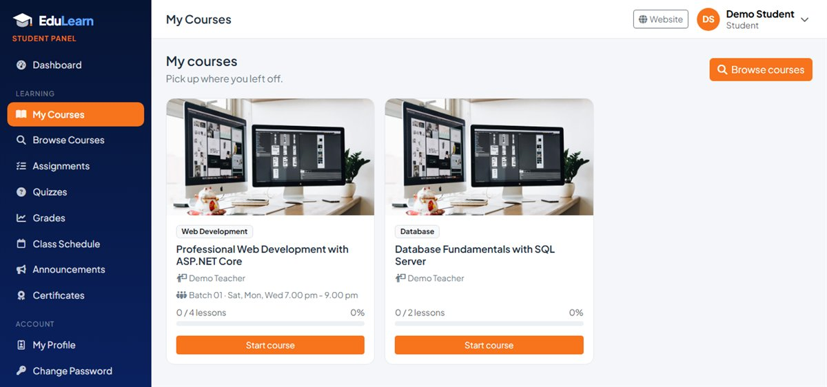
Figure 10: My Courses

5.4 Learning in the course player
Click Continue on a course to open the player. It always opens at the first lesson you have not finished.
- Top bar: back to My Courses, your progress (for example 2 / 4 lessons, 50%) and View certificate once the course is completed.
- Lesson area: the video or content, the lesson title, type and duration, a download button for attached files and the teacher's notes.
- Buttons: Previous, Mark as complete & continue and Next.
- Curriculum sidebar: all sections and lessons; finished lessons have a green tick and the current lesson is highlighted. Quick links open the course's quizzes, assignments and announcements.

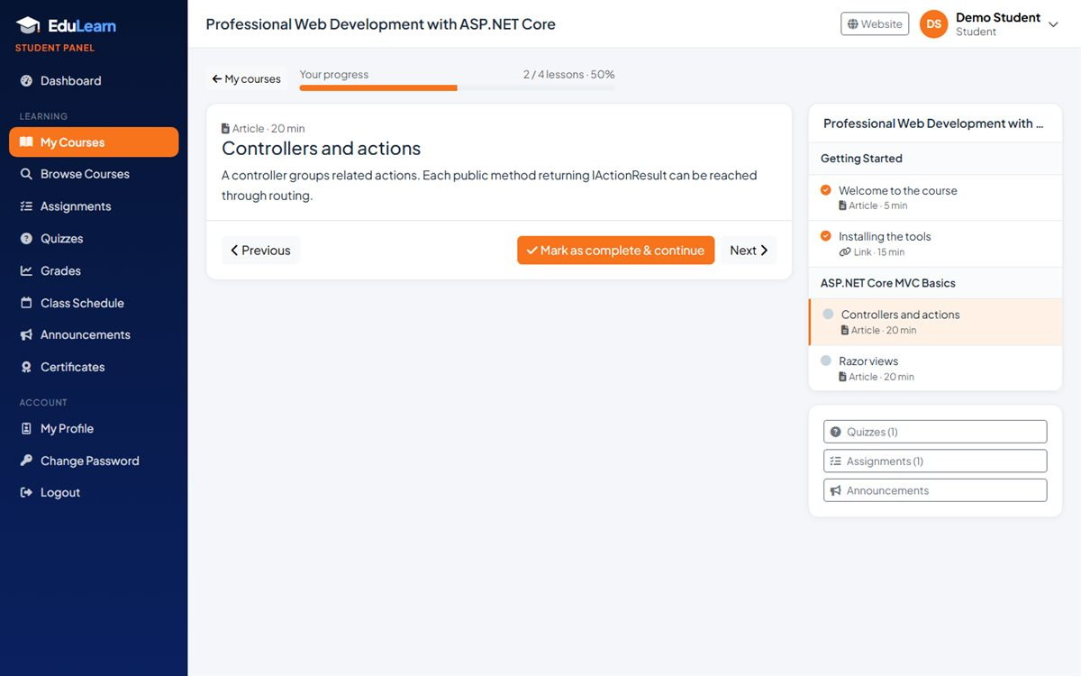
Figure 11: Course player with curriculum sidebar
Lesson type | What the student sees
Video | YouTube, Vimeo and Google Drive videos play inside the page; MP4 files play in the built-in player. Other video sites show a "Watch it in a new tab" link.
Article | Text written by the teacher, shown with line breaks.
File | A Download lesson file button (PDF, slides, ZIP and so on).
Link | An Open resource button that opens an external web page.

Course completion: When you mark the last remaining lesson as complete, the course becomes Completed and your certificate is issued automatically — the player takes you straight to it.

5.5 Assignments
Assignments lists the assignments of your courses, both those for the whole course and those made for your batch, with the due date and a status: To do, Submitted, Graded x / y or Missed (deadline passed without a submission).
- Click Submit to open an assignment. Read the instructions and download any attachment.
- Type your answer (or paste a link to your work) and/or attach a file (PDF, Office, ZIP, images or MP4 up to 100 MB).
- Click Submit assignment. You can change it with Update submission until the deadline or until the teacher grades it.
- After grading, the page shows your grade and the teacher's feedback.

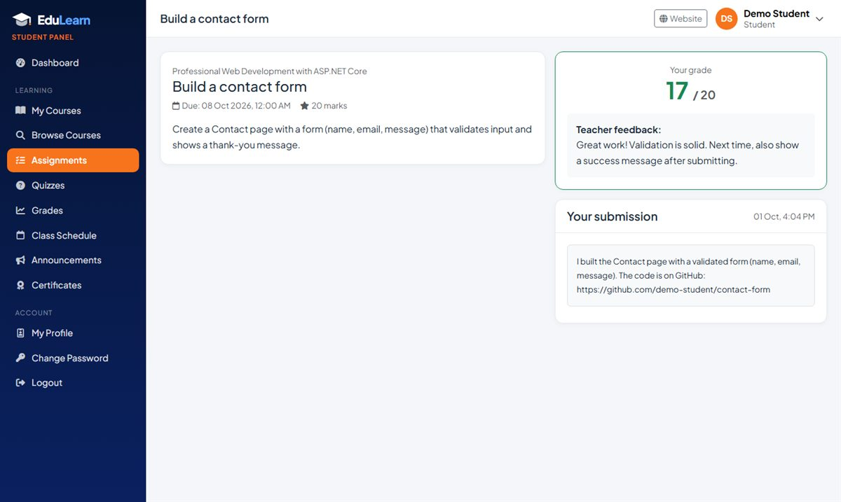
Figure 12: Graded assignment with teacher feedback

5.6 Quizzes
Quizzes shows the published quizzes of your courses: number of questions and marks, time limit, pass mark, attempts left and your best score.
- Click Start quiz (or Resume if you left a quiz open). Timed quizzes ask for confirmation first.
- Choose one answer for each question. A counter shows how many you have answered and, for timed quizzes, a countdown timer turns red in the last minute.
- Click Submit quiz. If time runs out, the quiz is submitted automatically.
- The result page shows your percentage, score, pass or fail and a review of every question. Use Try again if attempts remain.

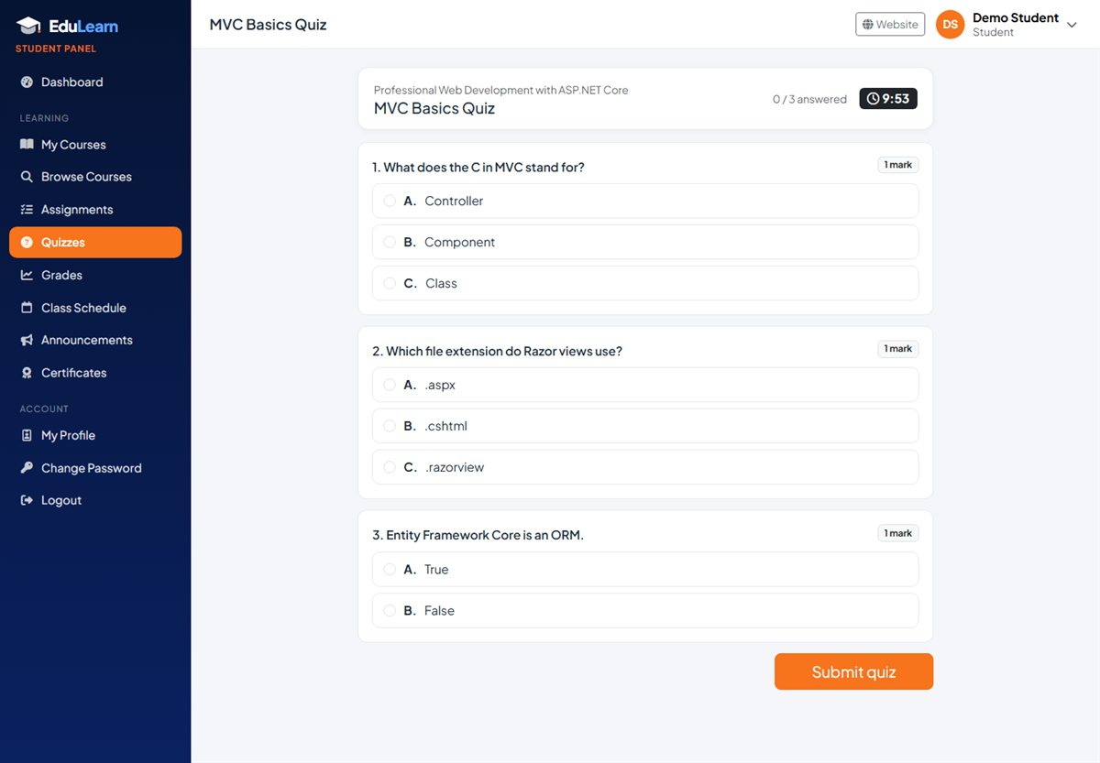
Figure 13: Taking a timed quiz
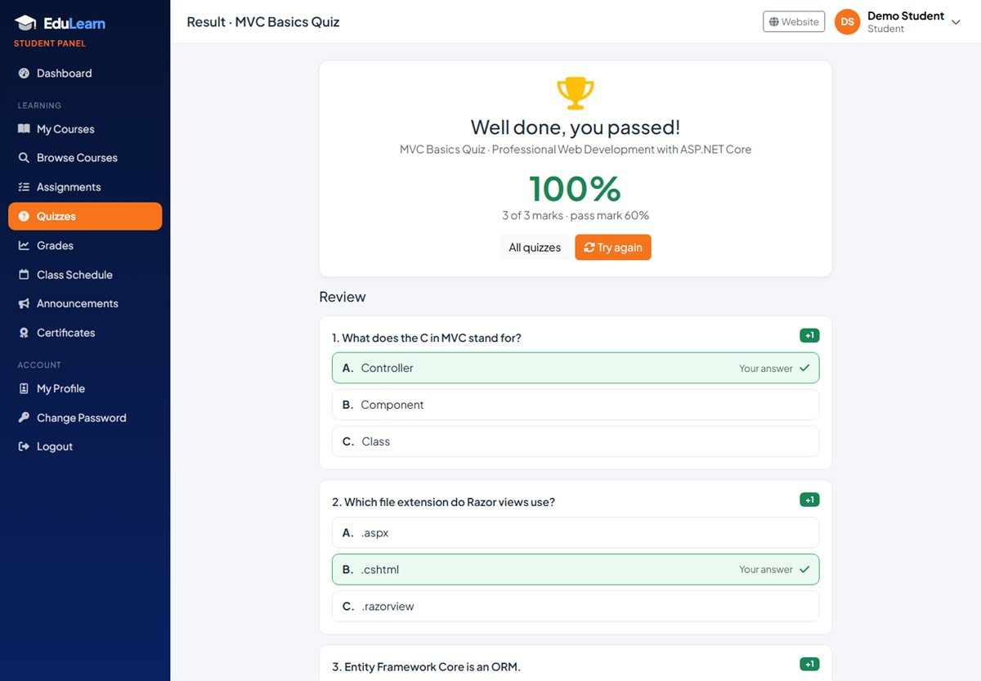
Figure 14: Quiz result with review
Good to know: Correct answers to the questions you got wrong are revealed only after you have used all your attempts, so retakes stay meaningful. Unanswered questions score zero.

5.7 Grades
Grades gives one card per course with your lesson progress, each assignment's marks and your best result in every quiz. Use Print for a paper copy.
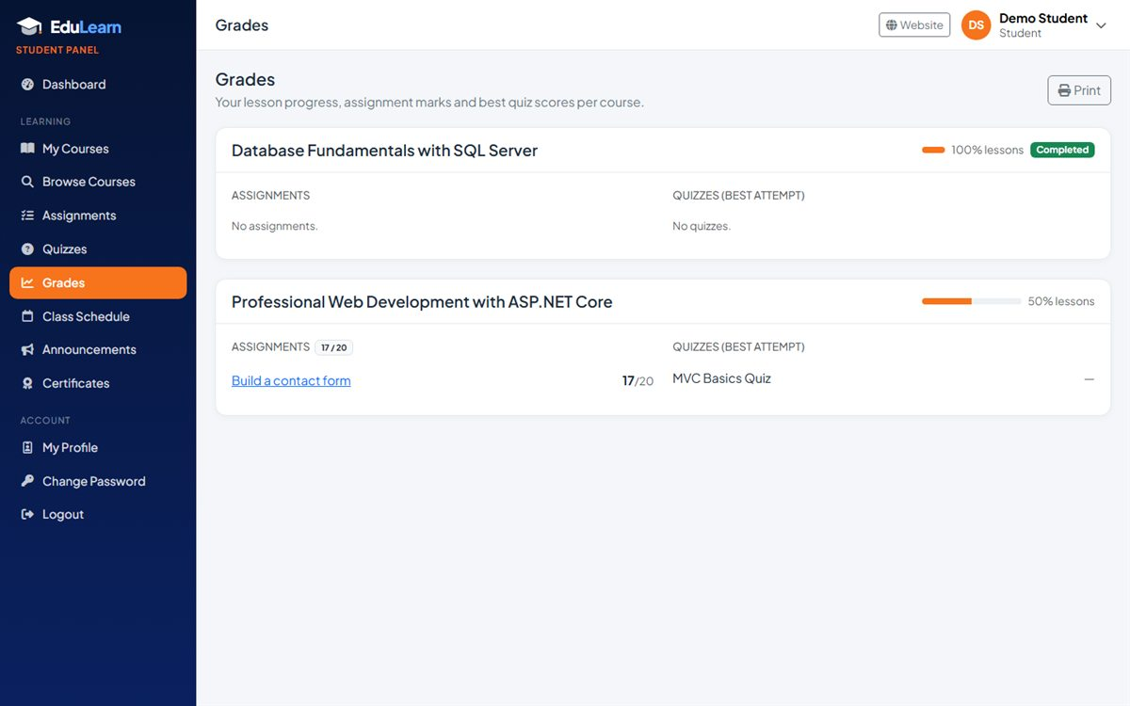
Figure 15: Grades overview

5.8 Class schedule and live classes
Class Schedule lists upcoming live classes of your courses and your batch, grouped by day (Today, Tomorrow, date) with the time, duration, course and notes. The Join button opens the Zoom or Google Meet link; it turns red when the class is live. My batches & class times shows, for each course, your batch, its dates, trainer and regular class times. Recent classes are listed too.
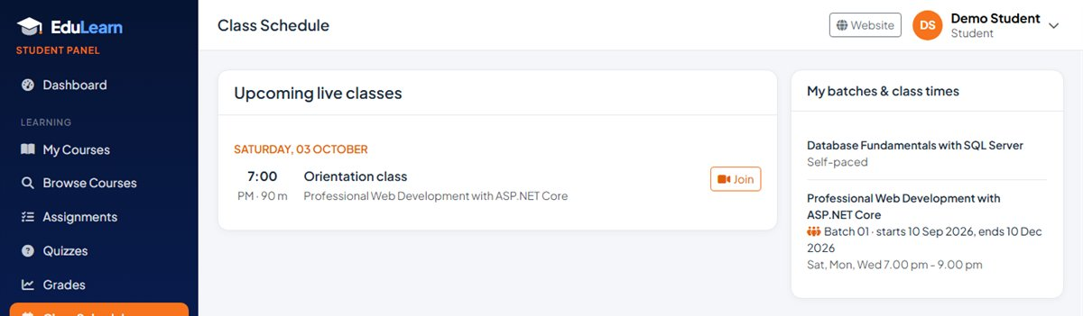
Figure 16: Class schedule with your batch and class times

5.9 Announcements
Announcements shows messages for everyone from the office plus announcements for your courses and your batches, newest first.

5.10 Certificates
Certificates lists every completed course with its certificate number. Open shows the certificate with your name, Student ID, course, completion date, instructor, certificate number and verification address. Click Print / Save as PDF to print it or save it as a PDF file.
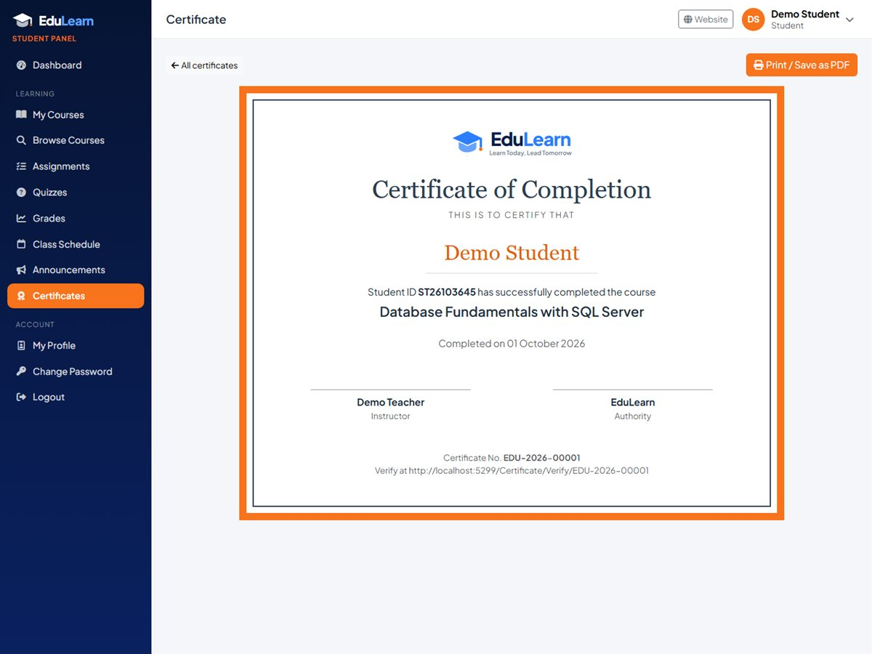
Figure 17: Certificate of completion

5.11 My profile
My Profile lets students update their name, mobile number, father's and mother's names, date of birth, address, a short "about" text and a profile photo (JPG, PNG, WEBP or GIF up to 5 MB). The email address is the login name and can only be changed by the office.

6. Teacher Guide
Teachers see and manage only the courses the admin has assigned to them, as the course teacher or as the trainer of one of its batches. Opening another teacher's course shows "not found".

6.1 Teacher dashboard
- Counters: my courses, active students, submissions to grade and quizzes.
- My courses with lesson and student counts and a Manage button.
- Recent submissions — ungraded work first, with a Grade button.
- Upcoming live classes and a quick button to schedule a new one.

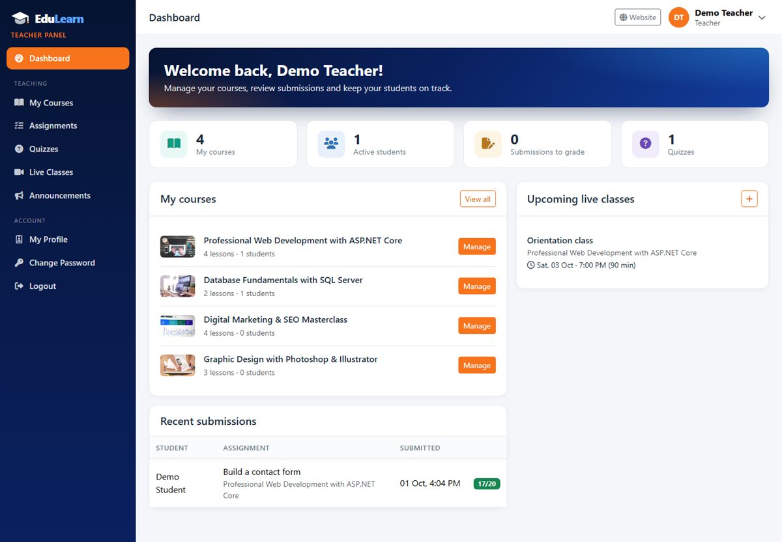
Figure 18: Teacher dashboard

6.2 My courses and student progress
My Courses shows a card per course with its status (Published / Draft) and counts of sections, lessons and students. Buttons open the Curriculum, Students, Assignments and Quizzes of the course.
The Students page lists everyone with access to the course with their contact details, lesson progress, number of assignments submitted, quiz average and status. For a course with batches, the tabs at the top show All batches or a single batch (with its dates, schedule and trainer), and Print gives a class list.
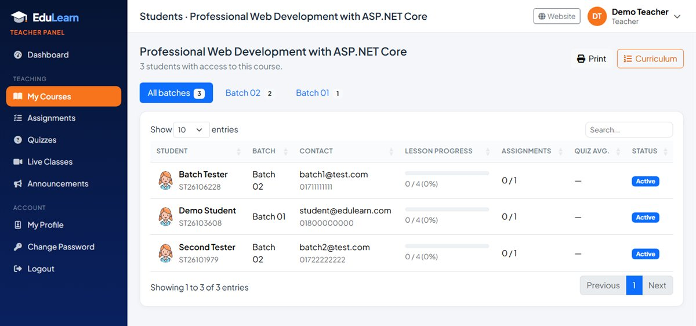
Figure 19: Students of a course, with a tab for each batch

6.3 Building the curriculum
A course is organised in sections (for example "Week 1: Getting started") that contain lessons. Open My Courses > Curriculum.
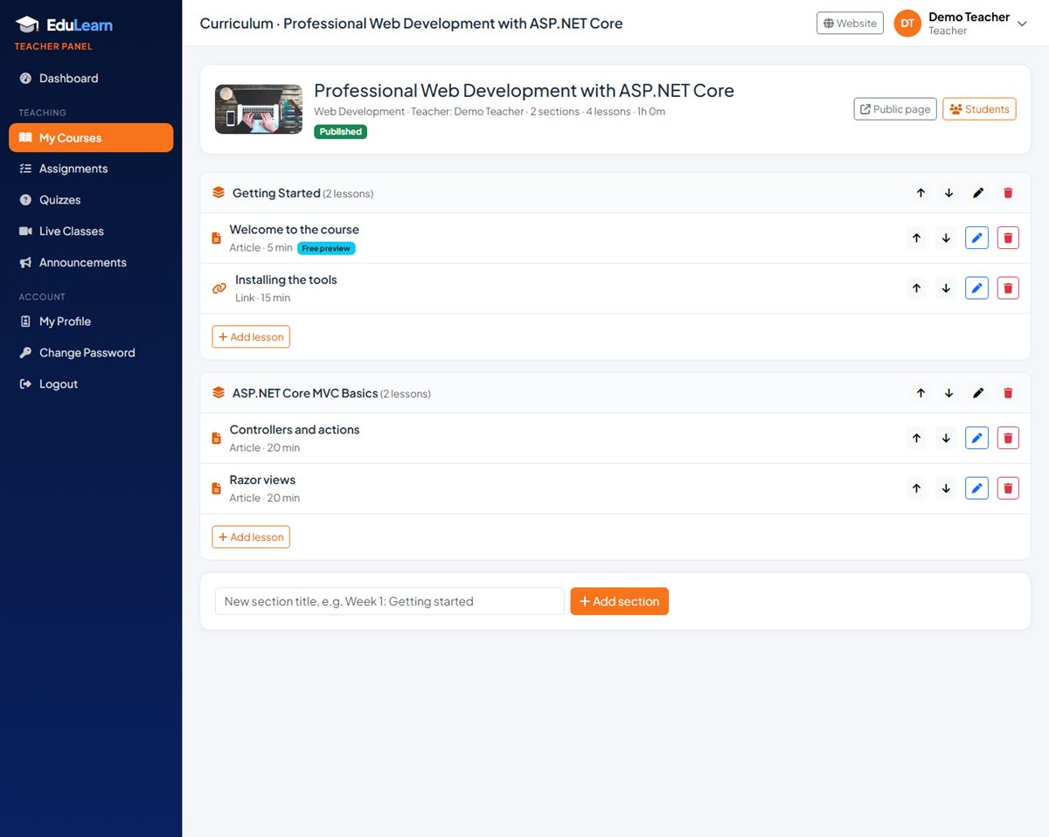
Figure 20: Curriculum editor

Sections
- Add section: type a title in the box at the bottom and click Add section.
- Rename (pencil), move up / down (arrows) or delete a section. Deleting a section also deletes its lessons.

Adding a lesson
- Click Add lesson under a section.
- Enter the title and choose the lesson type: Video, Article, File or Link.
- For a video or link, paste the URL (YouTube, Vimeo, Google Drive or a direct MP4 link). Write the article text or optional notes in Content.
- Optionally attach a file (PDF, Office, ZIP, images or MP4, up to 100 MB), set the duration in minutes and switch on Free preview to show the lesson on the public course page.
- Click Add lesson. Use the arrows to change the order and the pencil to edit later.

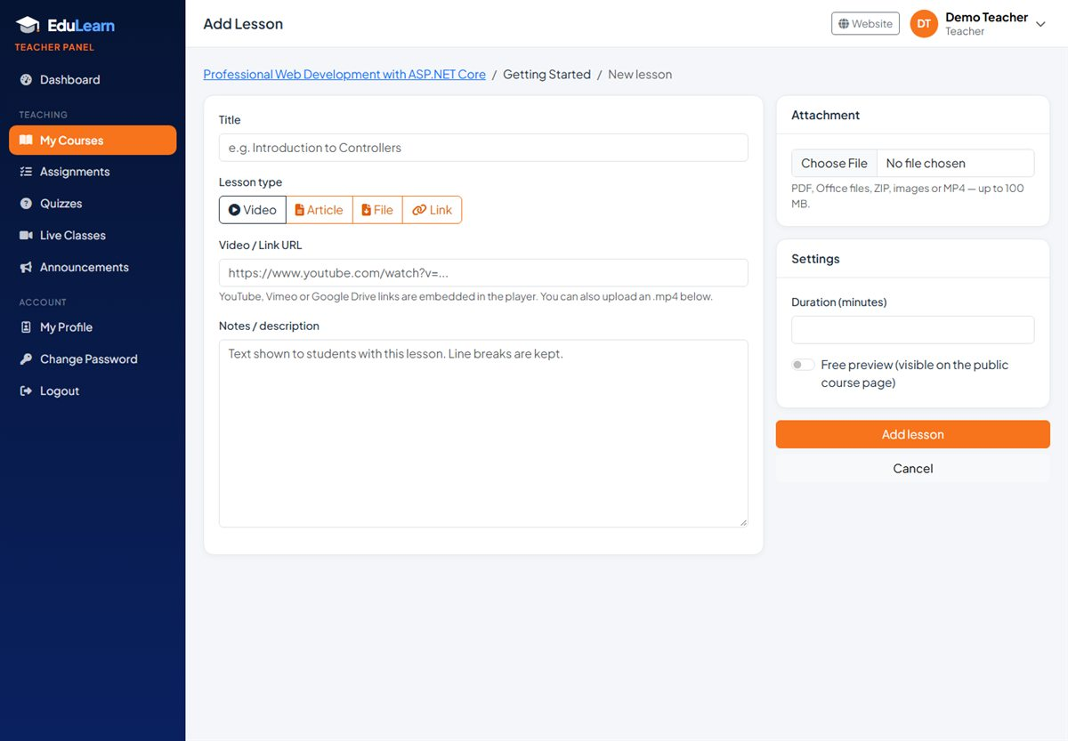
Figure 21: Add lesson form
Lesson type | Required
Video | A video link or an uploaded MP4 file.
Article | The article text (Content).
File | An attached file.
Link | A web address. All links must start with http:// or https://.

Tip: Mark the first lesson of each course as Free preview — visitors can watch it from the course page, and the home page "Watch a free lesson" button opens it.

6.4 Assignments
- Open Assignments and click New assignment.
- Choose the course and, if it has batches, All batches or one batch (batches start on different dates, so each can get its own assignment and due date). Enter the title, instructions, due date (leave empty for no deadline), total marks and an optional attachment. Click Publish assignment. The students it is for see it immediately.
- Click Submissions to see every enrolled student: not submitted, submitted (with time) or late, their answer text and file.
- Enter the marks (0 to the total, half marks allowed) and optional feedback, then click Grade. Grades can be updated later.

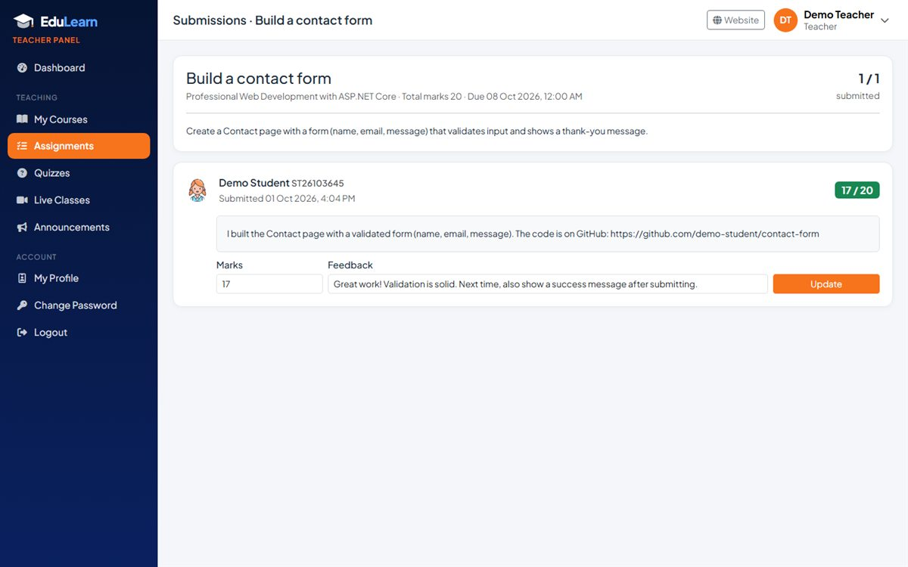
Figure 22: Grading submissions
Note: Students can update a submission until the deadline or until it is graded. Deleting an assignment also deletes its submissions.

6.5 Quizzes
- Open Quizzes and click New quiz. Choose the course and set the title, instructions, time limit (minutes, empty = no limit), pass mark (%) and max attempts (empty = unlimited). New quizzes start as drafts.
- On the Questions page, type the question, set its marks, enter at least two answer options and select the correct one. Click Add question; repeat for every question.
- Click Publish. Students can now take the quiz (a quiz needs at least one question to be published).
- Open Results to see each attempt: score, pass or fail, time taken and submission time, plus totals and the average score.

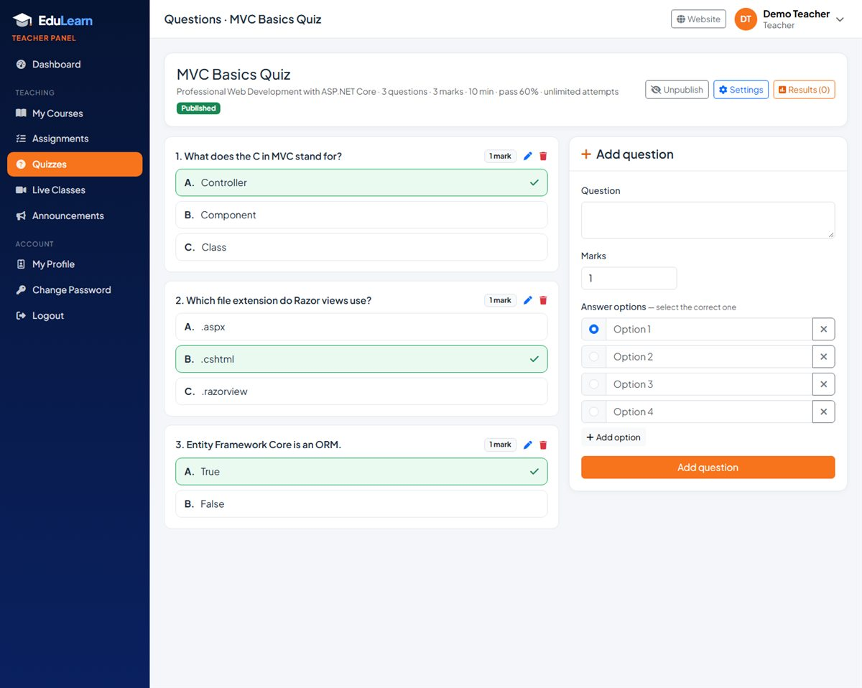
Figure 23: Quiz question builder
Questions lock after the first attempt: Once a student has attempted a quiz, its questions cannot be edited, so past results stay correct. If you really need to change them, use Clear attempts — this deletes all results of that quiz.

6.6 Live classes
Open Live Classes > Schedule class. Choose the course and the batch (keep All batches for a class for everyone, or pick one batch so only its students see it), enter a title, the start date and time, the duration (5–600 minutes), the meeting link (Zoom, Google Meet…) and optional notes such as a passcode. Enrolled students see the class on their dashboard and Class Schedule with a Join button. The list shows each class as Upcoming, Live now or Finished.

6.7 Announcements
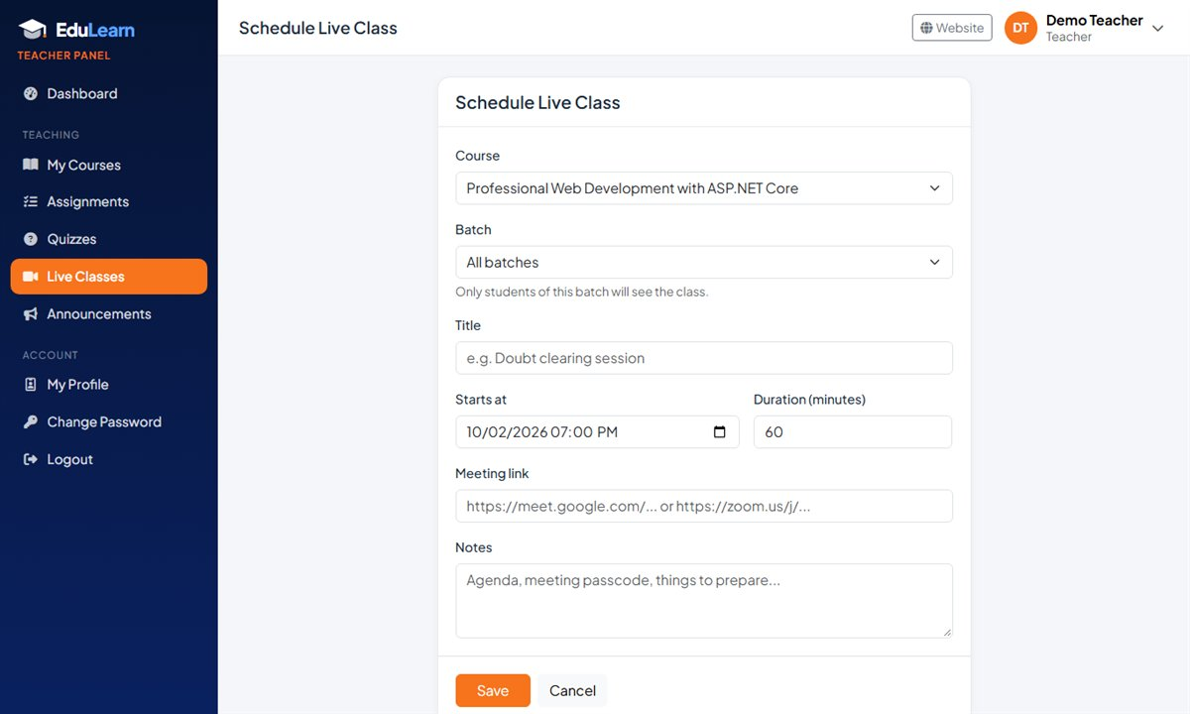
Figure 24: Scheduling a live class for one batch
Open Announcements, choose one of your courses (and, optionally, one of its batches), write a title and message and click Send announcement. Students of that course or batch see it on their dashboard and Announcements page. Teachers can delete their course announcements; site-wide announcements belong to the admin.

6.8 My profile
Teachers can update their name, mobile number, designation, date of birth, address, "about" text and photo. The profile appears on the public Instructors page and on the course pages.

7. Admin Guide

7.1 Admin dashboard
- The banner shows quick buttons when there are enrollments waiting for approval or new website messages.
- Counters: students, teachers, published courses, total revenue, pending enrollments, active learners and course completions (click a counter to open the related list).
- Recent enrollments and Top courses (by students, with pending requests highlighted).

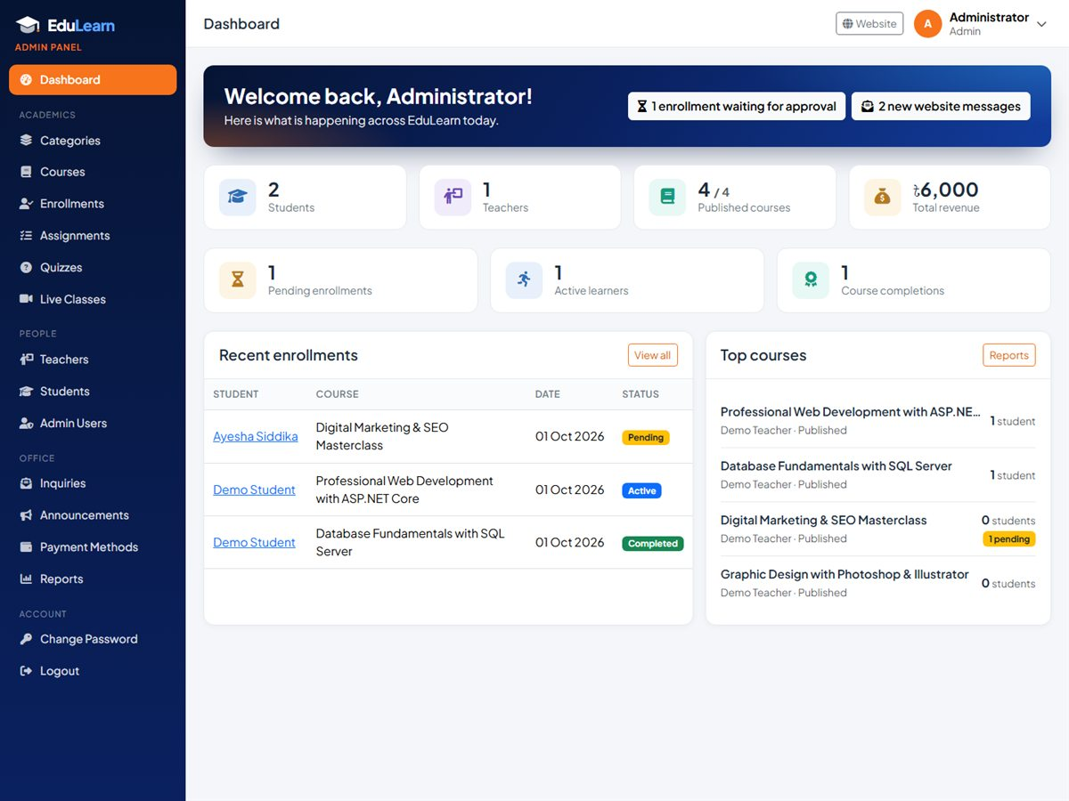
Figure 25: Admin dashboard

7.2 Course categories
Categories groups courses (for example Web Development, Graphic Design). Add a category with a title (3–100 characters) and optional description; edit or delete it from the list. A category that still has courses cannot be deleted.

7.3 Courses
Courses lists every course with its thumbnail, category, teacher, price, number of lessons and students, pending requests and status. Actions: Content (curriculum editor), Edit, Publish / Unpublish and Delete.
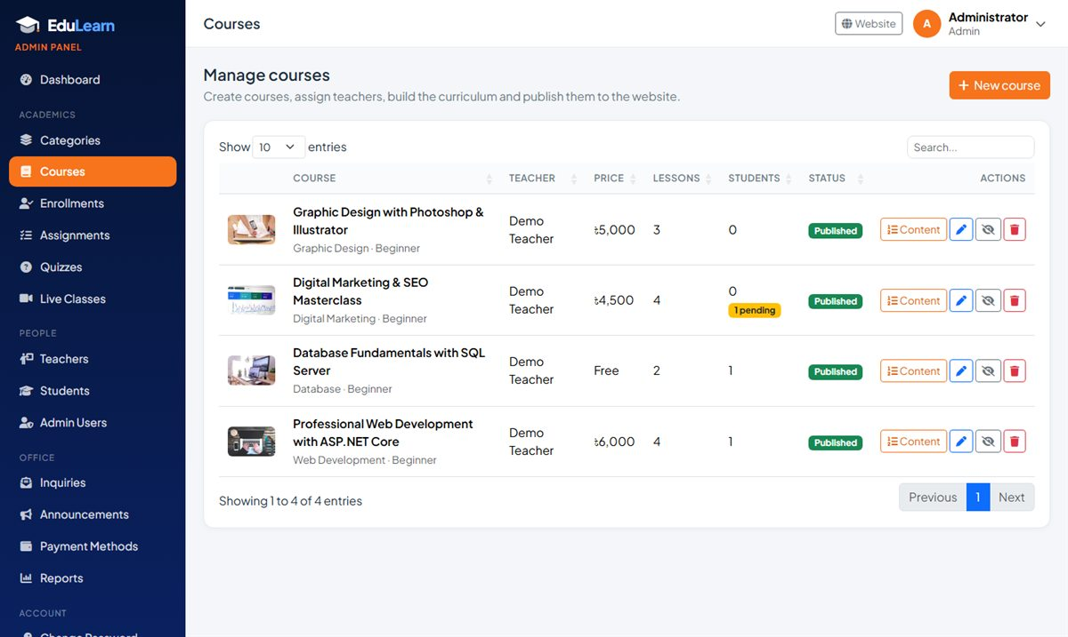
Figure 26: Course management
Click New course to create one. After saving, the curriculum editor opens so content can be added.
Field | Description
Title * | Course name (up to 200 characters).
Short description | One line shown on course cards (up to 300 characters).
Full description | What students will learn, requirements and outcomes.
Category * | One of the course categories.
Teacher | The instructor who will manage the content (optional; can be set later).
Price (BDT) | Course fee. 0 or empty = free course (instant enrollment).
Level | Beginner, Intermediate, Advanced or All levels.
Duration / Class schedule | Shown on the course page, for example "3 Months" and "Sat, Mon 7.00 pm – 9.00 pm".
Available seats | Maximum number of students. Pending requests also hold a seat. Empty = unlimited.
Thumbnail | JPG, PNG, WEBP or GIF up to 5 MB; a 16:9 picture looks best.
Published | Only published courses appear on the website. Keep a course as Draft while the content is being prepared.

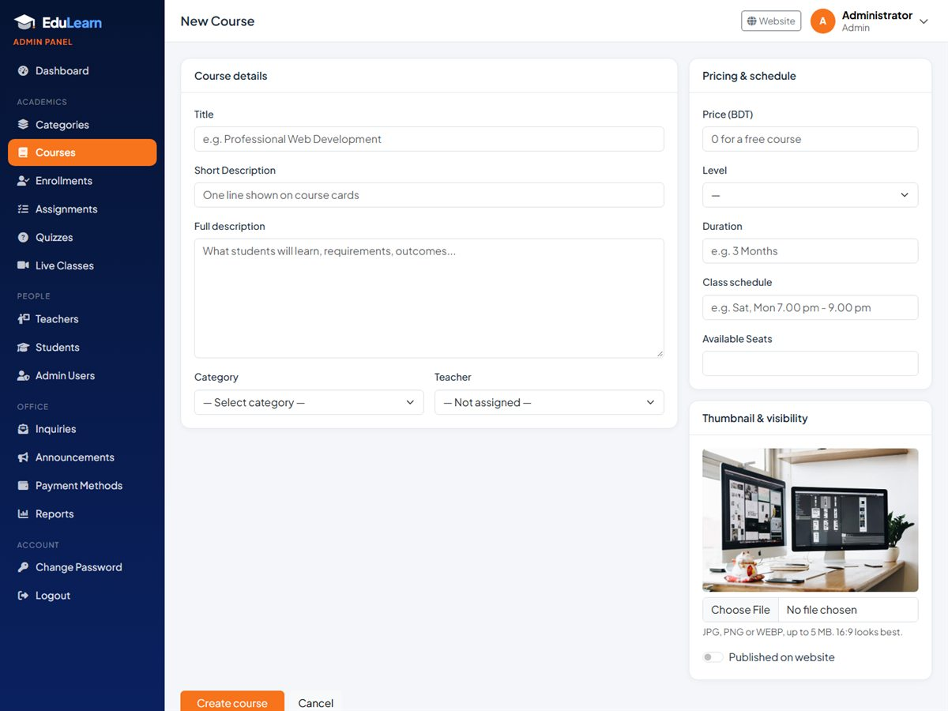
Figure 27: New course form
Deleting courses: A course that has any enrollment cannot be deleted — unpublish it instead. Deleting a course without enrollments also removes its curriculum, assignments, quizzes, live classes and uploaded files.

7.4 Batches
A batch is one intake of a course: a group of students who start on the same date and attend classes at the same times. One course can run many batches (for example Batch 01 in September and Batch 02 in October). The curriculum, quizzes and certificate are shared by every batch; the seats, class schedule and trainer belong to each batch. Courses without batches keep working as before.
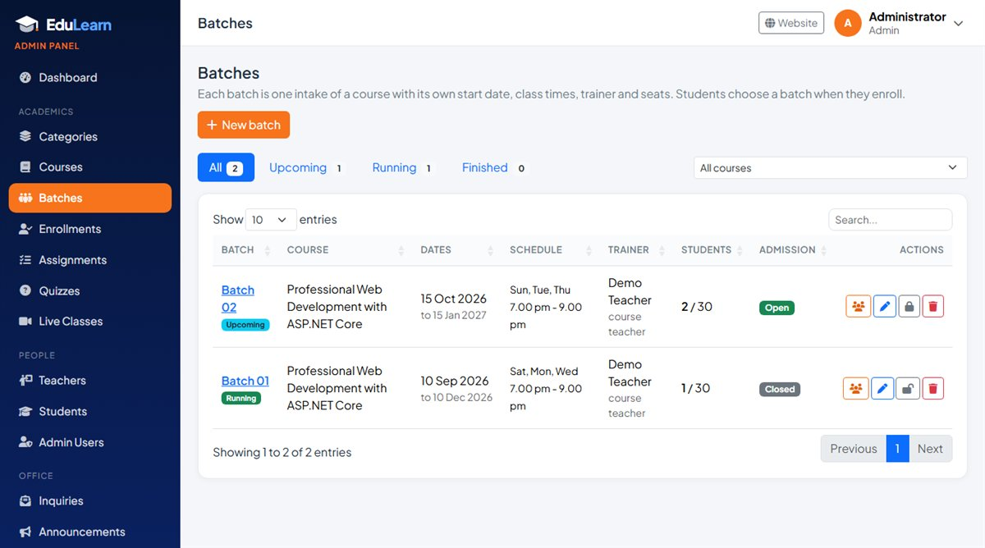
Figure 28: Batch list with Upcoming, Running and Finished tabs
Batches lists every batch with its course, dates, schedule, trainer, students (and seats), pending requests and admission status. The tabs show Upcoming (not started yet), Running and Finished (end date passed) batches, and the drop-down shows one course. Row buttons open the batch page, edit it, open or close admission and delete it. The Courses list also shows how many batches each course has, with an Add batch link.

Creating a batch
- Click New batch (or Add batch on a course in the Courses list).
- Choose the course. The next name (for example "Batch 03") is suggested and the class schedule and seats are copied from the course.
- Set the start date, an optional end date, the class schedule, the trainer (keep "Course teacher" or pick another teacher) and the seats (empty = unlimited).
- Keep Admission open switched on and click Create batch. Students can now choose it on the course page and the enroll page.

Field | Description
Course * | The course this batch belongs to. It cannot be changed later.
Batch name * | For example "Batch 05" or "Jan-2027 Evening". Must be unique within the course.
Start date * / End date | Decide whether the batch is Upcoming, Running or Finished. A finished batch stops taking admission.
Class schedule | Class days and times, shown to students instead of the course schedule.
Trainer | The teacher who takes this batch. Empty means the course teacher. A trainer can manage the course from the Teacher panel.
Seats | Maximum students in this batch. Pending payment requests also hold a seat.
Admission open | Whether students can choose this batch when they enroll.

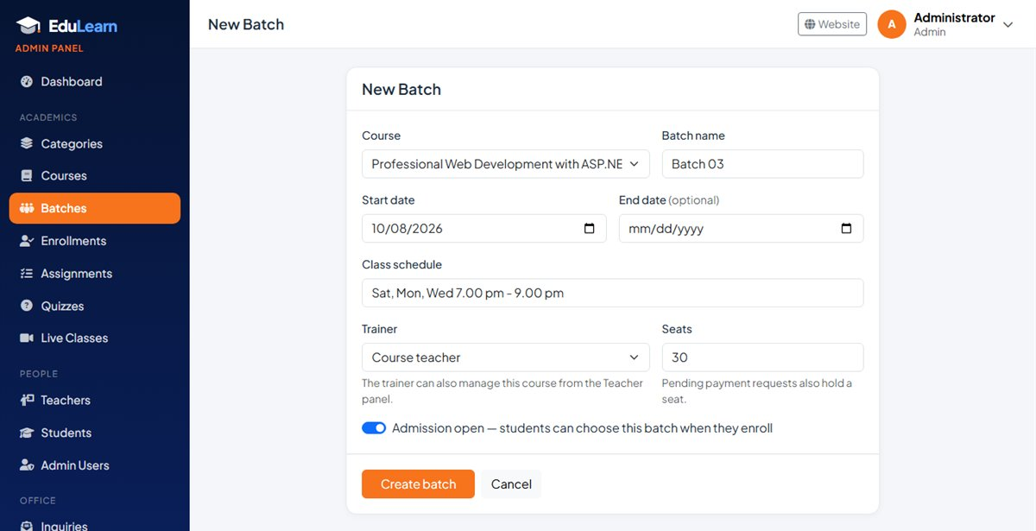
Figure 29: New batch form

The batch page
Click a batch name to open its page: dates, schedule, trainer, seats held (active and pending), the upcoming live classes and the full student list with contact details, status, lesson progress and payment. From here you can Enroll a student straight into the batch, Schedule class or add a New assignment for the batch, open Progress, and Print the class list.
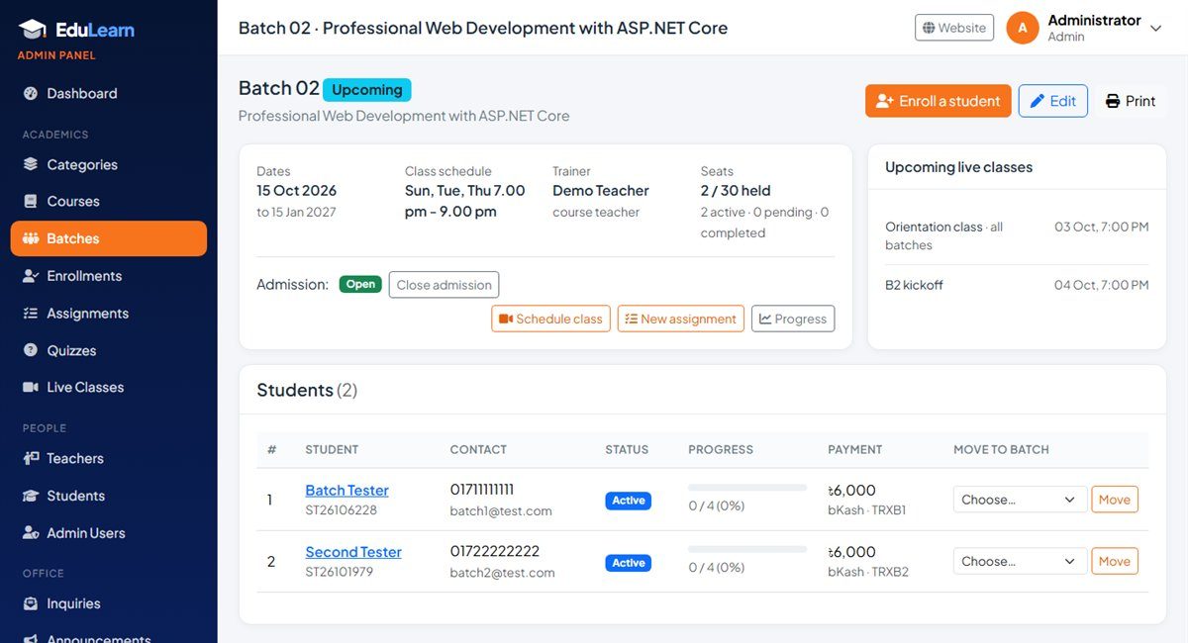
Figure 30: Batch page with the student list

Moving a student to another batch
In the student list of a batch, pick another batch of the same course under Move to batch and click Move. The student keeps their lesson progress, submissions, quiz results and certificate; from then on they see the new batch's classes, assignments and announcements.

Admission and deleting
- Close admission when a batch is full or classes have started: students can no longer choose it, but its students keep their access. A batch also stops taking admission after its end date.
- Seats: active, completed and pending enrollments count. A full batch cannot be chosen by students.
- The office can still place a student in a closed or full batch with Enroll a student.
- A batch with students cannot be deleted; close its admission or move the students first. Deleting an empty batch also removes the live classes, announcements and assignments made only for it.

7.5 Enrollments and payment verification
Enrollments is where payments are verified. Tabs filter by status (All, Pending, Active, Completed, Rejected, Cancelled) and show counts; pending requests are listed first.
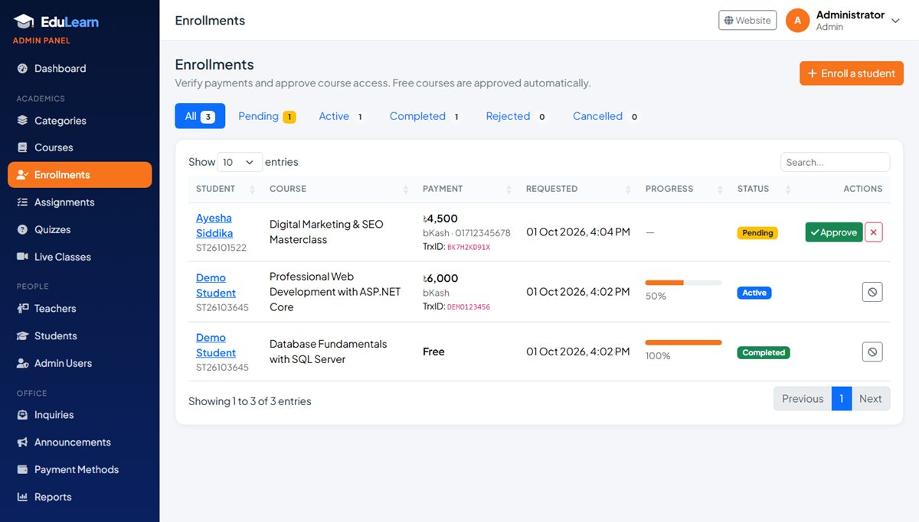
Figure 31: Enrollments with a pending payment
Use the course and batch drop-downs next to the tabs to see the enrollments of one course or one batch; the counts on the tabs follow the filter. Each enrollment shows its batch under the course name.
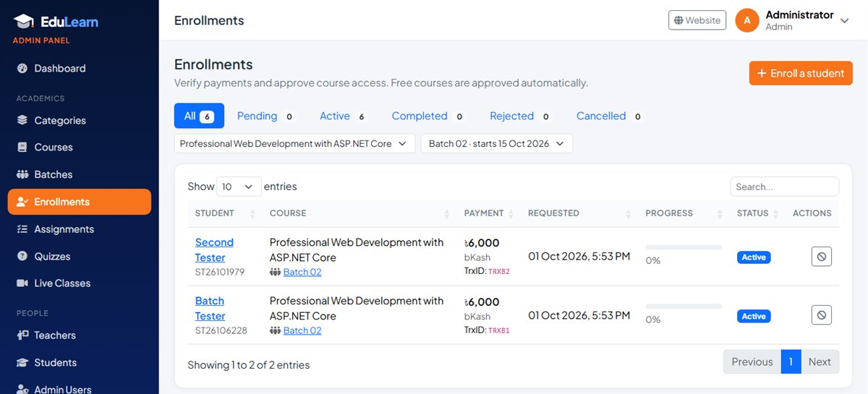
Figure 32: Enrollments filtered to one batch
Action | When to use it | Result
Approve | The payment (amount, method, sender number, transaction ID) has been confirmed. | Status becomes Active and the student can open the course.
Reject | The payment cannot be found or is wrong. | Status becomes Rejected. The reason you type is shown to the student, who can submit the details again.
Remove access | Access must be taken away (refund, misconduct, duplicate). | Status becomes Cancelled. It can be approved again later.

Manual enrollment (payment at the office)
- Click Enroll a student (or Enroll in course on a student's details page).
- Select the student and course, and for a course with batches the batch (any batch, even a closed or full one). The amount is filled in from the course price — change it if needed.
- Enter the method (default "Cash (office)") and a receipt or transaction number, then click Enroll student. Access is given immediately.

7.6 Teachers
Teachers lists every teacher with their Teacher ID, contact details, assigned courses and status. Click Add teacher to create a login and profile: name, email (used to log in), mobile, designation, password, parents' names, date of birth, address, "about" text and photo. A Teacher ID such as T264821 is generated automatically.
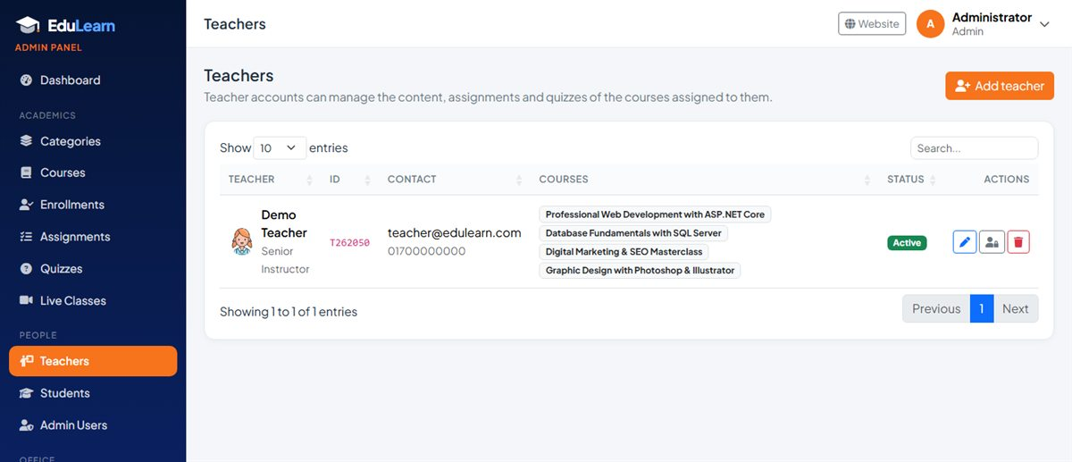
Figure 33: Teacher management
- Edit — update details; fill New password only to reset the password.
- Activate / Deactivate — switches the login on or off without deleting anything.
- Delete — only possible when the teacher has no assigned courses (reassign them first).

7.7 Students
Students lists all students with their Student ID, contact details, number of courses (and pending requests) with their batches, join date and status. Choose a course and a batch above the list for a batch-wise student list. Add student works like adding a teacher. The details page shows the profile, every enrollment with progress and payment, assignment submissions with marks and quiz attempts — plus Edit and Enroll in course buttons.
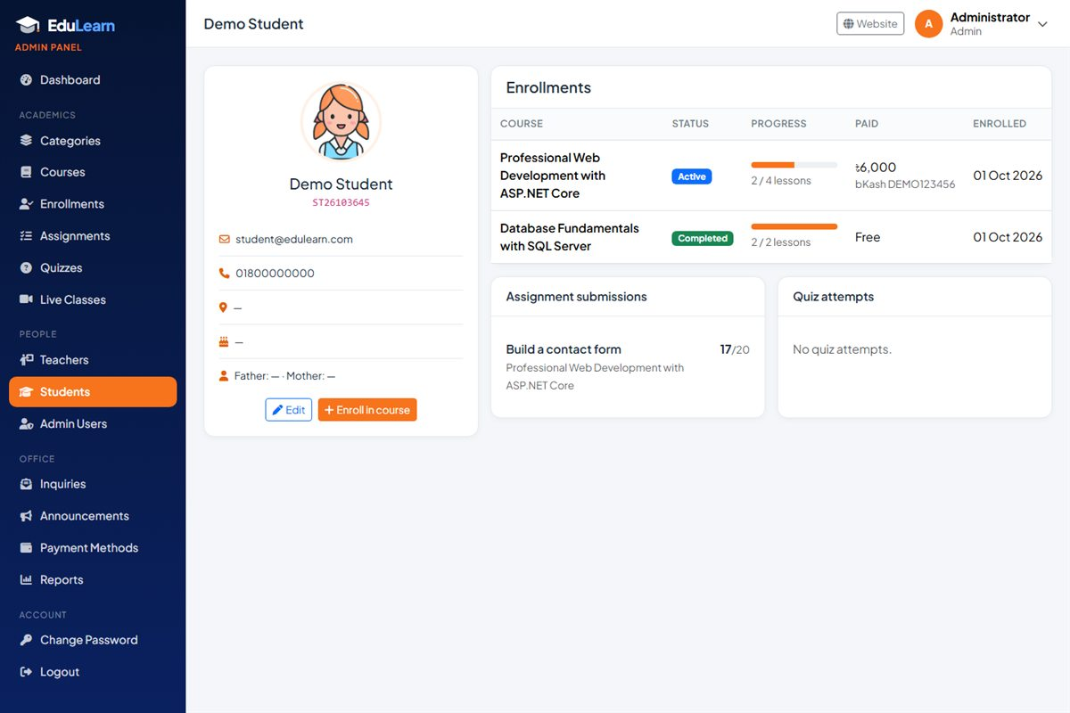
Figure 34: Student details
- Students with enrollments cannot be deleted; deactivate them instead.
- To reset a forgotten password, open Edit and fill in New password.

7.8 Admin users
Admin Users lists the administrator accounts. Add an admin with name, email, mobile and password; set a new password with the key button; activate or deactivate other admins (you cannot deactivate yourself).

7.9 Website inquiries
Inquiries collects messages from the website: Contact, Seminar registrations, Newsletter subscribers and Feedback. Each tab shows how many are new. For each message you see the date, sender (name, email, phone), course or subject and message. Mark messages as handled when done, or delete them. The dashboard counts new messages (newsletter sign-ups are not counted).
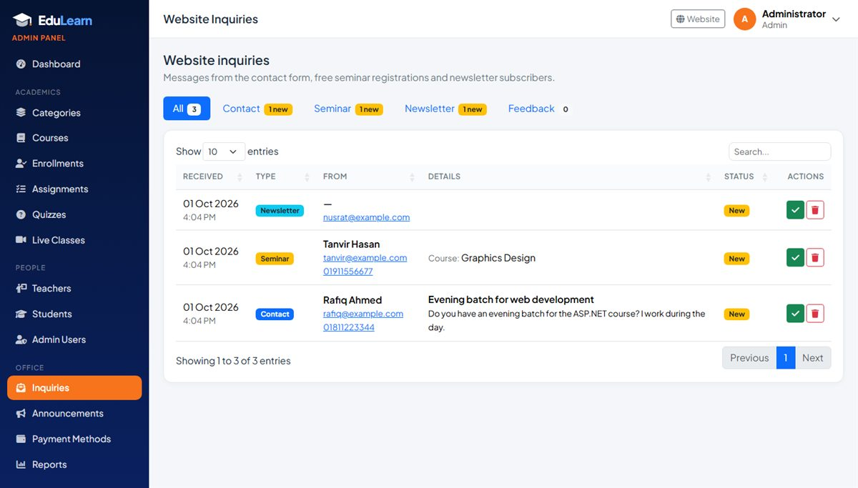
Figure 35: Website inquiries

7.10 Announcements
Announcements publishes a message to everyone (all students and teachers), to the students of one course, or to one batch of a course. Write a title and message and click Publish. Announcements can be deleted at any time.

7.11 Payment methods
Payment Methods defines where students pay. Each method (for example bKash, Bank Transfer, Nagad) has a name, instructions and one or more accounts (type, number, branch, note). These details appear on the student enroll page and on the website Contact page.
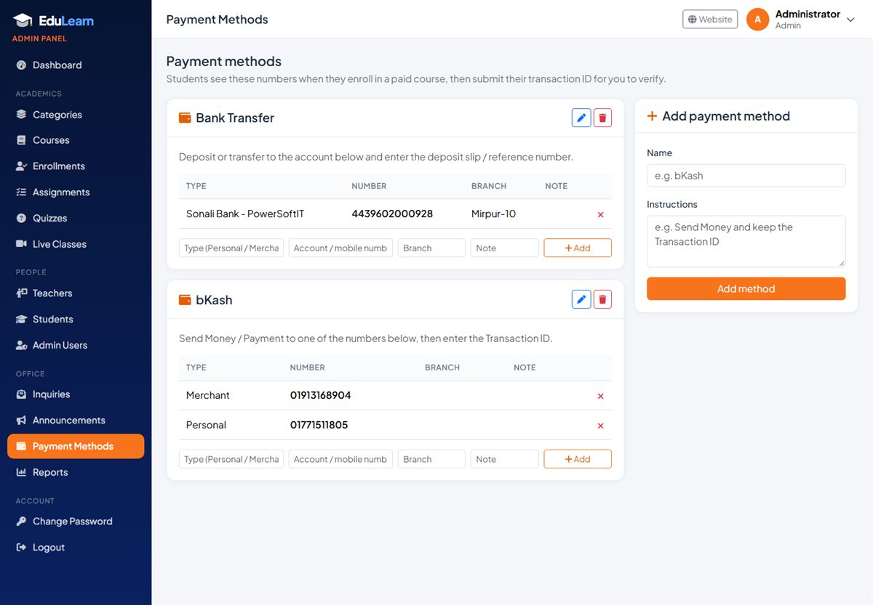
Figure 36: Payment methods

7.12 Reports
- Course performance: for each course — teacher, price, learners, completions and completion rate, pending requests, average lesson progress and revenue, with totals.
- Batch-wise summary: for each batch — course, trainer, start date, learners (and seats), completions, pending requests, average lesson progress and revenue.
- Payments received: every approved paid enrollment with date, student, course, method, transaction ID and amount. Filter by date range; the total is shown at the bottom.
- Use Print for a paper or PDF copy.

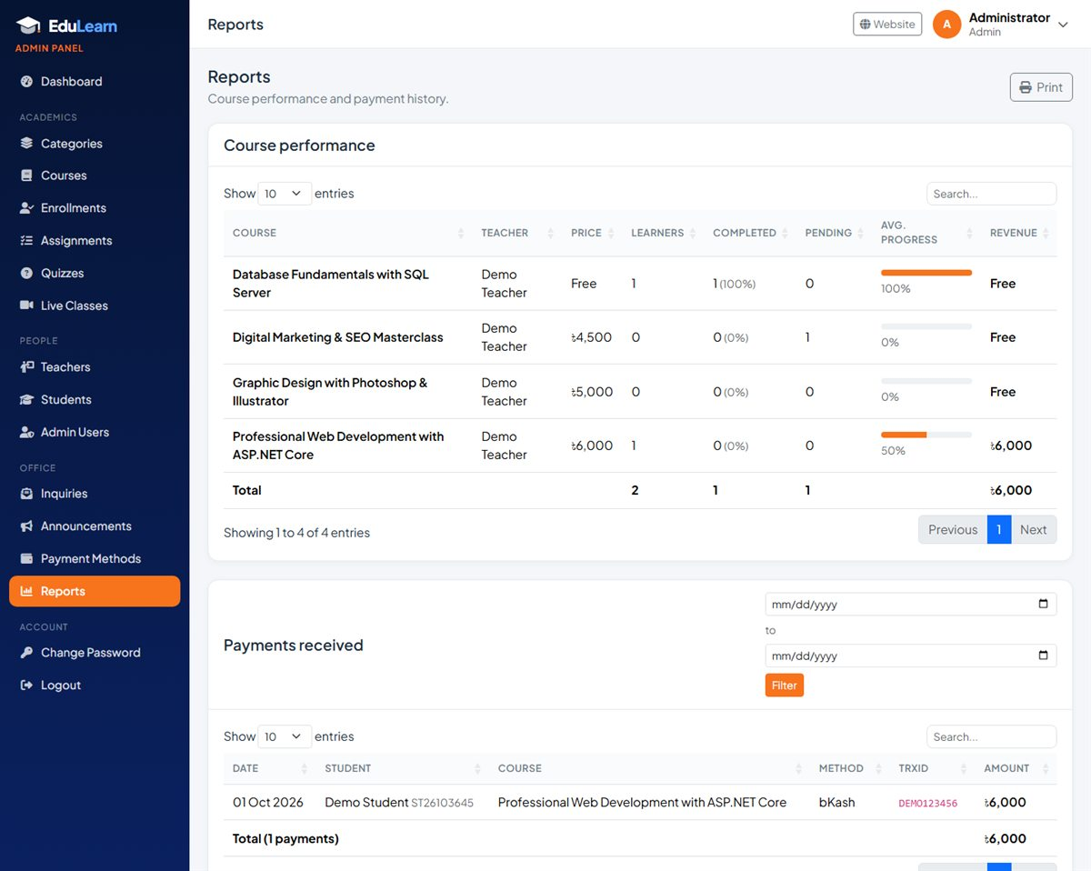
Figure 37: Reports

7.13 Managing course content as admin
Admins can do everything a teacher can, for all courses: the Content button on a course opens its curriculum, and the Assignments, Quizzes and Live Classes menu items show every course. This is useful when a course has no teacher yet or a teacher is away.

8. Key Workflows (Step by Step)

8.1 Launching a new course
- Admin — Categories: make sure the category exists.
- Admin — Teachers: create the teacher account if needed.
- Admin — Courses > New course: fill in the details, choose the teacher, keep Published off, save.
- Teacher (or admin) — Curriculum: add sections and lessons; mark one lesson as free preview.
- Teacher — add assignments, quizzes (and publish them) and schedule live classes.
- Admin — Courses: click Publish. The course now appears on the website.
- Admin — Batches: create the first batch (start date, class times, trainer, seats) with admission open, so students can enroll.

8.2 Paid enrollment: from payment to access
- Student pays by bKash / bank and submits the transaction ID on the enroll page → status Pending.
- Admin sees the request on the dashboard and in Enrollments > Pending, checks the payment in the bKash / bank statement.
- Admin clicks Approve → status Active. (Or Reject with a reason → the student can resubmit.)
- Student opens My Courses and starts learning. The payment appears in Reports > Payments received.

8.3 From first lesson to certificate
- The student opens the course player and marks each lesson as complete.
- Progress is updated on My Courses, the dashboard, the teacher's Students page and the admin reports.
- When the last lesson is completed, the enrollment becomes Completed and a certificate number (for example EDU-2026-00001) is issued.
- The student prints or saves the certificate; anyone can verify the number on the website.

8.4 Assignment lifecycle
- Teacher publishes the assignment (with due date and marks).
- Students see it on their dashboard and Assignments page and submit text and/or a file.
- Teacher grades each submission with marks and feedback.
- Students see the grade and feedback; marks appear in Grades and in the admin's student details.

8.5 Quiz lifecycle
- Teacher creates the quiz (draft), adds questions and publishes it.
- Students take the quiz within the time limit and allowed attempts; it is marked automatically.
- Teacher reviews Results; students see their best score in Quizzes and Grades.

8.6 Running a new batch
- Admin — Batches > New batch: choose the course, set the start date, class times, trainer and seats; keep admission open.
- Students choose the batch on the course page or the enroll page; the office approves payments as usual (Enrollments, filtered by the batch).
- Teacher / trainer — schedule the live classes and add assignments with Batch set to this batch, and send batch announcements.
- Admin — when the batch is full or classes have started, click Close admission and open the next batch for new students.
- Use the batch page to print the class list, and My Courses > Students (batch tab) or Reports > Batch-wise summary to follow progress.

8.7 Moving a student to another batch
- Admin — open the current batch (Batches > batch name).
- In the student's row, choose the new batch under Move to batch and click Move.
- The student keeps all progress and now sees the new batch's classes, assignments and announcements.

9. Rules and Reference

9.1 Enrollment statuses
Status | Meaning | Student can learn?
Pending | Payment details submitted, waiting for the office to verify. | No
Active | Approved (or free course / manual enrollment). | Yes
Completed | Every lesson finished; certificate issued. | Yes (review)
Rejected | Payment not verified; the reason is shown to the student, who can try again. | No
Cancelled | Access removed by the admin; can be approved again. | No

9.2 Course and enrollment rules
- A course with price 0 (or no price) is free and unlocks instantly.
- Only published courses are visible on the website and can be enrolled in.
- Seats: a course with batches uses each batch's seat limit; otherwise the course seat limit applies. Active, completed and pending enrollments count towards the limit; when it is reached, enrolling is disabled.
- A transaction ID can be used only once in the whole system.
- A student can have only one enrollment per course; a rejected or cancelled request is reused when they try again.
- Completion requires every lesson to be marked complete. Lessons added after completion do not remove the certificate. If lessons are deleted, students who have finished all the remaining ones are completed automatically.

9.3 Quiz rules
- Questions are single-answer multiple choice with marks per question; the score is shown as a percentage and compared with the pass mark.
- Time limit is optional. Answers are accepted up to 60 seconds after the limit (to cover slow connections); later submissions score zero.
- Max attempts is optional. An unfinished attempt is resumed instead of starting a new one.
- Correct answers are revealed in the review only when no attempts are left.
- Questions are locked after the first attempt (see Clear attempts).

9.4 Assignment rules
- One submission per student per assignment; it can be updated until the deadline or until it is graded.
- Submissions after the due date are not accepted.
- Marks can be from 0 to the assignment's total, in steps of 0.5.

9.5 File upload limits
Upload | Allowed types | Maximum size
Course thumbnails, profile photos | JPG, JPEG, PNG, WEBP, GIF | 5 MB
Lesson files, assignment attachments, student submissions | PDF, DOC/DOCX, PPT/PPTX, XLS/XLSX, TXT, CSV, ZIP, RAR, 7Z, JPG, PNG, MP4, MP3 | 100 MB

Uploaded files are stored in wwwroot/uploads with random file names. Anyone who has the exact link can open a file, but links cannot be guessed.

9.6 Deletion protection
Item | Cannot be deleted when… | Do this instead
Category | It still has courses. | Move or delete the courses first.
Course | It has any enrollment. | Unpublish it.
Batch | It has any enrollment. | Close its admission, or move the students to another batch first.
Teacher | Courses are assigned to them. | Reassign the courses or deactivate the teacher.
Student | They have any enrollment. | Deactivate the student.
Admin | It is your own account (cannot deactivate yourself). | Ask another admin.

9.7 Generated numbers
Number | Format | Example
Student ID | ST + year + month + 4 random digits | ST26101234
Teacher ID | T + year + 4 random digits | T264821
Certificate number | EDU- + year + - + 5-digit enrollment number | EDU-2026-00001

9.8 Batch rules
- A course with at least one batch asks students to choose a batch; a course without batches is enrolled in directly.
- Students can only choose batches whose admission is open and that have not finished. The office can use any batch.
- Live classes, assignments and announcements without a batch are for every student of the course; with a batch, only for the students of that batch.
- Lessons, quizzes and certificates are shared by the whole course.
- A student is in one batch per course. Moving them to another batch keeps all their progress and work.
- Batch names are unique within a course, and a batch always stays with its course.
- A batch is Upcoming before its start date, Running from the start date until its end date, and Finished after the end date.
- The trainer of a batch can manage the course from the Teacher panel, like the course teacher.

10. Security and Privacy
- Role-based access: every panel page checks the user's role; teachers can only reach their own courses and students only their own enrollments, submissions and quiz attempts.
- Passwords are never stored as plain text. They are hashed with PBKDF2-SHA256 (100,000 iterations) and a random salt. Older SHA1 hashes from the previous system are still accepted.
- Sessions use secure, HTTP-only cookies that expire after one day of inactivity.
- Forms are protected against cross-site request forgery with anti-forgery tokens, and the public forms against spam robots with a hidden field.
- Account control: admins can deactivate any teacher, student or other admin instantly.
- Uploads are limited by type and size and saved with random names.
- Use HTTPS on the live server and change the default admin password immediately after installation.

11. Technical Overview (for Developers)

11.1 Technology stack
Layer | Technology
Framework | ASP.NET Core 9 MVC with Razor views and Areas (Admin, Teacher, Student)
Database | Microsoft SQL Server with Entity Framework Core 9 (code-first migrations)
Authentication | Cookie authentication with roles (Admin, Teacher, Student) and a custom user table
Front end | Bootstrap 5.3, Bootstrap Icons, Font Awesome 6, AOS animations, jQuery 3.7, DataTables (dashboards); fonts Plus Jakarta Sans and Caveat
Design files | wwwroot/css/premium.css (website), wwwroot/css/Dashboard.css (panels), wwwroot/js/premium.js, wwwroot/js/dashboard.js

11.2 Project structure
Folder / file | Purpose
Areas/Admin | Admin panel controllers and views (courses, batches, enrollments, people, inquiries, payments, reports).
Areas/Teacher | Course authoring: curriculum, assignments, quizzes, live classes, announcements, profile. Admins use these screens too.
Areas/Student | Student panel: dashboard, courses, enroll, course player, assignments, quizzes, grades, schedule, certificates, profile.
Controllers | Public website (Home, Courses, Instructors, Contact, Certificate, Inquiry, Login, Register…).
Models, Models/Lms, Models/ViewModels | Database entities (users, courses, lessons, enrollments, quizzes, inquiries…) and page view models.
Services | AccountService (accounts and IDs), LearningService (progress, completion, certificates), FileService (uploads), UserService (passwords), IdentityService (sign-in).
Infrastructure | DbSeeder (migrations and default data), SiteInfo (contact details), UiHelpers, claims helpers.
Migrations | EF Core migrations: init, LmsCore, WebsiteInquiries, Batches.
Views | Public pages and shared layouts: _Layout (website), _DashboardLayout (panels), _AuthLayout (login/register), _Logo.
wwwroot | Static files: CSS, JS, images (Images/site, Images/logo) and uploaded files (uploads).
../db | SQL scripts to create the database without running the app.
../docs | This project guide (Word and PDF).

11.3 Main database tables
Table | Stores
Tbl_Users, tbl_roles | Login accounts (email, password hash, role, active flag) and the three roles.
Students, Teachers | Profiles linked to logins (IDs, contact details, photos).
CourseCategorys, Courses | Categories and courses (price, teacher, seats, thumbnail, published).
CourseSections, Lessons | Curriculum structure and lesson content.
Enrollments, LessonProgresses | Who has access to which course (status, payment details, certificate number) and completed lessons.
Assignments, AssignmentSubmissions | Assignments and student submissions with marks and feedback.
Quizzes, QuizQuestions, QuizOptions, QuizAttempts, QuizAnswers | Quizzes, questions, answer options, attempts and the answers chosen.
LiveClasses, Announcements | Scheduled live sessions and announcements.
Batches | Batches of a course (dates, schedule, trainer, seats, admission). Enrollments, LiveClasses, Assignments and Announcements have an optional BatchId.
PaymentGetways, GetwayInfo | Payment methods and their accounts.
Inquiries | Website contact messages, seminar registrations, newsletter subscribers and feedback.

Some older tables from the original website (sliders, hero banners, navigation, etc.) are still in the database but are not used by the current pages.

12. Installation and Deployment

12.1 Requirements
- Windows server or PC with the .NET 9 runtime (SDK for development) — or any host that supports ASP.NET Core 9.
- Microsoft SQL Server 2016 or newer (Express edition is fine).
- For development: Visual Studio 2022 (or newer) or VS Code with the .NET SDK.

12.2 Running the project
- Open the solution in Visual Studio (or a terminal in the project folder).
- Check the connection string in appsettings.json (ConnectionStrings:DefaultConnection) — server name and database name EduLearn.
- Press F5 in Visual Studio, or run dotnet run.
- On first start the application creates the database, applies all migrations and adds the roles, the default admin and the payment methods. In development mode it also adds demo courses (one with two batches) and the demo teacher and student.
- Open the address shown (by default http://localhost:5232 or https://localhost:7292) and log in as admin@edulearn.com / Admin@123.

12.3 Configuration
Setting | Where | Purpose
ConnectionStrings:DefaultConnection | appsettings.json | SQL Server connection (server, database EduLearn, authentication).
Seed:AdminEmail, Seed:AdminPassword | appsettings.json | The first admin account created when no admin exists.
Seed:DemoData | appsettings.Development.json | true adds demo data in development. It is off in production.
ASPNETCORE_ENVIRONMENT | Server environment variable | Development or Production (production shows friendly error pages and enables HSTS).

12.4 Database setup options
- Automatic (recommended): the app applies migrations and default data on every start, so updates are applied automatically. The database login needs permission to create and alter tables.
- SQL scripts: in the db folder, run EduLearn_full_install.sql in SQL Server Management Studio (creates the database, all tables, roles, the admin and payment methods). 04_demo_data.sql optionally adds demo content. All scripts can be run more than once safely.

12.5 Going-live checklist
- Set ASPNETCORE_ENVIRONMENT=Production on the server.
- Log in and change the admin password; remove or deactivate any demo accounts.
- Update contact details, emails, social links and the next seminar date in Infrastructure/SiteInfo.cs.
- Check the payment methods (numbers and bank account) in the admin panel.
- Install an SSL certificate and use HTTPS.
- Set up regular backups of the database and of the wwwroot/uploads folder (course images, lesson files, student submissions).

13. Customization

13.1 Contact details and site information
Most public details are kept in one file, Infrastructure/SiteInfo.cs:
Setting | Used for
Name, Tagline | Brand name and the tagline under the logo ("Learn Today, Lead Tomorrow").
Phone, Phone2 (and display versions) | Header, footer, contact page and call links.
Email, SupportEmail, HrEmail | Contact page and footer.
AddressLine1, AddressLine2, OfficeHours, MapEmbedUrl | Contact page, footer and Google map.
FacebookUrl, YoutubeUrl, LinkedinUrl, InstagramUrl | Social icons — an icon appears only when its link is filled in.
NextSeminar | Optional "Next session" text on the home page seminar card.
SeminarCourses | Course choices in the free seminar form.

13.2 Branding
- Logo: Views/Shared/_Logo.cshtml (graduation cap mark and "EduLearn" wordmark) and the browser icon wwwroot/Images/logo/edulearn-icon.svg.
- Colours: the variables at the top of wwwroot/css/premium.css (--ps-orange, --ps-blue, --ps-navy-900) and --brand in wwwroot/css/Dashboard.css.
- Images: hero and promotional pictures in wwwroot/Images/site.
- Home page text: statistics, categories and testimonials are in Views/Home/Index.cshtml.

13.3 Content managed from the admin panel
Courses, categories, teachers, payment methods, announcements and all course content are managed from the panels — no code changes are needed.

14. Troubleshooting and FAQ
Problem | Solution
"Your account has been deactivated" | An admin can reactivate it from Teachers, Students or Admin Users (Activate button).
A student paid but cannot open the course | The enrollment is still Pending. The admin approves it in Enrollments.
"This transaction ID has already been used" | Each transaction ID can be used once. Check the number; contact the office if it is correct.
"This course is full" | The seat limit is reached. The admin can increase Available seats in Courses > Edit.
A course is not visible on the website | It is a Draft. The admin clicks Publish in Courses.
A video does not appear in the player | Use a YouTube, Vimeo or shared Google Drive link, or an MP4 file. Other sites open in a new tab.
An upload is rejected | Check the allowed file types and sizes (images 5 MB, documents and videos 100 MB).
A course / teacher / student / category cannot be deleted | It is protected because it is in use — unpublish or deactivate instead (see 9.6).
Quiz questions cannot be edited | Students have already attempted the quiz. Use Clear attempts only if the results may be deleted.
No certificate after finishing | Every lesson must be marked complete. Open the course player and check for lessons without a green tick.
Forgot password | Ask the office; the admin sets a new password via Edit (students/teachers) or Admin Users.
A student cannot find a batch on the enroll page | The batch is closed for admission, finished or full. Open admission, extend the end date or add seats in Batches > Edit, or create a new batch.
"Admission closed" on a course page | The course has batches but none is taking admission. Create a new batch or open admission on one.
A student does not see a live class or assignment | It was made for another batch. Check its Batch field, or move the student to the right batch.
The app cannot connect to the database | Check that SQL Server is running and the connection string in appsettings.json is correct.

15. Current Limitations and Future Enhancements
The following features are not part of the current version and are good candidates for the next phase:
- Online payment gateway (SSLCommerz, bKash API) for automatic payment confirmation — payments are verified manually today.
- Email / SMS notifications (enrollment approved, new assignment, live class reminders).
- Self-service password reset by email.
- Student reviews and ratings submitted from the panel (the Reviews page currently shows fixed testimonials).
- Discussion / Q&A per lesson, blog, batches and class routine management.
- Different fees per batch: all batches of a course share the course price today.
- Bangla language interface and a mobile app.

Appendix A: Page Address Reference
Area | Page | Address
Public | Home / Courses / Course details | /, /Courses, /Courses/Details/{id}
Public | Free preview / Instructors / About | /Courses/Preview/{id}, /Instructors, /AboutUs
Public | Services / Products / Reviews | /Services, /Product, /StudentsFeedback
Public | Contact / Verify certificate / Privacy | /ContactUs, /Certificate/Verify, /Home/Privacy
Account | Login / Register / Change password / Logout | /Login, /Register, /Home/ChangePassword, /Home/Logout
Student | Dashboard / My courses / Browse | /Student, /Student/Courses, /Student/Courses/Browse
Student | Enroll / Course player | /Student/Enroll/Index/{courseId}, /Student/Learn/Index/{courseId}
Student | Assignments / Quizzes / Grades | /Student/Assignments, /Student/Quizzes, /Student/Grades
Student | Schedule / Announcements / Certificates / Profile | /Student/Schedule, /Student/Announcements, /Student/Certificates, /Student/Profile
Teacher | Dashboard / My courses / Curriculum | /Teacher, /Teacher/Courses, /Teacher/Curriculum/Index/{courseId}
Teacher | Assignments / Quizzes / Live classes | /Teacher/Assignments, /Teacher/Quizzes, /Teacher/LiveClasses
Teacher | Announcements / Profile | /Teacher/Announcements, /Teacher/Profile
Admin | Dashboard / Categories / Courses / Enrollments | /Admin, /Admin/CourseCategory, /Admin/Course, /Admin/Enrollment
Admin | Teachers / Students / Admin users | /Admin/Teacher, /Admin/Student, /Admin/ManageUser
Admin | Batches / Batch page / New batch | /Admin/Batch, /Admin/Batch/Details/{id}, /Admin/Batch/Create
Admin | Inquiries / Announcements / Payment methods / Reports | /Admin/Inquiry, /Admin/Announcement, /Admin/PaymentMethod, /Admin/Report

Appendix B: Glossary
Term | Meaning
Course | A training program with a price, teacher, curriculum, assignments and quizzes.
Section | A group of lessons inside a course, such as a week or a module.
Lesson | One learning item: video, article, file or link.
Free preview | A lesson visible to everyone on the public course page.
Enrollment | A student's access to a course, with a status (Pending, Active, Completed, Rejected, Cancelled).
Transaction ID | The reference number of a bKash or bank payment, used by the office to verify it.
Attempt | One try at a quiz.
Published / Draft | Whether a course or quiz is visible to students.
Inquiry | A message from the website: contact, seminar registration, newsletter subscription or feedback.
Live class | A scheduled online session (Zoom, Google Meet) with a join link.
Batch | One intake of a course with its own start date, class schedule, trainer and seats. Students choose a batch when they enroll.
Admission open | A batch that students can still choose when they enroll.
Trainer | The teacher who takes a particular batch.

