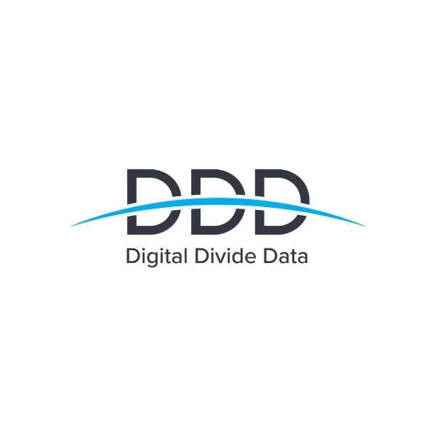
DDD FlowHub
Technical Stack, Languages, Tools & Architecture Documentation
Organization: Digital Divide Data (DDD) | Version: 2.4 | Car Vision Program
“We did not replace Google Chat & Sheets. We fixed the gaps between them.”
Tagline: Right info, right person, right time.

1. Project Overview & Operational Context
DDD FlowHub is a dedicated enterprise web application designed for Digital Divide Data (DDD) operations staff. Operating across three 8-hour daily shifts (Shift 1, Shift 2, and Night Shift), DDD delivers mission-critical autonomous vehicle car labeling annotations. FlowHub sits directly on top of existing tools (Google Chat and Google Sheets) and provides real-time role-based workspaces for Associates, Seniors, Team Leaders (TLs), and Project Managers (PMs).

2. Programming & Code Languages
Language | Implementation Scope | Key Roles in DDD FlowHub
JavaScript (ES6+) | Core logic, state, Web APIs | Powers reactive state management, synthesizes audio frequencies via the Web Audio API, handles localStorage caching, simulates Google Chat webhooks, and orchestrates live turnover transitions.
JSX (JavaScript XML) | Component rendering (React) | Declarative component templates used across all 4 role screens (Associate, Senior, TL, PM), modals, drawers, and the interactive 9-slide pitch deck.
HTML5 | index.html & Semantic structure | Semantic tags including <header>, <aside>, <main>, <nav>, <table>, and <form> ensuring high accessibility and search engine / accessibility standards.
Vanilla CSS3 | src/index.css design system | Custom modern enterprise design system based on DDD logo colors (#00A3E0 Arc Blue & #232733 Charcoal Slate). Uses CSS variables, Flexbox, CSS Grid, and custom scrollbars with zero neon glow effects.

3. Frameworks, Libraries & Dependencies
Package / Library | Version | Type | Technical Purpose & Implementation
react | ^19.2.8 | Runtime | Core declarative UI framework providing reactive hooks: useState, useEffect, and createContext for application-wide state synchronization.
react-dom | ^19.2.8 | Runtime | Direct DOM reconciliation and rendering of the React application tree into index.html (#root).
vite | ^8.3.0 | Dev / Build | High-performance frontend tool providing Hot Module Replacement (HMR) during development and optimized Rolldown production bundling.
@vitejs/plugin-react | ^6.1.1 | Dev Tool | Babel/Fast-Refresh integration for seamless real-time React component reloading without full page refreshes.
lucide-react | ^1.48.0 | Runtime | Tree-shakable modern SVG icon system used for all role navigation, status indicators, audio icons, and modal controls.
canvas-confetti | ^1.9.4 | Runtime | Micro-interaction utility triggering visual acknowledgment bursts when associates confirm emergency alerts.
oxlint | ^1.81.0 | Dev Tool | High-speed Rust-based JavaScript and JSX linter for code health, syntax verification, and static analysis.

4. Native Browser Web APIs (Zero-Dependency Utilities)
To ensure high reliability on company workstations with strict IT security policies, DDD FlowHub avoids heavy external third-party services for audio and local storage. The following native browser APIs are utilized:
- Web Audio API (AudioContext, OscillatorNode, GainNode): Located in src/utils/audio.js. Synthesizes high-priority dual-tone emergency alert sirens (880 Hz to 1046.5 Hz) and harmonious confirmation chimes purely from mathematical waveform frequencies. No external audio MP3 or WAV files are downloaded over the network.
- Web Storage API (localStorage): Maintains persistent client-side state across browser reloads. Persists current active role, client queue count, fallback protocols, active alert acknowledgments, and auto-archived tasks.
- Clipboard API (navigator.clipboard): Powers the instant 1-click 'Copy Steps' feature on the Known-Issues troubleshooting board so seniors and associates can paste PC fixes directly into system prompts.

5. DDD Operational Problems & Technical Solutions
Operational Problem | Impacted Roles | DDD FlowHub Technical Solution
1. Missed Important Messages (Google Chat muted, seniors shouting) | Associates, Seniors, TLs | Unmissable Full-Screen Alerts with synthesized audible siren and mandatory 'I have seen this' button. Live acknowledgment tracker shows who has and has not confirmed.
2. Empty Task Queue ('What do I do now?') | Associates, TLs | 'What Do I Do Now' Dashboard dynamically activates fallback protocols configured in advance by Team Leaders (e.g. secondary QA reviews, refresher training).
3. Scattered Schedules & Shift Info | Associates | 'My Schedule & Shift Hub' tab centralizes meetings, daily handover syncs, and break times filtered by shift (Shift 1, 2, Night).
4. Repeated Car Labeling Questions | Associates, TLs, PMs | Official Rulings Board where Project Managers publish client decisions once as searchable cards with tags, DO/DON'T rules, and high-res vehicle imagery.
5. Repeated PC & Tool Freezes (Chrome RAM, WebGL crash) | Associates, Seniors | Known-Issues Troubleshooting Catalog with numbered, copyable steps and community upvotes so seniors do not repeat themselves.
6. Manual Task Link Generation & Turnover | Team Leaders | Auto-Turnover Generator provisions batch task links automatically, appends them to Google Sheets, and sends webhook alerts to Google Chat.
7. Manual Deletion of Submitted Tasks (Lost history) | Team Leaders | Auto-Archive Engine automatically migrates completed tasks to a separate 'Submitted Archive' tab, preserving 100% audit history.
8. Information Spread Across Tools | All DDD Staff | One Unified Portal sitting directly on top of Google Workspace. Google Sheets remains the database, ensuring zero disruption to muscle memory.

6. UI Architecture & Left Navigation Tab
To prevent cramped cards, awkward text indentations, and crowded navigation bars, DDD FlowHub implements a collapsible left navigation tab (Sidebar.jsx). Key design principles include:
• Collapsible Left Navigation Drawer: Can be expanded for full navigation and role switching, or collapsed into an unobtrusive tab on the left edge.
• Dynamic Fluid Expansion: When the sidebar is collapsed, the main workspace dynamically expands to 100% width, providing ample room for multi-column vehicle cards and tables.
• Exact Logo Brand Palette: Strict adherence to the official Digital Divide Data palette (#00A3E0 Arc Blue, #232733 Charcoal Slate, and crisp #253047 1px structural borders).
• Modern Flat Aesthetics: Total elimination of neon halos, blur drops, and glow effects, delivering a clean, corporate-grade enterprise appearance.

7. Local Execution & Commands
To run DDD FlowHub locally on macOS:
1. Open Terminal and navigate to the project directory:
cd /Users/macbook/Documents/new
2. Start the local Vite development server:
npm run dev
3. Open the browser to:
http://localhost:5173/
4. To generate a production-ready optimized build:
npm run build
5. To preview the production bundle:
npm run preview

