|  |  |  |  |
| --- | --- | --- | --- |
| **Logical Circuit & Design Homework #02** | | | |
| Due date | May 11, 2020 | Instructor | Yoo, Younghwan |
| Student ID |  | Name |  |

1. A majority function has an output value of 1 if there are more 1s than 0s on its inputs. The output is 0 otherwise. Design a four-input majority function.

2. Design a circuit with a 3-bit input A, B, and C, in the form of Gray code, that produces a 3-bit output X, Y, and Z in binary form. For example, if the Gray code inputs are 001 and 011, then the circuit will produce 001 and 010, respectively.

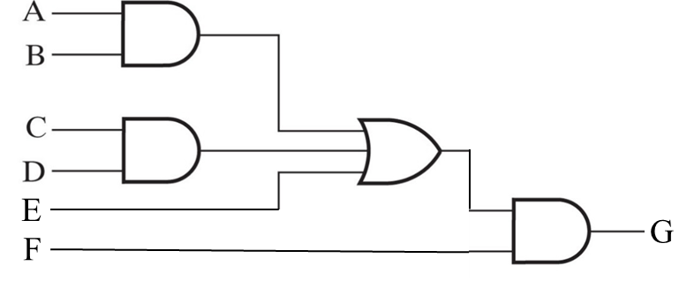3. Perform technology mapping to NAND gates for the circuit in the following figure. Use cell types selected from: Inverter (n=1), 2NAND, 3NAND, and 4NAND, as defined at the beginning of Section 3-2.

4. A combinational circuit is defined by the following three Boolean functions:

$$F_{1}=\overline{X}Y\overline{Z}+\overline{X}\overline{Y}Z+X\overline{Y}\overline{Z} \\ F_{2}=\overline{X}\overline{Y}\overline{Z}+YZ \\ F_{3}=YZ+XY \\ F_{4}=\overline{X}Y+XY\overline{Z}$$

Design the circuit with a decoder and external OR gates.

5. Perform the indicated subtractions with the following unsigned binary numbers by taking the 2s complement of the subtrahend:

1. 11010 – 10001
2. 11110 – 1110
3. 101001 – 101

6. Use contraction beginning with a 4-bit adder with carry out to design a 4-bit increment circuit with carry out that is incremented by 0011. The function to be implemented is $S=A+0011$. Design the circuit with AND-OR-XOR gates.