Приветствие (1)

Greetings ladies and gentlemen, today we'd like to talk about Unveiling the Invisible an In-depth Analysis of Text Steganography Techniques, Challenges, and Advancement.

План (2)

Задачи (3)

* To introduce what steganography is
* To tell about the main methods of text steganography
* Provide an algorithm for the White Spacing method
* Analyse the disadvantages of text steganography

Введение (4)

Text steganography is the art and science of concealing hidden messages inside ordinary text without raising red flags. It’s an intriguing field. Because of the increasing dependence on digital communication and the urgent need for secure and confidential information transfer, text steganography has attracted a lot of attention as a dependable means of establishing covert communication and data verification.

Методы изменения текста (5-6)

Text steganography can be classified into different types based on the techniques used to hide the secret message in the text. Here are some of the common types of text steganography.

A. Linguistic Steganography *(A sort of text steganography called linguistic steganography includes changing the text’s linguistic composition in order to conceal a hidden message)*

1. Synonym Substitution *(The process of replacing a word or phrase with another word or phrase that has a similar meaning is known as synonym substitution. It is often used in academic writing to avoid repetition and enhance the clarity and precision of the text)*

Table 1: Sample Words and the Respective Synonyms

|  |  |
| --- | --- |
| **Words** | **Synonyms** |
| Leave | Depart, Go away |
| Port | Harbour, Dock |
| Subsequent | Successive, Later |
| Consequence | Result, Effect |

1. Word Order Change *(Word order modification involves rearranging the words in the original text to produce a new phrase or sentence with the same content but a different structure.)*

Table 2: Sample us and UK Spelling of Words

|  |  |
| --- | --- |
| **American Spelling** | **British Spelling** |
| Favorite | Favourite |
| Criticize | Criticise |
| Fulfill | Fulfil |
| Center | Centre |
| Dialog | Dialogue |
| Medieval | Mediaeval |
| Check | Cheque |
| Defense | Defence |
| Tire | Tyre |

B. Alignment Modification *(The secret message can be made to appear as a typical part of the text, yet stand out because of its distinctive alignment or location, which can be accomplished by changing the text’s alignment.)*

1. Line Shifting *(Concealing a sensitive message through the manipulation of the organisation or progression of lines present within a provided text.)*

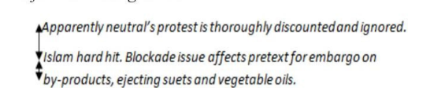

1. Word Shifting *(The practise of word shifting involves the strategic manipulation of word order or placement within a given sentence or text)*

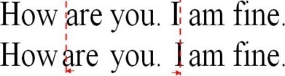

C. White Spacing *(White spacing or whitespace steganography, is a technique utilised in text steganography to conceal a sensitive message by modifying the white spaces, tabs, or other forms of white spaces)*

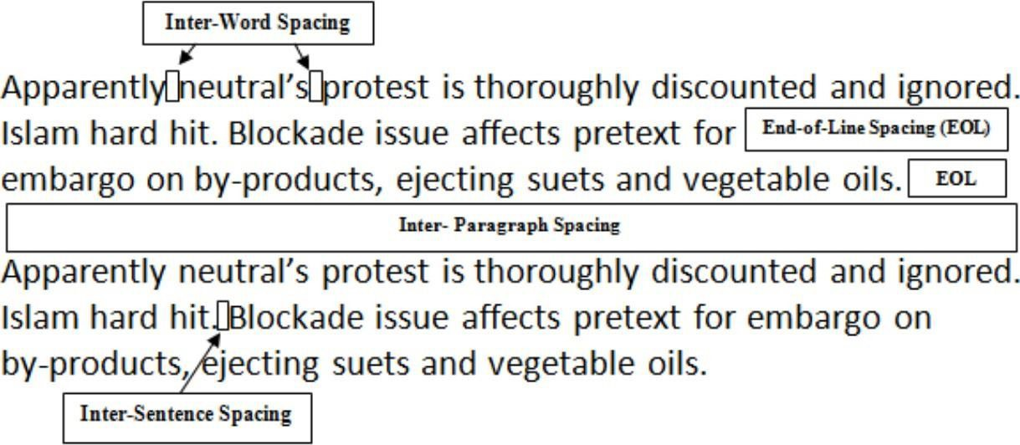

Методология (7)

A group of Unicode characters known as zerowidth characters are those that, when rendered, have no discernible representation. These characters are employed in a variety of contexts, such as text steganography, to conceal information within text without changing how it appears on the surface. Zero-width characters are useful for clandestine communication and data concealing since they are frequently used as nonprinting control characters.

Zero-width characters come in a variety of forms that can be steganographically used. Typical illustrations include:

* *Zero-Width Space (U+200B) (*This symbol is used to denote a space with no discernible width. It is frequently used as a delimiter or separator between words or phrases in steganography to encode information.*)*
* *Zero-Width Joiner (U+200D) and Zero-Width Non-Joiner (U+200C) (*In several languages, these characters are employed to regulate how neighbouring characters join together.*)*
* *Zero-Width Non-Breaking Space (U+FEFF) (* This character has no discernible width but is similar to a conventional non-breaking space. It can be used as a textual marker or identifier that is hidden.*)*

Результаты (8-9)

Text Steganography Encoding Algorithm

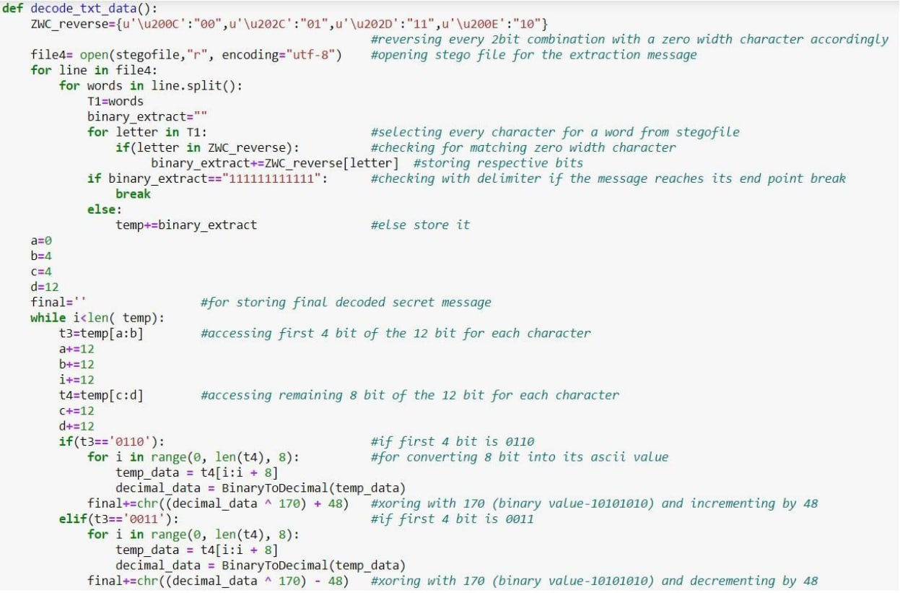

An algorithm for decoding text steganography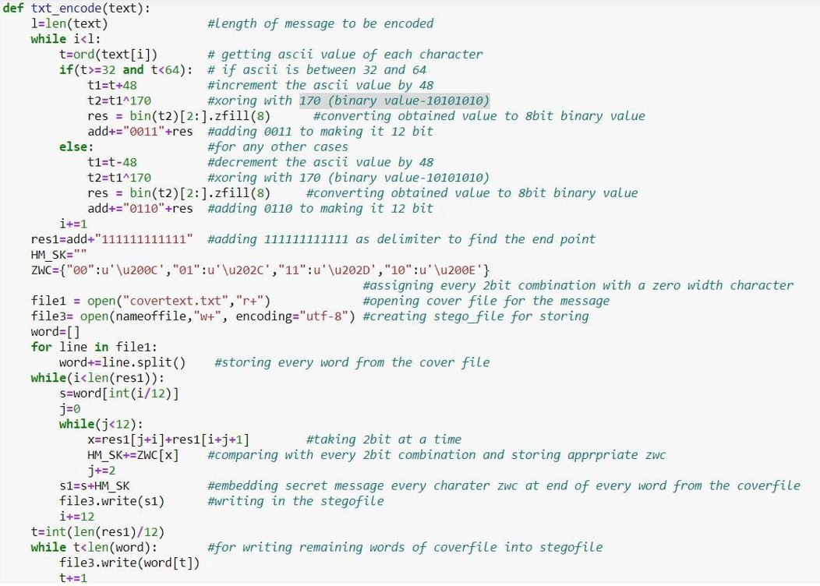

Дискуссия (10)

The challenges of resilience and detection present notable obstacles within the domain of text steganography. The primary objective of text steganography methods is to conceal messages within unencrypted text. However, it is crucial to guarantee that the covert data remains confidential and imperceptible to unapproved entities. Notwithstanding, antagonists may utilise diverse techniques, including statistical analysis or textual comparison, to detect the existence of concealed messages.

Вывод (11)

Text steganography is a useful technique for secret communication and data authentication in many different fields. Applications for it can be found in a variety of fields, including encrypted messaging, digital rights management, covert information transmission, and cybersecurity. Text steganography, however, faces a number of difficulties that scholars are working to solve. These include making sure the hidden message is undetectable within the cover text, preventing adversaries or security systems from discovering hidden messages, language specific rules, grammar structures, and contextual coherence, compression and encryption, and the computational complexity of text steganography techniques. To withstand advanced detection algorithms and attacks, researchers must constantly improve their methodologies.

Прощание (12)

That is it. Thank you for listening.