Movie Dubbing Studio Manager

Project Documentation

**Revision History:**

|  |  |  |  |
| --- | --- | --- | --- |
| Version | Change Description | Issue Date | Author |
| 0.8 | Add/Edit/Delete and listing features added for basic tables.  Workflow of application created.  User login and logout support. | 02/01/2020 | Sevdzhan Alkan |
| 0.9 | Projects list and detail page completed. | 02/02/2020 | Sevdzhan Alkan |
|  |  |  |  |
|  |  |  |  |

Table of Contents

1 Abstract 4

2 Keywords 4

3 Introduction 4

3.1 Support Pages 4

3.2 Main Pages 4

4 User Interface 5

4.1 Application UI Layout 6

4.2 Screens 7

4.3 Support Screens 7

4.3.1 List Page 7

4.3.2 Detail Page 8

4.4 Master Screens 8

4.4.1 List Page 8

4.4.2 Detail Page 9

5 What I Skip 11

5.1 Form Validation & Data Binding 11

5.2 Multi Language Support 11

5.3 Material Design For Everywhere 11

6 References 11

# Abstract

This document is describes user interface, using of application and application code of the project. You will see firstly UI and using introductions, then project structure and the application code.

# Keywords

C#, .Net Framework, NInject, Dependency Injection, WPF, Entity Framework, ORM, XAML, Material Design

# Introduction

The project developed for Advanced Software Technologies as a course work project.

The used technologies are listed below.

* C#, this programming language mainly supporting for WPF.
* .Net Framework, its stores useful class collection and the important part is the WPF app needs to .Net to work and build the project.
* EntityFramework, I used that as ORM framework. Basically, An Entity Framework does; managing Database via your table definitions and generates T-SQL queries via.
* NInject, the library for Dependency Injection.

The application helps to store data about ongoing dubbing projects to manage them. The application can store data about movies, persons, tags, publishers, users, genres.

## Screens

Some screens are designed to operate CRUD operation for simple tables, that’s are named as Support Screens. The other screen category is Master Screens, these screens using for CRUD operations like Support Screens. But the differences are; table of the master screen is has one or more than one relation with other tables and that makes master screens to more complex.

**Master Screens are:** Project, Movie

**Support Screens are:** User, Genre, Language, Person, Publisher, Tag

# User Interface

Let’s look at the first page, which is opening when the app launched.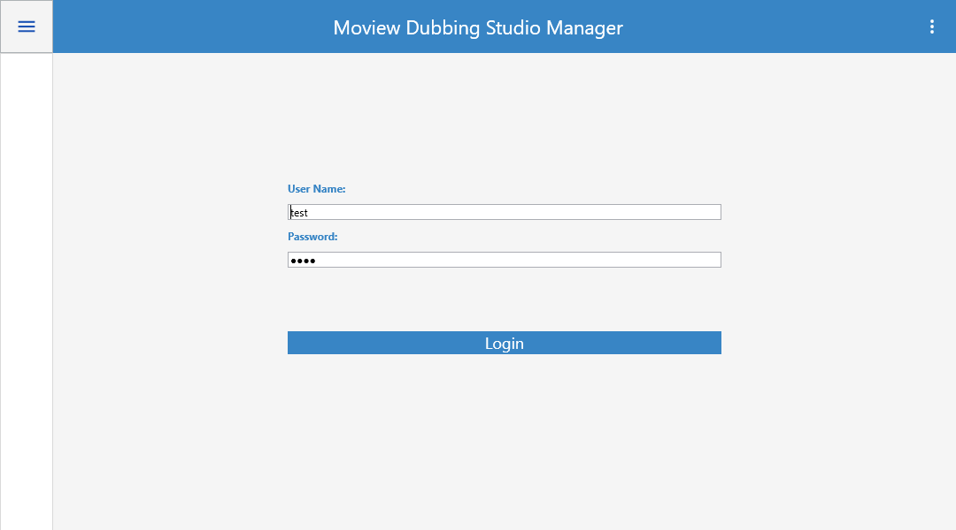

The main windows open when the application launched. If the user not already logged to the application, the main windows load the login page.

The application has only one window, it's working like a single page application. The application loads different pages into the main window up to user inputs.

## Application UI Layout

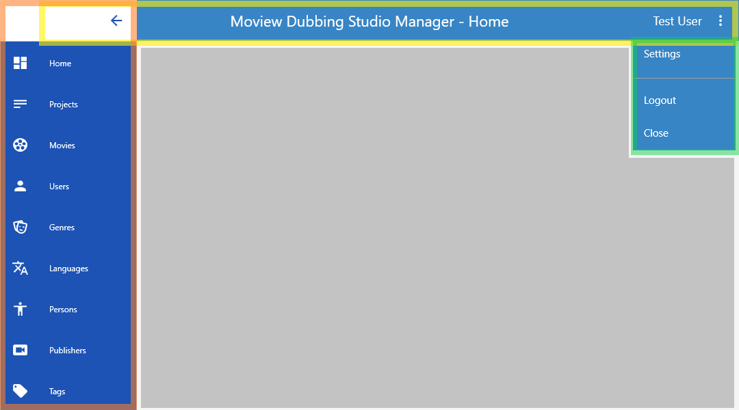

This is the application User Interface layout. It contains four different area. That’s are;

* Navigation menu. (selected with orange)
* Window border/toolbar. (selected with yellow)
* User menu. (selected with green)
* Page container. (filled with grey)

When user changes the page or the application loads a page up to an operation, the page loads into page container area. The application never created new window, all operations are doing into main window.

**Note:** First two screen, Home and Movie are not finished yet. I was panned locate some charts into Home screen, to be a dashboard. Also, Movie screen is little complex then the support pages because of that reason I couldn’t complete this screen in time.

Each button, which are in navigation menu, its opens related list page. Example: “Users’ button is opens ***UserList*** page. And each list screen has a detail page for add, edit operations.

List pages are maintains listing saved records, deleting selected record and navigation to the detail page.

Detail pages are maintains adding new record to he database or editing operation for existing records in the database.

## Support Screens

### List Page

Each screen has a list page, like showed below. List page are contains a button group on top right section and a DataGridView component to list saved records.

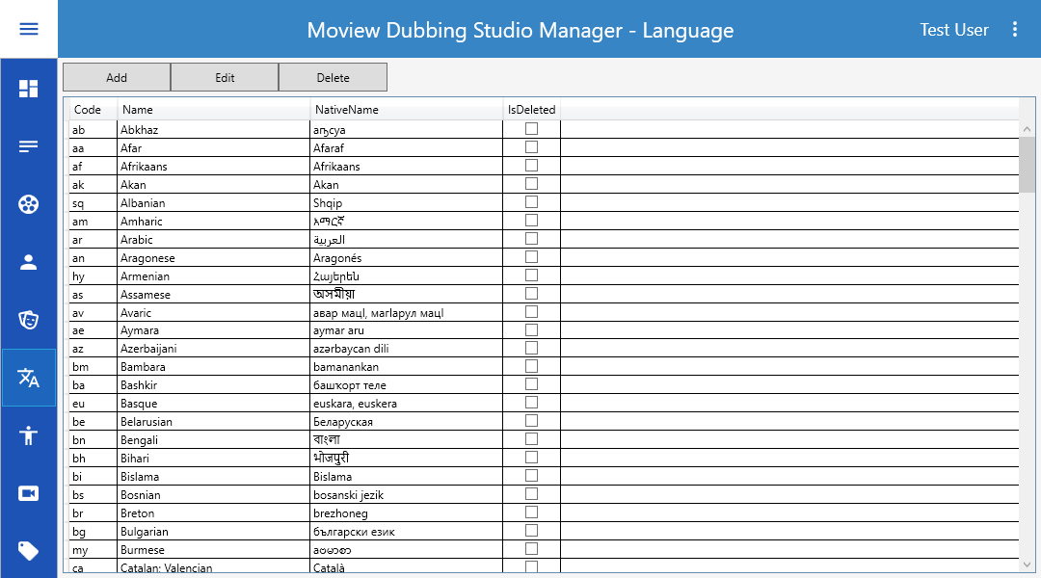

Functionalities of the buttons;

* Add: loads detail page with empty input fields.
* Edit: if user already select a row on grid component, the detail page loads with selected record data. Else its works like Add button.
* Delete: if user selected a record on Grid, this button deletes the record from database.

### Detail Page

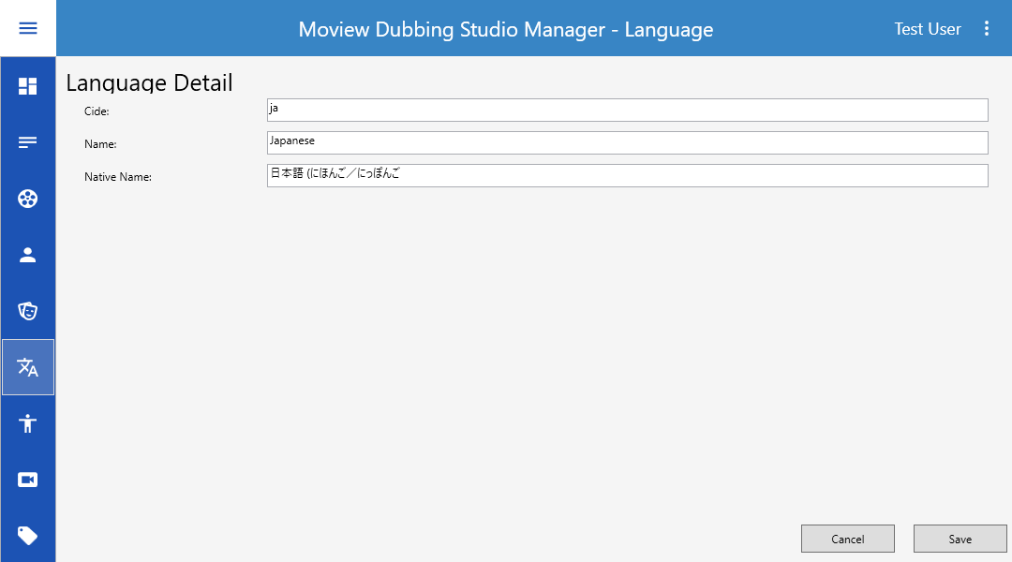

The detail page is contains fields of related database table and buttons for save or cancel adding/editing data.

## Master Screens

On this part is explaining the Project Screens because of Movie Screen aren’t completed.

### List Page

List page of the project screen almost same with other screens. Only it has an additional Status filter.

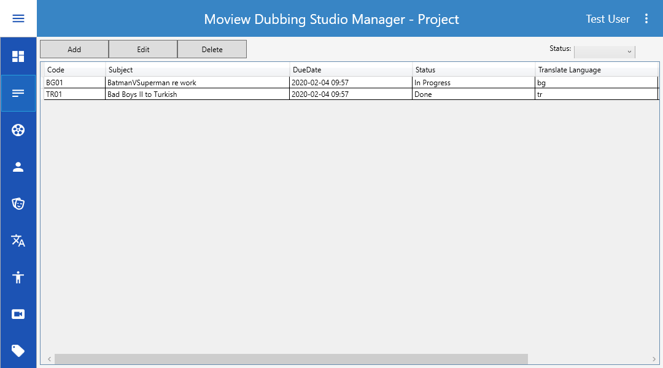

### Detail Page

The detail page has a tab control, each tab contains different components. ‘Main’ tab contains fields of the Project table. ‘Notes’ tab contains only Note filed of Project table. ‘Cast’ tab added for ProjectCast table operations. And the last tab is named as ‘Cast Detail’, its responsible to adding and editing dubbing artists of the project. Also ‘Cast Detail’ tab not visible default, when its needs to use, the application makes it visible.

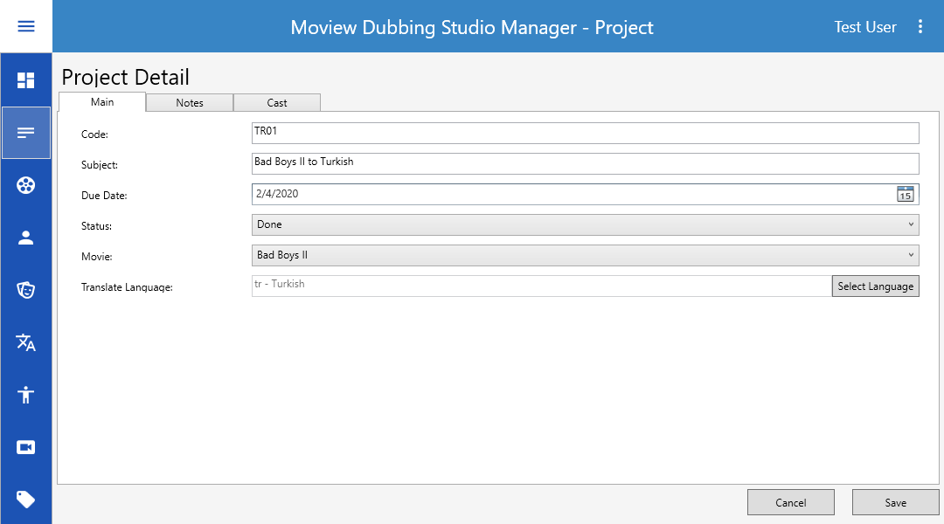

#### Cast List

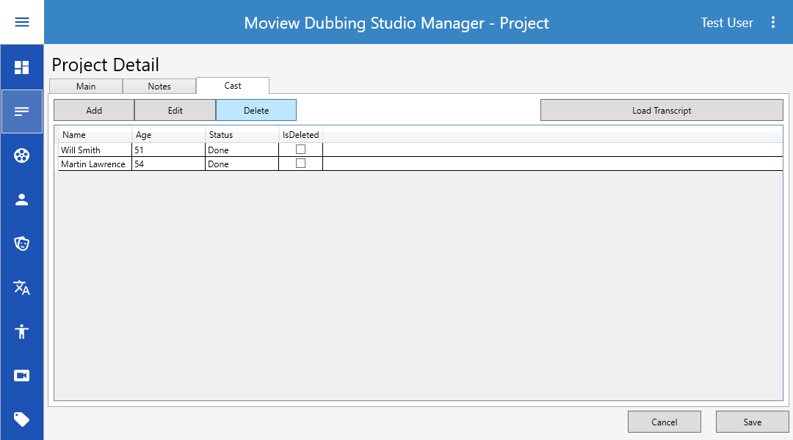

#### Cast Detail

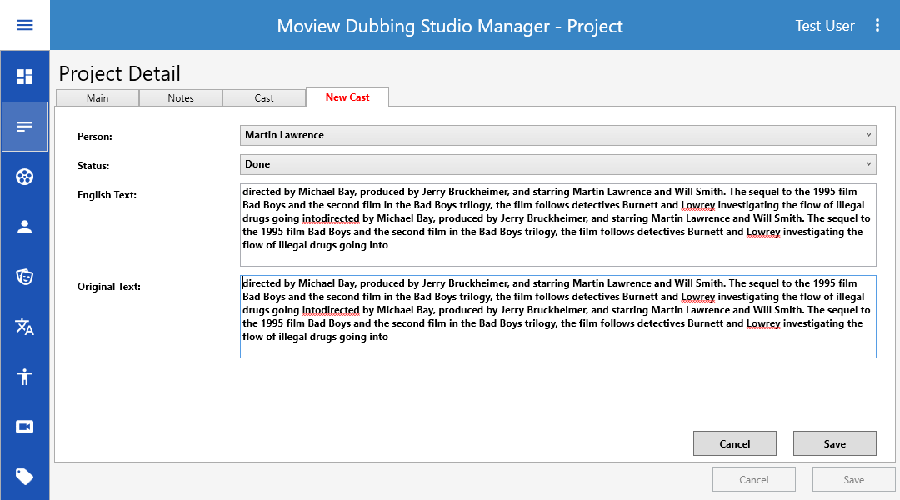

# Technical Review

This part of the document is describing how is the code working.

## Application Layout

|  |  |
| --- | --- |
|  | Firstly, I want to describe solution and projects. The solution has five different projects. That’s are;   * **Core:** It contains some useful classes to use entire solution. * **Data:** the database logic are located into this project. * **Desktop:** The main project of the solution, WPF application is this project. * **Domain:** database tables (poco classes) are located into this project. * **UI:** That project added to store custom UserControls, like custom grid component. It can useable, but it is not used. |
|  | The Core project only contains useful classes to be useable whole solution. Basically, it avoids code duplicates. Each other project can access to the Core project.   * **Entity Framework:** The base class of poco classes is located here. * **Enum:** All enums are located here. * **Validation:** Which class and its own methods using for validation, they are located here. Example: an extension method for Guid validation. * **ViewModel:** Base view model class is located here, all VM classes inherits this class. Like BaseEntity class.   **Convert:** It has some custom function for variable type conversation.  **ModelCopier:** Its basically copies all class properties of given variable to the other reference. It is using for copy a poco class object values to the VM object, or opposite way.  **ModerCopierAttribute:** If a property of class has this attribute, ModelCopier don’t copy the property. |
|  | The Data project contains business logic.   * **Helper:** Its has only one class, that are EnumHelper. This class has some useful methods for enum variable types. It should be located into Core project, but its needs to Domain project and the Domain project not reachable from Core project. * **Migrations:** EntityFramework migration files and configuration class. The configuration class contains ‘Seed’ method initialize default values into database, when ‘Update-Database’ used. * **Services:** Theseclasses are inherits ‘BaseService’ class. And makes the BaseSevice to customizable for specific table. * **SubStructure: ‘**Repository’ and ‘BaseService’ classes located here. ‘Repository’ class has basic query functions for DbContext. The ‘BaseService’ uses functions of the ‘Repository’ class and it adds more logic to base ‘Repository’ functions. * **ViewModel:** View Model classes located here. These VM classes for poco classes. They aren’t like View Model classes of the ‘Desktop’ project, VM’s of the ‘Desktop’ are using for MVVM pattern.   **MovieStoreDbContext:** DbContext class for Entity Framework. It defines our database, and its tables. |
|  | This project is the main project. This project starts when application launched. The project type is WPF, other projects of the solution, they are class library.  The project has only one window and many user controls.   * **Assets:** Images, Icons to use in application. * **DI:** Configurations for NInject dependency injection library. * **Helper:** Useful classes for Desktop project. * **ViewModel:** ViewModel classes of Views (UserControls). These view models have functions to communicate with business layer and they are storing database data of the View. * **Views:** WPFUserControls are located into this folder. They are representing into MainWindow up to user page selection.   **MainWindow:** The window of the application. All interaction does with user via this window.  **ViewModelLocator:** It returns a ViewModel to load a View via NInject. |
|  | The ‘Domain’ project is containing only poco classes.  Each poco class defines a database table to Entity Framework. The important part is; A poco class must be defined as DbSet<> property into DbContext class for detect by Entity Framework. |
|  | The UI project not used, I couldn’t finished in time it.  The idea was store custom UI components here. Example: A grid component with custom features like filtering. And use it dynamically in when needs to a grid. Another example; an autocomplete component. |

# What I Skip

I skipped some features to add the application. Because these features makes the application more complex or to add them, I need more time for implementation.

## Form Validation & Data Binding

WPF and NVVM design pattern supporting databinding and form validation. But its needs more XAML and C# codes to implement.

## Multi Language Support

On real world solutions I think it’s have to support by application. Each static text of the UI can get from a specific language file. Also, this language file can load on login by the user preference. But for this project it is not necessary.

## Material Design For Everywhere

Currently the material design using only main window layout. Its not using on components of UserControls. Again, its needs more customization in XAML.

## Better Entity Framework using

Using lazy loading, improvement for LINQ queries, additional mapping classes for poco classes.

# References

* [C# WPF Tutorial - Multiple Views](https://www.youtube.com/watch?v=xUwk2-_tRzo)
* [C# WPF UI Tutorials: 01 - The Basics](https://www.youtube.com/watch?v=Vjldip84CXQ)
* [Dependency Injection For WPF & MVVM](•%09https:/stackoverflow.com/questions/25366291/how-to-handle-dependency-injection-in-a-wpf-mvvm-application)
* [C# WPF Material Design UI: Navigation Drawer & Popup Menu](https://www.youtube.com/watch?v=YQ1EJJZBHyE&list=WL&index=11&t=0s)
* [Pluralsight WPF Course](https://app.pluralsight.com/library/courses/wpf-mvvm-in-depth/table-of-contents)