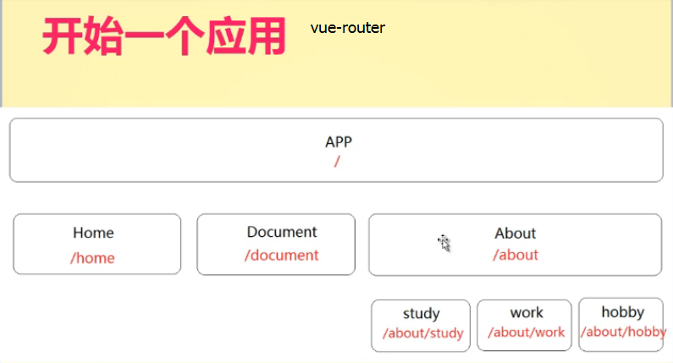

**前四部分学习可以完成home/document/about,的页面。**

**接下来完成about三个子页面的嵌套。**

**即路由嵌套-对应组件嵌套**

**注意：路由设置里‘/’开始的的路径是相对于根路径，所以在写子路由时不写‘/’直接跟子路由名字。**

......

Vue.use(VueRouter)

var router = new VueRouter({

mode: 'history',

linkActiveClass: 'is-active',

routes: [

{

path:'/',

component:home

},

{

path: '/home',

component: home,

name: 'home',

alias:'/index'//为home页设置别名

},

{

path: '/about',

component: about,

children:[

{

path:'*study*',

component:study

},

{

path:'*work*',

component:work

},

{

path:'*hobby*',

component:hobby

},

]

},

{

path: '/odocument',

component: odocument

},

{

path: '*',

//component: notFound

//重定向

//redirect:'/home'

//redirect:{path:'/home'}

//redirect:{name:'home'}

//动态重定向

redirect: (to) => {//to保存着一个对象-访问的路径的路由信息

//console.log(to);

switch(to.path){

case '/123':

return 'home';

break;

case '/456':

return '/odocument';

break;

default:

return '/about';

}

}

}

]

})

export default router

**about.vue里router-link标签里嵌套a标签，渲染后router-link标签跳转的地址，会自动添加到a标签上**

<template>

<div>

关于我！

<hr>

<ul class='nav about-nav'>

<router-link to="/about/study" tag='li'>

<a>study</a>

</router-link>

<router-link to="/about/work" tag='li'>

<a>work</a>

</router-link>

<router-link to="/about/hobby" tag='li' >

<a>hobby</a>

</router-link>

</ul>

<hr>

<router-view></router-view>

</div>

</template>

<script>

export default {

}

</script>

<style >

.about-nav li{font-size:30px;}

</style>

**接下来设置当访问about页面默认渲染study子页面**

**路由里about的子路由study的路径设置为空**

**如果想要当前默认的子组件study有默认状态（背景颜色之类的）在**

**about.vue中设置study的router-link的路径为to="/about"，**

**这样写可能会引起当选择work或者是hobby组件时，study也存在选中状态。**

**解决方法：about.vue中设置study的router-link的添加属性 exact**

........

{

path: '/about',

component: about,

children:[

{

path:' ',//设置为空默认访问此组件

component:study

},

{

path:'work',

component:work

},

{

path:'hobby',

component:hobby

},

]

},

**最后注意一点：一旦设置了子路由，父路由就不要设置name属性了，**

**但是子路由可以设置name 名字，**

**about.vue里面的router-link就可以不用写成 to='url'的形式了**

**直接写成动态绑定name名字**

**如：**

........

{

path: '/about',

component: about,

name:'about',//有子路由了这里父路由不要再写name

children:[

{

path:' ',

component:study，

**name**：'Study'

},

{

path:'work',

component:work

},

{

path:'hobby',

component:hobby

},

]

},

**about.vue里：**

<template>

<div>

关于我！

<hr>

<ul class='nav about-nav'>

<router-link **:to="{name:'Study'}"** exact tag='li'>

<a>study</a>

</router-link>

<router-link to="/about" tag='li'>

<a>work</a>

</router-link>

<router-link to="/about/hobby" tag='li' >

<a>hobby</a>

</router-link>

</ul>

<hr>

<router-view calss='tow-class'></router-view>

</div>

</template>

<script>

export default {

}

</script>

<style >

.about-nav li{font-size:30px;}

</style>