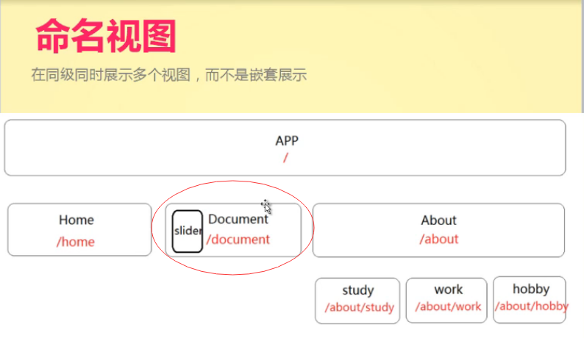

**就是一个路由里对应多个组件**

**如上图'/document' 对应两个组件slider和document**

**在App.vue里创建<router-view name=" doc_slider "></router-view>**

**作为slider的渲染容器。这只name名字，对应路由里的名字**

**在路由里('/document'),使用components表示多个组件default表示将document组件渲染到没有name名字的，router-view里，将slider组件渲染到name名字为doc_slider的router-view里。**

**.....**

**{**

**path: '/document',**

**components:{//一个路由对应多个组件**

**default:document,//默认组件**

**doc_slider:slider**

**}**

**},**

**.....**

**App.vue里**

<template>

<div id="app">

<div class='nav-box'>

<ul class='nav'>

<li>

<router-link v-bind:to='index' event='mouseover' exact>home</router-link>

</li>

<li>

<router-link v-bind:to="{path:'/odocument'}">document</router-link>

</li>

<router-link to="/about" tag='li' active-class="about-active">

<i class="iconfont icon-info"></i>

<span>about</span>

</router-link>

</ul>

</div>

**<router-view name="doc_slider"></router-view>**

**<router-view class='center'></router-view>**

</div>

</template>