### Used these test statements to wipe all previous data from the database and replace with test data that will be seen throughout this report.

SET SQL_SAFE_UPDATES = 0;

DELETE FROM Applications;

DELETE FROM Majors;

DELETE FROM School;

DELETE FROM Student;

DELETE FROM HighSchool;

DELETE FROM Admin;

DELETE FROM User;

SET SQL_SAFE_UPDATES = 1;

ALTER TABLE admin AUTO_INCREMENT=1;

ALTER TABLE applications AUTO_INCREMENT=1;

ALTER TABLE highschool AUTO_INCREMENT=1;

ALTER TABLE majors AUTO_INCREMENT=1;

ALTER TABLE school AUTO_INCREMENT=1;

ALTER TABLE student AUTO_INCREMENT=1;

ALTER TABLE user AUTO_INCREMENT=1;

insert into User (user_name, password, type) values

('cmatiebe0', '$2b$10$upT9vKHMmDXJ6XI4MZtK1e886q/WRzQc4rFFguD7Xm7eObfZ9Wc.C', 'Admin'),

('wloads1', '$2b$10$upT9vKHMmDXJ6XI4MZtK1e886q/WRzQc4rFFguD7Xm7eObfZ9Wc.C', 'Admin'),

('isorrel2', '$2b$10$upT9vKHMmDXJ6XI4MZtK1e886q/WRzQc4rFFguD7Xm7eObfZ9Wc.C', 'Student'),

('cmadocjones3', '$2b$10$upT9vKHMmDXJ6XI4MZtK1e886q/WRzQc4rFFguD7Xm7eObfZ9Wc.C', 'Student'),

('nbaudains4', '$2b$10$upT9vKHMmDXJ6XI4MZtK1e886q/WRzQc4rFFguD7Xm7eObfZ9Wc.C', 'Student'),

('wyepiskopov5', '$2b$10$upT9vKHMmDXJ6XI4MZtK1e886q/WRzQc4rFFguD7Xm7eObfZ9Wc.C', 'Student'),

('candrejevic6', '$2b$10$upT9vKHMmDXJ6XI4MZtK1e886q/WRzQc4rFFguD7Xm7eObfZ9Wc.C', 'Student'),

('hmarney7', '$2b$10$upT9vKHMmDXJ6XI4MZtK1e886q/WRzQc4rFFguD7Xm7eObfZ9Wc.C', 'Student'),

('tarndell8', '$2b$10$upT9vKHMmDXJ6XI4MZtK1e886q/WRzQc4rFFguD7Xm7eObfZ9Wc.C', 'Student'),

('cswansborough9', '$2b$10$upT9vKHMmDXJ6XI4MZtK1e886q/WRzQc4rFFguD7Xm7eObfZ9Wc.C', 'Student');

INSERT INTO Admin (id) SELECT id FROM User WHERE type = 'Admin';

insert into HighSchool (name, city, state, ap_enroll, sat_score, act_score, college_prep_rank, us_rank, stem_rank, interested_schools) values

('Electronic Classroom of Tomorrow', 'Houston', 'TX', 84.07, 179, 33, 2272, 3511, 3475, 'Stony Brook University, New York University, Binghamton University, Boston University'),

('Georgia Cyber Academy', 'Springfield', 'OH', 76.43, 101, 15, 12382, 16059, 6283, 'Stony Brook University, Georgia Tech University, Cooper Union University'),

('Noble Street Charter Schools', 'Indianapolis', 'IN', 57.43, 637, 2, 16315, 14995, 12, 'Georgia Tech University, Stony Brook University, Binghamton University'),

('Ohio Virtual Academy', 'Aiken', 'SC', 52.13, 520, 3, 1528, 115, 172, 'Stony Brook University, New York University, Hofstra University'),

('Pennsylvania Cyber Cs', 'Reno', 'NV', 90.89, 668, 2, 857, 282, 464, 'Long Island University, Stony Brook University, Nassau Community College'),

('Commonwealth Connections Academy Cs', 'Dallas', 'TX', 91.34, 64, 25, 715, 185, 525, 'Stony Brook University, Florida University'),

('Chicago International Charter', 'Phoenix', 'AZ', 88.29, 332, 12, 487, 154, 6501, 'Stony Brook University, Binghamton University, University of Buffalo'),

('Agora Cyber Cs', 'Evansville', 'IN', 22.49, 476, 2, 259, 111, 528, 'University of Buffalo, Stony Brook University, Binghamton University'),

('Uno Academy Charter Schools', 'Sioux Falls', 'SD', 25.82, 330, 32, 194, 160, 1433, 'University of Buffalo, Hofstra University, Georgia Tech University'),

('River Springs Charter', 'Fort Pierce', 'FL', 82.39, 168, 35, 508, 2952, 2412, 'Binghamton University, Northeaster University, Cornell University');

insert into Student (id, hs_id, financial_status, major1, major2, grad_year, sat_math, sat_ebrw, act_eng, act_math, act_reading, act_science, act_comp, sat_lit, sat_us, sat_mathI, sat_mathII, sat_eco, sat_mol, sat_chem, sat_phy, numAPs, gpa) values

(8, 4, '1', 'computer science', 'ams', 2242, 370, 418, 18, 4, 34, 5, 15, 350, 509, 471, 216, 676, 472, 651, 489, 21, 4),

(10, 1, '2', 'mechanical engineering', null, 4402, 521, 618, 35, 5, 20, 23, 34, 354, 633, 311, 436, 450, 307, 429, 608, 87, 3),

(7, 2, '1', 'civil engineering', null, 5012, 557, 271, 4, 33, 19, 5, 30, 525, 310, 471, 737, 537, 280, 592, 270, 34, 2.5),

(5, 3, '3', 'health science', null, 8003, 284, 521, 22, 25, 29, 21, 31, 340, 226, 427, 417, 294, 658, 680, 450, 9, 3.8),

(6, 4, '2', 'biology', 'chemistry', 4353, 507, 277, 2, 25, 33, 25, 35, 541, 740, 712, 754, 284, 671, 383, 377, 21, 3.6),

(4, 3, '1', 'business', 'economics', 3189, 651, 786, 32, 26, 1, 30, 29, 350, 469, 720, 412, 700, 383, 716, 745, 1, 3.18),

(9, 5, '3', 'psychology', 'sociology', 4228, 616, 755, 12, 30, 21, 29, 34, 387, 658, 551, 389, 749, 516, 385, 319, 0, 3.1),

(3, 6, '2', 'biochemistry', 'computer science', 5083, 710, 641, 34, 24, 22, 21, 5, 229, 669, 490, 593, 734, 408, 410, 586, 80, 4);

insert into school (name, city, region, admission_rate, cost, ranking, size, act_composite, sat_math, sat_ebrw, act_range_low, act_range_high, sat_math_range_low, sat_math_range_high, sat_ebrw_range_low, sat_ebrw_range_high, avg_accepted_gpa, state) values

('Stony Brook', 'Brooklyn', 'Northeast', 12.44, 34938, 15259, 31968, 21, 236, 562, 10, 20, 364, 615, 87, 592, 0, 'NY'),

('Rough Creek', 'Boulder', 'Northeast', 6.97, 56693, 11442, 80836, 30, 672, 136, 1, 36, 94, 565, 393, 724, 2, null),

('Rugged River', 'Tucson', 'West', 43.81, 78694, 12481, 33033, 13, 128, 486, 10, 24, 110, 531, 332, 567, 1, 'AZ'),

('Pebbly Stream', 'Baton Rouge', 'West', 88.16, 64829, 12323, 78223, 9, 504, 588, 7, 22, 280, 411, 169, 793, 3, 'LA'),

('Hard Watercourse', 'Fairfield', 'Northeast', 62.96, 28795, 22314, 32949, 7, 621, 497, 1, 20, 37, 410, 366, 468, 3, 'CT'),

('Gravelly Tributary', 'Knoxville', 'South', 99.72, 18926, 10917, 78271, 21, 122, 795, 14, 19, 209, 564, 121, 665, 1, 'TN'),

('Gritty Spate', 'Odessa', 'South', 57.55, 17954, 18702, 60538, 7, 380, 149, 11, 21, 155, 469, 374, 679, 2, 'TX'),

('Granular Inlet', 'Nashville', 'South', 56.54, 13523, 2100, 9096, 17, 148, 548, 6, 27, 21, 758, 345, 441, 0, 'TN'),

('Rocky Waterway', 'Ashburn', 'Northeast', 79.87, 7260, 8510, 36238, 13, 103, 455, 3, 20, 271, 783, 210, 584, 1, 'VA'),

('Bumpy Torrent', 'Boynton Beach', 'South', 33.9, 2844, 6326, 9057, 19, 662, 733, 4, 22, 294, 756, 242, 649, 3, 'FL');

insert into Majors (school_id, major) values

(1, 'computer science'),

(2, 'mechanical engineering'),

(2, 'health science'),

(3, 'biology'),

(4, 'chemistry'),

(5, 'civil engineering'),

(6, 'biochemistry'),

(7, 'computer engineering'),

(8, 'writing'),

(9, 'biology'),

(10, 'business'),

(1, 'business'),

(1, 'biochemistry'),

(1, 'biology'),

(1, 'chemistry');

insert into Applications (student_id, college_id, questionable, status) values

(3, 1, true, 'Accepted'),

(3, 2, false, 'Pending'),

(4, 3, true, 'Accepted'),

(5, 4, true, 'Accepted'),

(5, 5, true, 'Accepted'),

(6, 1, false, 'Accepted'),

(7, 1, false, 'Rejected'),

(8, 1, false, 'Pending'),

(9, 2, false, 'Accepted'),

(10, 3, false, 'Rejected'),

(10, 6, false, 'Pending'),

(8, 7, false, 'Accepted'),

(6, 3, false, 'Accepted'),

(7, 2, false, 'Rejected');

# Beginning of Test Report

## Unit Tests

A basic rundown of all the methods in app.js tested using the RESTED Chrome client, Git Bash, and a local database all on Windows 10.

### To start:

“node app.js” is ran via Git Bash within the backend (“/CSE416/Project/backend”)folder

#### 

#### student.getProfile

Outcome: all the columns from the entry where id = 3 in the student table (as seen below).

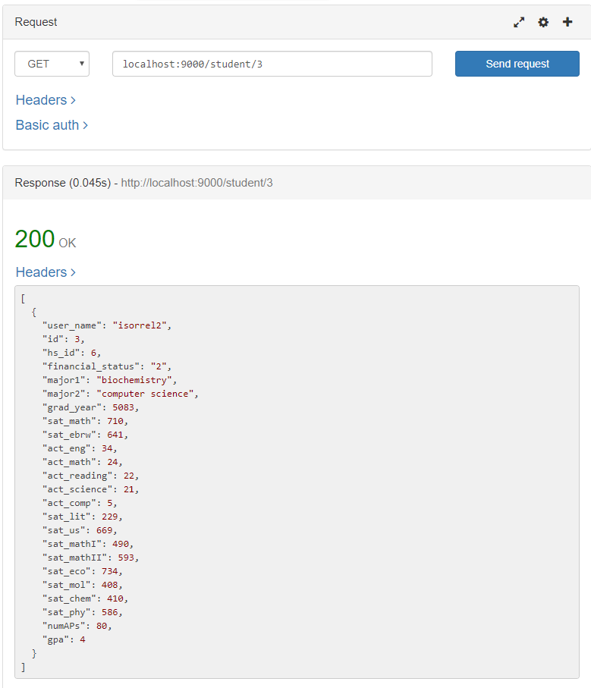

### 

#### school.get

Outcome: all the columns from the entry where id = 5 in the school table (as seen below).

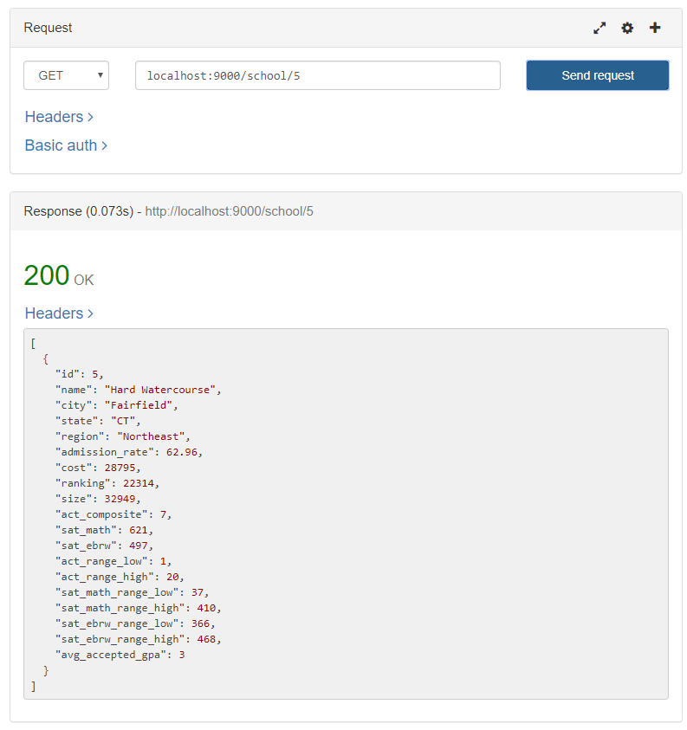

#### 

#### student.editProfile

Using student.getProfile (tested prior) to ensure correctness

#### calling student.getProfile before calling student.editprofile for future comparison

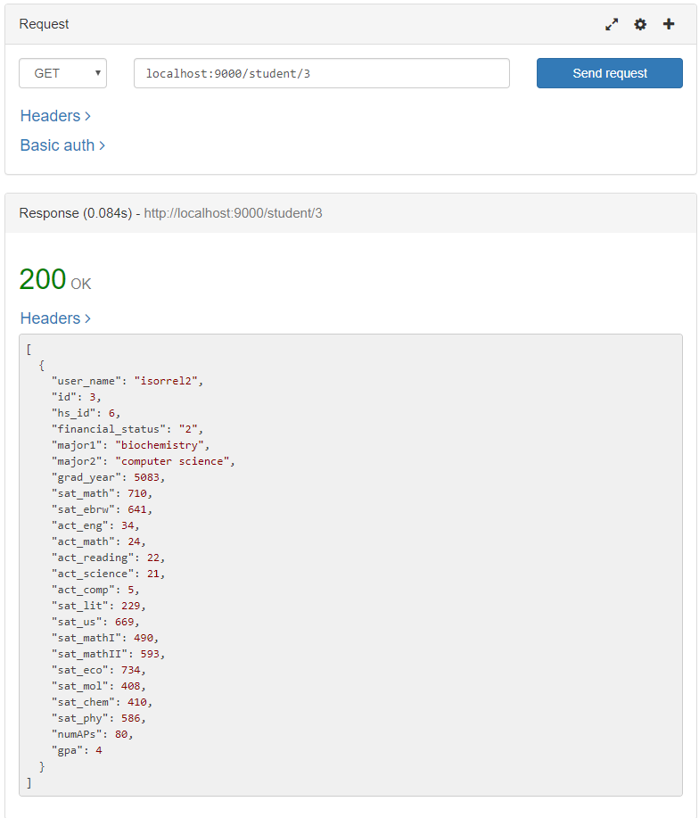

#### 

#### call editProfile

Intent is to change “numAPs” from 80 to 69 and “major1” from “biochemistry” to “chemistry”

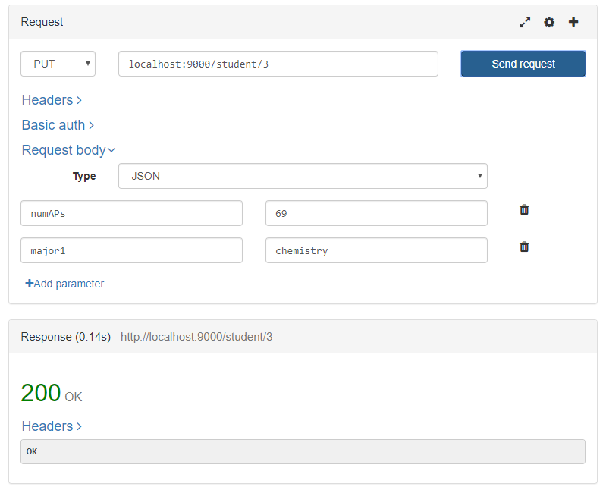

#### Using student.getProfile to confirm change

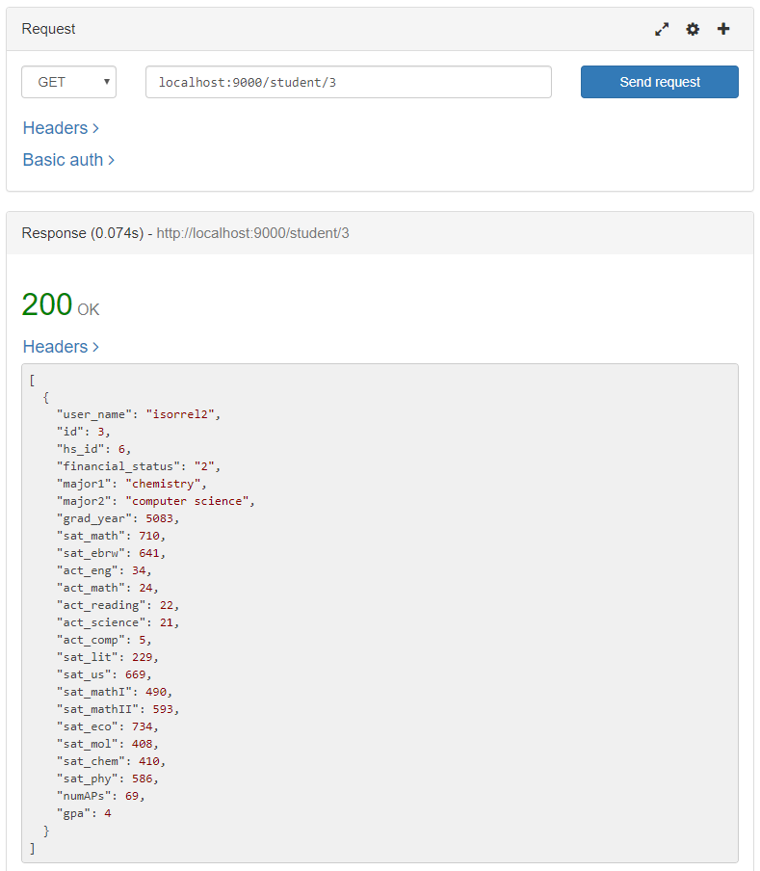

Correct!

### 

#### student.editProfile (continued)

Now that we know it works changing two values at once we will now test changing all the values of student.

Using student.getProfile (tested prior) to ensure correctness

#### calling student.getProfile before calling student.editprofile for future comparison

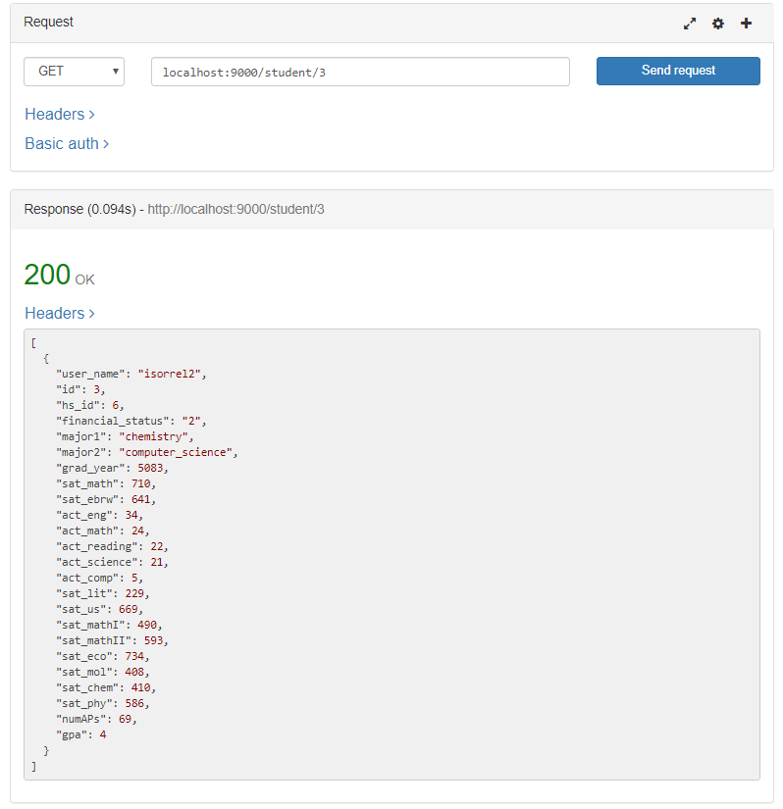

#### 

#### call editProfile

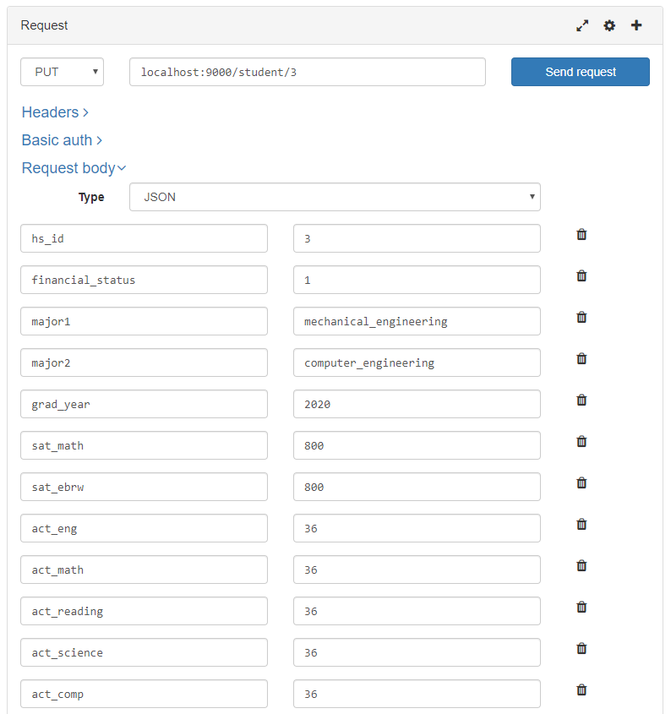

#### call editProfile (continued)

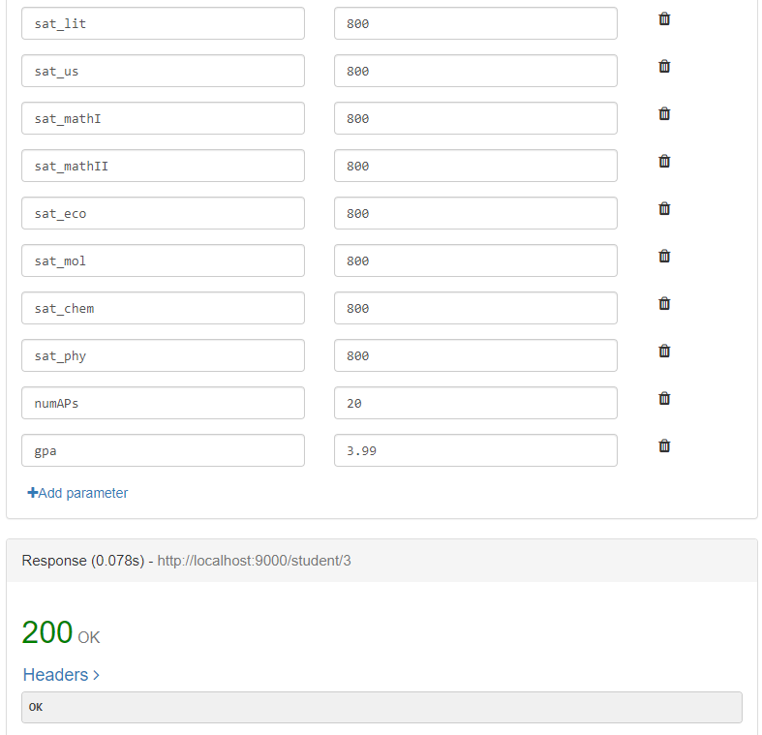

#### Using student.getProfile to confirm change

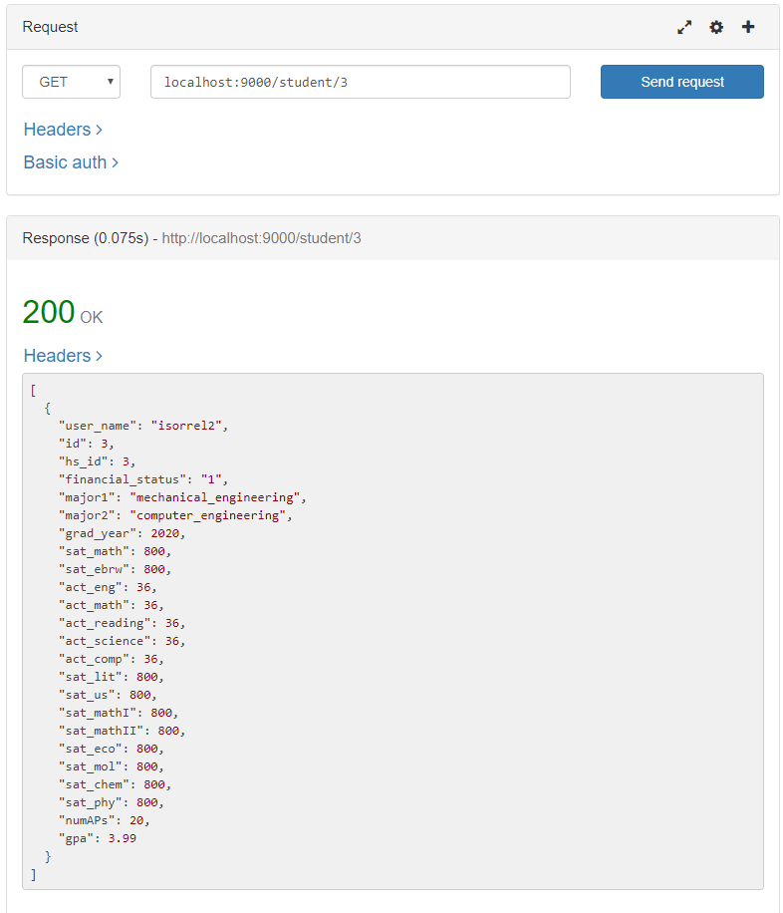

Correct! This student is very smart.

### 

### school.search

Because of many parameters we’ll be testing several fields individually and then all together.

##### relaxed searching by states

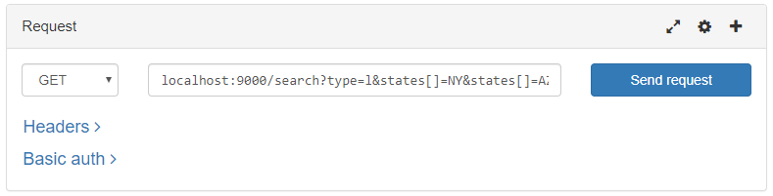

Here is what is returned through lax search:

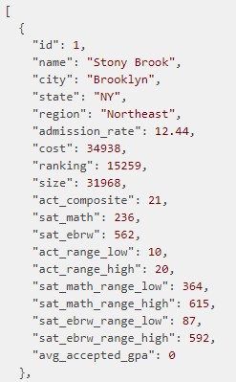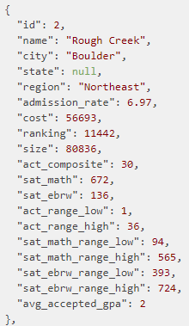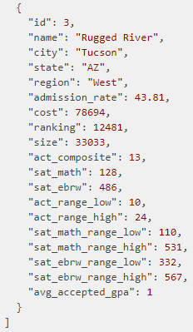

##### 

##### 

##### 

##### 

##### 

##### strict search by states

If users want to ignore results contain null values they may enable strict search

### 

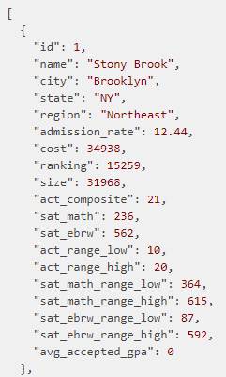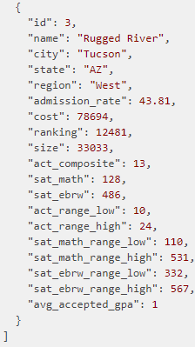

### searching by region

#### successful search

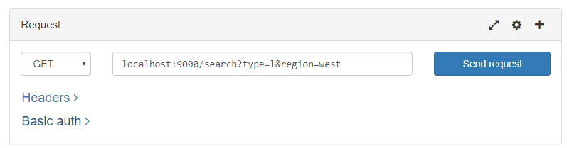

#### 

### 

### searching by region (continued)

#### unsuccessful search

Ideally the user will be unable to enter false regions, but have we ensured that nothing is returned.

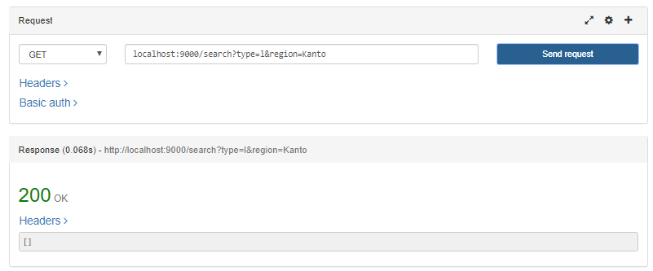

### 

### searching by admission

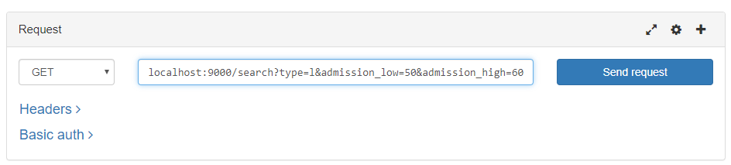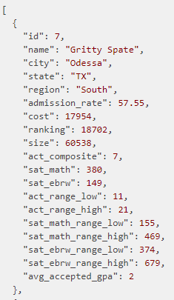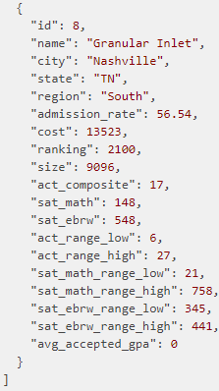

### application.createApplication

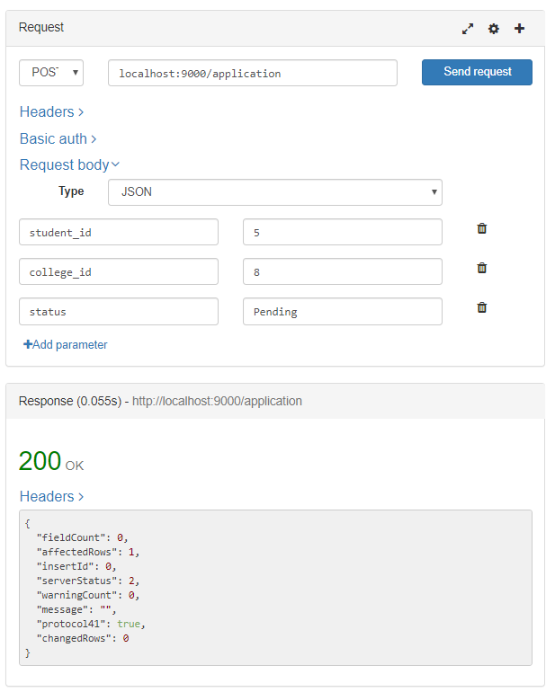

#### 

#### Using MySQL Workbench to confirm results

using “select * from applications;”

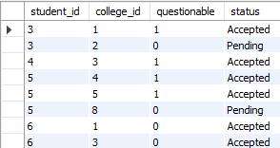

From the above image a new entry of student_id=5 and college_id=8 has been added with its status as “Pending” just as stated in the POST request.

### application.updateApplication

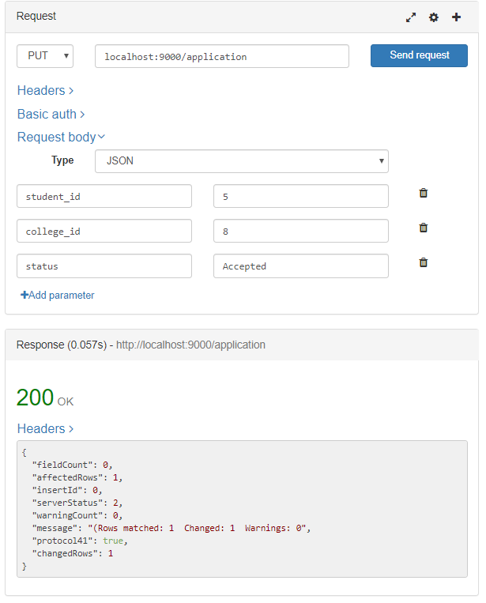

#### 

#### Using MySQL Workbench to confirm results

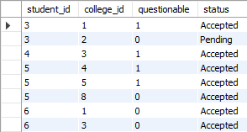

As one can see from the previous test case and this one. The entry where student_id=5 and college_id=8 has updated its status from “Pending” to “Accepted”. Congratulations!

### application.getQuestionable

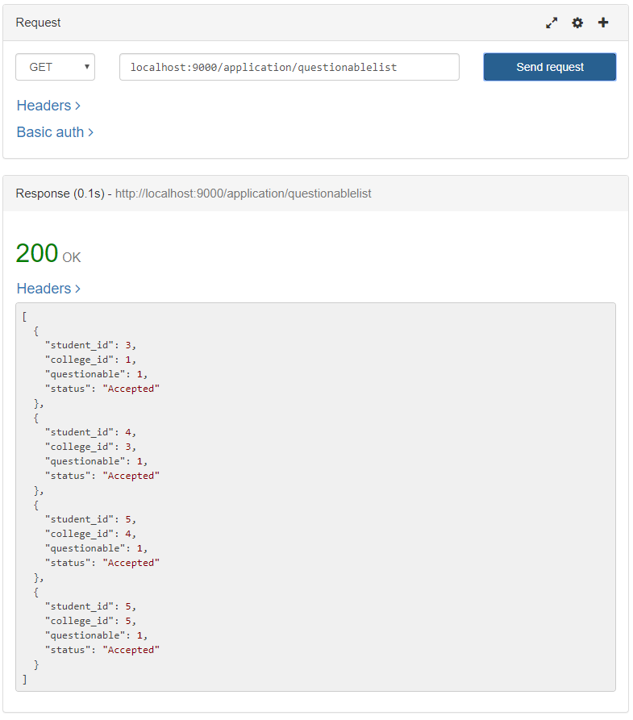

returns all Applications records where questionable=true

### application.delete

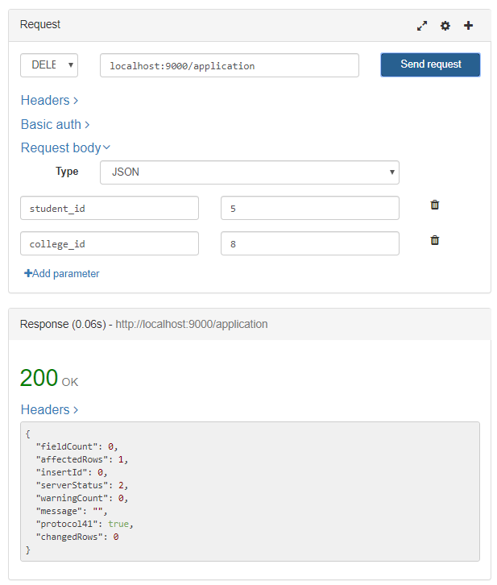

### Using MySQL to confirm that it was the application was deleted

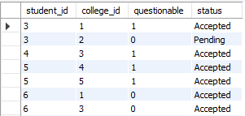

### application.allApplicationsForSchool

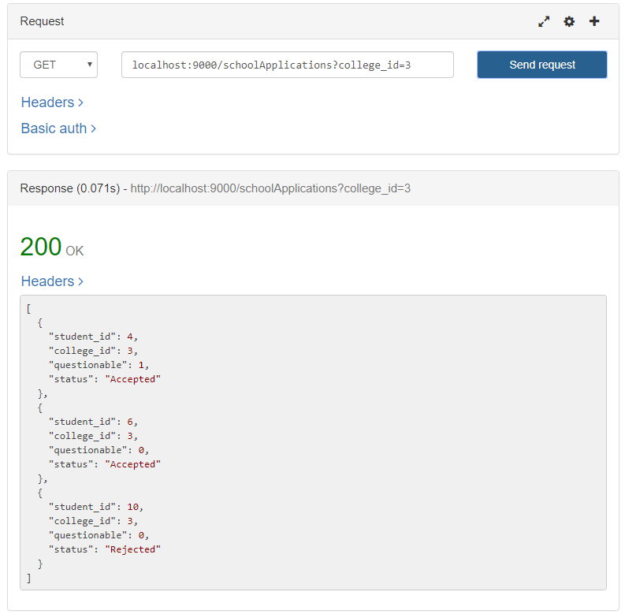

### admin.deleteAllStudents

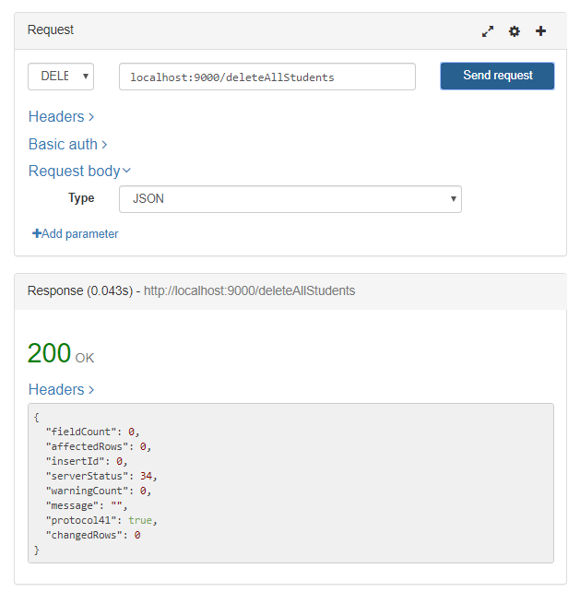

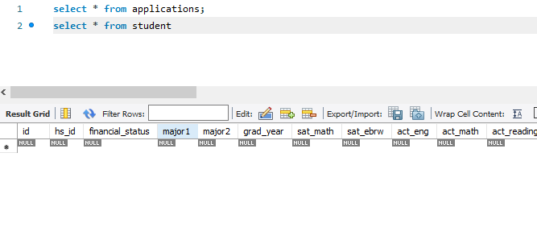

### user.login

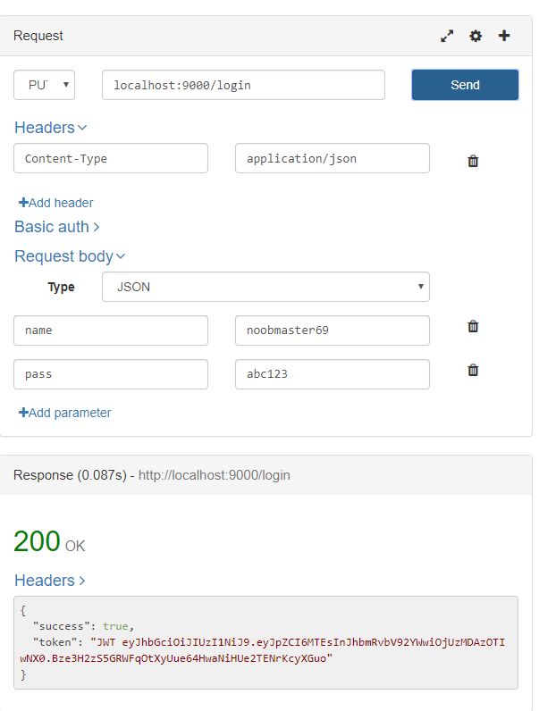

### user.createAccount

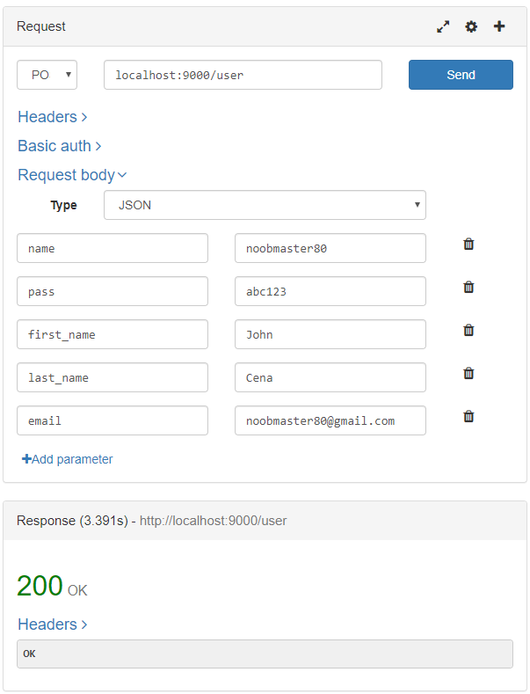

#### Checking through MySQL using “SELECT * FROM USER”

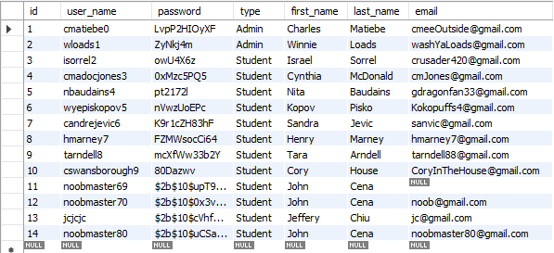

### school.rank

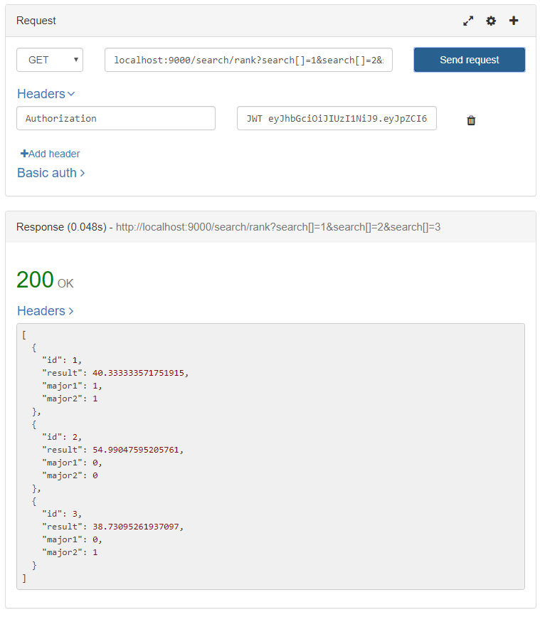

### application.allApplicationsForSchool

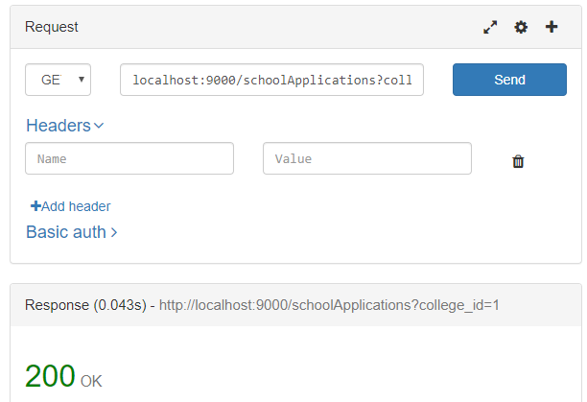

#### Return values are on the next page, not showing all returns.

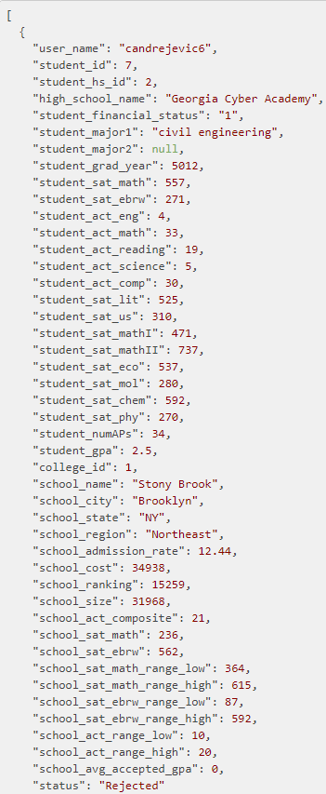

### application.getQuestionableAllData

#### Not going to show all results because there are a lot.

### 