LAB SESSION 3: TEXT ANALYSIS USING LEX

DATE:

AIM: To implement a program for word frequency analysis in a text file using the Lex Tool.

PROBLEM DEFINITION: Develop a Lex program to analyze a text file and count the frequency of each word, ignoring case and punctuation. The program should:
- Recognize words consisting of letters (a-z, A-Z).
- Convert all words to lowercase.
- Ignore numbers, punctuation marks, and special symbols.
- Print the frequency of each word found in the input file.

Input: A text file with multiple lines of text.
Output: List of words and their frequencies, sorted alphabetically.

THEORY: Lex in compiler design is a program used to generate scanners or lexical analyzers, also called tokenizers. These tokenizers identify the lexical pattern in the input program and convert the input text into the sequence of tokens. It is used with the YACC parser generator. Eric Schmidt and Mike Lesk initially developed the code for Lex, which was intended for Unix-based systems.

The function of Lex is as follows:
Lexical Analyzer Creation: The process begins by creating a program called lex.l using Lex's language. This program defines the rules and patterns for recognizing tokens in the source code

Lex Compiler Execution: The lex.1 program is then executed using the Lex compiler. This step generates a C program named lex.yy.c

C Compiler Execution: The C compiler is then used to compile the generated lex.yy.c program. The result is an object program referred to as a.out

Lexical Analysis: The a.out object program is essentially a lexical analyzer. When this program is run, it takes an input stream of source code and transforms it into a sequence of tokens based on the rules defined in the original lex.1 program

Working of Lex
The working of lex in compiler design as a lexical analysis takes place in multiple steps. Firstly we create a file that describes the generation of the lex analyzer. This file is written in Lex language and has a .l extension. The lex compiler converts this program into a C file called lex.yy.c. The C compiler then runs this C file, and it is compiled into a.out file. This a.out file is our working Lexical Analyzer which will produce the stream of tokens based on the input text.

Conflicts in Lex
Conflicts arise in Lex if a given string matches two or more different rules in Lex. Or when an input string has a common prefix with two or more rules. This causes uncertainty for the lexical analyzer, so it needs to be resolved.

Conflict resolution
Conflicts in Lex can be resolved by following two rules-
- The longer prefix should be preferred over a shorter prefix.
- Pick the pattern listed first in the Lex program if the longest possible prefix corresponds to two or more patterns.

The Architecture of Lexical Analyzer
The task of the lexical analyzer is to read the input character in the source code and produce tokens one by one. The scanner produces tokens when it is requested by the parser. The lexical analyzer also avoids any whitespace and comments while creating tokens. If any error occurs, the analyzer correlates these errors with the source file and the line number.

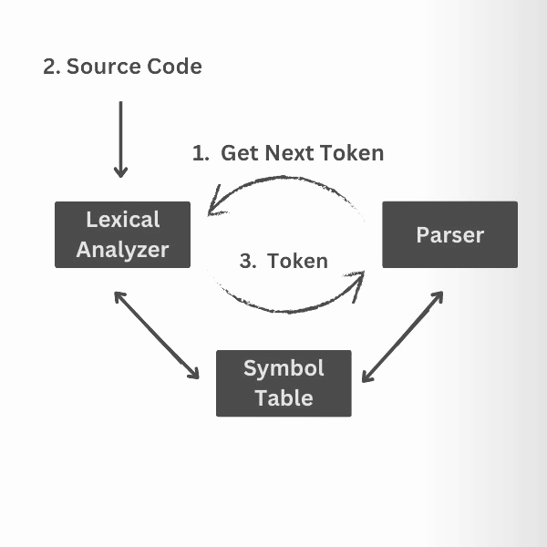

Lookahead Operator
An additional character is read by Lex to differentiate between other patterns of a token. This is done by Lex by reading an extra character ahead of the valid lexeme. However, sometimes, we want a particular pattern to be matched to the input only when certain other characters follow it. Then, we may use a slash in a pattern to indicate the end of the part of the pattern that matches the lexeme.

For example:
The Lookahead operator is the addition operator read by Lex to distinguish different patterns for a token. A lexical analyzer reads one character ahead of a valid lexeme and then retracts to produce a token.
In some languages, keywords are not reserved. So the statements IF (A, B) = 10 and IF(condition) THEN
Results in conflict about whether to produce IF as an array name or a keyword. To resolve this, the lex rule for the Keyword IF can be written as,
IF/\ (.* \) { letter }

Frequently Asked Questions

How to make a compiler with lex?
Creating a compiler with Lex involves a few key steps. First, we need to define regular expressions that describe the patterns of tokens in the source code. Then, we need to write a Lex specification file where you associate these regular expressions with corresponding actions.

What is the difference between C and lex?
C and Lex serve distinct roles. C is a versatile programming language used for various applications, offering a wide range of features. On the other hand, Lex is a specialized tool that generates code (often in C) for lexical analysis – the task of tokenizing source code.

Why do we need a lexical analyzer?
Lexical Analyzer is used to perform lexical analysis. The lexical analyzer also performs tasks like removing the white spaces and comments from the source code and is related to the source code's error messages.

What is a lexical error with an example?
A lexical error is a string of characters that doesn't follow any rules specified for the creation of tokens, and it cannot be categorized as a token. Examples of lexical errors include spelling mistakes, identifier or numerical constant length exceeding, etc.

PROGRAM
%{
#include <stdio.h> #include <string.h> #include <ctype.h> #include <stdlib.h>

#define MAX_WORDS 10000
#define MAX_LEN 100

struct Word {
char word[MAX_LEN]; int count;
};

struct Word words[MAX_WORDS]; int count = 0;

void toLower(char *s) { for (int i = 0; s[i]; i++)
s[i] = tolower(s[i]);
}

void insertWord(char *w) {
for (int i = 0; i < count; i++) {
if (strcmp(words[i].word, w) == 0) { words[i].count++;
return;
}
}
if (count < MAX_WORDS) { strcpy(words[count].word, w); words[count].count = 1; count++;
}
}

void bubbleSort() { struct Word temp; int i, j;

for (i = 0; i < count - 1; i++) {
for (j = 0; j < count - i - 1; j++) {
if (strcmp(words[j].word, words[j + 1].word) > 0) { temp = words[j];
words[j] = words[j + 1]; words[j + 1] = temp;
}
}

}
}

void printFreq() { bubbleSort();
for (int i = 0; i < count; i++) {
printf("%s : %d\n", words[i].word, words[i].count);
}
}
%}
%%
[a-zA-Z]+ {
toLower(yytext); insertWord(yytext);
}
.|\n ;
%%

int main(int argc, char **argv) { if (argc > 1) {
FILE *fp = fopen(argv[1], "r"); if (!fp) {
perror("Error opening file"); return 1;
}
yyin = fp;
}
yylex(); printFreq(); return 0;
}
int yywrap() { return 1; }

Contents of input.txt file
Hello, World!
This is a test. Hello again...
Numbers like 1234 or symbols #@! should be ignored. HELLO mixed with hello should still count as hello.
New-lines also
separate words.

OUTPUT
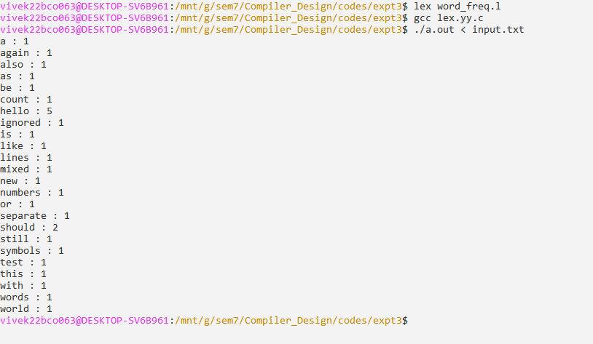

CONCLUSION: The Lex program for text analysis was successfully implemented to count the frequency of words in a text file. It recognized words, ignored case and punctuation, and produced alphabetically sorted word frequencies. This demonstrated the usefulness of Lex in text processing applications beyond compiler design.

