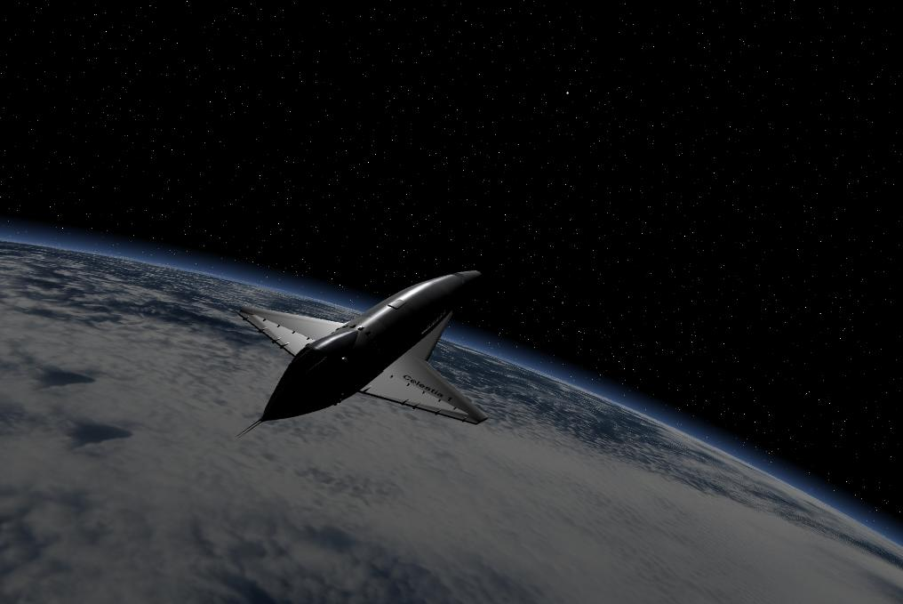

Figure 1 – the Earth and Milky Way from space – created using Celestia

Instructions
for Educators, Students and General Users

Rev. 16 – February 2012
Updated for use with Celestia version 161-ED
For Windows 98, XP, Vista and Windows 7 Users
© 2003, 2012, Frank Gregorio

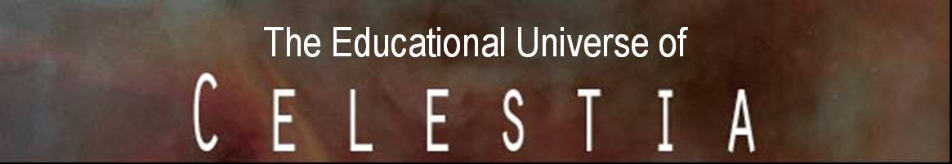

Table of Contents
Click any entry to go there

(A) Introduction 3
(B) List of Activities 6
(C) Where to Obtain Celestia and Celestia Educational Activities: 8
(D) What is provided: 9
(E) Computer Requirements: 10
(F) How to install the free version of Celestia Educational Activities on a home computer 11
(G) How to install our CD set or DVD on a home computer 11
(H) How to install Celestia Educational Activities on individual computers in a school or computer lab 12
(I) How to install Celestia Educational Activities on a central school server 12
(J) Adjustments for installation of Celestia161-ED on a school server 13
(K) How to uninstall Celestia 15
(L) Starting a Celestia161-ED journey 15
(M) Recommendations for using the Activities in a school computer lab 17
(N) Recommendations for using the Activities in a single classroom or Presentation 18
(O) Initial Adjustments of Celestia 18
(P) Adjustments to Celestia161-ED for slower computers: 18
(Q) Troubleshooting & Cautions (read carefully) 20
(R) Conclusion 20

(A) Introduction
Many people around the world understand vaguely that a “universe” exists in the night sky. What most do not understand is just how spectacular it really is. How many people know the true size of the universe? Most cannot even name the planets in order, let alone define a Black Hole or a Pulsar.
There are several reasons for this. Due to the light pollution of our skies, the Milky Way is no longer visible from most populated places on Earth. The sky has become … unimpressive. Astronomy is also not a common course in high school and is only briefly discussed in Earth Science. Space is also rather distant. We cannot simply summon a spaceship and orbit Neptune or follow a comet as it streaks toward the Sun. While we can see a video documentary or movie about space, the experience is purely as a spectator. That can hold our interest just so far.
Due in part to a lack of resources or convenience of use, most Educators have not used space simulation programs in their classroom or computer lab to teach students about Astronomy. Aside from textbooks and handouts, many teachers primarily present Power Point slides or videos about space, bring out a scale model or two, or guide their students to some Astronomy websites.
We are pleased to advise you that this limitation can now be overcome. Welcome to the World of Celestia. Celestia is a unique, real-time FREE space simulation program that lets you and your students interactively experience our universe in stunning three dimensions. Using detailed surfaces and textures and over 18 GB of customized add-on files developed by its many professional contributors, it is capable of taking you deep into space to produce a virtual world seen only in supercomputer simulations, Hollywood films and high-end computer games. Celestia is not a video program simply giving you some canned video clips to watch. Nor does Celestia confine you to the surface of the Earth to view the sky from one spot only, as many applications do.
Instead, Celestia is the only space simulation program in existence that places you (or your students) in the command seat of your own hyperdrive spacecraft. Its destination is yours to set. As you wish, you can personally travel throughout the Solar System and beyond into deep space, at any speed, in any direction you choose and at any time in history. If desired, you can visit stars or nebula circling the Milky Way or travel completely out of our galaxy and view it or thousands of other galaxies from intergalactic space. You can travel back in time to fly alongside famous spacecraft like Sputnik or Voyager and be with them as they make history. You can even travel five billion years into the future to witness the death of our Sun and of Earth.
Celestia is a very accurate program. It depicts the Solar System of planets, dwarf planets, moons, asteroids, comets and spacecraft in vivid detail, and can draw and track over 2 million stars in real time and proper position. It can also illustrate and put into motion rotating stars, planet atmospheres, planetshine on other objects, drifting clouds, moving surface shadows, reflections off oceans and ice, magnetic fields, constellations, eclipses, speeding comet tails, erupting solar flares and swirling nebula gas. Beyond our Milky Way, Celestia draws and plots over 10,000 separate galaxies and hundreds of Globular clusters.
Celestia was created and is provided open source, free of charge by Mr. Chris Laurel and the Celestia Development group, a collection of space enthusiasts and professionals who are willing to donate their talent to bring it to the rest of the world. Celestia is available at http://www.shatters.net/celestia. Celestia-161-ED is a customized version of Celestia containing additional features for education to include sound and overlay textures.
Celestia is a sophisticated program that can be daunting to learn and use, particularly in the classroom. Consequently, in 2004, work began on development of a set of educational lesson-plans that would facilitate the power of Celestia to be used at home by a lay user or to be employed in the classroom. Today, the Celestia Educational Activities series is complete and is updated yearly with the latest in astronomical facts and graphics. The Series represents 12 detailed tours of space to almost 400 destinations. They are ideal for users of all ages, for home or school computer lab use in grades 7 - 12 and in introductory college courses as a valuable tool in the visualization and understanding of Astronomy and of our Universe.
Celestia’s Educational Activities were created by Frank Gregorio, an award-winning high school Astronomy teacher who is part of the Celestia development forum. The Activities and required files are 2.5 GB in size and are available on a 2-CD/DVD set and DVD that can be purchased for a nominal fee for home or school use from the author’s website (see below). The Activities can also be downloaded individually as installation zip files at no charge from Celestia’s educational website.
These Activities employ hundreds of add-on files developed by Celestia’s professional volunteers to depict our universe in beautiful detail. With a little practice, you can personally modify or create your own Celestia add-ons. Tutorials to become an add-on designer exist on forum websites. Each Activity takes you on a different journey through the Celestia universe and includes a written student Worksheet to complete and submit for grading, plus detailed line-by-line instructions to students for how to control their spaceship and to travel to places of interest. Each Activity also provides a comprehensive written explanation of the astronomical wonders users/students will be seeing. In several cases, the written Activity can serve as a primary educational tool for teaching that topic.
All Activities meet applicable requirements of the National Educational Standards in Science and Math.
Here is just a sampling of what Celestia users and students will enjoy:

- Learn the unbelievable size and magnitude of our universe firsthand, with a journey from the surface of Earth to the far reaches of our observable universe … at hyperspeed.
- Watch solar flares and prominences rising off the Sun and measure its rotation using sunspots.
- Hover over each of the planets in our Solar System as they rotate slowly below you. See clouds drift by (where applicable) and shadows being cast on mountains and craters as the Sun sets low.
- Fly along with Mariner 10 on its historic flyby of Mercury.
- Observe the new Mercury Messenger spacecraft as it drops into Mercury orbit in 2011.
- Visit the searing surface of Venus and view it in a panoramic 360° vista from the surface.
- Take a spin down to the Earth’s surface in your own hyperdrive spacecraft. Skim over the oceans of Earth as you fly below the clouds. Soar back into space to see the lights come on in the cities of Earth.
- Be present as Apollo 11 lands on the Moon in 1969, or fly by Sputnik 1 in 1958 shortly after its launch.
- Rendezvous with the ISS or the Hubble Space Telescope. Attempt a docking at the ISS Shuttle port.
- Peer through the primary focus from inside the Hale Telescope on Palomar mountain.
- View Earth’s Magnetic Field from space and see the Aurora glowing and shimmering.
- Display an internal X-section of Earth and peer deeply into its tectonic layers and structure.
- Choose from over a dozen surface maps of Earth, depicting oceans, coastlines, volcanoes, earthquakes, impact sites, tectonic plates and boundaries, temperature ranges, vegetation maps and more
- Discover Mir as it passes over the Russian homeland with its cosmonaut crew onboard.
- See the massive size of Hurricane Katrina as it makes landfall on New Orleans.
- Hover over Mar’s Gusev crater and Meridiani Planum and drop down to visit Spirit and Opportunity, then fly over to Olympus Mons and Valles Marineris and fly through the canyon itself.
- Be there in the year 2029 when the asteroid Apophis will approach Earth on a possible collision course.
- Observe a spectacular lunar eclipse of our own Moon and a total solar eclipse on Earth.
- View our Asteroid Belt from high above, watching as its millions of members orbit the sun.
- Position yourself above Jupiter and watch as its large moons drift across the face of the planet, casting multiple eclipse shadows on its banded clouds and Great Red Spot.
- Examine the actively erupting volcanoes on Jupiter’s moon Io. Fly through a spewing volcanic plume.
- Hover far beyond Saturn, plunge through its rings, and count its 60 moons.
- Witness Cassini arrive in Saturn space in 2004 and drop the Huygens probe into the atmosphere of Titan in January 2005. Follow Huygens down toward a parachute landing on Titan’s surface.
- Journey to the frozen wasteland of Pluto and its three moons and see their icy coldness for yourself.
- Take up station behind comet Halley in 1986 as its gaseous lavender tail streams out behind it near Earth.
- Seek out Ceres, Eris, Makemake and Haumea, our Solar System’s newest “dwarf planets”.
- Fly out to the edges of our Solar System and follow Voyagers 1 and 2 as they head to distant stars.
- Witness the impact of the Deep Impact spacecraft onto the surface of comet Tempel1 in July 2005.
- Set your ship at faster-than-light speed and sail to Rigel Kentaurus A, located 4.3 light years away.
- View the red glow of sunlight on Gliese 581c, an earthlike world orbiting it’s small red dwarf star.
- Travel in time to 3000 CE to witness giant mirrors melt the Martian polar ice caps and help to terraform Mars into a verdant world of water, plants and cities of the future.
- Travel far into the future and rendezvous with a colossal rotating Space Station as it orbits Earth.
- Journey to the edges of a massive rotating Black Hole as it spins near its stellar companion. Witness another Black Hole swallowing its companion star.
- Travel to the heart of Betelgeuse, a distant Red Supergiant star that will Hypernova someday.
- See stellar creation from deep within the Rosette and Eagle Nebulas, giant stellar nurseries.
- Observe for yourself the deep field galaxies that were photographed by the Hubble Space Telescope.
- Hear the pulses of the new pulsar in the Crab Nebula, spinning before you at over 30 times a second.
- Witness the end of Earth, as it is swallowed by our swelling Red Giant sun billions of years from now.
- Jump at hyperspeed to the Andromeda spiral galaxy, M 87 located in the rich Virgo Cluster or the beautiful Whirlpool galaxy, or visit over ten thousand galaxies in filaments and super-clusters, accurately drawn.
- See the super-massive Black Hole at the center of our Milky Way
- Cruise next to Cosmos, a revolutionary new spacecraft that may someday “sail” on a wind of pure sunlight.
- Travel backward in time 4 billion years to witness the planet “Orpheus” catastrophically collide with Earth to actually form our Moon.
- Take a detailed scripted journey through the Zodiac and another through Conjunctions and Occultations.
- Learn what efforts are being taken to discover if extraterrestrial intelligence exists in the universe.
- Travel in tandem with the USS Enterprise commanded by Captain Picard as it battles the Borg Empire.
- Travel in the whimsical world of Hollywood and visit the StarWars® worlds of Tatooine, Endor and Hoth. Fly next to the Imperial Death Star or Star Destroyer as the Millennium Falcon swoops in for an attack. Experience a 1-hour scripted journey through the tableau of “2001, a Space Odyssey”.
- Fly directly through a theoretical wormhole on your way to a distant solar system.
- Visit Pandora, the fictional world made famous by the smash hit movie, “Avatar”
- Explore several fictional solar systems, complete with meticulously detailed, exotic alien civilizations, terraformed moons, futuristic space stations, space fleets, and interstellar spacecraft.
These are just a few of the exciting discoveries awaiting you.
Periodically as new Activities are added, this exciting list will grow.

(B) List of Activities
The World of Celestia – (requires about 90 minutes to complete) - Available on DVD Version only
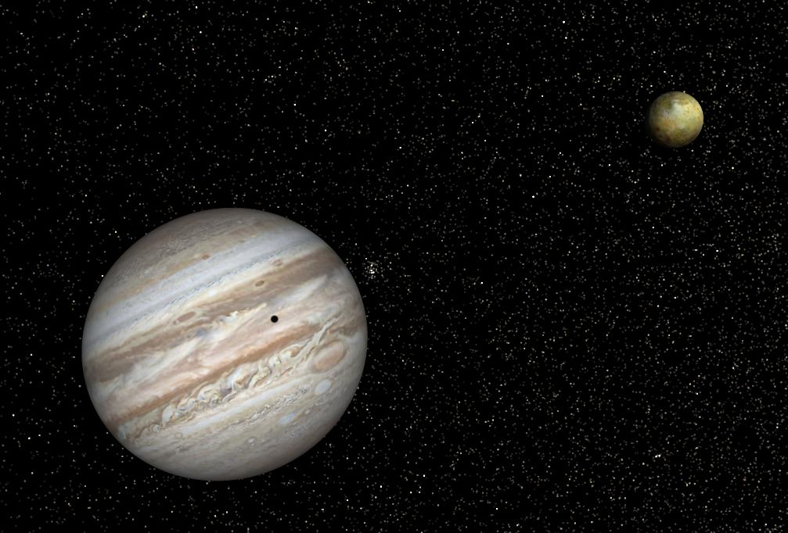
This is a spectacular introductory showcase journey through Celestia space. It begins on Earth. Under your command, launch a sleek hyperdrive spacecraft and climb above the clouds and atmosphere into orbit to fly by spacecraft. View Hurricane Katrina from orbit, then travel to our Moon, Mars, Jupiter, Saturn, Halley’s Comet and on to the stars. Stop by Rigel Kentaurus A and B and the Red Supergiant, Betelgeuse. Traverse the Rosette Nebula. See black holes, pulsars and theoretical wormholes Fly beyond the Milky Way into intergalactic space. Visit the Virgo Galaxy Cluster. Learn the true scale of the universe. Fly with some fictional Hollywood spacecraft. The tour makes 41 great stops in all.
Celestia Educational Activity 1 and 2, the Universe – (about 2 – 3 hours to complete)
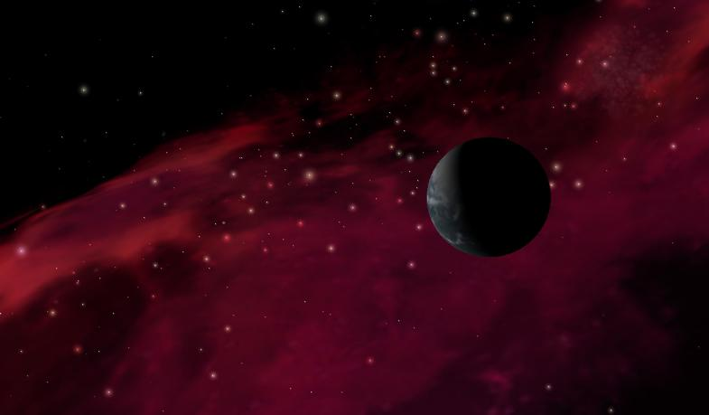
This is a detailed astronomical tour of the visible universe. Explore the concept of infinity. Originating on Earth, soar into space, stopping at some of our solar system’s planets, moons, asteroids, comets and spacecraft. Rendezvous with Voyager 2 as it leaves our Solar System. Swing by the Rosette Nebula and Ring Nebula, and then hover above and hear the rotating pulsar in the Crab nebula. Pass a dramatic Black Hole deep in space. See the 10,000 galaxies that the Hubble Space Telescope photographed. Learn the unbelievable size and scale of the universe.

Celestia Educational Activity 3 and 4, the Solar System General Tour – (4 - 5 hours to complete)
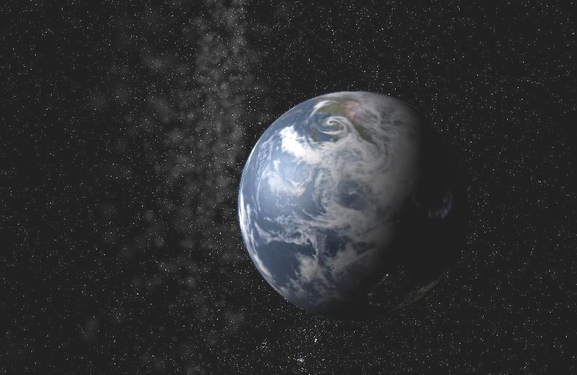
Study the Sun and measure its rotation. Observe Helios 1 on its solar flyby. Discover the brutal conditions on Mercury and Venus. Orbit Earth, and then fly down to the Kennedy Space Center. Visit the Hubble Space Telescope and ISS. Accompany Apollo 11 as it orbits the Moon in 1969. Orbit Mars and see the Spirit and Opportunity rovers on its surface. Fly over Olympus Mons and Valles Marineris. Chase several asteroids, then rocket over to Jupiter, Saturn, Uranus and Neptune. Fly through Saturn’s rings. Witness a triple eclipse of Jupiter’s moons and examine Europa up close. Fly through an erupting volcanic plume on Io. Pace the Cassini spacecraft. Discover Pluto and its moons. See Eris, our Solar System’s new dwarf planet and comet Halley. Enjoy a flyby of Voyager 2 as it passes Neptune and leaves the Solar System forever. Conclude with a fly of a lonely comet in the Oort Cloud as it silently orbits the sun.

Celestia Educational Activity 3E, the Solar System – Enhanced Tour – (2 - 3 hours to complete)
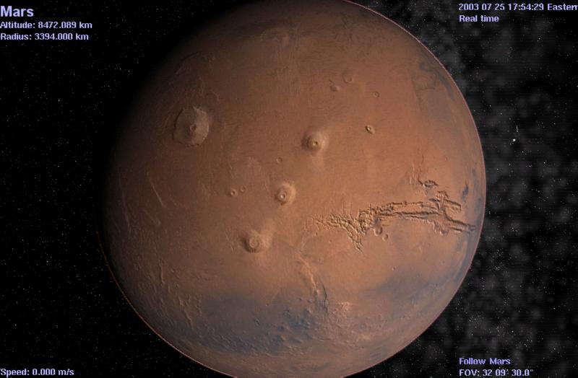
Is a tutorial on the Inner Solar System and can serve as a primary teaching tool on this topic. Observe the Sun’s solar flares, prominences and granules and measure its rotation. Chase Helios 1, then see Mercury during the Mariner 10 flyby. Watch Magellan map Venus. Drop a probe to the surface. Experience Earth from high orbit and witness its magnetic field and Aurora Borealis. Fly down to the Kennedy Space Center and the Florida Keys. Witness the size of Hurricane Katrina from orbit. Delve into Earth’s interior via a rotating cutaway. Visit the Hubble Space Telescope and ISS. Travel back in time and pace Apollo 11 as it orbits the Moon in 1969, and lands the LEM on its surface. Observe a dramatic lunar eclipse. Travel to Mars where the Mars Spirit and Opportunity await you. Orbit with Mars Global Surveyor and MRO, and observe a rare conjunction of nine solar system objects. Learn what a Mars colony might experience. Fly over Olympus Mons and the Valles Marineris canyon. See where the new Mars Phoenix has landed to look for the waters of life.

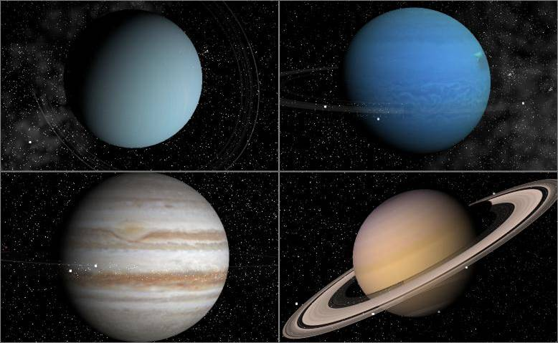
Celestia Educational Activity 4E - – (2 - 3 hours to complete)
is the extended companion journey that tours the outer Solar System and can serve as a primary teaching tool on this topic. See two Near Earth Object asteroids almost hit Earth. View Gaspra, and Ida and its moon Dactyl. Then move on to Jupiter, Saturn, Uranus and Neptune. See Galileo orbit Jupiter. Examine the four Galilean moons close up. Observe actual volcanic eruptions on Io. Witness a triple Jovian lunar eclipse. Fly through Saturn’s rings. Pace Cassini in 2004 and follow the Huygens probe to the surface of Titan. Visit Uranus and hover over Neptune then fly by Triton while accompanying Voyager 2 as it leaves our solar system forever. Discover Pluto and its three moons. Travel to Eris, Sedna and our new dwarf planet Makemake. Consider Comet Halley’s beautiful lavender tail close up. Journey to beyond the Kuiper Belt, to visit a dark lonely comet in the distant Oort Cloud.
Celestia Educational Activity 5, the Terraforming of Mars - (1 ½ hours to complete)
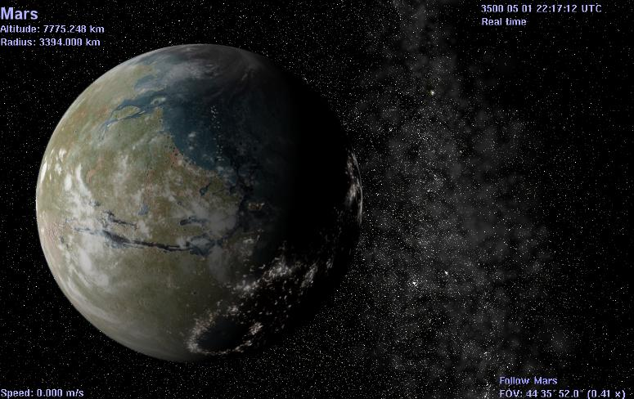
takes you into the 26th century to witness our attempt to transform Mars from a dead, cold, dry planet to a wet, warm and breathable world covered in seas and suitable for colonization. The Activity can serve as a primary teaching tool on this topic. Travel to Earth of the future, to visit a massive rotating space station in orbit. Then it’s on to Mars to view a battery of eight giant reflecting mirrors orbiting Mars, reflecting sunlight onto Mar’s polar caps. Over centuries, see Mars become a world of seas, life and new beginnings. View and hear a video made by future Martian colonists showcasing some of the scenes of their world.
Celestia Educational Activity 6, the Life and Death of Stars – (4 hours to complete)
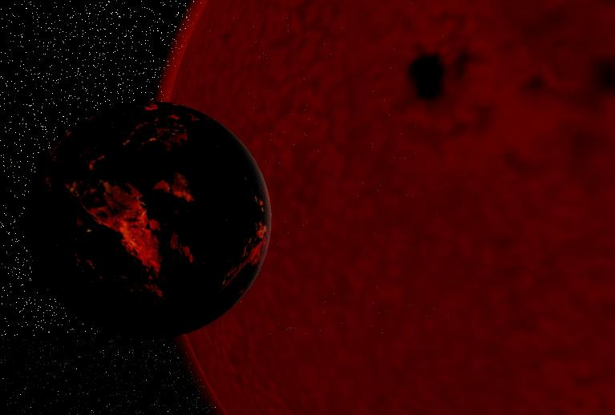
This Activity can serve as a primary teaching tool on this topic. The journey begins in our Solar System and travels through the galaxy, stopping at nebula, protostars, main sequence stars, brown and red dwarfs, yellow, white, red and blue Supergiant stars, planetary nebula, white dwarfs, black dwarfs, supernova, hypernova, neutron stars, whirling pulsars and spinning black holes. There are over 28 stops in all. Fly through star-forming nebula, skim across the surface of an exploding star, witness the death of Earth when our Sun swells to a Red Giant, hear a pulsar rotating 30 times a second. Orbit three rotating black holes and a spinning protostar. Fly through a Black Hole! Travel deep into the Rosette and Eagle Nebulas.
Celestia Educational Activity 7 – the Spacecraft of Celestia Part 1 – (2 - 3 hours to complete)
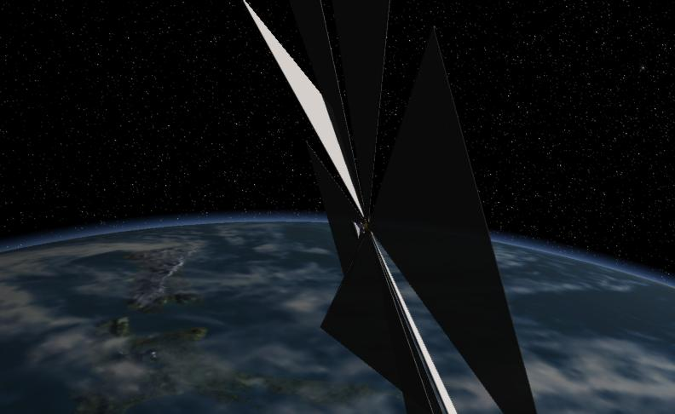
Guides you on a visit to some of the spacecraft built by humans to explore Earth orbit and can serve as a primary teaching tool on this topic. Pace Sputnik 1 in 1957 and listen to its actual signal. Hover next to Explorer 1, and the Mercury and Gemini capsules. Examine Skylab and Mir, then it’s on to the U.S. Space Shuttles, the International Space Station, the powerful Hubble Space Telescope, Corot, Spitzer, Chandra and Planck space telescopes. See China’s manned Shenzhou V, VI and VII. Visit the Apollo 11 spacecraft for its monumental trip to a landing on the moon. See the threat that space junk can pose to spacecraft. Fly near Cosmos 1, the first spacecraft designed to sail the night on sunbeams.
Celestia Educational Activity 8 – the Spacecraft of Celestia Part 2 - (2 – 3 hours to complete)
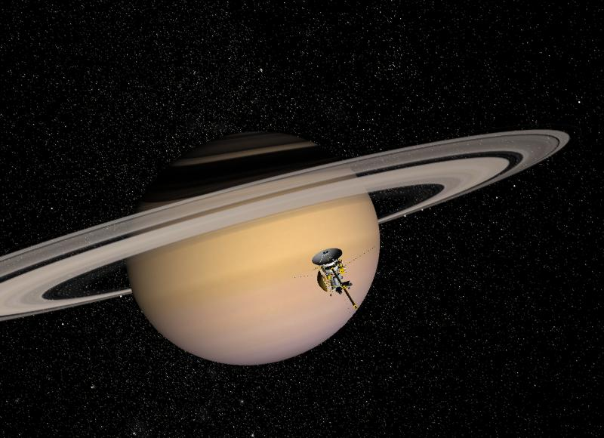
The Activity can serve as a primary teaching tool on this topic. See Mariner approaching Mercury and the Venera probes drop onto Venus. Watch the Venus Express brake around Venus. Fly with Magellan mapping the surface. Visit Viking on Mars and follow the Mars Odyssey, MGS and MRO from orbit. Consider Spirit and Opportunity and the new Phoenix mission as they search for evidence of water. Fly with Pioneer and the Voyagers past the outer planets. Witness Galileo orbiting Jupiter and the Cassini probe enter Saturn orbit. Follow Huygens down through the Titan’s atmosphere for a soft landing. See NEAR land on Eros. Chase New Horizons on its way to Pluto. Fly next to Ulysses. Observe Deep Impact hit comet Tempel1. Then, travel into the fictional future of Hollywood to stop at Deep Space 9 and Valley Forge around Saturn. Try docking with a massive Space Station orbiting Earth. Locate Discovery and its pod and the massive monolith, adrift in Jupiter space as you listen to Also Sprach Zarathustra. End your trip by exploring the Cygnus orbiting a distant Black Hole.
Celestia Educational Activity 9 – the Primitive Earth and Moon – (2 hours to complete)
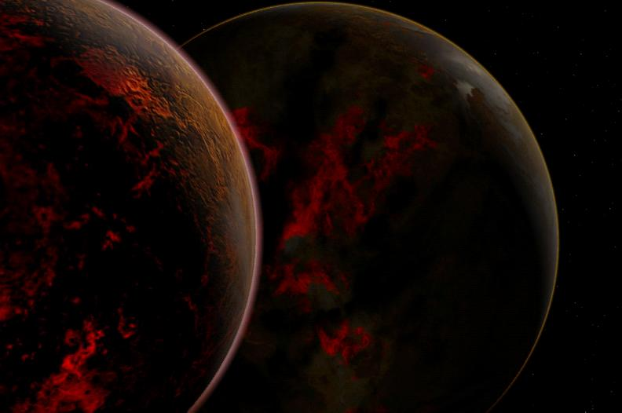
Can serve as a primary teaching tool on this topic. Journey back four billion years to a time when Earth had no moon and was a big volcanic ball of hot rock and primitive ocean. Witness the collision of Earth with another planet called Orpheus, breaking both worlds into pieces that splatter into orbit forming a huge ring of hot rubble. Fly through the ring and over time, watch as gravity reshapes that debris into a new Earth … and our Moon.
Celestia Educational Activity 10 – The Search for Extraterrestrial Intelligence - (2 - 3 hours to complete)
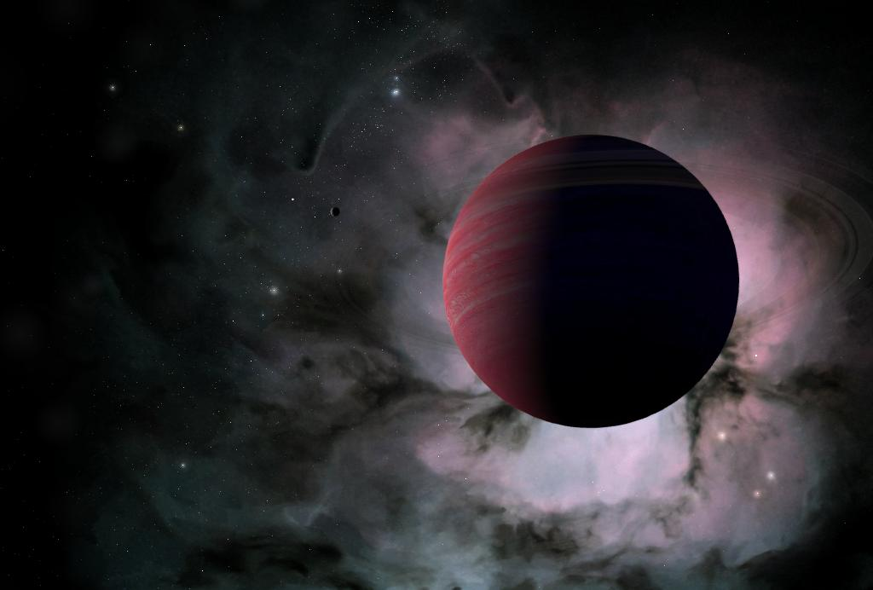
Explores the world of SETI. Consider infinity and the number of stars that could be home to life and intelligence. Contemplate what life on other worlds might be like, and what planets or moons they might live on. Solve the Drake Equation. Travel next to a radio message at the speed of light. View the messages on the Pioneer and Voyager probes. Then, visit some of Hollywood’s famous interstellar craft as they meet alien races. Witness the USS Enterprise battle the Borg Cube and visit the Borg home world. Help Luke Skywalker and R2D2 in their X-Wing fighter battle the Imperial Death Star and Star Destroyer protected by tie fighters in orbit around Tatooine. Follow Han Solo and Chewee in the Millennium Falcon. Finally, journey to the fictional civilization of Ran, a beautiful fantasy Solar System filled with striking alien planets and moons with advanced civilizations, mining colonies and starships capable of interstellar travel.

Under development:
Celestia Educational Activity 11 – The Impact that shook the world
We will take you back in time 65 million years to watch a fateful asteroid smash into Earth. The resulting changes to our planet may have wiped out 70% of all life on Earth including the dinosaurs, and opened the planet to colonization by our distant mammalian ancestors. It truly was an Extinction Level Event!!

Celestia Educational Activity 12 – Origins
Planning has begun for a new educational activity that will use the power of Celestia to depict the very origin of our universe. The time … 13.7 billion years ago … the event … the BIG BANG! What a story there is to tell!
Watch our educational websites for announcements regarding the completion of these new and exciting Activities.

(C) Where to Obtain Celestia and Celestia Educational Activities:
Celestia has been under development since 2001 and has been released in numerous versions, each more sophisticated than those before. As of February 2012, the latest released version of the program is Celestia 161. It is available at no charge at http://www.shatters.net/celestia.
NOTE: The older version of Celestia (Celestia 1.6.0 or Celestia 160-ED), will NOT function with these Activities. If you have older versionss on your computer, installation of these Activities will install the new Celestia161-ED version in a separate folder titled Celestia161-ED. It will not disturb your older files. However, we recommend you uninstall any older versions, since they take up a lot of RAM memory.
Celestia-161-ED is a special version of Celestia designed for use in education. It incorporates sound and overlay textures and must be used with these Activities. For your convenience, the complete Celestia Educational Activities series and all of its add-ons are available from the author in a very convenient self-installing 2-CD set or single DVD. No downloading, unzipping or manual installation is required. You can purchase the CD/DVD set from the author’s website for a nominal fee at http://gregs-educational.info/ or via email at fsgregs@comcast.net
If you plan to use Celestia-161-ED and the educational activities series in the classroom, please purchase the school license for a very modest fee. See website for details.
Celestia Educational Activities are also available at no charge by downloading, unzipping and installing a large set (2.8 GB) of zipped files from the main Celestia educational website located at http://www.celestiamotherlode.net/catalog/educational.php. Details on installation can be found in section F below.
The primary Celestia add-on website is located at http://www.celestiamotherlode.net/. It contains links to several resources to learn how to operate Celestia, plus add-on development and script writing. Another good tutorial site is located at http://www.lns.cornell.edu/~seb/celestia/.
The Celestia forum & chat room is located at http://shatters.net/forum/index.php

(D) What is provided:
Celestia Educational Activities consist of the following:
- The basic Celestia program, which must be installed in advance on each student, home or teaching computer that will be taking a Celestia journey, or on a school server that is accessed by students. NOTE: A special customized version of this program MUST be used (Celestia161-ED). It is included with and auto-installs from our CD/DVD or it can be downloaded for free and manually installed from our educational website.
- An extensive set of additional files and folders called “Add-ons”, which contain hundreds of command files, graphics, video and sound files used by our Activities. These additional files will be installed automatically on your computer when using our CD/DVD set, but must be installed in the proper place manually when installing our free downloaded Activities (see later topic).
- 12 written Flight Plan Activity documents provided as on-screen text documents. The Activities were developed using Microsoft MS Word® (MS Word 2002® or later is required). If you do not have MS Word, we suggest you download and install a free program called “OpenOffice”. It is available from the website http://openoffice.org, and includes a good text editor that is fully functional with our Activities.
- A comprehensive Activity Worksheet for each Activity, which can be optionally printed, handed out to students and completed for a grade.
- All Flight Plan documents and worksheets are saved as Read-Only documents to protect them from being inadvertently overwritten. If you with to edit one of the documents, save it under a new name.
Using MS Word or OpenOffice, the student or user will open each Activity on screen, read each Activity document at his/her own speed and will simultaneously launch and run the Celestia161-ED program. Each Activity provides extensive background discussion and facts on space science, interlaced with exact step-by-step instructions for how to take the Celestia161-ED journey through space. Opportunities to optionally link to specific Astronomy websites are also provided (if internet connected).
No prior knowledge of Celestia is required to enjoy a Celestia Educational Activity.
Celestia Educational Flight Plans are not designed to be printed and read from a paper handout. That is because they contain special embedded “links” that control the Celestia program and help users or students guide their ship to fascinating space locations. These links cannot be clicked if the Activity is being read from paper. However, the optional Worksheet can be printed and distributed to students and completed with pen for submission to the teacher.
The Activities are designed for use by a teacher in a classroom, within a school’s computer lab or by users at home. Each Activity will typically take 1 – 4 hours to accomplish but can be divided into shorter segments, if desired. The Activities can also be used at college level as an excellent visualization tool. If enough computers are available, we recommend that each student do an Activity on their own or as part of a 2-person “team”. Students can also perform the Activities on their home computer by downloading them and the Celestia program to their computer at home or by obtaining the CD/DVD set (see links later in this document).
We strongly urge that if you are a teacher/educator, you first become well familiar with each of these Activities and with the Celestia161-ED program as a whole before you introduce it in your classroom or computer lab. There will be many questions from younger students about how to operate this control, or how to go “there”, which good teacher experience can help to answer. In addition to detailed step-by-step instructions in each Activity, we offer a comprehensive Celestia 161 Users Guide, which will teach you every control and feature in Celestia. A copy of the Guide is available on our CD/DVD or can be downloaded as part of the Educational base package zip file on our website.
Because Celestia is a space program traveling through the darkness of the cosmos, it is best enjoyed with the room lights dimmed or even turned off, if possible. We also strongly recommend that you play some quiet, ethereal, instrumental “space music” in the background, as discussed later.

(E) Computer Requirements:
Celestia161-ED runs on many computers but it is a higher-end software program that loads high-resolution textures and graphics. It will not perform satisfactorily on all computers. In general, to experience Celestia161-ED properly, your home or school computers should have the following desired capabilities:
- A CPU speed of at least 1 GHz
- An operating system running Windows® 98, XP, Vista or 7
- A RAM memory of at least 1 GB
- An Open GL video graphics card with at least 128 MB of video RAM (256 – 512 MB preferred)
- Free memory on your hard drive of at least 3 Gigabytes (total if all Activities are installed)
- A 14” or bigger color monitor, or LCD/DVD Projector and screen
- Computer sound speakers (optional), preferably with some bass sound
- Mouse and keyboard
- Microsoft® Word 2002, 2003, 2007 or 2010, or OpenOffice 3.1 or later
- Apple QuickTime® (available free from http://www.apple.com/quicktime/download/ )
- Internet connection (optional)
You may or may not know what your home computer or computer lab’s specifications are. Many school computers for example, have built-in graphics display cards rather than separate video cards. In that case, simply install Celestia161-ED. Then, open any Activity of your choice and follow its instructions. If things look good, then your computer is adequate. If the program is running slowly, is jerky or freezes completely, you may be able to make some adjustments to reduce its demands on your system (discussed below). If the adjustments do not fix the problem, your computer(s) are regretfully not of sufficient capability to run these Activities. The Activities can be uninstalled or inactivated (see uninstall paragraph below).

(F) How to install the free version of Celestia Educational Activities
on a home computer
- Celestia Educational Activities require the use of a customized version of Celestia 161-ED. Step 1 is to download the basic program file (Celestia 161-ED-WIN.zip) to your desktop or to any convenient folder from http://www.celestiamotherlode.net/catalog/educational.php. It is a zipped file, “compressed” to save space. In order to use it, it must first be unzipped. Windows XP, Vista and 7 come with an unzipping utility. Windows 98 does not. However, you can download a free unzipping utility from the internet.
Once downloaded, double-click on the file name with your left mouse button. It will begin the unzipping process, and will place its contents in a new folder typically located in the same place you stored the zipped file. Open that folder and double-click on the file inside named Celestia 161-ED-WIN.exe. It will launch the installation. Click “yes” or “accept” or “OK” in all cases when prompted.
By default, these activities will be installed into the C:|\Program Files\Celestia161-ED directory, or into C:\Program Files (x86)\Celestia161-ED if you are running Windows 7. However, you may install the Activities into any drive or directory you wish.
- Download the “Educational Base Package” zip file from our education website and store it on your desktop. Do not install/launch it yet.
- Next, download one or more Celestia Educational Activity(s) of your choice and store the zip file(s) on your desktop, or in any convenient memory location. Do not launch/install them yet.
- Double-click on the “Educational Base Package” zip file and it will begin the unzipping process. A menu will appear, asking you where you want the files unzipped to. Select the same menu path that you placed the parent program. Typically, this is C:\Program Files\Celestia161-ED or C:\Program Files (x86)\Celestia161-ED (for Windows 7 users). Then click “unzip”. All files must be unzipped directly into your Celestia161-ED main directory in the appropriate folders. If prompted, allow overwrites. A set of detailed high-resolution files will be added to your Celestia161-ED directory for use by the program.
- Next, unzip and install the first Celestia Educational Activity zip file. Unzip it into the same Celestia161-ED directory that you placed the main program. You can install one or all Activities during this initial setup phase, so that they are all available and ready to enjoy.
- Proceed to section L below.

(G) How to install our CD set or DVD on a home computer
- Make sure the computer has MS Word 2002 or later, or OpenOffice 3.1 or later installed on it. If not, either install MS Word (highly preferred), or go here and download the free OpenOffice program. Install it.
Insert CD disk # 1 or the DVD into the CD/DVD drive. It will auto-start and begin the install process. Say “yes” to any questions and check all boxes. It will ask you for the destination folder or drive that you wish to install the program and its activities. By default, these activities will be installed into the C:|\Program Files\Celestia161-ED directory, or into C:\Program Files (x86)\Celestia161-ED if you are running Windows 7. However, you may install the Activities into any drive or directory you wish.
- When prompted, insert CD # 2, wait for it to continue installation, then click OK and close the menu.
- A menu will appear asking if you wish to launch Celestia161-ED. Choose “No” for the moment.
- Please proceed to section L below.
(H) How to install Celestia Educational Activities on individual computers in a school or computer lab
Celestia Educational Activities are available for use on one or more multiple computers in a school classroom, computer lab or on a school server accessible from lab computers by purchasing our CD/DVD with a school license for a nominal fee from our website at http://gregs-educational.info/ or via email at fsgregs@comcast.net

Per our license agreement (see EULA), copying all free downloaded Educational Activities to CD/DVD’s and installing them on school computers is respectfully not allowed.

A teacher has the choice to install the Activities repeatedly from the CD/DVD onto individual school computers in a classroom or computer lab, or to install the Activities once only on a school server that other computers can access. The most trouble-free approach is individual installation. That is because some school servers are overloaded and loading Celestia from one server onto 30 separate computers can cause significant slowdowns. If you choose to load onto one central school server, there are some important additional setup steps needed if you choose that route. You will also need to confer with your school’s IT professional. If you choose server installation, skip this section and go to section I below.
To install on individual school computers, follow these steps for a trouble-free installation:
- Make sure the computer has MS Word 2002 or later, or OpenOffice 3.1 or later installed on it. If not, either install MS Word (highly preferred), or go here and download the free OpenOffice program. Install it.
Feel free to copy the CD set or DVD for installation use in a school lab. For example, you may wish to make 4 or 5 copies of the CD/DVD so that you can install the program on 5 lab computers at once. Insert CD disk # 1 or the DVD into the CD/DVD drive. It will auto-start and begin the install process. Say “yes” to any questions and check all boxes. It will ask you for the destination folder or drive that you wish to install the program and its activities. By default, these activities will be installed into the C:|\Program Files\Celestia161-ED directory, or into C:\Program Files (x86)\Celestia161-ED if you are running Windows 7. However, you may install the Activities into any drive or directory you wish.
- When prompted, insert CD # 2, wait for it to continue installation, then click OK and close the menu.
- A menu will appear asking if you wish to launch Celestia161-ED. Choose “No” for the moment.
- Please proceed to section L below.

(I) How to install Celestia Educational Activities
on a central school server
Most schools have central school servers that other computers in the school can access. If so, it can be convenient to install Celestia Educational Activities onto that server just once. It saves time, and if you ever have to edit any of the files in the Activities, you need only to edit them once on the server.

However, the server is not going to be located on a C: drive. It most likely will have a different location on the network. Installing the activities onto that server may cause some of the pathways (called “relative links”) that the program uses to locate files, to be different than what it expects. As a result, following initial installation, you may have to manually edit a few of the files in Celestia Educational Activities, to point the program to the location of the server. Your IT professional can assist you. Details of how to make these adjustments are in section J below.

A second concern is one of student access. To launch Celestia Educational Activities from a student computer in a computer lab or from a teaching computer in a classroom, that computer MUST be able to “see” the server, and to access the Celestia161-ED program application on it. This may not be allowed until your IT professional sets “permissions”. For example, students rarely are given access to a school server storing programs. Instead, they may have access to a “Student” partition on that server or another server. Links with permission to open the Educational Activities and launch the Celestia.exe program MUST be placed in the Student partition, if you want a student to be able to open, read and launch the Activities through a server. Consult your IT professional for help.

A 3rd issue to consider is speed. School servers are fast, but Celestia loads a variety of high-resolution files during its operation. If 30 computers are all linked to the server running Celestia161-ED and are all trying to call it at once, the speed with which the application loads or runs may be too slow to be practical. This possibility should be tested in advance.
To install the Activities on a central school server:
- Identify the server to use. Consult your IT professional for help.
- Insert CD disk # 1 or the DVD into the CD/DVD drive. It will auto-start and begin the install process. Say “yes” to any questions and check all boxes. It will ask you for the destination folder or drive. Type the path to the server. For example, if your school’s server stores programs on the J:\APPS drive path, the installation path might be J:\APPS\Celestia161-ED.
- When prompted, insert CD # 2, wait for it to continue installation, then click OK and close the menu.
- A menu will appear asking if you wish to launch Celestia161-ED. Choose “No” for the moment.
- The Activities and parent program will have been installed in a folder named “Celestia161-ED”. Look in that folder on that drive if you ever need to find or edit files.
- VERY IMPORTANT! Consult section { J } below and follow its instructions. Your IT professional may have to adjust some files within the Celestia161-ED folder.
- Celestia161-ED contains a sub-folder named “Educational Activities”. In it are all of the Activity Flight Plan documents that students will have to open and access. A Windows shortcut to that sub-folder MUST be placed on each student computer in the school that will be accessing Celestia161-ED Activities. Alternatively, the shortcut to that folder can be placed in a “Student” partition on a server that all computers in the school can see/access. Students must be able to access and launch these Activities from any school computer lab.

(J) Adjustments for installation of Celestia161-ED on a school server
Celestia161-ED is typically installed into the Windows default directory named C:\Program Files, or into the default directory of C:\Program Files (x86) for Windows 7 users. If a school chooses to install our program onto a network server such as F:\Apps, or J:\Programs, etc., there is a possibility that some of the files needed to launch the program may not be immediately locatable. For example, our Activities are MS Word documents that contain relative “hyperlinks”, i.e., places in the document that you click on to launch Celestia161-ED. Those links are designed to locate a specific file called a “vbs” file, which is in a sub-folder in the Celestia161-ED directory called the “Activity_cels” sub-folder. Usually, those relative hyperlinks have no trouble finding the vbs files. However, if the server is on a remote computer network, the document’s hyperlinks may lose their way, and need to be reset.

To determine if you need to make these simple adjustments, please do the following:
- Locate the Celestia161-ED root folder/directory/path that you’ve installed the program into. Open the folder and inside, you will find a sub-folder titled “Educational-Activities”. [Right-click] on it and create a Windows shortcut to it. Drag/place that shortcut into a location that any school computer on the network can access (typically a “student partition”). Students across the school or network MUST be able to access and open the documents inside the Educational-Activities sub-folder. Your IT professional must set permissions to allow that access.
- Open any Activity document in the Educational-Activities sub-folder. Navigate inside the document to page 3, 4 or 5, and look for a paragraph that launches Celestia161-ED as shown below. For example, that text looks like this:

To begin our journey, left-click HERE just once,
and wait for Celestia to open.

- Embedded in the word “HERE” is a hyperlink to a set of special “vbs” files, located inside a sub-folder in Celestia161-ED named the Activity_cels sub-folder. Clicking once on this embedded hyperlink in the MS Word document is supposed to activate the appropriate vbs file, which in turn, will launch Celestia161-ED. These links are designed to be “relative”, that is, they are supposed to change on their own and point to the Activity_cels sub-folder, no matter where it has been installed, on any server or drive. However, that may not always be the case.
- If you open an Activity document, click on the “HERE” hyperlink and you get an error message, the hyperlink has simply lost its way.
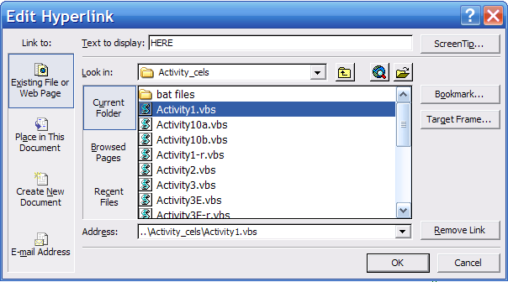
- To correct it, [right-click] on the word, “HERE” in the above paragraph, choose “edit hyperlink”, and in the menu field, relocate the proper link to the corresponding vbs file in the Activity_cels folder. For Activity 1, the menu would look like this.
- Click OK, then click once on the link. It should now launch Celestia-161-ED.
- Repeat for all remaining Activities. Please note that in all Activities, there is a 2nd location where hyperlinks may have to be reset. In a paragraph with red text located below each of the original HERE hyperlinks, there is a 2nd HERE link. It points to a different vbs file and looks like this:
If you ever have to interrupt Part 1 of your Celestia journey by closing the program, you MUST return to this page and click HERE once to reopen the program.
- In two of the Activities (Activity 1, and Activity 10), there is a “Part 2” to each journey. Part 2 of Activity 2 is located on/about page 16. Part 2 of Activity 10 is also located on/about pg 16. These links may also have to be reset to their appropriate vbs file (e.g.- Activity2.vbs, and Activity10b.vbs).
- Lastly, there are occasional links embedded in the Activity documents that launch media files or script files located within the “multimedia” and “scripts” folders inside the Celestia161-ED root directory. If these links lose their way, reset them by locating their targets via an edit to the hyperlink menu.

(K) How to uninstall Celestia
To uninstall Celestia-161-ED, navigate to the Windows Control Panel, Add/Remove Programs and choose Celestia Educational Activities, volume 1. Click “remove”.

(L) Starting a Celestia161-ED journey
- A Celestia161-ED journey begins by opening one of the 12 MS Word Flight Plan Activity documents. To access those documents, look for a Windows shortcut on your desktop called “Educational-Activities”. It will be placed there automatically during installation. Clicking the shortcut will open the Educational-Activities sub-folder, containing each of the Activity journeys in the series. Double-click one of them, turn down the room lights, and begin a stunningly visual educational experience into the world of Astronomy. Detailed, step-by-step instructions to take the journey and to launch the program will be found inside the Activity document.
- The actual Flight Plans and the worksheets accompanying them are located in the main Celestia161-ED directory in a folder named, “Educational-Activities”. The folder “tree” will look like this (C: drive is used as an example):
C:\Program Files/ ( or C:\Program Files (x86) for Windows 7 systems)
Celestia161-ED\ (main directory folder)
Celestia161-ED.exe (the customized version of Celestia using during the activities)
+ lots of other loose files
Educational-Activities (folder)
Activity_1&2-161–The_Universe (file), Activity 1&2 Worksheet (file)
Activity_3-161-Solar_System (file), Activity 3 Worksheet (file)
Activity_4-161-Solar_System (file), Activity 4 Worksheet (file)
Etc.
educational-extras (folder) (contains all of the folders and files needed by the Activities)
Activity_Cels (folder) (contains special vbs files to launch each Activity)
other program folders (such as sounds, scripts, multimedia, models, textures, data, etc.)
- If you are using this journey in a school, open the “Educational-Activities” folder and you will find worksheets to accompany each Activity. Print the worksheet in advance that pertains to the Activity journey you or your students would like to take. Make enough paper copies of this document for each student to fill out as study guides and/or submit to you for grading. To make it easier, I always grade the worksheets in class with all students when complete, then enter the grades.
- Once a Flight Plan is opened, follow all instructions and read the introduction. Eventually, you will reach page 3, 4 or 5 of that document where you will find a paragraph that tells you to “click HERE to launch your journey”. Point at the link and your cursor should change to a hand. When it does, left-click once on that link, and it should launch the Celestia161-ED program and all of the add-on files applicable to that particular journey (it may take a few moments). Make sure you click the link only ONCE.
- If you point at the link and your cursor does not change to a hand, hold down the [Ctrl] key, then try left-clicking on the link. It should open Celestia161-ED.
- If you had to use the Ctrl key, it will be cumbersome for students to have to do that throughout the Activities. Fortunately, MS Word gives you an option to eliminate the need for the Ctrl key. Open the “Tools” menu at the top of MS Word, select the “Options” menu, then select the “Edit” menu. One of the choices will be a box labeled “Use CTRL+click to follow hyperlink”. Uncheck that box and close the menus. From then on, you will not need to use Ctrl.
- In OpenOffice 3.0 or later, you can disable the CTRL+ click by opening the Tools/Options/Security/Options menu, and unchecking the box that says, “CTRL+click required to open hyperlinks”.
- On some computers, clicking on an Activity hyperlink to open Celestia161-ED simply does nothing. This is an occasional bug in MS Word. To circumvent the problem, open the Celestia161-ED folder and find a sub-folder named “Activity_cels”, containing “vbs” files for all 12 Activities. Open that folder and click on the appropriate activity vbs file. Celestia161-ED will now launch properly. You can then return to the written document and continue your journey.
- Microsoft Office 2007 has an annoying security feature. Whenever a cel:url in a Flight Plan is clicked, the user will first get a warning message telling him that the hyperlink is not a legitimate internet link, and asking if the user wants to execute it. Simply click “OK’ and Celestia will go to the correct spot. The warning message is annoying, but there is not way to turn it off.
- The Celestia161-ED program includes sound effects controlled by the program itself. To activate sounds, there will be a “click here” link inside each Activity document. Look for it and click once on it when prompted. To hear a sound, each computer’s speakers must be on, set to a reasonable volume and not muted. Should you wish to mute sound during an activity, simply mute the speakers or at any time, press the [0] key at the top of the keyboard.
- Please note that many students will feel “funny” using the sound effects in Celestia (it calls attention to them). That is OK. They can choose not to listen to sound, or you can encourage them to do so.
- When done the trip, close the document and Celestia161-ED.
- Important Note: None of our Activity journeys will be active if you launch the Celestia program by simply clicking on its main icon in the Celestia161-ED folder or on your desktop. That is because the educational add-ons are accessible only by clicking certain links inside an Activity document.
- If you wish to use our add-ons in Celestia without having to launch an Activity document first, you can do so by opening the folder titled, “Activity_cels”. Click one of those files and the program will launch a particular Activity with all of its add-ons without having to open an Activity Flight Plan document.
- If your students close a Celestia journey before finishing it (e.g. – the bell rings), they MUST return to the “Important Notes” section within the Introduction chapter (or at the start of Part 2 within an Activity), and click both hyperlinks in the flashing paragraph first, before resuming their journey. See section P below!!!
- If you wish to add some new add-ons to our educational collection, simply paste the new add-on folder into the extras folder. For example, some folks have downloaded fictional worlds or spacecraft that are not included with our Activities. However, they are available elsewhere on other Celestia websites. If you have downloaded them and wish to enjoy them in Celestia161-ED with one of our Activities running, a copy of them must be present in the extras folder. However, make sure we do not already have that add-on operating. If we do and you load a second copy of it, Celestia will load two of the same object in the same place. The object will flicker on the screen, and the program may lock up.

(M) Recommendations for using the Activities in a school computer lab
The Educational Flight Plans must be read line by line. Written for a 7th – 12th grade and introductory college course reading level, they contain lesson material and step-by-step instructions. Each Flight Plan also has “hyperlinks” (called cel: //urls) that when clicked, take your students to different places in Celestia, and/or open a variety of optional webpages and animated movies. As such, it is not practical to print these Activities on paper (the links won’t work).
While reading a Flight Plan, a student will simultaneously launch Celestia161-ED and access it repeatedly to complete the Activity. There is also a Worksheet which students can fill out manually as the activity progresses. This sounds complicated to handle but it is not, if done systematically.
- You will find the Activity Worksheet for each Activity in the “Educational-Activities” folder. Give a copy to each student or a team of two students to complete in pen and ink.
- Then, show each student(s) how to open both the written Flight Plan and the Celestia161-ED program on the same computer by opening the document and when the time comes, clicking the hyperlink inside the document that launches the program.
- Tell them to begin reading and FOLLOW EVERY INSTRUCTION TO THE LETTER!
- To switch from Activity Flight Plan to Celestia161-ED and back again, simply [left-click] on the icons on the Taskbar at the bottom of the video window, or press the [Alt] and [Tab] keys together at the same time. This “toggles” between views and is the method I recommend. You can also open a website and access its icon on the Taskbar, switching between all three windows as needed. It takes a bit of practice and will require you to show your students how to do it, but once learned, it functions smoothly and allows your students complete freedom to read the Activity, explore Celestia and/or visit a website. It also permits your computer lab to have reasonably darkened lights, which offers a much richer Celestia journey.
- Although connection to the Internet is useful to enjoy a few of the links built into the Activities, it is not mandatory. Going out to the internet takes significant time and can add an hour or more to an Activity.
- As a working high school teacher, I have found an ideal way to keep kids from talking to each other during a Celestia journey. I stream into the computer lab some beautiful instrumental background music. The website I prefer is www.live365.com. It contains over 1,500 FREE music stations. The perfect music for Celestia is in the category named “New Age/Ambient”. Over 100 such stations are available. The music is spectacularly peaceful, spacy and ethereal, and will keep your students really engaged in their journey. It gives them the feeling that they are watching a space movie, or are sitting in a planetarium. They automatically stop talking.
- Three stations in particular that I like are called “ferngerms sleeps” (really), “nspace” and “moving through space”. Search for them in the radio station’s search field. For around $6.00/month, the music can be obtained commercial-free (highly recommended). You may need to have your IT staff unblock the web address of this site, since it is a radio station and some school IT depts. automatically block such sites unless you ask them not to.
- Alternatively, you can play classical music or any new age music you wish. A good set of speakers on your teaching computer in the computer lab is all you need … and you’re all set.
- I cannot stress this tool enough. Playing this music has DRAMATICALLY improved the experience of my students, and kept them quiet.
- Once the kids are reading the Activity Flight Plan, using Celestia161-ED and completing the worksheet, your job as a teacher is simply to keep order, answer questions and tell them when to quit before the bell. Make sure they close Celestia161-ED and the Activity document before they leave the computer lab.
- Be sure to read the section below titled “Cautions”. Some of them apply to computer lab use!

(N) Recommendations for using the Activities
in a single classroom or Presentation
Celestia educational Activities can be used by a teacher in a classroom or in front of a professional audience, as a great way to take your students or audience members into space from the comfort of their seats. By connecting your teaching/professional computer to an LCD Projector and dimming the lights, your audience can go deep into space, while you present them astronomical facts along the way.
You may use our purchased CD/DVD set for classroom use, or you may download Celestia161-ED and its activities for free from our educational website. If you intend to use Celestia161-ED routinely in a classroom for instruction, we ask that you buy the CD/DVD set teaching license for only $49.00.
To best use the Activities in your classroom, first print out an Activity Flight Plan to use as your guide. Then, open the Activity flight plan on your computer. Proceed to the hyperlink that launches Celestia161-ED (usually on page 3, 4 or 5). Click once on the link. Celestia161-ED will launch and go to its opening scene.
From that point forward, you can read the document aloud or summarize its contents to your audience. When you reach a (click here) hyperlink that will take you to a new location in Celestia, click it once and the program will go to the new location. You can then showcase the view, using the visual power of Celestia161-ED to demonstrate space.
For example, if you are teaching your class about the Solar System, open Activity 3 or 3E, launch Celestia from the link on page 4, 5 or 6 then click on any link in the document and your students will be taken to that planet or moon. Follow the keystroke commands to change time or initiate an event in the program (eclipse, etc.) Switch between the document and Celestia161-ED using the [Alt+Tab] keys.
You can also edit an Activity Flight Plan to take out all unnecessary text and leave just the “click here” links. Save the edit as a “links only” version of that Celestia161-ED journey. Open that document in class, launch Celestia161-ED from the link displayed on the LCD Projector, and use the “click here” links to jump quickly from one location to another, without having to read through all the background text.

(O) Initial Adjustments of Celestia
Celestia Educational Activities automatically sets the program up in an optimum configuration. The only setting you may wish to adjust is “Star Styles”. After the program has opened, the stars will appear as “fuzzy points”. They are useful when using an LCD Projector or when the viewing room/computer lab you are in has a few lights burning. Celestia also offers the stars as “Points”. They are smaller, crisper and a bit more realistic, provided your room is very dark. To switch to Points, simply pull down the “Render” menu at the top of the program screen, select “Star Styles” from the menu choices, and select “Points”. A third choice is called “Scaled Discs”. When selected, it makes the stars bigger and brighter, based upon their apparent magnitude and color.

(P) Adjustments to Celestia161-ED for slower computers:
If you have discovered that your student computer or home computer is having a hard time running Celestia, you can try adjusting Celestia to make it less demanding on your computer resources.

TURN OFF ALL PROGRAMS YOU DON’T NEED - Celestia draws lots of computing power. If you are running more than 2 programs or so, try closing all programs not critical to the Educational Activity.
INSTALL THE LATEST VIDEO DRIVERS ON YOUR COMPUTER(S). This may solve your problem. It is not difficult to do but does take a few steps. Check with your IT professional in your school or contact your computer manufacturer for directions on how to update video card drivers. Note: If new drivers make things worse, roll back the drivers to the older version or use the “System Restore” feature of Windows.
If that doesn’t improve performance, launch Celestia161-ED by clicking its icon or an Activity shortcut. You should see some text in the four corners of the screen. If you do not, press the [V] key on the keyboard.
Press the [ ` ] key (above the [Tab] key) on a Windows keyboard. In the lower left of your screen will be a text entry that says, “FPS ….” This is the “frame rate” of your computer and tells you how fast Celestia161-ED is operating. If the frame rate (FPS) at any time drops below 6.0 and stays there, your computer is struggling to keep up with Celestia. The higher the FPS, the better will be your graphic performance. Use this feature to edit the next several steps.
RESET TEXTURES: - Celestia can load three different levels of surface texture. High-res textures use the most computing power and RAM memory. Medium-res and Low-res textures use less memory. Lowering the texture level can improve computer performance. To do so, pull down the “Render” menu, select “Texture Resolution” and choose High, Medium or Low. Close Celestia, relaunch it and check frame rates.
RESET RENDERING: - Celestia uses a technique of graphic drawing called “Open GL”. There are several “Rendering levels”. By default, the program utilizes the maximum rendering level when it first launches. Sometimes, you can speed up slow performance by lowering that level. To do so, press the [Ctrl + V] keys together to cycle through each level available to your computer. See what each level does to performance by checking frame rates. Try to get FPS above 6.0 at all times.
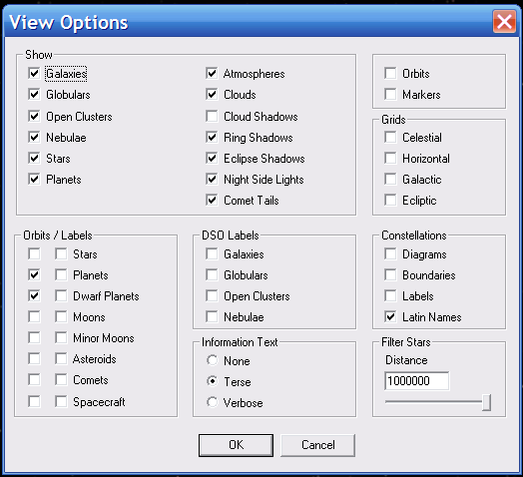
RESET STAR LEVELS: - Celestia Educational Activities draw and track over 1,000,000 stars at the same time. Since Celestia must mathematically calculate the position of every star, it puts a demand on your computer’s CPU. Lowering the number of stars can improve performance. To do so, press the {[} key repeatedly (it’s next to the [P] key). A text message will tell you star levels. A good compromise value is between 7.0 and 9.5. To raise that value, press the {]} key. After resetting star level, check frame rates. If it is still jerky …
- RESET FEATURES: - At the top of the program, you will find a toolbar menu titled, “Render”. Left-click on it and a menu will drop down. Select “View Options”. The ideal choices for these selections are shown here.
- Each checked feature requires computer power and RAM memory. If your computer is still running too slowly, you can uncheck a few of these choices to prevent them from being displayed in Celestia. That may help your computer speed, but you will not be able to see that feature. For example, the feature marked “Ring Shadows” commands Celestia to draw the shadow that a planetary ring may cast on the planet below. If you uncheck the box, your computer will operate faster but you will not see ring shadows.
- If your computer still exhibits jerky performance or freezes, we regret that it may be too slow with insufficient video RAM or CPU speed to operate Celestia properly.

(Q) Troubleshooting & Cautions (read carefully)
1. An audio control file that is vital for the proper functioning of sound in the program is included with this installation in the main Celestia161-ED directory. It is called “openal32.dll”. The version included with our program works well on most computers. However, some computers may require a different version of openal32.dll. If your computer is one of those, you may experience a program crash every time you close Celestia161-ED, or you may not hear any sounds when you launch the program. If that is happening to you, simply look inside the Celestia161-ED main directory for a sub-folder named “openal32_dll. Inside it will be two other files. Simply copy one of them and paste it directly into the main Celestia161-ED root directory, overwriting the dll file present there. Then, launch Celestia161-ED., navigate to the link in an Activity document that activates sound, and determine if sound is now heard. If not, try the 3rd openal32.dll file. Usually, that will fix the problem.
2. Inside the written activity are many places that instruct you to "click here". These are called “cel: //url hyperlinks” and each time you click on them, Celestia will go to a particular location in space. Please note that you MUST click on those links ONLY ONCE. If you double-click on them (which is very common in computer programs), you will launch two copies of Celestia161-ED at the same time. This will probably lock up your computer. You must tell your students to click on those internal hyperlinks only once
3. Microsoft Office 2007 has an annoying security feature. Whenever a cel:url in an Activity document is clicked, the user will first get a warning message telling him that the hyperlink is not a legitimate internet link, and asking if the user wants to execute it. Simply click “OK’ and Celestia will go to the correct spot. The warning message is annoying, but there is not way to turn it off.
4. NOTE: If a user tries to minimize Celestia during a trip by clicking the [-] button at the top of the program, and then clicks on a cel:url in an Activity document, the result may be a weird view of space. The stars will all look weird, and the text display will state that your “FOV” is some number greater than 100. If that occurs, simply click on the hyperlink or cel: //url again, just once. The problem will typically fix itself. Tell the students not to minimize Celestia.
5. MOST IMPORTANT: Every Activity document begins its journey by left-clicking on a [click here] link in the document (usually within the first 3 - 6 pages). Clicking on that link not only launches Celestia, it also tells the program which files to load. Frequently, students will not finish an Activity in one sitting, and will close Celestia161-ED and come back to it next period to finish the journey. Whenever they do, they MUST go to the “Important Notes” section below that initial starting link, and sequentially click both links in the flashing paragraph to relaunch the Activity. Once Celestia161-ED relaunches from these flashing paragraph links, only then can they locate the place in the Activity document where they last left off and continue from there. Remind your students this MUST BE DONE every time they resume!!!
6. On occasion, you will find Celestia pausing a long time. Perhaps the screen even turns white. Be patient. That means the program is loading a big data file and can take up to 10 – 30 seconds for it to load. This is particularly true for media video files.
7. A student may sometimes press the [Ctrl+R], or [Ctrl+U] keys by accident. If they do, the Celestia161-ED screen will “split” into Multiviews. Up will go their hand for help. To return the screen to single view, simply press the [Ctrl+D] keys.

Consult the Celestia 161 User’s Guide for further guidance on how to control the program. It comes with our CD/DVD set and is inside the Educational base Package zip file downloaded on our free site. In either case, it will be present in the Celestia161-ED main directory.

(R) Conclusion
I hope you enjoy these exciting Educational Activities. I plan to add new Activities periodically. Should you have any problems or questions or compliments, feel free to contact me at fsgregs@comcast.net

Sincerely, Frank Gregorio February 2012

