ACCESA

Process Definition Document

Poker POC

Document history
Date | Version | Role | Name | Organization/  Department | Function | Comments
27.05.2021 | 1.0 | Author | Adrian Pitu | Accesa | Business Analyst | First version

Contents

1. Introduction 3
1.1 Purpose of the document 3
1.2 Automation objectives 3
1.3 Process key contacts 3
1.4 Automation prerequisites 4
2. As-Is Process Description 4
2.1 Process overview 4
2.2 Applications used in the process 5
2.3 As-Is process map 5
2.4 As-Is steps 5
2.5 Additional sources of process documentation 6
3. To-Be Process Description 6
3.1 To-Be process map 6
3.2 To-Be steps 6
3.2.1 Areas already automated 6
3.3 In scope for RPA 7
3.4 Out of scope for RPA 7
3.5 Business exceptions handling 7
3.5.1 Known exceptions 7
3.5.2 Unknown exceptions 7
3.6 Application exceptions handling 7
3.6.1 Known exceptions 7
3.6.2 Unknown exceptions 7
4. Document approval 8

Introduction

Purpose of the document
The Process Definition Document outlines the business process chosen for automation using Robotic Process Automation (RPA) technology.
The document describes the sequence of steps performed as part of the business process, the conditions and rules of the process prior to automation and how they are envisioned to work after automation, be it partial or complete. This specifications document serves as a base for developers, providing them with the details required for applying robotic automation to the selected business process.

Automation objectives
The business objectives and benefits expected by the Business Process Owner following the automation of the selected business process are:
- Play a Texas Holdem poker game on the Poker Stars desktop application

Process key contacts
This specifications document includes concise and complete requirements of the business process and is based on the input provided by both RPA Consultant and Process Owner. The Process Owner is expected to review and sign-off on the document, to ensure an accurate and complete description of the steps, the context, the impact and the complete set of process exceptions. Other roles involved in the automation of the business process are listed and described below:
Role | Name | Contact details | Notes
Process Owner | Paul Trestian | paul.trestian@accesa.eu | Provide necessary input for the RPA Team to thoroughly understand the process and client expectations.
PM/RPA Consultant | Alexandru Lates | alexandru.lates@accesa.eu | Accountable for Project outcome, primary point of contact for queries on status. FTE impact, RACI matrix, Process Health.
Business Analyst | Adrian Pitu | adrian.pitu@accesa.eu | Create PDD, Design As-Is + To-Be Process Mapping.
Software Architect | Andrei Napradean | andrei.napradean@accesa.eu | Infrastructure design and guidance on development.
Quality Engineer |  |  | Test developed RPA solution based on client expectations.
Developer | Paul Trestian | paul.trestian@accesa.eu | Develop RPA solution based on client expectations.

Automation prerequisites
- Filled in Process Definition Document (PDD), reviewed and signed off by respective Process Owner
- Poker Stars application must be installed
- A working account for the Poker Stars application
- As-Is Process Description

Process overview
General information about the process selected for RPA.
# | Item | Description
1 | Process full name | Poker POC
2 | Process area | Accesa R&D
3 | Department | Accesa R&D
4 | Process short description | Automated play poker on the Poker Stars desktop application
5 | Role(s) required for performing the process | Poker player

Process volumetry
General quantitative information on the selected process prior to automation.
# | Item | Value
1 | Process schedule and frequency | Any time
2 | Average no. of items processed per month | Not applicable
3 | Average handling time per item | 3 Minutes
4 | Number of employees performing the task | 1
5 | Total time/year spent (FTEs) | Not applicable

Applications used in the process
The table includes a comprehensive list of all the applications that are used as part of the automated process, at various steps in the flow.
# | Application name | System language | Login module | Environment / Access method | Comments, incl. URLs
1 | Google Chrome | EN |  | Desktop  Browser
2 | Microsoft Excel | EN |  | Desktop
3 | Gmail (Gmail SMTP) | EN | Gmail account and single-use app password | Brow

Additional sources of process documentation
Additional material created to support the process automation, along with the supporting documentation provided.
Documentation | Access | Comments
Video recording of the process | Insert object of the files for client access.
Standard Operating Procedure/ User Manual
Anything else?

To-Be Process Description

To-Be process map
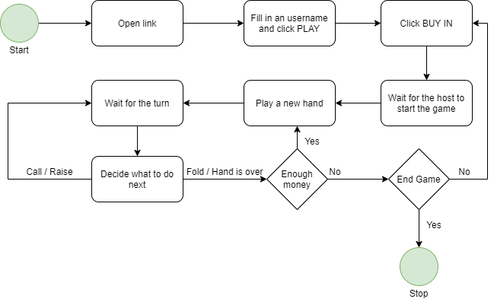

To-Be process steps
# | Short description of key process steps | Step owner
1 | Open the mail and navigate to the game link | Robot
2 | Fill in a username and click play  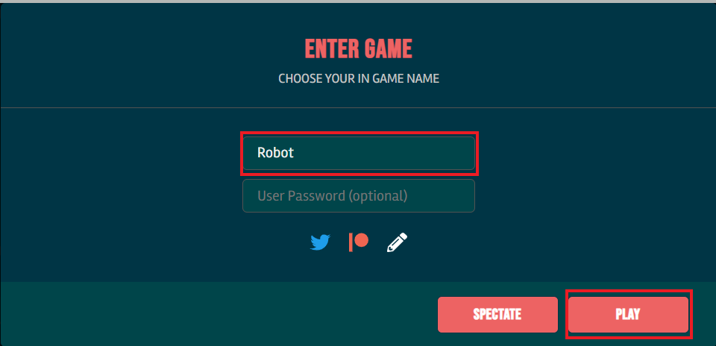 | Robot
3 | Click Buy In  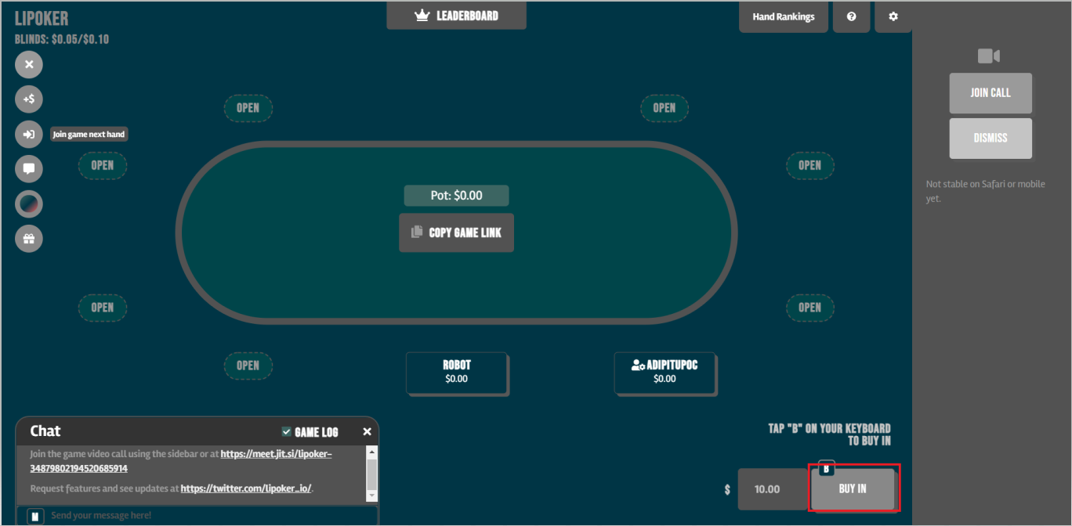 | Robot
4 | Wait for the game or a new hand to begin  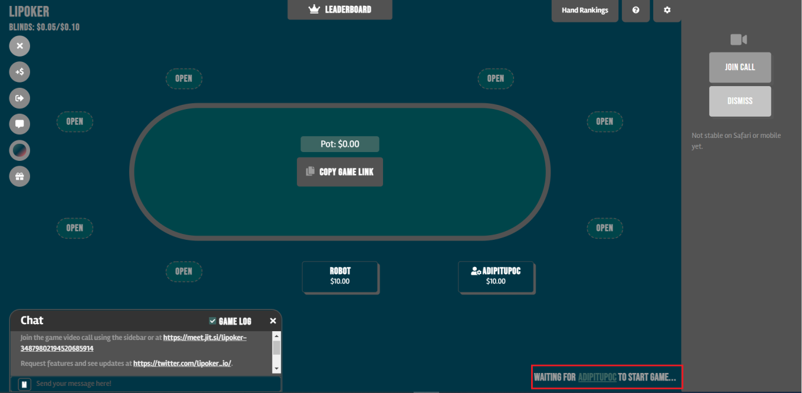 | Robot
5 | Evaluate the hand and decide what to do: RAISE TO, RAISE ALL IN, CALL <amount> or FOLD 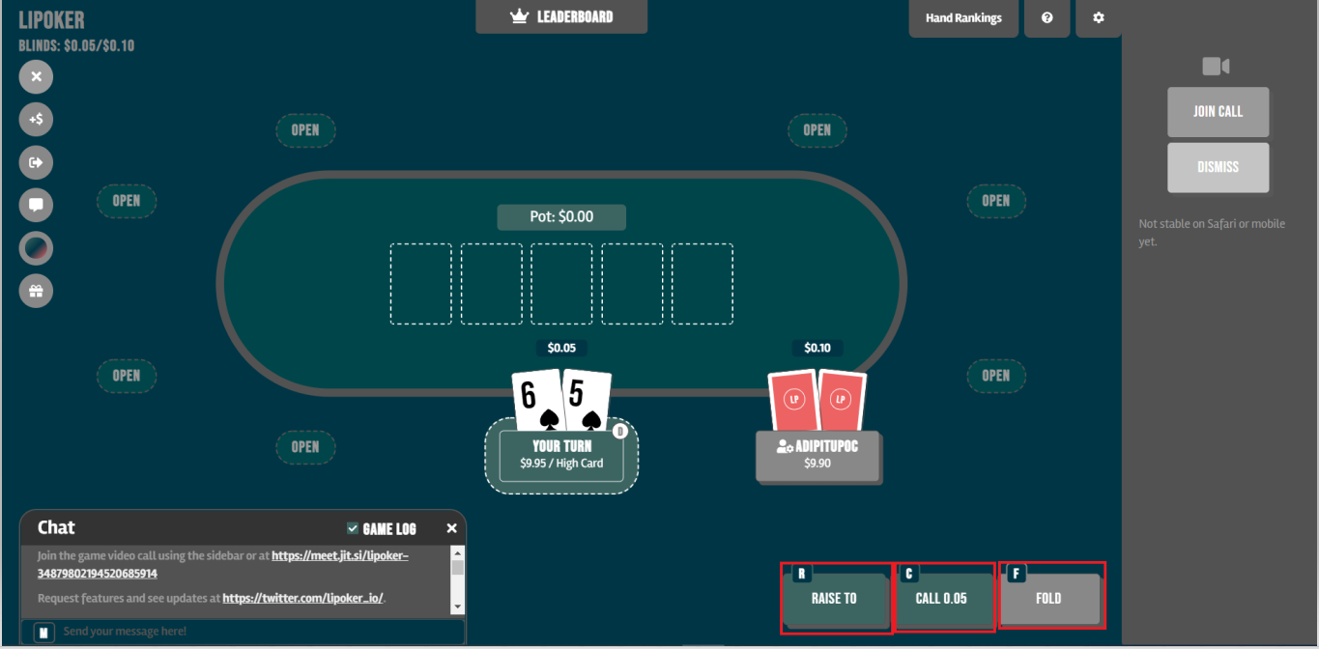 | Robot
5.1 | If FOLD was clicked go to step 4 | Robot
5.2 | If CHECK was clicked go to step 5 | Robot
5.3 | If RAISE TO was clicked select the amount to bet | Robot
5.3.1 | Use %POT selector 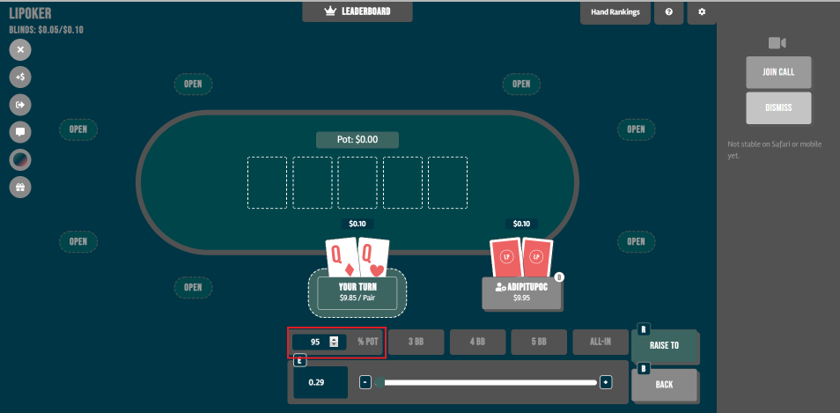 | Robot
5.3.2 | Use pre-existing buttons 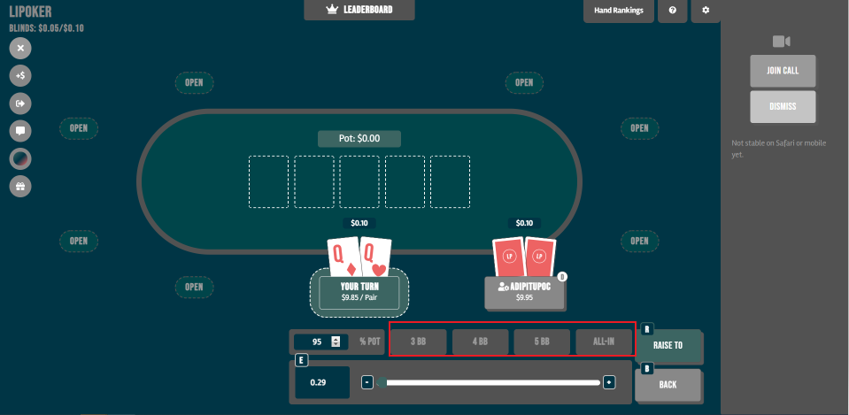 | Robot
5.3.3 | Use the fill-in text box 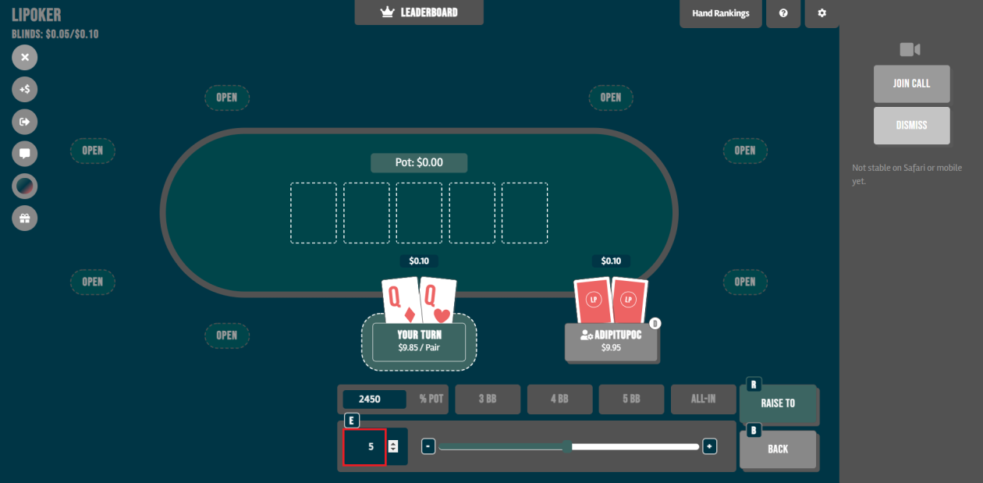 | Robot
5.3.4 | Use the spinner to set the amount 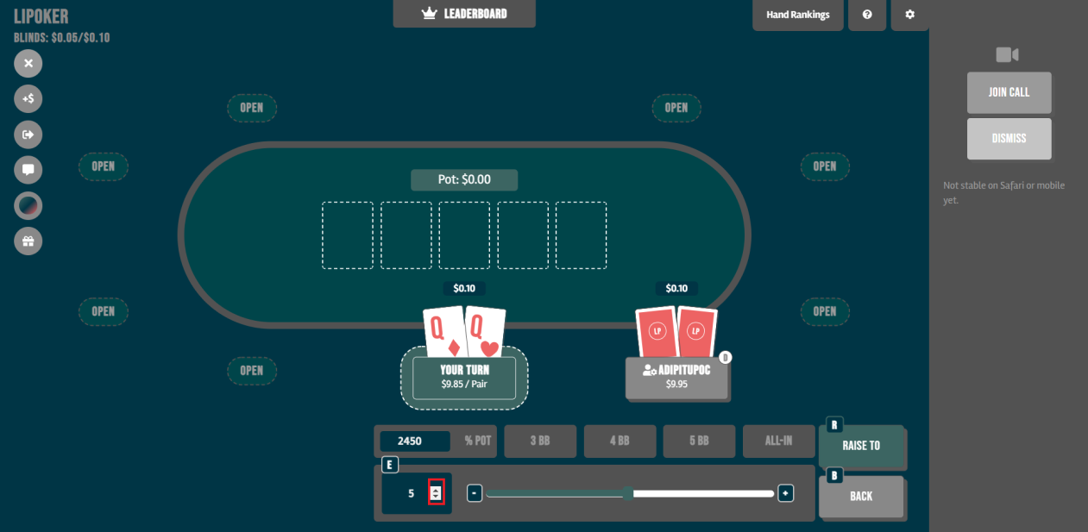 | Robot
5.3.5 | Use the slide bar 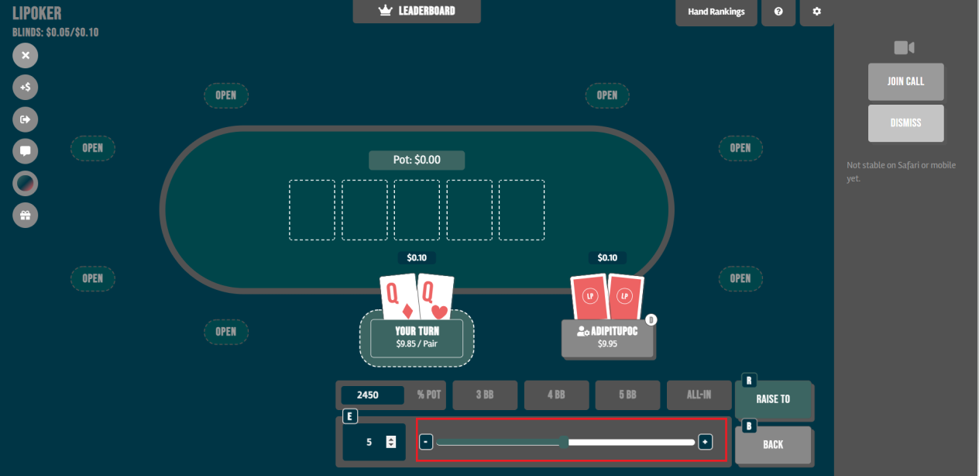 | Robot
5.4 | After setting the amount click RAISE TO and go to step 4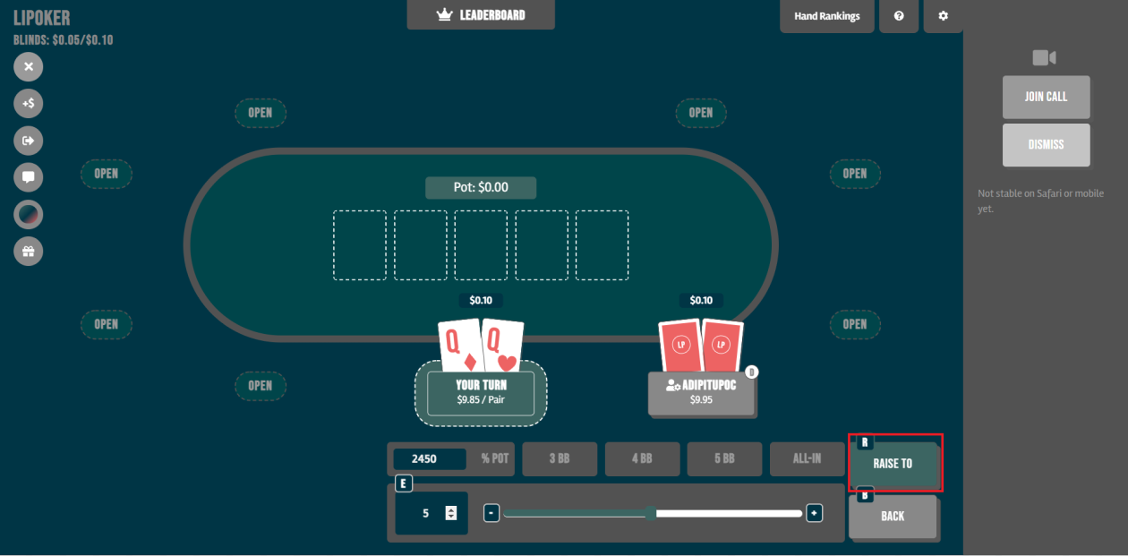 | Robot

Solution Overview

List of packages (H)
Describe how the business process is structured in packages and sub-processes. Fill this out for the high-level solution design.
# | Package Name | Description
1 | e.g RPA_ProcessName | A process description
2

Solution diagram of the process (H)
The solution diagram, an overview of the process, displays the interaction between components (packages, robots, Orchestrator queues) in running order. Fill this out for the high-level solution design.

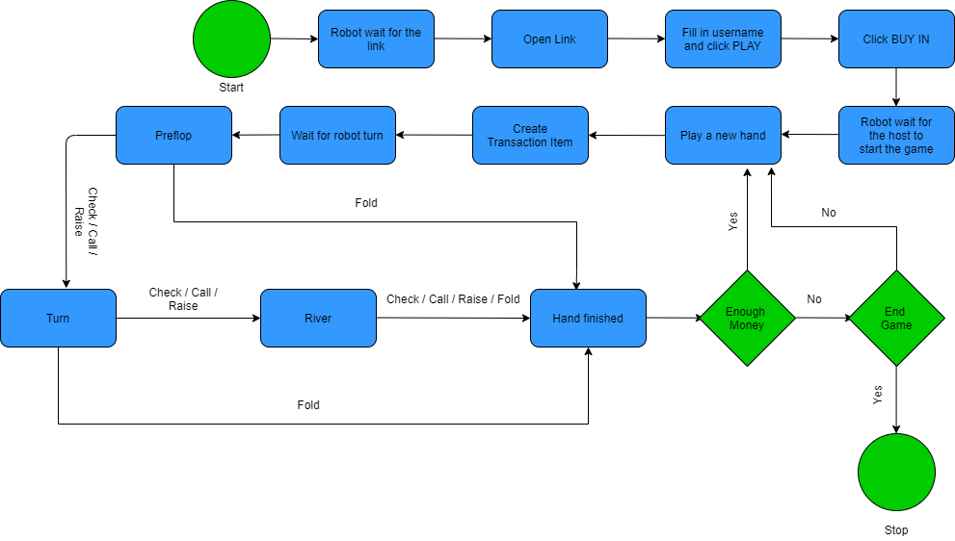

Solution description of the process

State machine general Overview (H)
For each package, describe which major activities are handled in which state machine part. Fill this out for the high-level solution design.
State | Description
Init  Initializes all the necessary applications – Google Chrome | Robot does the following:  - Init Settings  - InitAllApplications
Get Transaction Data  Creates a Transaction from the dealt cards and passes it to the Process state | - GetTransactionData
Process Transaction  Here we actually play the hand of poker | - Decision_Preflop  - Action_Preflop  - Decision_Flop  - Action_Flop  - Decision_Turn  - Action_Turn  - Decision_Rover  - Action_River
End Process | - CloseAllApplications

Detailed workflow description
Describe all elements used within the process. In case of multiple processes, dedicate a sub-chapter to each. Fill this out for the high-level solution design as detailed as possible.

Workflow details of <Poker POC>
Describe each Element of a package briefly.
# | State Machines | Element (Workflow file name) | Description | Input Arguments | Output Arguments
1 | Init | InitAllSettings | Reads the config file and saves arguments to config. | in_ConfigFile | out_config
2 | Init | InitAllApplications | Opens Google Chrome | n/a | n/a
3 | Get Transaction Data | GetTransactionData | Gets the information from the playing cards (number and suit) if a new hand starts. If there are no more players left the process goes into End State and stops. | n/a | out_transactionItem (here is the information about the 2 cards)
6 | Process Transaction | Action_Preflop | Invokes Decision_Preflop and takes the action needed | n/a | n/a
7 | Process Transaction | Decision_Preflop | Checks the action before the robot turn and decides what to do (check/call/fold/raise) | in_cards (this is out_transactionItem from GetTransactionData) | n/a
8 | Process Transaction | Action_Flop | Invokes Decision_Flop and takes the action needed on flop | n/a | n/a
9 | Process Transaction | Decision_Flop | Checks the action before the robot and based on a simple algorithm with the cards on the board makes a decision (check/call/fold/raise) | in_cards | n/a
10 | Process Transaction | Decision_Turn | Checks the action before the robot and based on a simple algorithm with the cards on the board makes a decision | in_cards | n/a
11 | Process Transaction | Action_Turn | Invokes Decision_Turn and takes the action needed on the turn | n/a | n/a
12 | Process Transaction | Decision_River | Checks the action before the robot and based on a simple algorithm with the cards on the board makes a decision | in_cards | n/a
13 | Process Transaction | Action_River | Invokes Decision_River and takes the action needed on the river | n/a | n/a
9 | Process Transaction | Action_River | Takes the action needed preflop ( fold/check/call/raise) | in_TransactionData | n/a
10 | End Process | CloseAllApplications | Closes all the applications | in_Config | n/a

Business exceptions handling
Business exceptions identified prior to or during the automation process are documented below:

Known exceptions
# | Exception name | Step | Parameters | Action to be taken
1 | Disconected users | Any steps | All other users are disconnected | End game

Unknown exceptions
For all the other unanticipated or unknown business (process) exceptions, the robot should:
Send an email to Process Owner, with a screenshot of the window where the exception/error was encountered.

Application exceptions handling
A comprehensive list of all errors, warnings or notifications, with the description and action to be taken, for each, by the Robot.

Known exceptions
# | Exception name | Step | Parameters | Action to be taken
1

Unknown exceptions
For all the other unanticipated or unknown application errors/exceptions, the robot should:
Send an email to IT Specialist, with a screenshot of the window where the exception/error was encountered.

