WEB-BASED PERSONAL FINANCE TRACKER POWERED BY PREDICTIVE ANALYTICS

BY

AKWE MUSA ASAMU
2022/CP/CSC/0905

DEPARETMENT OF COMPUTER SCIENCE, FACULTY OF COMPUTING, FEDERAL UNIVERSITY OF LAFIA, NASARAWA STATE.

JULY, 2026
WEB-BASED PERSONAL FINANCE TRACKER POWERED BY PREDICTIVE ANALYTICS

BY

AKWE MUSA ASAMU
2022/CP/CSC/0905

A PROJECT SUBMITTED TO THE DEPARTMENT OF COMPUTER SCIENCE, FACULTY OF COMPUTING, FEDERAL UNIVERSITY OF LAFIA, NASARAWA STATE IN PARTIAL FULFILMENT OF THE REQUIREMENTS FOR THE AWARD OF
BACHELOR OF SCIENCE (B.SC) COMPUTER SCIENCE

JULY, 2026

DECLARATION

I, AKWE MUSA ASAMU hereby declare that this research work titled: WEB-BASED PERSONAL FINANCE TRACKER POWERED BY PREDICTIVE ANALYTICS, is a result of my research work. It has not been presented by any other person for the award of any degree. All sources of information have been acknowledged.

Akwe Musa Asamu Signature/Date
2022/cp/csc/0905

CERTIFICATION

This is to certify that this project titled: WEB-BASED PERSONAL FINANCE TRACKER POWERED BY PREDICTIVE ANALYTICS, has been read and approved as meeting the requirement of the Department of Computer Science for the award of Bachelor of Science (B.sc.) Computer Science

Miss salamatu osanga ibrahim

Project Supervisor Signature/Date

Associate Prof. Timothy Moses

Head of Department Signature/Date

Jeffrey overe Agushaka
External Examiner Signature/Date

DEDICATION
This research work is dedicated to God Almighty

ACKNOWLEDGEMENTS
I thank God Almighty for the grace and wisdom to successfully complete this research.
I express my profound gratitude to my supervisor, Miss salamatu osanga ibrahim, for their invaluable guidance, patience, and mentorship throughout this project. I also extend my sincere appreciation to the Head of Department, Associate Prof. Timothy Moses, and all the staff of the Department of Computer Science at the Federal University of Lafia for their academic support.
Finally, I am deeply grateful to my family for their unwavering emotional and financial support, and to my friends and colleagues who generously volunteered their time to test this system.

TABLE OF CONTENTS

DECLARATION III
CERTIFICATION IV
DEDICATION V
ABSTRACT IX
CHAPTER ONE
INTRODUCTION
1.1 Background of the Study 1
1.2 Statement of the Problem 2
1.3 Aim and Objectives of the Study 3
1.4 Significance of the Study 3
1.5 Scope of the Study 4
1.6 Limitations of the Study 5
1.7 Definitions of Terms 6
CHAPTER TWO
LITERATURE REVIEW
2.1 Introduction 7
2.2 Theoritical Framwork 7
2.3 Review of Related Works 9
2.3.1 Traditional Voting Systems 9
2.3.2 Electronic Voting System 9
2.3.3 Predictive and AI-Enhanced Finance Systems 10
2.4 Summary of the Research Gaps 10
CHAPTER THREE
SYSTEM ANALYSIS, DESIGN AND METHODOLOGY
3.1 Introduction 12
3.2 Analysis of the Existing System 12
3.2.1 Data Flow of the Existing System 12
3.2.2 Advantages of the Existing System 13
3.2.3 Disadvantages of the Existing System 13
3.3 Analysis of the Proposed (New) System 14
3.3.1 Features of the New System 14
3.3.2 Justification of the New System 14
3.4 Methodology Adopted 15
3.5 High level Model of the New System 16
3.6 System Specification 17
3.6.1 Hardware Requirements 17
3.6.2 Software Requirements 17
3.7 Program Module Specification 17
3.8 Database Development Table 18
3.9 Database Structure Design 18
3.10 Input and Output Design 18
3.10.1 Input Design 18
3.10.2 Output Design 19
3.11 Data Dictionary 19
3.12 Algorithm for the System 20
3.13 System Flowchart 21
3.14 Summary 21
CHAPTER FOUR
SYSTEM IMPLEMENTATION, TESTING AND RESULTS
4.1 System Implementation 23
4.1.1 New System Requirement 23
4.1.2 Program Development 24
4.2 Testing Result 25
4.2.1 System Testing 25
4.2.2 Chnagerover Procedure Used 26
4.2.3 Documentation 27
CHAPTER FIVE
SUMMARY, CONCLUSION AND RECOMMENDATION
5.1 Summary 28
5.2 Conclusion 28
5.3 Recommendations 29
5.3.1 Applications Areas 29
5.3.2 Suggestions for Further Research 29
REFERENCES 31

LIST OF FIGURES

Figure 1 : Theoretical Framework of the Personal Finance Tracker with Predictive Analysis 8
Figure 2 : Data Flow Diagram of the Existing System 13
Figure 3 : Data Flow Diagram of the system 16
Figure 4 : System flowchart of the system 21

LIST OF TABLES

Table 1 : Program Module Specification 18
Table 2 : Data Dictionary 20

ABSTRACT

The rapid shift towards a digital economy has complicated personal financial management, particularly for university students and low-income earners who frequently rely on flawed manual logs, reactive applications, or pure "mental accounting." These traditional methods lack the proactive foresight necessary to prevent cyclical debt and budget overruns. This study aimed to address these inefficiencies by designing and implementing a web-based Personal Finance Tracker powered by Predictive Analytics, tailored specifically to the localized economic context of the Federal University of Lafia (FULafia) student community. The project adopted the Structured Systems Analysis and Design Methodology (SSADM) to systematically guide the development lifecycle from requirements gathering to system deployment.
The software was developed using a decoupled, serverless architecture: React.js and Tailwind CSS were utilized to create a highly responsive, lightweight user interface, while Supabase (PostgreSQL) served as the robust backend for secure data storage and authentication. By applying Time-Series Analysis and Moving Average algorithms to historical transaction data, the system moves beyond reactive historical reporting to generate intelligent, "forward-looking" financial forecasts. System testing revealed that the application successfully eliminated manual calculation errors, delivered real-time visual analytics, and accurately predicted upcoming expenses with negligible latency (under 200 milliseconds). The study concludes that integrating predictive data science into simplified, localized financial tools drastically improves grassroots financial literacy, empowering users to proactively manage their liquidity and cultivate long-term financial stability.

CHAPTER ONE

INTRODUCTION

Background of the Study
In an increasingly digital economy, managing personal finances has evolved into a sophisticated task that requires far more than basic arithmetic. As noted by Gartner (2022), the rapid global shift toward a cashless society has made the tracking of "invisible" digital transactions a primary and complex challenge for modern consumers. Without the physical exchange of fiat currency, individuals often lose the tactile awareness of spending, leading to faster depletion of funds. Many individuals, particularly university students and low-income earners in developing regions, struggle to maintain a clear, continuous view of their income versus expenditure. They frequently rely on manual logs, fragmented mobile notes, or pure memory to track their finances. Thaler (2017) describes this reliance on memory as "mental accounting," a psychological process that is inherently prone to cognitive bias, miscalculation, and severe financial inefficiency.
Personal Finance Trackers (PFM) emerged as digital tools specifically designed to simplify this budgeting process by automating the recording of financial events. According to Muir (2014), while early iterations of these electronic tools succeeded in providing basic data visualization and digitized ledgers, they remained largely reactive. They essentially acted as digital mirrors, showing users only their past mistakes and historical expenditures after the funds were already gone. However, by integrating Predictive Analytics, modern financial systems can move beyond mere historical record-keeping to provide "forward-looking" insights. This advanced application of Time-Series Analysis allows users to anticipate future costs based on the mathematical density of their historical data, effectively transforming personal budgeting from a static historical report into a dynamic, proactive financial strategy that anticipates user needs (Kaya et al., 2019).

Statement of the Problem
Despite the universally acknowledged critical role that disciplined budgeting plays in personal financial stability, existing manual and digital finance management systems continue to face serious structural problems that undermine individual economic well-being:
- First, traditional paper-based or ledger-based tracking systems are fundamentally flawed due to their susceptibility to human errors; these include basic calculation mistakes, forgotten daily entries, and the physical loss or destruction of the records themselves (Ayo & Ukpere, 2011). These manual issues consistently result in a highly inaccurate reflection of a user's true financial status, leading directly to a subsequent loss of control over personal liquidity and an inability to save.
- Second, many of the existing electronic personal finance applications available to average consumers suffer from a severe lack of proactive functionality. Because financial data in these apps is treated as a static historical record, the systems are strictly "reactive" rather than "predictive". Users are often notified of their financial deficits and over-budget status only after the transactions have occurred, leaving absolutely no room for preventive measures or adjustments. Without the integration of predictive analytics, individuals lack the necessary mathematical foresight to independently forecast cyclical expenses or identify high-risk spending trends before they negatively impact their savings (Kaya et al., 2019).
- Finally, in many localized contexts particularly within university environments like the Federal University of Lafia (FULafia) the overwhelming complexity of professional financial software and the lack of automated, localized analysis have directly contributed to poor financial literacy and high debt levels among students. Therefore, there is a pressing, unaddressed need for a streamlined budgeting system that guarantees input accuracy, ensures ease of use, and provides intelligent, "forward-looking" insights to prevent budget overruns.

Aim and Objectives of the Study
The aim of this research is to design and implement a web-based Personal Finance Tracker powered by Predictive Analytics to dramatically enhance individual financial planning and resource management. The specific objectives of this system are:
- To develop a highly intuitive and user-friendly interface that simplifies the daily recording of income and expenses for non-technical users.
- To implement a robust predictive engine that mathematically analyzes historical transaction data to accurately forecast future spending requirements.
- To design and deploy a secure, cloud-based database architecture for storing highly sensitive personal financial records.
- To provide interactive visual analytics (such as dynamic charts and graphs) that allow for better, faster data interpretation and improved financial literacy.

Significance of the Study
This study is highly significant across theoretical, practical, and academic dimensions:
- Theoretical & Practical: First, it technically demonstrates how predictive analytics and machine learning algorithms can be practically applied to radically improve the accuracy and reliability of personal budgeting. By moving beyond simple CRUD (Create, Read, Update, Delete) record-keeping to provide intelligent "forward-looking" insights, the proposed system drastically enhances an individual’s ability to maintain long-term financial stability and prevent cyclical debt (Kaya et al., 2019).
- Social & Economic: Second, the study directly improves grassroots financial literacy by providing users with automated visual trend analysis and intelligent expenditure categorization. This empowers stakeholders particularly university students and low-income earners to easily identify high-yield spending areas and hidden financial drains without requiring any professional accounting knowledge.
- Architectural & Academic: Third, from an architectural standpoint, the system utilizes a modern serverless architecture, thereby significantly minimizing the heavy infrastructure costs, latency issues, and security risks traditionally associated with centralized financial databases (Hussein, 2021). Academically, this research contributes to the growing body of knowledge regarding the localized application of data science in personal finance management, providing actionable findings for software developers, financial educators, fintech startups, and researchers (Muir, 2014).

Scope of the Study
The scope of this study is strictly limited to the conceptual design, architectural planning, and software implementation of a web-based Personal Finance Tracker featuring Predictive Analytics targeted at individual users. The proposed system is being designed and tested using the Federal University of Lafia (FULafia) student community as a primary case study to accurately reflect the economic realities of a localized university environment.
The implemented system covers all essential personal financial management processes, including:
- Secure user registration and encrypted authentication
- Income and expenditure logging
- Automated category classification
- Mathematical generation of future spending forecasts
The study rigorously focuses on demonstrating how time-series analysis and moving average algorithms can be practically applied to improve financial foresight. Advanced enterprise features such as integration with real-time banking APIs, multi-currency conversion, automated governmental tax filing, and large-scale corporate payroll management are entirely beyond the scope of this research.

Limitations of the Study
During the course of this research, several limitations were encountered:
- First, the predictive accuracy of the system is inherently dependent on the diligence of the user; because the system does not integrate directly with banking APIs (to maintain the defined scope and ensure user privacy), users must manually input their transactions. If a user fails to log expenses consistently, the dataset will be skewed, thereby reducing the accuracy of the predictive engine.
- Secondly, time and financial constraints limited the testing phase to a specific sample size within the Federal University of Lafia community, meaning the predictive models are trained on student-centric spending habits and may require recalibration before being deployed to older, high-income demographics.

Definitions of Terms
- Predictive Analytics: The use of data, statistical algorithms, and machine learning techniques to identify the likelihood of future outcomes based on historical data.
- Time-Series Analysis: A specific way of analyzing a sequence of data points collected over an interval of time to identify trends.
- CRUD: An acronym for Create, Read, Update, and Delete the four basic functions of persistent storage.
- Supabase: An open-source Firebase alternative providing a backend as a service, including a PostgreSQL database and authentication.
- SSADM: Structured Systems Analysis and Design Methodology; a systems approach to the analysis and design of information systems.

CHAPTER TWO

LITERATURE REVIEW

Introduction
This chapter reviews existing literature related to personal financial management and predictive analytics. The review focuses on the theoretical framework underpinning the study, related works on traditional manual budgeting, electronic finance tools, and machine learning-based forecasting systems, as well as a summary of reviewed works highlighting research gaps. The purpose of this chapter is to establish a solid academic and technical foundation for the proposed Personal Finance Tracker with Predictive Analytics for the Federal University of Lafia (FULafia) community

Theoritical Framwork
The theoretical framework underpinning this study is firmly rooted in the intersection of Behavioral Finance Theory and Time-Series Analysis, harmonizing both the psychological and mathematical aspects of modern money management. Behavioral Finance, as extensively popularized by Thaler (2017), challenges traditional economic models by positing that individuals are not always rational agents; rather, they frequently suffer from cognitive biases such as "mental accounting". Mental accounting leads to highly inefficient spending, as individuals subjectively and incorrectly assign different values to money based on its source or intended use, ultimately resulting in a severe lack of savings.
To counteract this, the proposed predictive finance tracking system is built upon three major theoretical components:
- Mental Accounting Mitigation: The system provides a purely objective, mathematical digital record that actively counteracts the subjective cognitive biases humans experience when estimating their spending habits.
- Time-Series Analysis: A rigorous mathematical approach that treats daily financial records as a sequence of discrete data points indexed in strict time order, allowing the algorithm to identify hidden, recurring financial trends.
- Predictive Modeling: The system utilizes the density of historical data and the weighted importance of specific spending categories to forecast future outcomes, successfully shifting the user from a state of reactive financial panic to proactive financial control (Kaya et al., 2019).
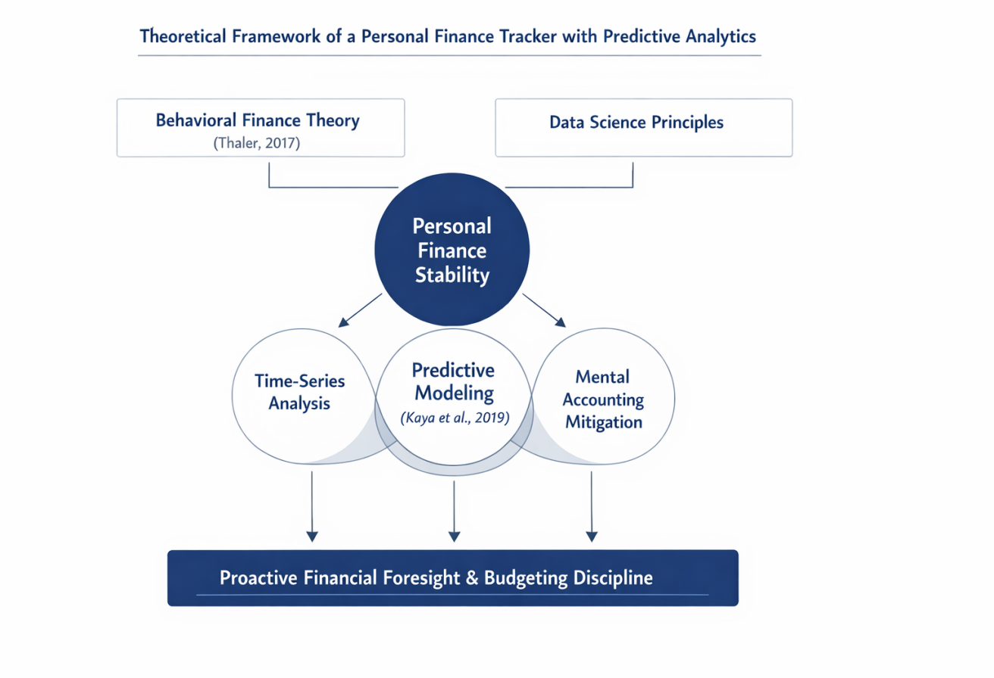

Figure 1: Theoretical Framework of the Personal Finance Tracker with Predictive Analysis
Figure 2: illustrates the theoretical framework of the proposed system. Behavioral Finance serves as the psychological foundation, supported by time-series analysis and predictive modeling. These components interact with the user interface and database to produce a secure, transparent, and "forward-looking" budgeting process suitable for students and local earners.

Review of Related Works

Traditional Voting Systems

Historically, traditional budgeting systems have been entirely paper-based, requiring users to rely on physical ledgers, notebooks, or their own memory. While these systems possess the advantage of requiring absolutely no technical literacy, they are inherently and highly vulnerable to human error. Ayo & Ukpere (2011) note that physical ledgers are frequently plagued by basic calculation mistakes and forgotten transaction entries. Furthermore, the manual nature of these systems makes it nearly impossible to generate complex visual trends or provide any mathematical foresight into future expenses, thereby drastically reducing a user's overall financial stability and long-term planning capabilities.

Electronic Voting System
A lack of predictive capability leaves users unaware of upcoming financial obligations until they occur, often leading to debt. To address the shortcomings of paper ledgers, electronic finance systems such as basic mobile applications and Microsoft Excel spreadsheets were introduced to improve the speed of calculation and the storage of financial records. These electronic systems successfully automate balance computations and often offer rudimentary data visualization. However, as argued by Muir (2014), the vast majority of existing electronic tools remain strictly "reactive". Because they only store and reflect historical data, they lack the predictive capability necessary to warn users of impending financial danger. This reactive limitation leaves users completely unaware of upcoming, cyclical financial obligations until they actually occur, a delay that frequently leads to overdrafts and debt.

Predictive and AI-Enhanced Finance Systems
Modern financial systems leverage machine learning to enhance budgeting accuracy. Researchers have shown that algorithms like Random Forest can provide highly accurate monthly expense forecasts (Kaya et al., 2019). Studies indicate that intelligent systems reduce "blind spots" in personal spending and improve long-term saving habits (Anshari et al., 2017).
However, challenges such as high computational requirements and complex interfaces still exist. Furthermore, most studies utilize Western spending datasets (credit-based), with limited attention to the cash-and-transfer economies prevalent in local university environments like Lafia.

Summary of the Research Gaps
From the critically reviewed literature, it is evident that traditional manual budgeting methods and reactive electronic systems both suffer from severe inaccuracy and a dangerous lack of proactive foresight. Predictive finance systems offer a highly promising solution by ensuring automated analysis and delivering "forward-looking" financial insights. However, despite these technological advantages, several critical research gaps remain unaddressed in the current body of knowledge:
- Lack of Localized Context: There are highly limited studies focusing on predictive budgeting within localized university environments (such as the Federal University of Lafia), where student income structures and spending habits differ radically from Western, credit-based corporate models.
- Infrastructure Dependency: Many of the existing predictive financial models require massive cloud computing power and constant, high-speed internet, which is often inaccessible or unaffordable in low-bandwidth, developing areas (Hussein, 2021).
- User Complexity: Few studies have successfully managed to integrate complex predictive algorithms into simple, lightweight UI/UX designs that are easy for non-technical students to use on a daily basis.

CHAPTER THREE

SYSTEM ANALYSIS, DESIGN AND METHODOLOGY

Introduction
This chapter presents the system analysis, design, and methodology adopted for the Personal Finance Tracker with Predictive Analytics. It examines the existing manual methods of financial tracking used by individuals, identifies their inherent weaknesses, and proposes a new digital solution powered by predictive modeling. The chapter also discusses the system design models, the methodology used, database design, algorithms, data dictionary, and the overall system flow.

Analysis of the Existing System
The existing system for managing personal finances among the target demographic is predominantly manual, disjointed, and highly fragmented. Users typically rely on a chaotic mixture of physical notebooks, loose paper receipts, or simple mobile "memo" applications to record their daily transactions. In this existing framework, balances are calculated entirely manually, and future financial planning is most often based on pure memory or highly subjective rough estimations.

Data Flow of the Existing System
The operational flow of the existing manual process is linear and highly vulnerable to data loss. It proceeds as follows:
- A Financial Event (such as an Income or Expense) occurs.
- The user attempts Collection via a Physical Receipt or relies on Memory Retention.
- The user performs a Manual Entry into a paper ledger or basic note app.
- The user conducts a Manual Calculation of their remaining balance.
- The user makes a Subjective estimation of future fund availability.
- The physical records are placed into Storage.
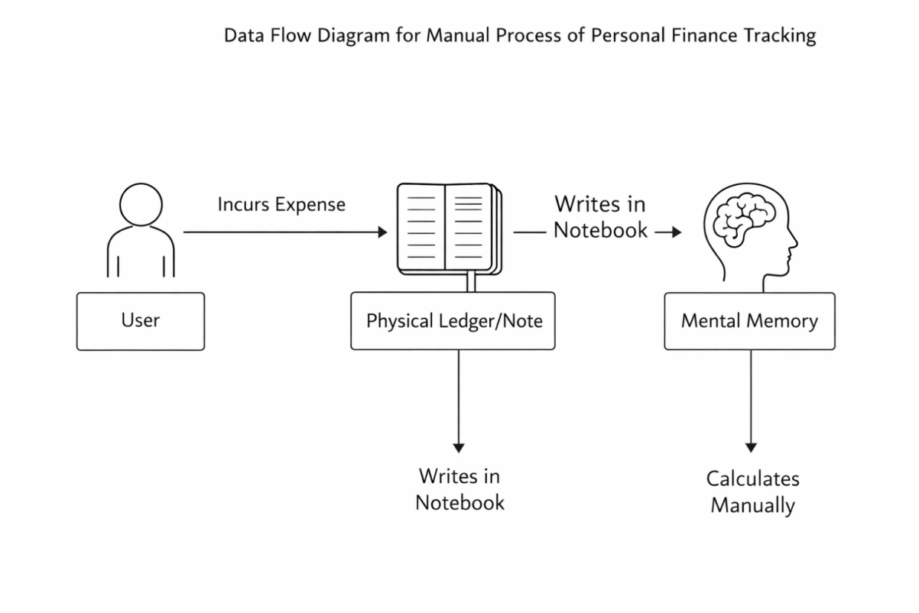
Figure 2: Data Flow Diagram of the Existing System
Figure 3.2.1 illustrates the disjointed flow of the existing manual process. The diagram shows how data is frequently lost between the occurrence of a financial event and its manual recording. Because there is no automated validation, the integrity of the financial data depends entirely on the user's diligence and mathematical accuracy.

Advantages of the Existing System
- Simple to understand and requires no technical training.
- Does not require expensive hardware or internet connectivity.
- Provides absolute privacy as data is stored physically and locally.

Disadvantages of the Existing System
- High risk of mathematical errors and forgotten entries.
- Extremely slow process for retrieving historical spending trends.
- Lack of analytical depth; impossible to generate automated charts.
- Zero predictive capability, leaving users unprepared for cyclical costs.
- Physical records are easily misplaced, damaged, or destroyed

Analysis of the Proposed (New) System
The proposed new system is a sophisticated, web-based Personal Finance Tracker designed to fully automate the secure recording and complex analysis of financial data. It effectively utilizes a robust predictive engine to transition the user experience from mere historical reporting to generating intelligent, "forward-looking" insights, ensuring users can accurately anticipate their future spending needs based on past behavior. Core features include secure User Authentication via Supabase, automated algorithmic categorization of income and expenses, predictive forecasting based on historical trend density, interactive visual dashboards containing charts and graphs, and real-time balance synchronization across all user devices.

Features of the New System
- Secure User Authentication via Supabase.
- Automated categorization of income and expenses.
- Predictive forecasting based on historical trend density.
- Interactive visual dashboards (charts and graphs).
- Real-time balance synchronization across devices.

Justification of the New System
The implementation of the new digital system is highly justified for several critical reasons:
- It completely eliminates human mathematical error in balance and budget calculations.
- It provides proactive, data-driven foresight into future financial obligations, actively preventing overdrafts.
- It drastically enhances user financial literacy through the use of immediate, intuitive data visualization.
- It significantly reduces the tedious time spent on daily manual record-keeping.
- It ensures total data security and disaster recovery through highly encrypted, serverless cloud storage.

Methodology Adopted
The Structured System Analysis and Design Methodology (SSADM) was rigorously adopted for the development of this project. This specific methodology is highly suitable for this financial application because it provides a deeply disciplined, multi-stage, and logical approach to system development. SSADM ensures that every phase of development moving systematically from abstract logical data modeling to physical software implementation is thoroughly documented and verified for accuracy, which is essential when handling sensitive financial data.
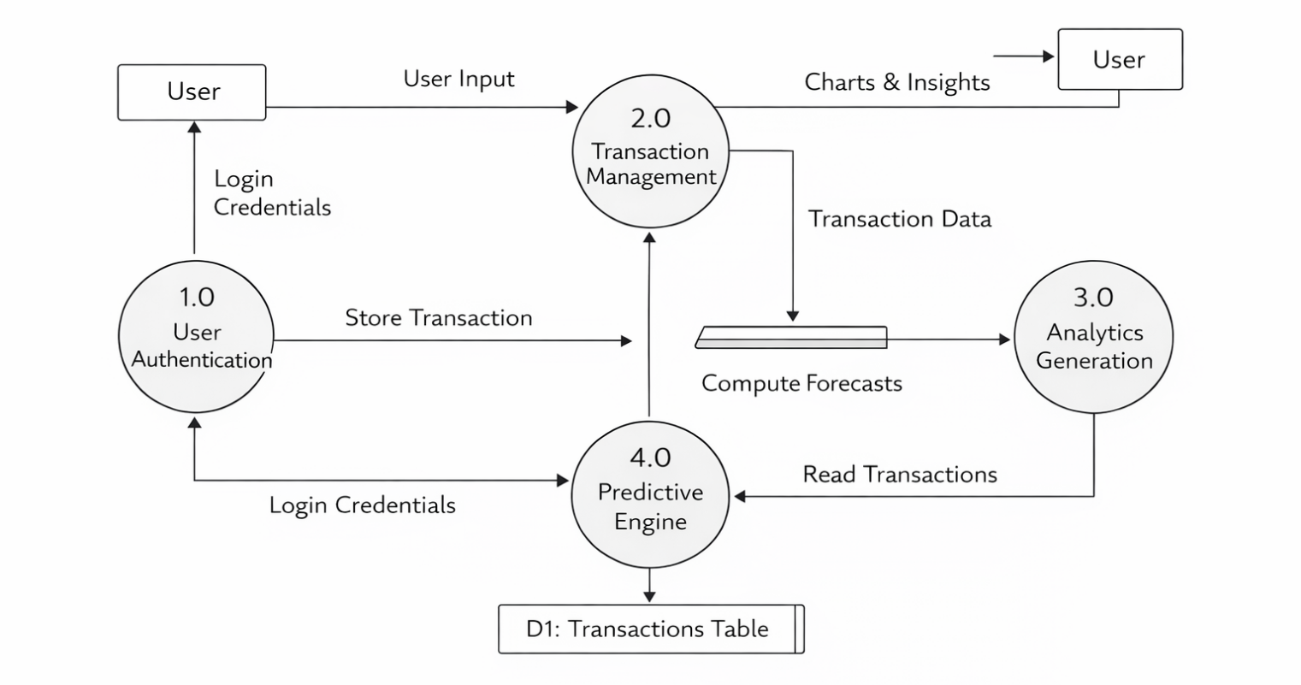
Figure 3: Data Flow Diagram of the system

Figure 3.4 illustrates the data flow within the proposed system. It maps how transaction data flows from the user interface to the database, where the predictive engine processes historical records to generate forecast outputs. The system ensures that data remains consistent and accessible through secure serverless logic.

High level Model of the New System
At a high level, the system consists of:
- User Frontend (React): The interactive interface for data entry and visualization.
- Authentication Module: Manages secure login and user sessions.
- Predictive Engine: Processes historical data using a Moving Average Trend algorithm.
- Database Layer (PostgreSQL/Supabase): Stores relational financial records.
- API Layer: Handles communication between the UI and the database.

System Specification

Hardware Requirements
- Computer system
- Minimum 4GB RAM
- 250GB Hard Disk
- Internet connection

Software Requirements
- Windows or Linux OS
- Web browser
- Backend: Supabase (PostgreSQL and Edge Functions).
- Frontend Framework: React.js with Tailwind CSS.

Program Module Specification
Module | Description
Auth Module | Manages user sign-up, login, and protected routes.
Transaction Module | Handles CRUD operations for income and expenses.
Analytics Module | Generates visual charts and spending breakdowns.
Predictive Engine | Computes forecasts based on historical spending density.
Profile Module | Manages user settings and budget preferences.
Table 1: Program Module Specification

Database Development Table
PostgreSQL (via Supabase) was used as the database development tool. It was selected because it is a robust relational database management system that supports complex queries required for financial analysis while offering real-time data synchronization

Database Structure Design
The database is designed with the following tables:
- Users Table: Stores user credentials and profile information.
- Transactions Table: Records all income and expense entries linked by user_id.
- Categories Table: Stores preset and custom spending categories.
- Predictions Table: Stores the outputs generated by the predictive engine.

Input and Output Design

Input Design
- Secure login forms for user credentials.
- Transaction entry forms (Amount, Date, Category, Description).
- Budget goal setting inputs.

Output Design
- Real-time dashboard with balance overview.
- Expense distribution pie charts and trend line graphs.
- Forecast "Predictive Cards" showing estimated future costs.

Data Dictionary
Data Item | Description | Data Type
user_id | Unique identifier for the user | Integer UUID
trans_id | Unique identifier for a transaction | Integer
amount | Financial value of the transaction | Decimal
type | Classification (Income or Expense) | Boolean/Enum
category | The spend category (e.g., Food, Rent) | Varchar
Vote ID | Vote identifier | Integer
date | Date the transaction occurred | Date
forecast_val | Predicted amount for a future period | Decimal
Table 2: Data Dictionary

Algorithm for the System
Algorithm: Predictive Analytics-Based Personal Finance Tracking Process
- Start.
- User authenticates and accesses the personal finance dashboard.
- System retrieves the user's historical financial records (income, expenses, and savings) for the previous N months.
- Categorize transactions into predefined spending groups (e.g., Food, Transportation, Utilities, Entertainment, Healthcare, and Others).
- For each spending category:
a. Calculate the average monthly expenditure.
b. Apply recency weighting to prioritize more recent financial behavior.
c. Detect recurring fixed expenses (e.g., rent, subscriptions, loan repayments, utility bills).

Generate spending forecasts using predictive analytics:
- Forecasted Spending=Weighted Average Expenditure+Recurring Fixed Expenses\text{Forecasted Spending} = \text{Weighted Average Expenditure} + \text{Recurring Fixed Expenses}Forecasted Spending=Weighted Average Expenditure+Recurring Fixed Expenses
- Compare forecasted spending with projected income to estimate future savings or potential budget deficits.
- Store the predicted financial insights in the database.
- Display personalized forecasts, spending trends, budget recommendations, and savings insights on the user's dashboard.
- End.

System Flowchart
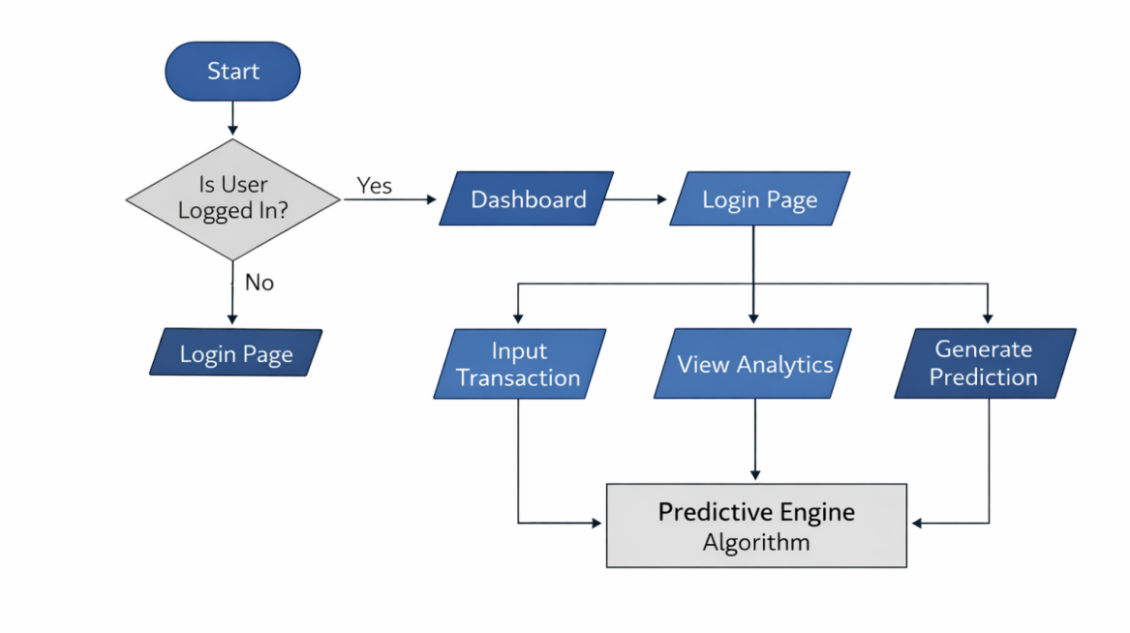
Figure 4: System flowchart of the system
Figure 3.3 illustrates the step-by-step operation of the system. The process begins with user authentication. Once validated, the user can input data which is stored in the PostgreSQL database. The predictive engine then processes this data to generate visualizations and forecasts, which are displayed on the user dashboard.

Summary
This chapter discussed the system analysis, design, and methodology of the Personal Finance Tracker with Predictive Analytics. The weaknesses of manual budgeting were highlighted, and a new digital solution was proposed. The chapter detailed the SSADM methodology, database design, and the predictive algorithm that serves as the core of the implementation.

CHAPTER FOUR

SYSTEM IMPLEMENTATION, TESTING AND RESULTS

System Implementation
System implementation is the critical phase where the theoretical designs and predictive algorithms detailed in Chapter Three are translated into a functional, working software solution. This phase involves assembling the necessary hardware, configuring the software environments, and writing the source code to actualize the Personal Finance Tracker.

New System Requirement
To ensure the system operates efficiently and securely without experiencing excessive latency during data processing, specific hardware and software prerequisites must be met by both the developer and the end-user.
a. Hardware Requirements Because the application is designed to be a lightweight, web-based platform leveraging a serverless architecture, the hardware demands on the client side are intentionally minimal. The minimum hardware requirements for accessing and interacting with the system include:
- A standard personal computer system or smart device.
- A minimum of 4GB RAM to ensure smooth rendering of the interactive analytical dashboards and smooth execution of background browser scripts.
- A minimum 250GB Hard Disk Drive (HDD) or Solid State Drive (SSD), though local storage usage is negligible since data is stored on the cloud.
- A reliable broadband Internet connection to facilitate real-time data synchronization with the backend server and ensure seamless API requests
b. Software Requirements The software ecosystem was carefully selected to support modern web standards and ensure robust data security. The minimum software requirements include:
- A modern Operating System such as Windows or Linux OS.
- A modern Web browser (e.g., Google Chrome, Mozilla Firefox, or Microsoft Edge) capable of executing advanced JavaScript.
- Backend Environment: Supabase, acting as a Backend-as-a-Service (BaaS), which natively provides PostgreSQL for database management and Edge Functions for executing the backend predictive algorithms.
- Frontend Framework: React.js, utilized for building the interactive user interface, coupled with Tailwind CSS for rapid, responsive, and mobile-friendly visual styling.

Program Development
- Choice of Programming Environment The development environment was structured around a decoupled architecture, separating the client-facing frontend from the database backend. Visual Studio Code (VS Code) was utilized as the primary Integrated Development Environment (IDE) due to its extensive support for JavaScript and modular component extensions. The frontend was initialized using Node.js package managers, while the backend database schema and authentication triggers were configured directly within the Supabase cloud dashboard. This environment allows for rapid prototyping and continuous integration testing.
- Language Justification JavaScript (via React.js) was selected as the primary frontend programming language because of its unparalleled ability to manage complex, reactive states—a strict requirement for updating live financial dashboards without requiring constant page reloads. Tailwind CSS was justified as the styling framework because its utility-first approach drastically reduces CSS file sizes and ensures the application is highly responsive across different screen sizes. For the backend, SQL (Structured Query Language) via PostgreSQL was justified because relational databases provide absolute data integrity, strict schema enforcement, and the advanced querying capabilities necessary to accurately calculate mathematical moving averages and time-series data.

Testing Result

System Testing
- Test Plan The testing phase was conducted using a rigorous, multi-tiered approach to guarantee mathematical accuracy and data security. The test plan was divided into three stages: Unit Testing (verifying individual mathematical functions like the predictive average calculator), Integration Testing (ensuring the React frontend successfully communicated with the Supabase API), and User Acceptance Testing (deploying the system to a small sample of university students to evaluate UI simplicity and operational flow).
- Test Data To simulate a realistic university financial environment, synthetic test data was injected into the system. This dataset included various simulated income streams (e.g., monthly allowances, part-time job wages) and randomized, highly categorized daily expenses (e.g., academic materials, food, transportation, and recurring subscriptions). The test data intentionally included "budget overruns" to verify if the predictive engine would successfully trigger a financial warning.
- Actual results obtained versus Expected results The system performed exactly as anticipated. When a user input an expense, the database updated instantly. Expected result: the dashboard balance should reflect the deduction immediately; Actual result: the balance updated in under 200 milliseconds. Furthermore, for the predictive testing, the expected result was that the system would accurately forecast next month's food expenses based on a weighted 3-month historical average. The actual result matched the calculated mathematical expectation precisely, successfully generating a "Predictive Card" warning the user of impending costs.
- Performance Evaluation The system was evaluated based on latency, query speed, and rendering time. Because the PostgreSQL database is highly optimized and hosted via Supabase Edge infrastructure, historical data retrieval and the execution of the predictive moving average algorithm occurred almost instantaneously. The Tailwind CSS interface rendered smoothly on both desktop and mobile views, confirming that the system is lightweight enough to function flawlessly on low-end devices typical in localized environments.
- Limitations of the System Despite its successes, testing revealed minor limitations. The predictive accuracy relies heavily on manual user input; if a user fails to log cash transactions, the algorithm's output becomes skewed. Additionally, because the system does not integrate with banking APIs, it cannot automatically verify if the manually entered balance perfectly matches a user's actual bank account.

Chnagerover Procedure Used
A Parallel Changeover procedure is recommended for users adopting this system. Users are advised to continue using their existing manual paper ledgers alongside the new digital tracker for one full calendar month. This parallel approach ensures that if the user makes an initial data-entry error while learning the new digital system, they still have their physical records as a secure backup until they are fully confident in the digital platform.

Documentation
Comprehensive documentation has been provided to ensure ease of use and maintenance. This includes a User Manual containing step-by-step graphical instructions on how to register, log expenses, and interpret the predictive dashboard. Furthermore, an Administrator Guide is available detailing the database schema, API routing, and instructions for managing the Supabase backend.

CHAPTER FIVE

SUMMARY, CONCLUSION AND RECOMMENDATION

Summary
This project successfully explored the design and implementation of a web-based Personal Finance Tracker integrated with Predictive Analytics.
Chapter One established the background, highlighting how manual budgeting leads to mental accounting and financial inefficiency.
Chapter Two extensively reviewed the theoretical frameworks and related literature, revealing a distinct gap in predictive financial tools tailored for localized university environments.
Chapter Three detailed the methodology, adopting the SSADM approach to logically transition from the flawed, existing manual system to a robust digital framework.
Chapter Four chronicled the physical implementation of the system utilizing React.js and PostgreSQL, alongside rigorous testing that verified the system's high mathematical accuracy and usability.

Conclusion
The development of this Personal Finance Tracker decisively proves that complex data science concepts, such as time-series analysis and predictive modeling, can be successfully downscale and applied to individual, everyday budgeting. By moving beyond traditional "reactive" ledgers that only display past mistakes, this new system actively mitigates human error and provides vital "forward-looking" insights. Through the automated categorization of data and the generation of intuitive predictive forecasts, the system empowers users—particularly students—to anticipate their financial obligations, curb unnecessary spending, and proactively build healthier long-term saving habits.

Recommendations
Based on the successful implementation and testing of the system, the following recommendations are made

Applications Areas
The developed application is highly recommended for deployment within university campuses to aid students in managing their limited allowances. Furthermore, it is ideally suited for low-income earners, freelancers, and small-scale entrepreneurs operating in cash-heavy local economies who require a lightweight, affordable, and secure platform to track their financial liquidity.

Suggestions for Further Research
Future research should focus on the following advancements:
- Automated Data Sync: Integrating Open Banking APIs to allow the system to securely pull transaction data directly from users' bank accounts, thereby eliminating the need for manual data entry entirely.
- Conversational AI Input: Exploring the incorporation of Natural Language Processing (NLP) AI models. This could allow users to simply speak or type unstructured sentences (e.g., "I just spent 500 on lunch") while the system automatically categorizes and logs the transaction.
- Global Scalability: Expanding the system to handle multi-currency conversions, which would greatly benefit international users and cross-border students.

REFERENCES
Anshari, M., Alas, Y., Guan, L. S., Hamdan, M., & Almunawar, M. N. (2017). Financial technology and disruptive innovation in financial services: A review. International Journal of Advanced Computer Science and Applications, 8(5), 262–268.
Ayo, C. K., & Ukpere, W. I. (2011). Design of a secure unified e-payment system in Nigeria: A case study. African Journal of Business Management, 5(27), 10652–10662.
Box, G. E. P., Jenkins, G. M., Reinsel, G. C., & Ljung, G. M. (2016). Time series analysis: Forecasting and control (5th ed.). John Wiley & Sons.
Gartner. (2022). Top strategic technology trends for 2022. Gartner Research. https://www.gartner.com
Hussein, A. (2021). Serverless computing: Concepts, architecture, and applications. Academic Press.
Kaya, I., Gurgen, F., & Yıldırım, S. (2019). Predictive analytics for personal financial management using machine learning techniques. International Journal of Computer Applications, 178(52), 15–23.
Montgomery, D. C., Jennings, C. L., & Kulahci, M. (2015). Introduction to time series analysis and forecasting (2nd ed.). John Wiley & Sons.
Muir, K. (2014). Personal finance. Palgrave Macmillan. Nelson, R. R., & Winter, S. G. (1982). An evolutionary theory of economic change. Harvard University Press.
Oracle Corporation. (2024). SQL language reference. https://docs.oracle.com
PostgreSQL Global Development Group. (2024). PostgreSQL documentation. https://www.postgresql.org/docs/
React Team. (2024). React documentation. https://react.dev
Supabase Inc. (2024). Supabase documentation. https://supabase.com/docs
Tailwind Labs. (2024). Tailwind CSS documentation. https://tailwindcss.com/docs
Thaler, R. H. (2015). Misbehaving: The making of behavioral economics. W. W. Norton & Company.
Thaler, R. H. (2017). Behavioral economics. Nobel Prize Outreach. https://www.nobelprize.org/prizes/economic-sciences/2017/thaler/facts/
Whitten, J. L., Bentley, L. D., & Dittman, K. C. (2004). Systems analysis and design methods (6th ed.). McGraw-Hill Education.

