29-12-2025
ReactJS
Features:
1.Responsive web design-in form of components.
2.Visualization layouts
3.Feel and look same for mobile
import React from 'react';
import ReactDOM from 'react-dom/client';
function Greeting(props) {
return <h1>Welcome to TutorialsPoint</h1>
}
const container = document.getElementById("root");
const root = ReactDOM.createRoot(container);
root.render(<Greeting />);
4.Functional component/class component

Q1. Create a ReactJS code that displays your semester marks

Characteristics of ReactJS
- Virtual DOM
- Reusable Components
- One-Way Data Binding
JSX( Javascript extension): For creating html elements. Eg: createElement

The data cannot be passed by a component to its parent component in any situation.
Scalability: you create components of any size.
Flexibility
Modularity

Limitations of reactJS :
- Lack of quality documentation
- No standard / recommended way to develop application
- Fast development pace
- Advanced use of JavaScript
- JavaScript extension
- Just a UI library
Architecture of react
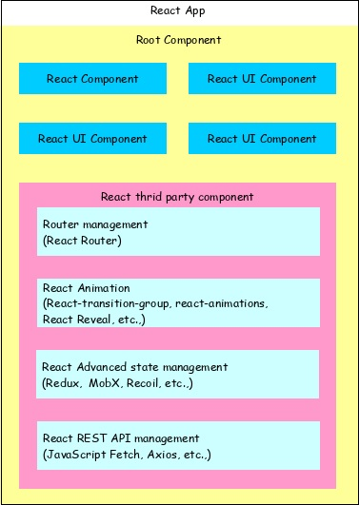
<!DOCTYPE html>
<html>
<head>
<meta charset="UTF-8" />
<title>React Application</title>
</head>
<body>
<div id="react-app">
</div> <script type="module"> import React from 'https://esm.sh/react';
import ReactDOM from 'https://esm.sh/react-dom/client';
function App() { return React.createElement('h1', null, 'Hello React!');
}
const root = ReactDOM.createRoot(document.getElementById('react-app')); root.render(React.createElement(App)); </script>
</body>
</html>

Q2. Modify this code to displlay the sum of two numbers 3+2=5
<!DOCTYPE html>
<html>
<head>
<meta charset="UTF-8" />
<title>React Application</title>
</head>
<body>
<div id="react-app">
</div> <script type="module"> import React from 'https://esm.sh/react';
import ReactDOM from 'https://esm.sh/react-dom/client';
function App() { return React.createElement('h1', null, '3+2=5');
}
const root = ReactDOM.createRoot(document.getElementById('react-app')); root.render(React.createElement(App)); </script>
</body>
</html>

Create element for get
React element or jsx
Root element for the web page
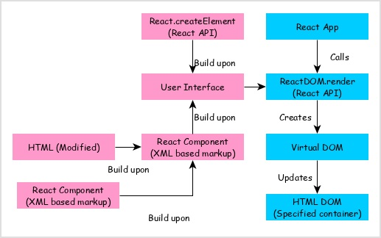
Q3. Create a form to enter marks for 5 subjects along with your rollno and name and display the total and average.

