NODE JS

Node.js is a runtime, similar to Java virtual machine, that converts JavaScript code into machine code.
popular choice for frontend development, application development around MERN (MongoDB, Express, React and Node.js.) and MEAN (MongoDB, Express, Angular and Node.js) stacks
Node.js is used for server-side programming with JavaScript.
Node.js implements asynchronous execution of tasks in a single thread with async and await technique.
Node.js is being used to build command line applications, web applications, real-time chat applications, REST APIs etc.

To create ‘hello, world’ web application using Nodejs
http = require('node:http');
listener = function (request, response) {
// Send the HTTP header
// HTTP Status: 200 : OK
// Content Type: text/html
response.writeHead(200, {'Content-Type': 'text/html'});

// Send the response body as "Hello World"
response.end('<h2 style="text-align: center;">Hello World</h2>');
};

server = http.createServer(listener);
server.listen(3000);

// Console will print the message
console.log('Server running at http://127.0.0.1:3000/');

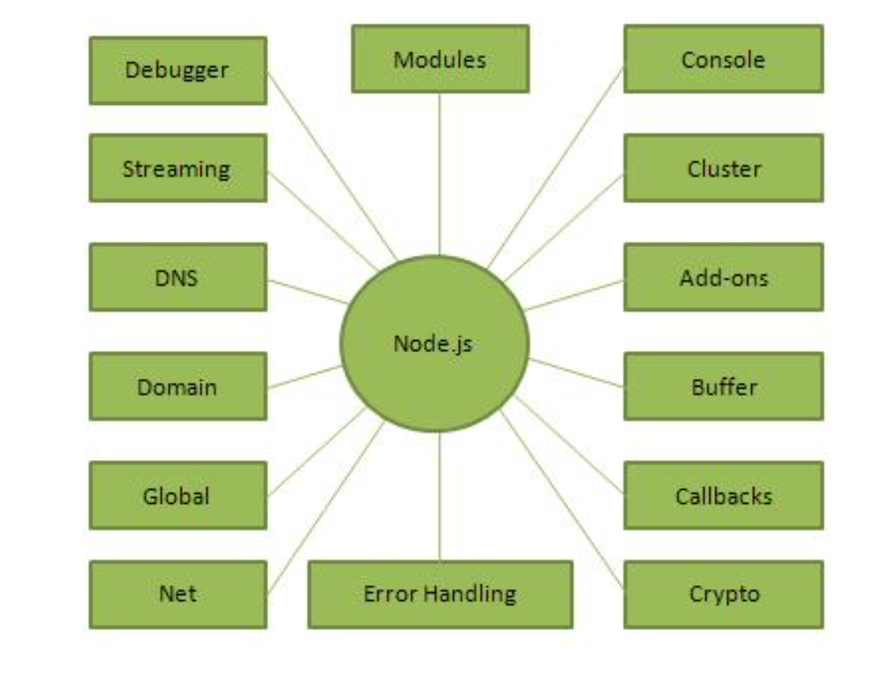

Import Required Module
var http = require("http");
Create Server
http.createServer(requestListener);
The requestlistener function takes request HTTP request and response objects from Node.js runtime, and returns a ServerResponse object.
listener = function (request, response) {
// Send the HTTP header
// HTTP Status: 200 : OK
// Content Type: text/plain
response.writeHead(200, {'Content-Type': 'text/html'});

// Send the response body as "Hello World"
response.end('<h2 style="text-align: center;">Hello World</h2>');
};

Testing Request & Response
http = require('node:http');
listener = function (request, response) {
// Send the HTTP header
// HTTP Status: 200 : OK
// Content Type: text/html
response.writeHead(200, {'Content-Type': 'text/html'});

// Send the response body as "Hello World"
response.end('<h2 style="text-align: center;">Hello World</h2>');
};

server = http.createServer(listener);
server.listen(3000);

// Console will print the message

console.log('Server running at http://127.0.0.1:3000/');

Node.js Architecture:
1. Client Request Phase
- Clients send requests to the Node.js server
- Each request is added to the Event Queue
2. Event Loop Phase
- The Event Loop continuously checks the Event Queue
- Picks up requests one by one in a loop
3. Request Processing
- Simple (non-blocking) tasks are handled immediately by the main thread
- Complex/blocking tasks are offloaded to the Thread Pool
4. Response Phase
- When blocking tasks complete, their callbacks are placed in the Callback Queue
- Event Loop processes callbacks and sends responses

Non-blocking Example :
const fs = require('fs');
console.log('Before file read');
fs.readFile('Marks.txt', 'utf8', (err, data) => {
if (err) throw err;
console.log('File contents:', data);
});
console.log('After file read');

Blocking Code :
console.log('Start of blocking code');
const data = fs.readFileSync('myfile.txt', 'utf8');// Blocks here
console.log('Blocking operation completed');

When to Use Node.js
Node.js is particularly well-suited for:
- I/O-bound applications - File operations, database queries, network requests
- Real-time applications - Chat apps, live notifications, collaboration tools
- APIs - RESTful services, GraphQL APIs
- Microservices - Small, independent services

Note: Node.js may not be the best choice for CPU-intensive tasks as they can block the event loop. For such cases, consider:
- Using worker threads
- Creating a microservice in a more suitable language
- Using native add-ons

Event Loop:
The event loop is what makes Node.js non-blocking and efficient.
It handles asynchronous operations by delegating tasks to the system and processing their results through callbacks, allowing Node.js to manage thousands of concurrent connections with a single thread.

How the Event Loop Works
Node.js follows these steps to handle operations:
- Execute the main script (synchronous code)
- Process any microtasks (Promises, process.nextTick)
- Execute timers (setTimeout, setInterval)
- Run I/O callbacks (file system, network operations)
- Process setImmediate callbacks
- Handle close events (like socket.on('close'))
Example: Event Loop Order :
console.log('First');
setTimeout(() => console.log('Third'), 0);
Promise.resolve().then(() => console.log('Second'));
console.log('Fourth');

Event Loop Phases
The event loop processes different types of callbacks in this order:
- Timers: setTimeout, setInterval
- I/O Callbacks: Completed I/O operations
- Poll: Retrieve new I/O events
- Check: setImmediate callbacks
- Close: Cleanup callbacks (like socket.on('close'))

Note: Between each phase, Node.js runs microtasks (Promises) and process.nextTick callbacks.

Event Loop Phases
console.log('1. Start');
// Next tick queue
process.nextTick(() => console.log('2. Next tick'));
// Microtask queue (Promise)
Promise.resolve().then(() => console.log('3. Promise'));
// Timer phase
setTimeout(() => console.log('4. Timeout'), 0);
// Check phase
setImmediate(() => console.log('5. Immediate'));
console.log('6. End');
The output will be:
1. Start
6. End
2. Next tick
3. Promise
4. Timeout
5. Immediate

Promises:
const fs = require('fs').promises;
console.log('1. Reading file...');
fs.readFile('myfile.txt', 'utf8')
.then(data => {
console.log('3. File content:', data);
})
.catch(err => console.error('Error:', err));
console.log('2. This runs before file is read!');

2. Async/Await (Recommended)
async function readFiles() {
try {
console.log('1. Starting to read files...');
const data1 = await fs.readFile('Marks.txt', 'utf8');
const data2 = await fs.readFile('personal.txt', 'utf8');
console.log('2. Files read successfully!');
return { data1, data2 };
} catch (error) {
console.error('Error reading files:', error);
}
}

Key Takeaways
- Use async/await for better readability
- Always handle errors with try/catch
- Run independent operations in parallel with Promise.all
- Avoid mixing sync and async code patterns
- Don't forget to await promises

Modules

HTTP Module:
Key Features
- Create HTTP servers to handle requests and send responses
- Make HTTP requests to other servers
- Handle different HTTP methods (GET, POST, PUT, DELETE, etc.)
- Work with request and response headers
- Handle streaming data for large payloads

Including the HTTP Module:
To use the HTTP module, include it in your application using the require() method:
// Using CommonJS require (Node.js default)
const http = require('http');

Basic HTTP Server Example:
// Import the HTTP module
const http = require('http');
// Create a server object
const server = http.createServer((req, res) => {
// Set the response HTTP header with HTTP status and Content type
res.writeHead(200, { 'Content-Type': 'text/plain' });
// Send the response body as 'Hello, World!'
res.end('Hello, World!\n');
});
// Define the port to listen on const PORT = 3000;
// Start the server and listen on the specified port
server.listen(PORT, 'localhost', () => {
console.log(`Server running at http://localhost:${PORT}/`);
});

Understanding the Code
- http.createServer() - Creates a new HTTP server instance
- The callback function is executed for each request with two parameters:
- req - The request object (http.IncomingMessage)
- res - The response object (http.ServerResponse)
- res.writeHead() - Sets the response status code and headers
- res.end() - Sends the response and ends the connection
- server.listen() - Starts the server on the specified port

Working with HTTP Headers

Setting Multiple Headers :
const http = require('http');
const server = http.createServer((req, res) => {
// Set status code and multiple headers
res.writeHead(200, {
'Content-Type': 'text/html',
'X-Powered-By': 'Node.js',
'Cache-Control': 'no-cache, no-store, must-revalidate',
'Set-Cookie': 'sessionid=abc123; HttpOnly'
});
res.end('<h1>Hello, World!</h1>');
});
server.listen(3000, () => {
console.log('Server running at http://localhost:3000/');
});
Code | Message | Description
200 | OK | Standard response for successful HTTP requests
201 | Created | Request has been fulfilled and new resource created
301 | Moved Permanently | Resource has been moved to a new URL
400 | Bad Request | Server cannot process the request due to client error
401 | Unauthorized | Authentication is required
403 | Forbidden | Server refuses to authorize the request
404 | Not Found | Requested resource could not be found
500 | Internal Server Error | Unexpected condition was encountered

Common HTTP Status Codes

Common Response Headers:
- Content-Type: Specifies the media type of the content (e.g., text/html, application/json)
- Content-Length: The length of the response body in bytes
- Location: Used in redirects (with 3xx status codes)
- Set-Cookie: Sets HTTP cookies on the client
- Cache-Control: Directives for caching mechanisms
- Access-Control-Allow-Origin: For CORS support

Working with URLs and Query Strings:
Accessing the Request URL
The req.url property contains the URL string that was requested, including any query parameters.
This is part of the http.IncomingMessage object.

Basic URL Handling:
const http = require('http');
const server = http.createServer((req, res) => {
// Get the URL and HTTP method
const { url, method } = req;
res.writeHead(200, { 'Content-Type': 'text/plain' });
res.end(`You made a ${method} request to ${url}`);
});
server.listen(3000, () => {
console.log('Server running at http://localhost:3000/');
});
Express.js

Key Characteristics:
- Minimal and flexible
- Unopinionated (you decide how to structure your app)
- Lightweight and fast
- Extensible through middleware
- Huge ecosystem of plugins and extensions

Why Choose Express.js?
It offers:
- A robust routing system
- HTTP helpers (redirection, caching, etc.)
- Support for middleware to respond to HTTP requests
- A templating engine for dynamic HTML rendering
- Error handling middleware

Frontend, middleware, backend
Express js code reference:
const express = require('express');
const app = express();
const port = 8080;

HTTP METHODS:
- app.get() - Handle GET requests
- app.post() - Handle POST requests
- app.put() - Handle PUT requests
- app.delete() - Handle DELETE requests
- app.all() - Handle all HTTP methods

Example:
const express = require('express');
const app = express();
const port = 8080;
// Respond to GET request on the root route
app.get('/', (req, res) => {
res.send('GET request to the homepage');
});
// Respond to POST request on the root route
app.post('/', (req, res) => {
res.send('POST request to the homepage');
});
// Respond to GET request on the /about route
app.get('/about', (req, res) => {
res.send('About page');
});
// Catch all other routes
app.all('*', (req, res) => {
res.status(404).send('404 - Page not found');
});
// Start the server
app.listen(port, () => {
console.log(`Example app listening at http://localhost:${port}`);
});

Route Parameters
They are specified in the path with a colon : prefix.
Route parameters that can be accessed via req.params.

Write the code in express for accessingAadhaar no., and name
const express = require('express');
const bodyParser = require('body-parser');

const app = express();
const PORT = 3000;

// Middleware to parse JSON data from request body
app.use(bodyParser.json());

// Route to accept Aadhaar number and name
app.post('/submit', (req, res) => {
const { aadhaar, name } = req.body;

if (!aadhaar || !name) {
return res.status(400).json({ message: 'Aadhaar number and name are required' });
}

// ⚠️ In real apps: validate and secure this data
console.log('Received data:');
console.log('Aadhaar Number:', aadhaar);
console.log('Name:', name);

res.json({
message: 'Data received successfully',
data: { aadhaar, name }
});
});

// Home route
app.get('/', (req, res) => {
res.send('Welcome! Use POST /submit with JSON { "aadhaar": "...", "name": "..." }');
});

app.listen(PORT, () => {
console.log(`Server running on http://localhost:${PORT}`);
});

Query Parameters
key-value pairs that appear after the ? in a URL.
parsed by Express and available in req.query.

Example:

// Route handling query parameters
app.get('/search', (req, res) => {
// Access query parameters using req.query
const { q, category } = req.query;
res.send(`Search query: ${q}, Category: ${category || 'none'}`);
});
MongoDB Insert
Example
Insert a document in the "students" collection:

let MongoClient = require('mongodb').MongoClient;
let url = "mongodb://localhost:27017/";
MongoClient.connect(url, function(err, db) {
if (err) throw err;
let dbo = db.db("schooldb");
let myobj = { name: "DPS", address: "CG04" };
dbo.collection("students").insertOne(myobj, function(err, res) {
if (err) throw err;
console.log("1 document inserted");
db.close();
});
});

Insert Multiple Documents
use the insertMany() method
Example
Insert multiple documents in the "customers" collection:
let MongoClient = require('mongodb').MongoClient;
let url = "mongodb://localhost:27017/";
MongoClient.connect(url, function(err, db) {
if (err) throw err;
let dbo = db.db("schooldb");
let myobj = [
{ name: 'John', address: 'Highway 71'},
{ name: 'Peter', address: 'Lowstreet 4'},
{ name: 'Amy', address: 'Apple st 652'},
];
dbo.collection("students").insertMany(myobj, function(err, res) {
if (err) throw err;
console.log("Number of documents inserted: " + res.insertedCount);
db.close();
});
});
The Result Object
When executing the insertMany() method, a result object is returned.
Example
Return the number of inserted documents:
console.log(res.insertedCount)

MongoDB Find

Example
Find the first document in the customers collection:
let MongoClient = require('mongodb').MongoClient;
let url = "mongodb://localhost:27017/";
MongoClient.connect(url, function(err, db) {
if (err) throw err;
let dbo = db.db("mydb");
dbo.collection("customers").findOne({}, function(err, result) {
if (err) throw err;
console.log(result.name);
db.close();
});
});

Example
Find all documents in the customers collection:
let MongoClient = require('mongodb').MongoClient;
let url = "mongodb://localhost:27017/";
MongoClient.connect(url, function(err, db) {
if (err) throw err;
let dbo = db.db("mydb");
dbo.collection("customers").find({}).toArray(function(err, result) {
if (err) throw err;
console.log(result);
db.close();
});
});

Find Some
Example
Return the fields "name" and "address" of all documents in the customers collection:
let MongoClient = require('mongodb').MongoClient;
let url = "mongodb://localhost:27017/";
MongoClient.connect(url, function(err, db) {
if (err) throw err;
let dbo = db.db("mydb");
dbo.collection("customers").find({}, { projection: { _id: 0, name: 1, address: 1 } }).toArray(function(err, result) {
if (err) throw err;
console.log(result);
db.close();
});
});

Example
This example will exclude "address" from the result:
let MongoClient = require('mongodb').MongoClient;
let url = "mongodb://localhost:27017/";
MongoClient.connect(url, function(err, db) {
if (err) throw err;
let dbo = db.db("mydb");
dbo.collection("customers").find({}, { projection: { address: 0 } }).toArray(function(err, result) {
if (err) throw err;
console.log(result);
db.close();
});
});

Modify the code to exclude a column in the output
let MongoClient = require('mongodb').MongoClient;
let url = "mongodb://localhost:27017/";
MongoClient.connect(url, function(err, db) {
if (err) throw err;
let dbo = db.db("mydb");
dbo.collection("customers").find({}, { projection: { column: 0 } }).toArray(function(err, result) {
if (err) throw err;
console.log(result);
db.close();
});
});

MongoDB Update

updateOne() method:
let myquery = { address: "Valley 345" };
let newvalues = { $set: {name: "Mickey", address: "Canyon 123" } };
dbo.collection("customers").updateOne(myquery, newvalues, function(err, res)

