MongoDB

KEYWORDS:
- Database is a physical container for collections.
- Collection is a group of MongoDB documents. It is the equivalent of an RDBMS table.
- A document is a set of key-value pairs. Documents have dynamic schema.

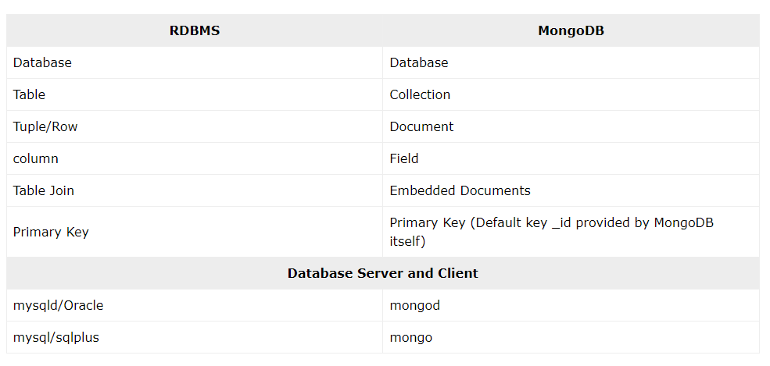

_id is a 12 bytes hexadecimal number which assures the uniqueness of every document.

CMD
- Mongod
- Mongosh
- Use databasename
- Db.createcollection(‘collection_name/excel_sheet name’)
- Db.collection_name.insertOne({})
- Show collections
- Db.name.find()
- Db.name.insertMany([{}])
- Updation: db.name.UpdateOne({‘name’:’Abdul’},{$set:{‘name’:’Shiva’}})
- Deletion: db.name.deleteOne({‘name’:’Arun’})

Create a collection named BillDetail
Db.createCollection(“BillDetail”)
The bill details contain bill no., Vendor name, date of delivery, bill value.
db.BillDetail.insertMany([{“billno”:1,”vendorname”:”jay”,”dod”:12.07.2025,”billvalue”:12345}])

Display the information in the collection
Db.billdetails.find()

Update the bill no. of any bill with its new bill value
Db.billdetails.updateOne({‘billno’:1},{$set:{‘billno’:2}})

Display the bill details of a specific bill no
Db.billdetails.find(billnoi[2])

Delete a record based on a column value
Db.billdetail.deleteOne({‘billno’:1})

INDEX
Disadvantages: read/write operation will affect the indexing and can introduce delay
Display indexes: dc.collection.indexes()

Create an index for the collection billno
Db.billdetails.createIndex({“billno”:1},{unique:true})

Display seven records from your collection
Db.billdetails.find().limit(7)
Display all the bills less than 1000
Db.billdetails.find({billvalue:{$lte:1000}})

Display the bills whose bill value is less than 1000 or its bill no is 101
Db.billdetails.find({$or:[{bill: {$lt:1000}},{billno:101}]})

Display the bill details whose bill value is greater than 1000
db.billdetails.find({ bill_value: { $gt: 1000 } })

Display the bill details whose bill value is greater than 1000
db.bills.find({ bill_value: { $lt: 1000 } })

Display the bill details whose billno is 101 and bill value is greater than 100
db.bills.find({ $and: [{ billno: 101 }, { bill_value: { $gt: 100 } } ]})

SUBSTRING
Display the records from the bill master table by displaying 1st two positions in the billno, 2nd to 4th position in the date

Db.collection.count()

Limit
Count
Skip

Db.collection.aggregate()
Db.billdetails.aggregate([$billAmount:{billno:”$billno”,count:{$sum:1}}])
[{billno:1, count:2},{billno:2,count:4},{billno:3,count:8}]
AVG
Db.billdetails.aggregate([{$group:{billdetail:”$bill_detail”,bill_detail:{$avg:”$Amount”},count:{$sum:1}}}])

Demonstrate the operations learnt in MongoDB in the form chosen

