CSS
HTML Layouts
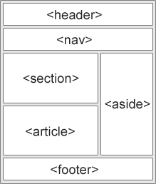
- <header> - Defines a header for a document or a section
- <nav> - Defines a set of navigation links
- <section> - Defines a section in a document
- <article> - Defines independent, self-contained content
- <aside> - Defines content aside from the content (like a sidebar)
- <footer> - Defines a footer for a document or a section
- <details> - Defines additional details that the user can open and close on demand
- <summary> - Defines a heading for the <details> element
Floating layout
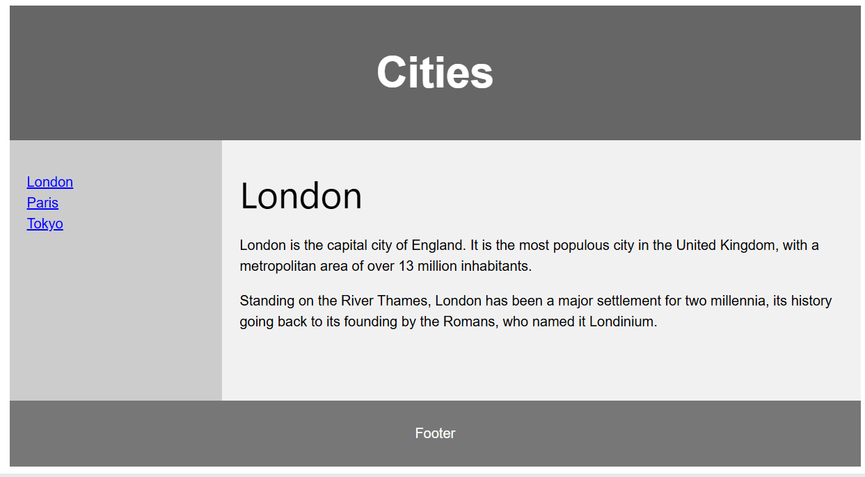
Flex-box Layout(adaptive)
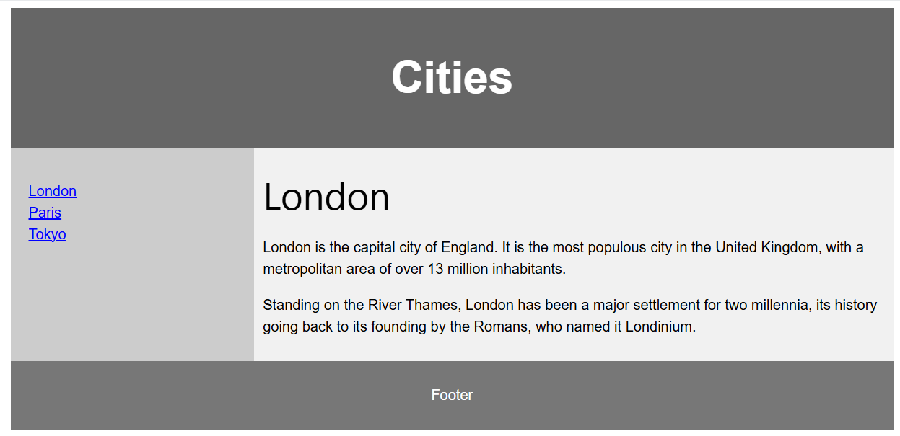
Grid Layout
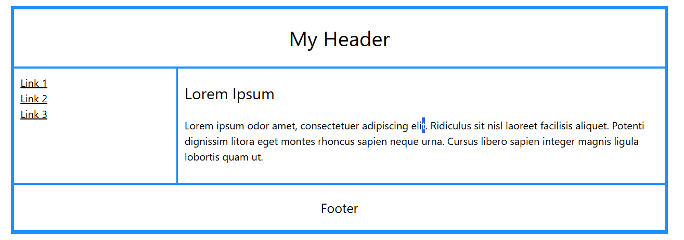

layout they are using:
1)Banking domain-flex box
2)shopping-flexbox and grid
3)college websites-flexbox/grid
Limitations of these layouts
1)float
❌ Not meant for complex layouts
- Difficult to create multi-column or responsive designs.
- Requires “clearfix” hacks to prevent container collapse.
❌ Poor alignment control
- No easy way to center items vertically or horizontally.
- No control over spacing or distribution.
❌ Layout breaks easily
- Float elements can overlap or break when content size changes.
❌ Requires many hacks
- clear, clear fix, and manual width settings make layouts brittle.
2)flex
❌ One-direction at a time
- Flexbox handles layout in either a row OR a column — not both simultaneously.
- Not ideal for entire page layout.
❌ Complex when scaling to large grids
- Hard to create large, structured layouts like dashboards.
- Items may wrap unpredictably.
❌ No control over row and column alignment together
- You can align along the main axis or cross axis, but not a full 2D matrix.
❌ Performance issues with many items
- Large numbers of flex items can cause rendering slowdowns.

3)grid
❌ Not supported by all legacy browsers
- Older browsers (IE11 partial support) cause issues.
❌ Overkill for simple layouts
- Using Grid when only one direction is needed can add unnecessary complexity.
❌ Learning curve
- Concepts like line-based placement, template areas, and implicit grid can be challenging.
❌ Items may not behave intuitively
- Auto-placement might put items where you don’t expect.
- Explicit vs implicit grid areas can confuse beginners.
❌ Harder when content size is unpredictable
- Grids may break if content grows beyond expected sizes.

Scripting
1)Client side scripting(button)
2)Server side scripting(button type=submit)connect to server

Difference between type script and java script
Feature | TypeScript | JavaScript
Typing | Provides static typing | Dynamically typed
Tooling | Comes with IDEs and code editors | Limited built-in tooling
Syntax | Similar to JavaScript, with additional features | Standard JavaScript syntax
Compatibility | Backward compatible with JavaScript | Cannot run TypeScript in JavaScript files
Debugging | Stronger typing can help identify errors | May require more debugging and testing
Learning curve | Can take time to learn additional features | Standard JavaScript syntax is familiar

December -02
Difference between get and post methods
Validation example: empty
not empty
validations like email or roll no
Control Name | Purpose | Validation/custom validation
empty
Non empty
Email or roll no validation
Date not today and not after that for dob
Design -1: mark ,validations ,function to write (emp salary calculation if hre given then total salary ,coding using ReactJS, scripting using JavaScript)-mid term
Insert, delete, update, search, display-crud operations

