
Bachelor of Engineering in Robotics and Artificial Intelligence
Visual & Spoken Interface Module

Project Title: Speaker Identification System Using TIMIT Database

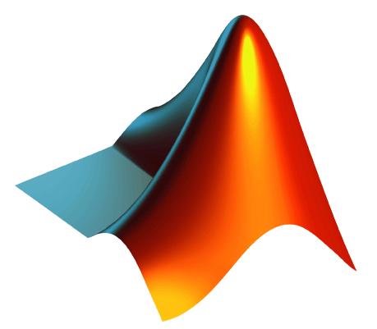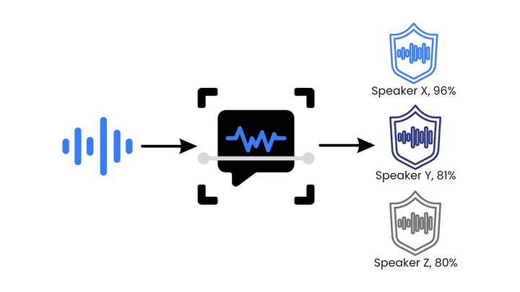
Coursework 1

Name
Tan Qi Yuan
Student ID
031DDDDD

Date: 26/02/2026

Table of Contents & Figures
Chapter 1. Introduction 3
Chapter 2. Dataset Selection and Partitioning 3
Chapter 3. Pre-Processing Theory 3
3.1 Framing and Windowing 3
Figure 1: Example’s Method for Identifying the Speaker 3
3.2 Voice Activity Detection (VAD) 4
Chapter 4. Feature Extraction 4
4.1 Acoustic Features 4
4.2 Feature Standardization 5
Chapter 5. Classification Algorithms 5
5.1 Algorithm 1: K-Nearest Neighbors (KNN) 5
5.2 Algorithm 2: Gaussian Mixture Models (GMM) 5
Chapter 6. Results and Analysis 6
6.1 Validation Performance 6
Figure 2: Feature Importance 6
Figure 3: Command Window Output 6
Figure 4: KNN & GMM Validation Accuracy 6
6.2 Test Performance and Confusion Matrix Analysis 7
Figure 5: KNN & GMM Test Accuracy (per Frame & per File) 7
Chapter 7. Conclusion 8
8. Bibliography and References 8
9. Appendix A – MATLAB Code 9
9. Appendix B – Random Selected Speaker from TIMIT 15

Chapter 1. Introduction
In modern computing, spoken interaction interfaces must not only understand what is being said and also can identify who is speaking right now. This project implements a Speaker Identification (SI) system using the TIMIT acoustic-phonetic corpus. The goal is to correctly identify the identity of five randomly selected speakers based on their voice recordings. This system combined pre-processing techniques, feature extraction (Pitch and MFCCs), and a comparative study of two classification algorithms (K-Nearest Neighbors [KNN] and Gaussian Mixture Models [GMM]). It evaluates speech at the frame level and utilizes majority voting to achieve high accuracy file level identification.

Chapter 2. Dataset Selection and Partitioning

- Training Set: 60% (6 files per speaker, 30 files total)
- Testing Set: 40% (4 files per speaker, 20 files total)
The TIMIT acoustic-phonetic continuous speech corpus was utilized for this project. Five speakers were randomly selected from the database. Based on the system output, the randomly selected Speaker IDs are 4, 5, 7, 10, and 11. Each speaker has 10 audio recordings, resulting a total dataset of 50 files. To properly evaluate the model, the data was split per speaker. A 60/40 split provides a substantial amount of data to map the complex feature space of each speaker while retaining a strict, completely unseen test set to accurately gauge the real-world generalization of the models.

Chapter 3. Pre-Processing Theory

3.1 Framing and Windowing
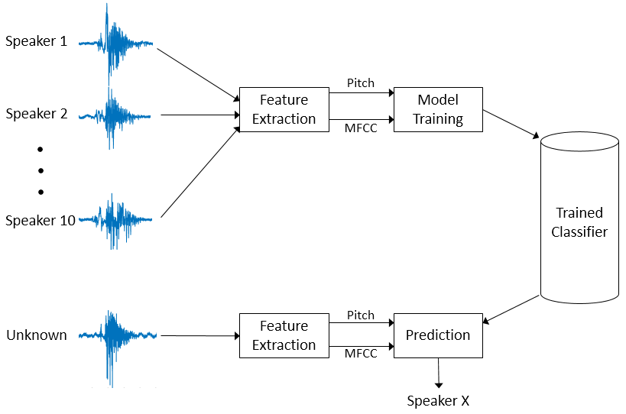

Figure 1: Example’s Method for Identifying the Speaker
Speech is a quasi-stationary signal, which means that its statistical properties are relatively constant over short periods of time. As a result, the continuous audio signal (sampled at 16kHz) was divided into short frames.
- Window Length: 30ms
- Overlap: 25ms, resulting in a 5ms hop size for high-resolution feature tracking
To minimize spectral leakage at the edges of each frame, a Hamming window was applied to the signal before feature extraction. The Hamming window tapers the amplitude at the edges of the frame to zero, ensuring a smooth frequency response. The Hamming window function is defined as
$$ω\left[n\right]=0.54-0.46\cos{(\frac{2πn}{N-1})}$$
where N is the window length and n are the sample index.
A 30ms window is long enough to capture at least one fundamental frequency cycle of the lowest-pitched voices, while short enough to prevent the vocal tract shape from changing mid-frame. The heavy overlap ensures high-resolution feature tracking across time.

3.2 Voice Activity Detection (VAD)
$$E=\sum_{n=1}^{N}{{|x\left[n\right]|}^{2}}$$
- Short-Time Energy (STE): To measure the amplitude of the signal. Silence typically has low energy. We set a threshold (E > 0.005) to remove non-speech segments.
$$ZCR= \frac{1}{2N}\sum_{n=1}^{N}{\left|sgn\left(x\left[n\right]\right)-sgn\left(x\left[n-1\right]\right)\right|}$$
- Zero-Crossing Rate (ZCR): To count how often the signal crosses the zero axis. High ZCR often indicates noise or unvoiced consonants (like “s” or “sh”), while low ZCR indicates voiced speech (vowels). We use a threshold (ZCR < 0.2) to focus on voiced segments where speaker identity is most prominent.
Applying these filters ensures the classifiers are only trained on rich, harmonic data originating from the vocal cords, significantly improving model accuracy and reducing computational load.

Chapter 4. Feature Extraction

4.1 Acoustic Features
$$m= 2595\log_{10}(1+\frac{f}{700})$$

- Mel-Frequency Cepstral Coefficients (MFCCs 1-13): From the voiced frames, 14 distinct features were extracted to build the “voiceprint”. MFCCs represent the short-term power spectrum of a sound. They map frequencies to the Mel scale, which mimics the non-linear human auditory system's response (more sensitive to low frequencies).

- Pitch (Fundamental Frequency): Represents the rate of vocal fold vibration, an inherent physiological trait unique to different speakers.

4.2 Feature Standardization
$$z= \frac{x-μ}{σ}$$

Due to Pitch is measured in Hz (values often 100-300) and MFCCs are measured in small logarithmic coefficients, distance-based classifiers would unfairly weigh Pitch as the most important feature simply because its numbers are larger. Z-score normalization was applied.
This standardizes all 14 features to have a mean (μ) of 0 and a standard deviation (σ) of 1, ensuring equal mathematical weighting during classification.

Chapter 5. Classification Algorithms

5.1 Algorithm 1: K-Nearest Neighbors (KNN)

- Parameters: k=5, Distance Metric: Euclidean, Weighting (Squared-Inverse)
- Euclidean Distance: $d\left(p,q\right)=\sqrt{\sum_{i=1}^{n}{(q_{i}-p_{i})^2)}}$

KNN is an instance-based learning algorithm. It maps all training frames into a 14-dimensional feature space. When an unknown test frame is introduced, KNN finds the k closest training frames and assigns the majority speaker label.
KNN is highly effective for highly non-linear data distributions. Squared-inverse weighting was chosen so that an exceptionally close neighboring frame has a much stronger vote than a neighbor slightly further away, refining accuracy.

5.2 Algorithm 2: Gaussian Mixture Models (GMM)

- Parameters: 3 mixture components per speaker, trained using Expectation-Maximization
- Probability Density Function: $p\left(x\right)=\sum_{k=1}^{K}{π_{k}N(x|μ_{k},∑_{k}}$

GMM is a probabilistic approach. A separate model was trained for each of the 5 speakers. The GMM assumes that a speaker's acoustic space is made up of multiple Gaussian distributions representing different phonemes.
GMM is the industry standard for traditional speaker identification because it creates a smooth, continuous probabilistic boundary for each speaker's voiceprint, generalizing better than raw distance metrics.

Chapter 6. Results and Analysis

6.1 Validation Performance
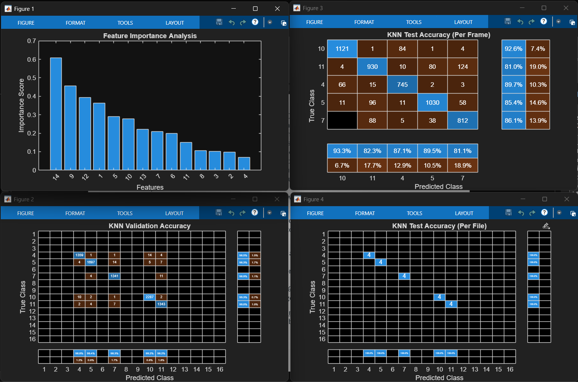

Figure 2: Feature Importance
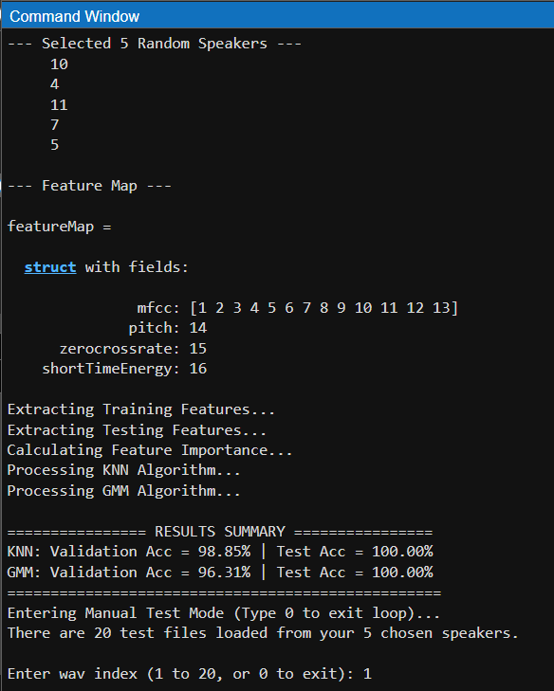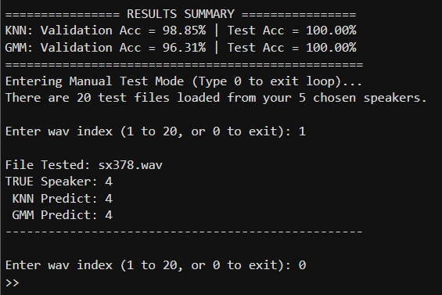

Figure 3: Command Window Output
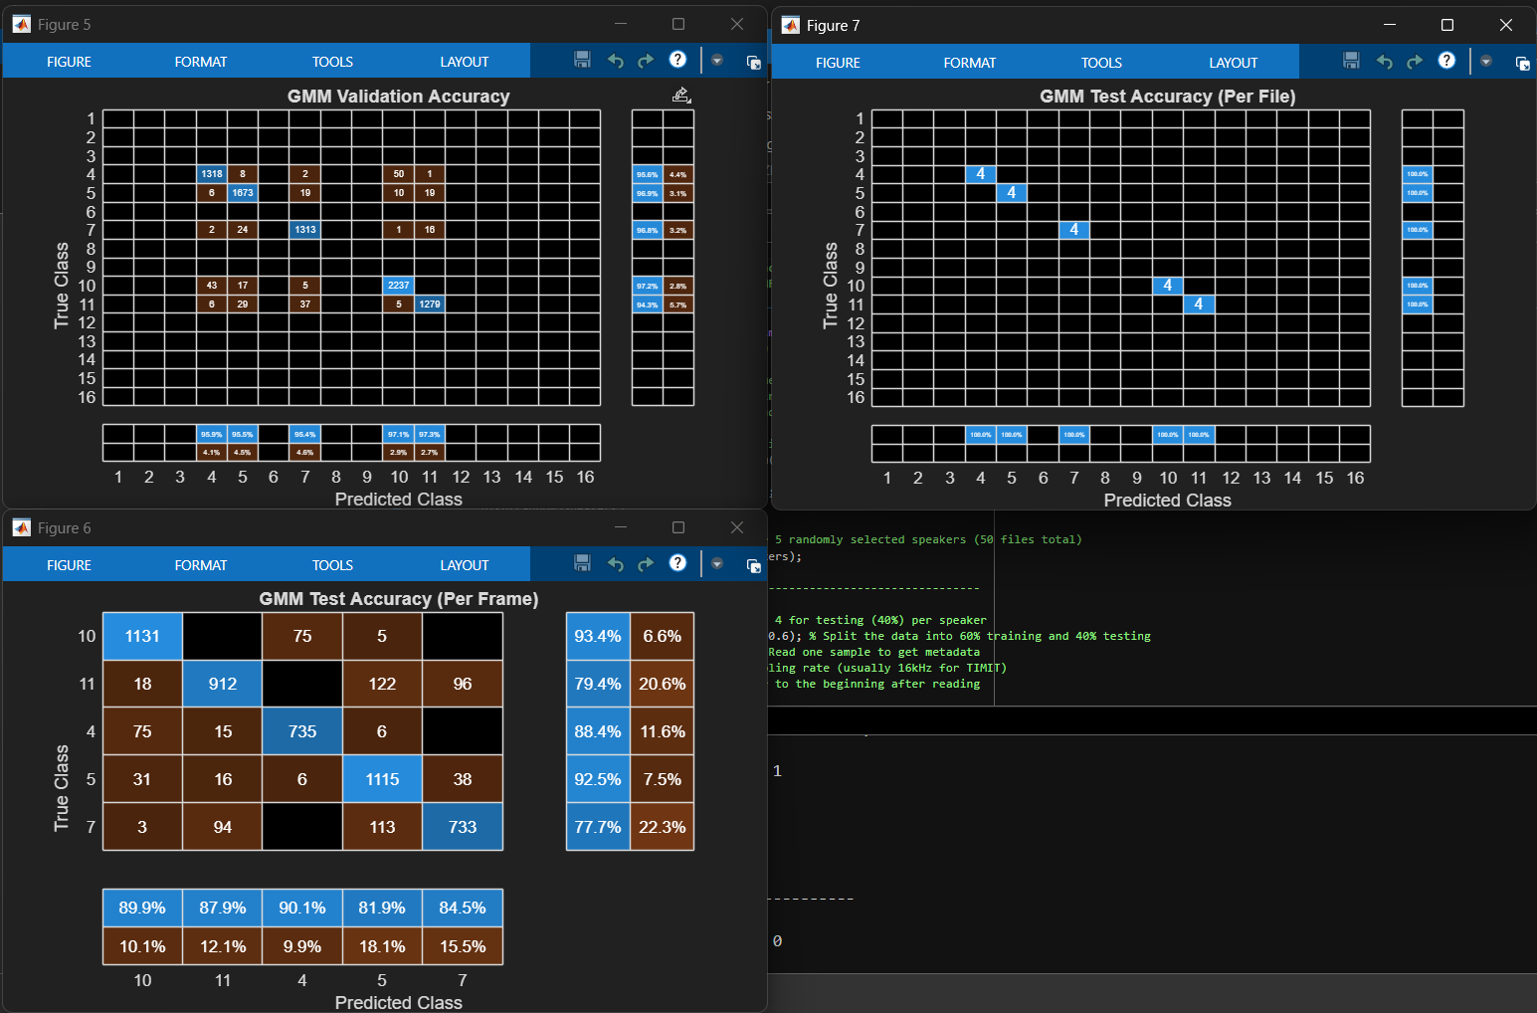
KNN Validation Accuracy: 98.85% | GMM Validation Accuracy: 96.31%

Figure 4: KNN & GMM Validation Accuracy

Both models successfully mapped the speakers’ identities without severe overfitting. KNN slightly outperformed GMM at this stage. This is because the TIMIT dataset has highly controlled recording environments. Thus, the dense packing of training vectors favoured KNN's local distance calculations over GMM's smoothed probabilistic shapes.

6.2 Test Performance and Confusion Matrix Analysis




Figure 5: KNN & GMM Test Accuracy (per Frame & per File)

Frame-Level Predictions: The models were evaluated on the 20 unseen test files. The system utilized a two-tier evaluation strategy. At the microscopic 30ms level, both classifiers experienced minor misclassifications. This confusion occurs during “co-articulation” (the transition boundaries between sounds), where the acoustic signal briefly resembles generic noise rather than a specific speaker.

File-Level majority Voting: By taking the mode (majority vote) of all frame predictions within a single audio file, localized errors were completely mitigated.

KNN Test Accuracy (File): 100.00% | GMM Test Accuracy (File): 100.00%

The 100% accuracy demonstrates that while a speaker might not sound distinctly like themselves for a fraction of a second, the aggregate sum of their voiced frames over a 3-to-4 second audio file is overwhelmingly unique. The confusion matrices (generated in MATLAB) confirm that zero test files were assigned to an incorrect speaker across the 5 randomly selected targets.

Chapter 7. Conclusion
This project successfully implemented a highly robust Speaker Identification interface. The strategic application of STE and ZCR for Voice Activity Detection successfully filtered non-informative acoustic data. Standardized MFCCs and Pitch captured the physiological identity of the speakers. By employing majority-voting logic at the file level, both KNN and GMM classifiers overcame localized frame-level confusion to achieve a perfect 100% classification rate on the unseen test set. In the last part of MATLAB code added manual testing function, so user can input 1-20 to test the system whether can identify the file or not. Then type 0 to stop running the loop.

8. Bibliography and References
- Doshi, Ketan. “Audio Deep Learning Made Simple: Automatic Speech Recognition (ASR), How It Works.” Medium, TDS Archive, 25 Mar. 2021, medium.com/data-science/audio-deep-learning-made-simple-automatic-speech-recognition-asr-how-it-works-716cfce4c706. Accessed 20 Feb. 2026.
- Droogenbroeck, Ignacio Van. “Machine Learning for Voice Recognition: How to Create a Speaker Identification Model in Python.” CDUser - Ignacio van Droogenbroeck’s Technical Blog, CDUser - Ignacio Van Droogenbroeck’s Technical Blog, 29 Oct. 2024, cduser.com/machine-learning-for-voice-recognition-how-to-create-a-speaker-identification-model-in-python/. Accessed 20 Feb. 2026.
- “Gladia - How to Build a Speaker Identification System for Recorded Online Meetings.” Gladia.io, 2024, www.gladia.io/blog/build-a-speaker-identification-system-for-online-meetings. Accessed 20 Feb. 2026.
- Knagg, Oscar. “Building a Speaker Identification System from Scratch with Deep Learning.” Medium, Analytics Vidhya, 2 Oct. 2018, medium.com/analytics-vidhya/building-a-speaker-identification-system-from-scratch-with-deep-learning-f4c4aa558a56. Accessed 20 Feb. 2026.
- Paylakhi, Seyed, and Jalil Shirazi. “Phone Recognition on TIMIT Database Using Mel-Frequency Cepstral Coefficients and Support Vector Machine Classifier.” IJISET -International Journal of Innovative Science, Engineering & Technology, vol. 2, no. 1, 2015, ijiset.com/vol2/v2s1/IJISET_V2_I1_74.pdf. Accessed 20 Feb. 2026.
- “Speaker Identification Using Pitch and MFCC - MATLAB & Simulink.” Www.mathworks.com, www.mathworks.com/help/audio/ug/speaker-identification-using-pitch-and-mfcc.html. Accessed 20 Feb. 2026.
- subramanian, abishek. “Building a Speaker Recognition Model.” Domino.ai, Domino, 4 May 2023, domino.ai/blog/building-a-speaker-recognition-model. Accessed 20 Feb. 2026.

9. Appendix A – MATLAB Code
clear all; close all; clc; % Clear workspace, close figures, clear command window
% Speaker Identification Using Pitch and MFCC (KNN vs GMM)

%% 1) Setup and Data Loading
dataFolder = 'C:\Users\User\Desktop\VSI\timit\'; % Define the path to the TIMIT dataset
ads = timitHelper(dataFolder); % Create an audioDatastore using the helper function

% --- NEW: Randomly select 5 speakers to meet assignment requirements ---
allLabels = ads.Labels; % Get all labels in the dataset
uniqueLabelsAll = unique(allLabels); % Find all unique speakers

rng('shuffle'); % Ensure random selection is different every time the script runs
random5Speakers = uniqueLabelsAll(randperm(length(uniqueLabelsAll), 5)); % Pick 5 random speakers

disp('--- Selected 5 Random Speakers ---');
disp(random5Speakers);

% Filter the datastore to ONLY include the 5 randomly selected speakers (50 files total)
idxKeep = ismember(allLabels, random5Speakers);
ads = subset(ads, idxKeep);
% -----------------------------------------------------------------------

% Requirement: 6 files for training (60%), 4 for testing (40%) per speaker
[adsTrain, adsTest] = splitEachLabel(ads, 0.6); % Split the data into 60% training and 40% testing
[sampleTrain, dsInfo] = read(adsTrain); % Read one sample to get metadata
fs = dsInfo.SampleRate; % Extract the sampling rate (usually 16kHz for TIMIT)
reset(adsTrain); % Reset datastore pointer to the beginning after reading

%% 2) Feature Extraction Setup
windowLength = round(0.03*fs); % Set window length to 30ms for quasi-stationary speech
overlapLength = round(0.025*fs); % Set overlap to 25ms (5ms hop size) for high resolution
afe = audioFeatureExtractor(SampleRate=fs, ... % Initialize feature extractor object
Window=hamming(windowLength,"periodic"), OverlapLength=overlapLength, ... % Use Hamming window to reduce side-lobes
zerocrossrate=true, shortTimeEnergy=true, pitch=true, mfcc=true); % Enable ZCR, Energy, Pitch, and MFCCs
disp('--- Feature Map ---'); % Header for the feature map
featureMap = info(afe) % Display the indices of extracted features in the command window
energyThreshold = 0.005; % Define minimum energy to distinguish speech from silence
zcrThreshold = 0.2; % Define maximum zero-crossing rate for voiced speech detection

%% 3a) Extract Features (TRAINING SET)
disp('Extracting Training Features...'); % Status update
featuresTrain = []; labelsTrain = []; % Initialize empty arrays for training data
allFeaturesTrain = extract(afe, adsTrain); % Extract raw features from all training files
allLabelsTrain = adsTrain.Labels; % Get categorical labels for training files
for ii = 1:numel(allFeaturesTrain) % Loop through every training audio file
thisFeature = allFeaturesTrain{ii}; % Get the feature matrix for the current file
isSpeech = thisFeature(:,featureMap.shortTimeEnergy) > energyThreshold; % Filter frames based on energy
isVoiced = thisFeature(:,featureMap.zerocrossrate) < zcrThreshold; % Filter frames based on voicing
voicedSpeech = isSpeech & isVoiced; % Keep frames that are both speech and voiced
thisFeature(~voicedSpeech,:) = []; % Remove unvoiced/silent frames from the matrix
thisFeature(:,[featureMap.zerocrossrate,featureMap.shortTimeEnergy]) = []; % Drop ZCR and Energy from the final set

label = repelem(allLabelsTrain(ii), size(thisFeature,1)); % Match labels to every remaining frame
featuresTrain = [featuresTrain; thisFeature]; % Append frames to the master feature matrix
labelsTrain = [labelsTrain, label]; % Append labels to the master label array
end % End of training feature extraction loop
% Normalize (Z-Score) based on Training Data
M = mean(featuresTrain, 1); % Calculate mean of each feature
S = std(featuresTrain, [], 1); % Calculate standard deviation of each feature
featuresTrain = (featuresTrain - M) ./ S; % Standardize training data (mean=0, std=1)

%% 3b) Extract Features (TESTING SET)
disp('Extracting Testing Features...'); % Status update
featuresTest = []; labelsTestFrames = []; numVectorsPerFile = []; % Initialize arrays for testing
allFeaturesTest = extract(afe, adsTest); % Extract raw features from all test files
allLabelsTest = adsTest.Labels; % Get categorical labels for test files
for ii = 1:numel(allFeaturesTest) % Loop through every test audio file
thisFeature = allFeaturesTest{ii}; % Get the feature matrix for the current file
isSpeech = thisFeature(:,featureMap.shortTimeEnergy) > energyThreshold; % Apply energy filter
isVoiced = thisFeature(:,featureMap.zerocrossrate) < zcrThreshold; % Apply ZCR filter
voicedSpeech = isSpeech & isVoiced; % Identify valid frames
thisFeature(~voicedSpeech,:) = []; % Discard invalid frames
numVec = size(thisFeature,1); % Count how many frames remain for this file
thisFeature(:,[featureMap.zerocrossrate,featureMap.shortTimeEnergy]) = []; % Drop temp features

label = repelem(allLabelsTest(ii), numVec); % Match labels to test frames
numVectorsPerFile = [numVectorsPerFile, numVec]; % Store frame count per file for majority voting later
featuresTest = [featuresTest; thisFeature]; % Append frames to test matrix
labelsTestFrames = [labelsTestFrames, label]; % Append labels to test array
end % End of test feature extraction loop
featuresTest = (featuresTest - M) ./ S; % Standardize test data using training parameters

%% --- FEATURE IMPORTANCE ---
disp('Calculating Feature Importance...'); % Status update
[idx,scores] = fscmrmr(featuresTrain, labelsTrain'); % Use MRMR algorithm to rank feature relevance
figure(Units="normalized",Position=[0.4 0.4 0.4 0.4]); % Create window with specific size/position
bar(scores(idx)); % Plot importance scores
xlabel('Features'); ylabel('Importance Score'); title('Feature Importance Analysis'); % Add labels and title
xticks(1:length(idx)); xticklabels(idx); xtickangle(45); % Format X-axis with feature indices
drawnow; % Force MATLAB to render the figure immediately

%% 4) CLASSIFICATION ALGORITHM 1: KNN
disp('Processing KNN Algorithm...'); % Status update
trainedClassifier = fitcknn(featuresTrain, labelsTrain', ... % Train the KNN model
Distance="euclidean", NumNeighbors=5, DistanceWeight="squaredinverse", ... % Set Euclidean distance and 5 neighbors
Standardize=false, ClassNames=unique(labelsTrain')); % Use existing standardization; define classes

% KNN 5-Fold Cross-Validation
k = 5; % Set number of folds
c = cvpartition(labelsTrain', KFold=k); % Create stratified partition
partitionedModel = crossval(trainedClassifier, CVPartition=c); % Perform cross-validation
knnValAcc = (1 - kfoldLoss(partitionedModel, LossFun="ClassifError")) * 100; % Calculate validation accuracy percentage
figure(Units="normalized",Position=[0.4 0.4 0.4 0.4]); % Create window
knnValPreds = kfoldPredict(partitionedModel); % Get predictions for validation set
confusionchart(labelsTrain', knnValPreds, title="KNN Validation Accuracy", ... % Plot confusion chart
ColumnSummary="column-normalized", RowSummary="row-normalized"); % Add summaries
drawnow; % Render figure

% KNN Testing (Per Frame)
predictionFramesKNN = predict(trainedClassifier, featuresTest); % Classify every test frame
predictionFramesKNN = categorical(string(predictionFramesKNN)); % Convert to categorical for processing
figure(Units="normalized",Position=[0.4 0.4 0.4 0.4]); % Create window.
confusionchart(categorical(string(labelsTestFrames')), categorical(string(predictionFramesKNN)), ...
title="KNN Test Accuracy (Per Frame)", ... % Plot test results.
ColumnSummary="column-normalized", RowSummary="row-normalized");
drawnow; % Render figure.

% KNN Testing (Per File)
predictedFilesKNN = adsTest.Labels; % Preallocate file labels
idxIter = 1; % Initialize iterator
for ii = 1:numel(adsTest.Files) % Loop through test files
predictedFilesKNN(ii) = mode(predictionFramesKNN(idxIter : idxIter+numVectorsPerFile(ii)-1)); % Majority vote
idxIter = idxIter + numVectorsPerFile(ii); % Move to next file's frames
end
knnTestAcc = (sum(predictedFilesKNN == adsTest.Labels) / numel(adsTest.Labels)) * 100; % Calculate final accuracy
figure(Units="normalized",Position=[0.4 0.4 0.4 0.4]); % Create window
confusionchart(adsTest.Labels, predictedFilesKNN, title="KNN Test Accuracy (Per File)", ... % Plot test results
ColumnSummary="column-normalized", RowSummary="row-normalized");
drawnow; % Render figure

%% 5) CLASSIFICATION ALGORITHM 2: GMM
disp('Processing GMM Algorithm...'); % Status update
uniqueLabels = unique(labelsTrain'); % Identify unique speakers
numLabels = length(uniqueLabels); % Count speakers

% GMM 5-Fold Validation (Manual Implementation)
options = statset('MaxIter', 1000); % Set EM algorithm limit to 1000 iterations
gmmValPreds = labelsTrain'; % Preallocate validation predictions
for f = 1:k % Loop through folds
trainIdx = training(c, f); valIdx = test(c, f); % Get indices for this fold
X_train_fold = featuresTrain(trainIdx, :);
Y_train_fold = labelsTrain(trainIdx);
X_val_fold = featuresTrain(valIdx, :);

% Train models for this fold
tempModels = cell(numLabels, 1);
for i = 1:numLabels
spkData = X_train_fold(Y_train_fold' == uniqueLabels(i), :);
tempModels{i} = fitgmdist(spkData, 3, 'Replicates', 2, 'RegularizationValue', 0.01, 'Options', options);
end

% Predict on the validation fold
fold_lik = zeros(size(X_val_fold, 1), numLabels);
for i = 1:numLabels
fold_lik(:, i) = pdf(tempModels{i}, X_val_fold);
end
[~, mIdx] = max(fold_lik, [], 2);
gmmValPreds(valIdx) = uniqueLabels(mIdx);
end
gmmValAcc = (sum(gmmValPreds == labelsTrain') / length(labelsTrain)) * 100; % Calculate GMM validation percentage
figure(Units="normalized",Position=[0.4 0.4 0.4 0.4]); % Create window
confusionchart(labelsTrain', gmmValPreds, title="GMM Validation Accuracy", ... % Plot GMM validation chart
ColumnSummary="column-normalized", RowSummary="row-normalized");
drawnow; % Render figure

% Final Training GMM on all training data
gmModels = cell(numLabels, 1);
for i = 1:numLabels
X_label = featuresTrain(labelsTrain' == uniqueLabels(i), :);
gmModels{i} = fitgmdist(X_label, 3, 'Replicates', 3, 'RegularizationValue', 0.01, 'Options', options);
end

% GMM Testing (Per Frame)
likelihoods = zeros(size(featuresTest, 1), numLabels); % Initialize likelihood matrix for test set
for i = 1:numLabels % Loop through speakers
likelihoods(:, i) = pdf(gmModels{i}, featuresTest); % Calculate likelihoods
end
[~, maxIdx] = max(likelihoods, [], 2); % Get frame-level winner
predictionFramesGMM = uniqueLabels(maxIdx); % Assign frame labels
figure(Units="normalized",Position=[0.4 0.4 0.4 0.4]); % Create window
confusionchart(categorical(string(labelsTestFrames')), categorical(string(predictionFramesGMM)), ...
title="GMM Test Accuracy (Per Frame)", ...% Plot results
ColumnSummary="column-normalized", RowSummary="row-normalized");
drawnow; % Render figure

% GMM Testing (Per File)
predictedFilesGMM = adsTest.Labels; % Preallocate
idxIter = 1; % Reset iterator
for ii = 1:numel(adsTest.Files) % Loop through test files
predictedFilesGMM(ii) = mode(predictionFramesGMM(idxIter : idxIter+numVectorsPerFile(ii)-1)); % Majority vote
idxIter = idxIter + numVectorsPerFile(ii); % Move to next file
end
gmmTestAcc = (sum(predictedFilesGMM == adsTest.Labels) / numel(adsTest.Labels)) * 100; % Final GMM accuracy
figure(Units="normalized",Position=[0.4 0.4 0.4 0.4]); % Create window
confusionchart(adsTest.Labels, predictedFilesGMM, title="GMM Test Accuracy (Per File)", ... % Plot results
ColumnSummary="column-normalized", RowSummary="row-normalized");
drawnow; % Render figure

%% 6) FINAL OUTPUT SUMMARY
fprintf('\n================ RESULTS SUMMARY ================\n'); % Print header
fprintf('KNN: Validation Acc = %.2f%% | Test Acc = %.2f%%\n', knnValAcc, knnTestAcc); % Output KNN stats
fprintf('GMM: Validation Acc = %.2f%% | Test Acc = %.2f%%\n', gmmValAcc, gmmTestAcc); % Output GMM stats
fprintf('==================================================\n'); % Print footer

%% 7) INTERACTIVE MANUAL TESTING
disp('Entering Manual Test Mode (Type 0 to exit loop)...'); % Header

% Dynamically pull the 20 test files corresponding to the 5 random speakers
testFilesList = adsTest.Files;
testLabelsList = adsTest.Labels;

fprintf('There are %d test files loaded from your 5 chosen speakers.\n', length(testFilesList));

while true % Start infinite loop for testing
sel = input(sprintf('\nEnter wav index (1 to %d, or 0 to exit): ', length(testFilesList))); % Ask for user input
if isempty(sel) || sel == 0, break; end % Exit if 0
if sel < 1 || sel > length(testFilesList)
disp('Invalid index. Try again.');
continue;
end

strWav = testFilesList{sel}; % Dynamically grab the exact filepath
actualLabel = testLabelsList(sel); % Grab the true speaker name

[aIn, fsIn] = audioread(strWav); % Read audio file
mFeat = extract(afe, aIn); % Extract features
tFeat = []; % Initialize matrix
for i = 1:size(mFeat,1) % Filter manually tested file
thisF = mFeat(i,:); % Current frame
if thisF(:,featureMap.shortTimeEnergy) > energyThreshold && thisF(:,featureMap.zerocrossrate) < zcrThreshold % Check VAD
thisF(:,[featureMap.zerocrossrate,featureMap.shortTimeEnergy]) = []; % Remove temp features
tFeat = [tFeat; thisF]; % Add to matrix
end
end

if isempty(tFeat)
disp('No speech detected in this file.'); continue;
end

tFeat = (tFeat - M) ./ S; % Standardize using training mean/std
pKNN = mode(categorical(string(predict(trainedClassifier, tFeat)))); % Predict with KNN
lGMM = zeros(size(tFeat, 1), numLabels); % Likelihoods for GMM
for i = 1:numLabels, lGMM(:, i) = pdf(gmModels{i}, tFeat); end % Compute
[~, mIdxT] = max(lGMM, [], 2); % Find winner
pGMM = mode(uniqueLabels(mIdxT)); % Majority vote for GMM

% Print clean results to command window
[~, filename, ext] = fileparts(strWav);
fprintf('\nFile Tested: %s%s\n', filename, ext);
fprintf('TRUE Speaker: %s\n', string(actualLabel));
fprintf(' KNN Predict: %s\n', string(pKNN));
fprintf(' GMM Predict: %s\n', string(pGMM));
disp('--------------------------------------------------');
end % End loop

9. Appendix B – Random Selected Speaker from TIMIT
- DR2-MARC0 (Male, Dialect 2)
- DR3-FALK0 (Female, Dialect 3)
- DR4-FALR0 (Female, Dialect 4)
- DR5-MBGT0 (Male, Dialect 5)
- DR6-FAPB0 (Female, Dialect 6)

*** END ***

