**How to run the slit plan generator:**

**If the exe.zip folder has just been shared to you:**

* Download exe.zip
* Once downloaded, open it File Explorer.
* Right click on exe.zip, click “Extract All” and extract the folder where you like.
* Once extracted, open the folder “exe”. You should see something like this:

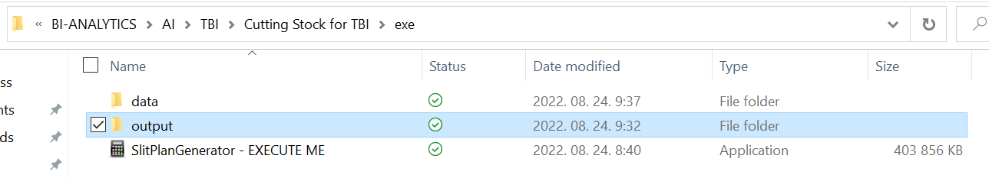

**Once you’ve extracted exe.zip folder, you just need to go through below instruction to run the program:**

* To run the SlitPlanGenerator, simply right click on “SlitPlanGenerator – EXECUTE ME.exe” and click on “Open” or “Run as Administrator”.
* The first time you’ll run the program, Windows will detect a security failure. Click on “More infos”, then “Run anyway”.
* The program will run for about 30sec and then in “output” folder, the slit plans and the updated stock files in the dedicated folder.
* Browse your slit plans and updated stock files in the folder “output”.

**How the data folder should be handled:**

The program “SlitPlanGenerator – EXECUTE ME.exe” browses the folder “data” to generate the plan. All the input can be modified, provided that the name of each file stays the same and that the structure of each file is preserved. Here how the input should be handled:

* the data folder is organized as follow:

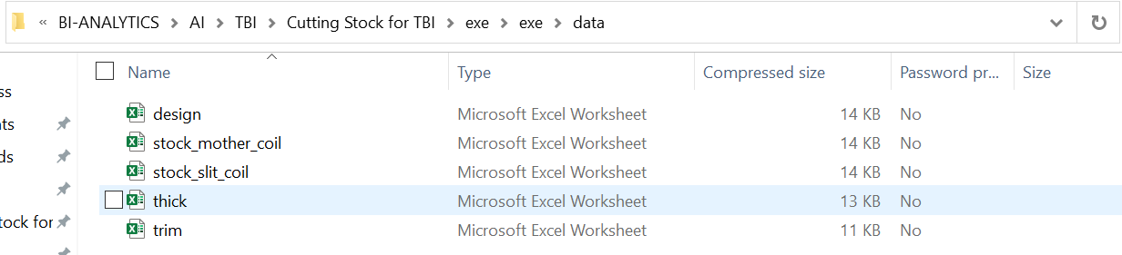

Figure 1 - Data Folder Content

* To be firstly noted that, for the program to run without error, all the data files should have the names displayed in Fig.1. They should also have the same structure.
* The file “design.xlsx” contains the request for slitting. It follows below structure:

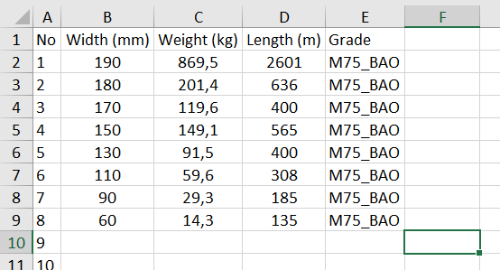

Figure 2 - Example of "design.xlsx" input file

* + Name of columns shouldn’t be modified otherwise the program will return an error.
  + In this file, you should add the Width in mm requested, the weight in kg, the length in m and the grade of material to be cut.
* The file “stock_mother_coil.xlsx” contains the stock of mother coil. Once again, its name shouldn’t change, and its structure should be respected to run the program.

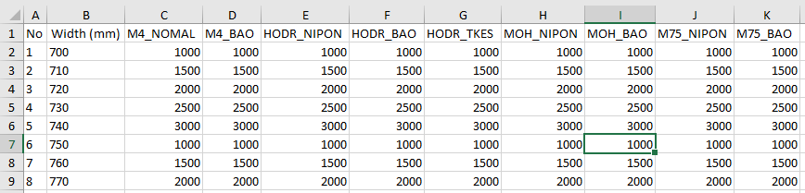

Figure 3 - Example of "stock_mother_coil.xlsx" input file

* + Name of columns shouldn’t be modified otherwise the program will return an error.
  + The “stock_mother_coil.xlsx” file contains, for each width of mother coil, the mass in stock for each grade of material.
* The file “stock_slit_coil.xlsx” follow the same structure as “stock_mother_coil.xlsx”. It contains the stock of slit coils that haven’t been used before. The program will check it, take it account when generating slit plans.

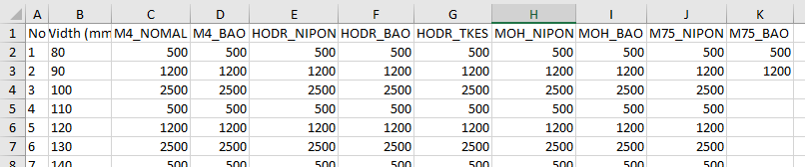

Figure 4 - Example of "stock_slit_coil.xlsx" input file

* + Name of columns shouldn’t be modified otherwise the program will return an error.
  + The “stock_slit_coil.xlsx” file contains, for each width of mother coil, the mass in stock for each grade of material.
* The file “thick.xlsx” contains the thickness for each grade of material. The program takes it into account for computing mass generated when slitting mother coils.

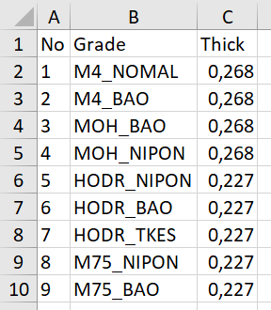

Figure 5 - Example of thickness file

* + Name of columns shouldn’t be modified otherwise the program will return an error.
* The file “trim.xlsx” contains the trim in mm on each side needed for each grade.

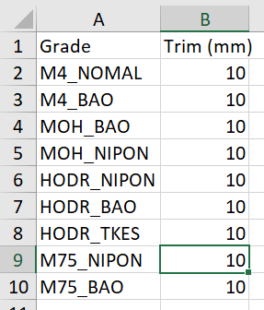

Figure 6 - Example of trim file

* + Name of columns shouldn’t be modified otherwise the program will return an error.

**How the output will be generated:**

Once you’ve entered and your input in data file, and executed “SlitPlanGenerator – EXECUTE ME.exe”, after a few seconds, in the “output” folder, several files will appear:

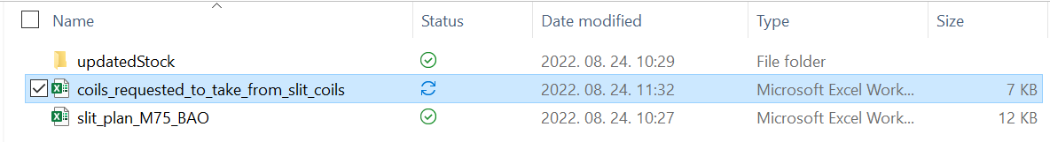

Figure 7 - Example of output generated by the executable

* For each grade of material, we will find an excel file name “slit_plan_<grade>.xlsx”. It contains the slit plan for each mother coil. Below is an example of such file:



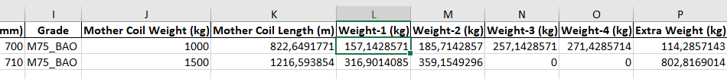

Figure 8 - Example of generated slit plan for grade M75_BAO

* A folder named “updatedStock” contains the stock files if all the slit plans are in reality followed and that mother coils or slit coils are processed.



Figure 9 - Content of "updatedStock" folder

* + The above files follow the same structure as “stock_mother_coil.xlsx” and can be used as input stock files in data folder.
* The file “coils_requested_to_take_from_stock.xlsx”, as its name indicates, contains the data of the coils requested that can be fulfilled with previous offcuts.

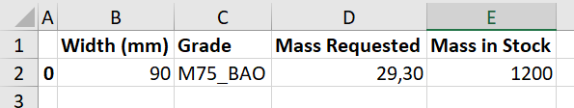

Figure 10 - Example of "coil_request_to_take_from_stock.xlsx"