# BP3 Simulink Simulation Package

Severson Research Group, August 2021

## Introduction

This simulation package includes all the needed files to simulate the BP3 prototype bearingless motor. This is the machine which has been the focus of the quarterly reports given to Delta. The Simulink files include a stand-alone simulation which includes both the plant model and a discrete-time controller. Both models are protected so they act as black boxes.

## Simulation

In the simulation file “TOP_LEVEL_SIM_4DOF”, the BP3 prototype starts at rest. First, the lift-off event occurs where the rotor is commanded to the center of the airgap, resulting in large suspension forces for a small time. After it is stably levitating, the rotor speed is accelerated to 35kRPM over one second.

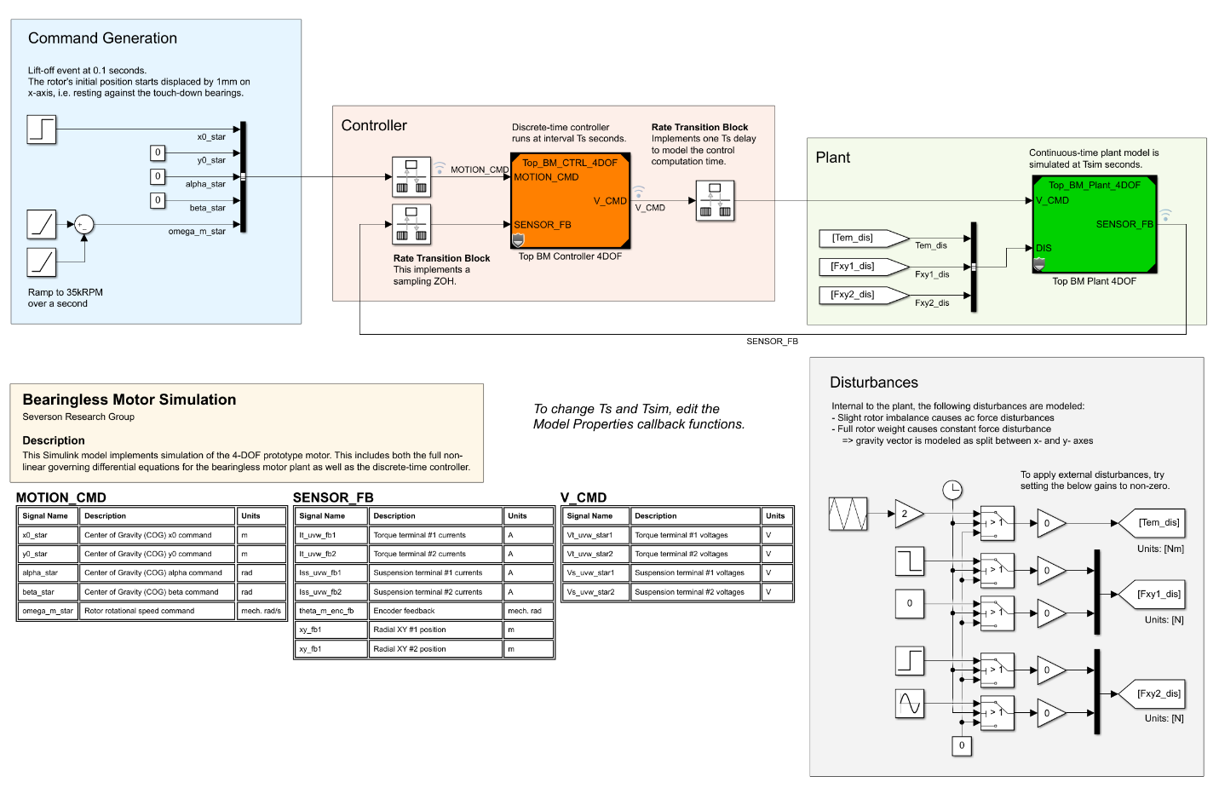

Figure 1: Screenshot of the top-level simulation block diagram: TOP_LEVEL_SIM_4DOF

The BP3 plant model includes force disturbances which model both rotor weight and rotor imbalance. The controller is implemented in discrete-time and runs every 1/10000 sec. The plant provides disturbance inputs which can be used to further verify the performance of the controller. Example disturbances are included in the Simulink file, but are disabled by default.

|  |  |  |  |
| --- | --- | --- | --- |
| **BP3 Parameters for Simulation** | | | |
| **Parameter** | **Symbol** | **Value** | **Units** |
| Coil Resistance | $$R$$ | 310 | $$mΩ$$ |
| Self Inductance | $$L$$ | 2.37 | mH |
| Mutual Inductance | $$M$$ | 0.53 | mH |
| Torque Constant | $$k_{t}$$ | 69 | mNm/A |
| Force Current Constant | $$k_{i}$$ | 9.8 | N/A |
| Force Displacement Constant | $$k_{δ}$$ | 45 | N/mm |
| Rotor Mass | $$m$$ | 0.43 | kg |
| Rotor Inertia | $$J_{z}$$ | 71e-6 | kg-m² |

## Viewing Signals

The simulation signals can be easily viewed by loading the Simulink Data Inspector tool.

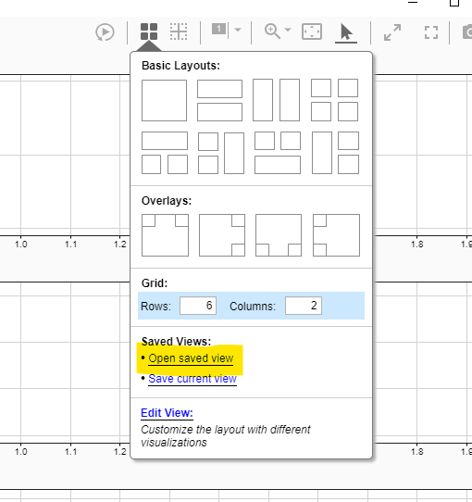

In this tool, load the included saved perspective “system_view.mldatx” file to see all the system signals. The default simulation output is shown below.

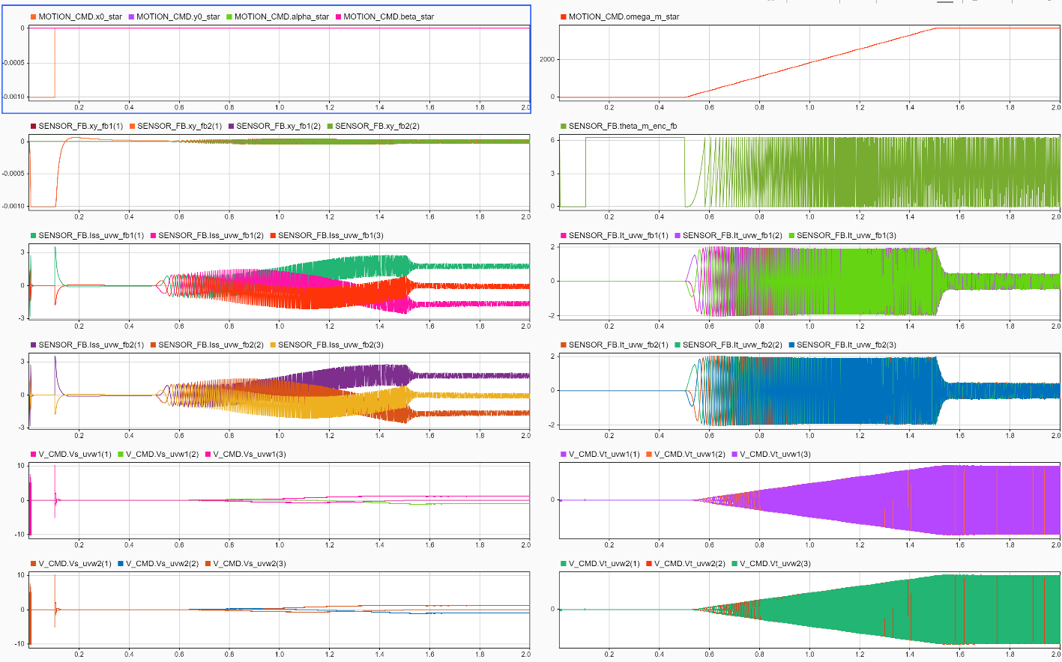

Torque System

Suspension System

Controller Voltage Commands

Sensor Feedback

Commands