# Ansys Structural Example:

Before being able to use ANSYS APDL from eMach, the Ansys Server (aas) must be started. To do this, open the ANSYS Mechanical APDL Product Launcher. First you’ll want to set the working directory and job name for ANSYS APDL. This directory is where all analysis files will be stored by ANSYS as well as the server key that is needed by Matlab to connect to APDL.

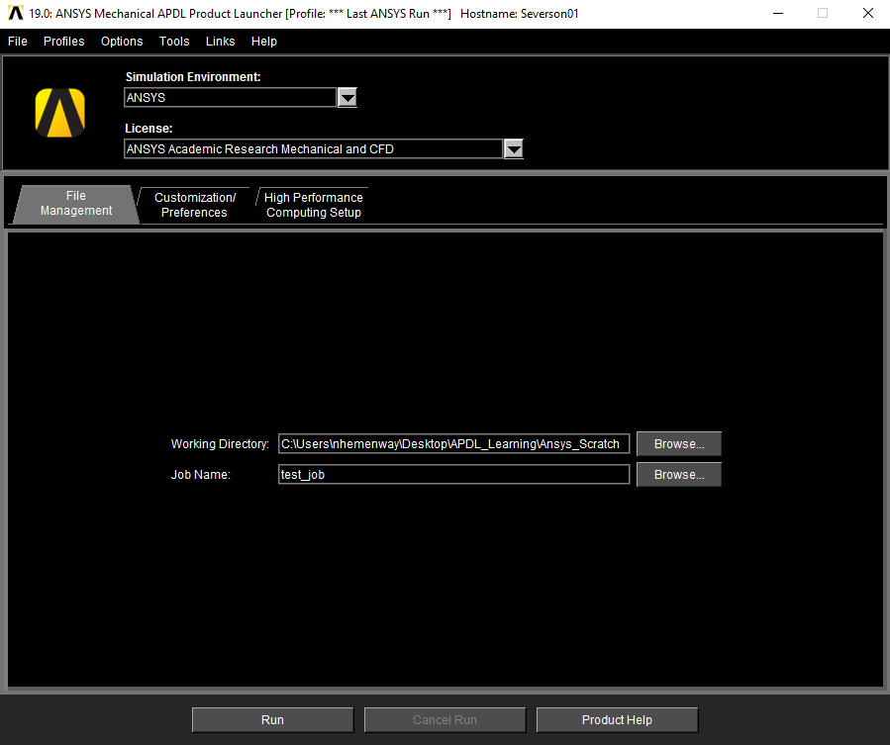

After setting the working directory and job name, go to the *Customization/Preferences* tab. Enter the flag “-aas” under additional parameters as shown, then click run. Note: ‘aas’ stands for ANSYS as a Server.

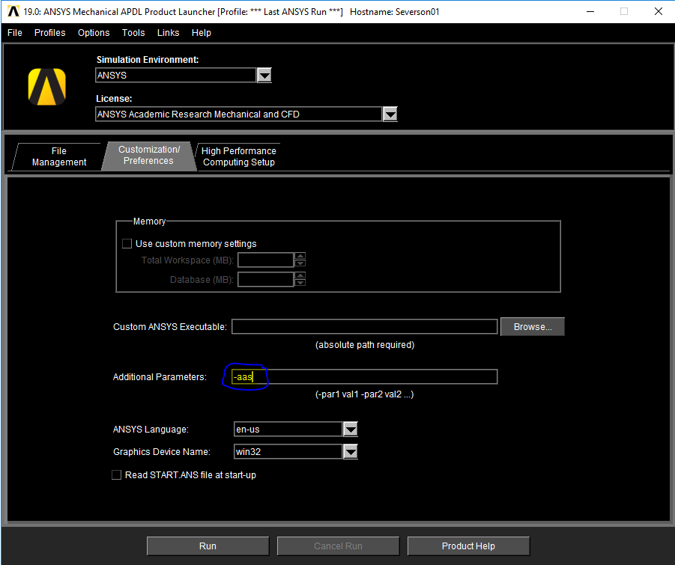

Upon pressing run, the ANSYS server will start and the working directory specified earlier will be populated with a set of files including the ‘aaS_MapdlId.txt’ file which is the server key needed by Matlab to connect to APDL. An image of the working directory after pressing run is shown below. Note that it is usually best practice to make sure the working directory is empty when starting the ANSYS server. Sometimes APDL will generate a lock file upon shutting down and then ANSYS server key file won’t be generated. The only way I’ve found to avoid this is to delete all of the files out of the ANSYS APDL working directory before starting the server.

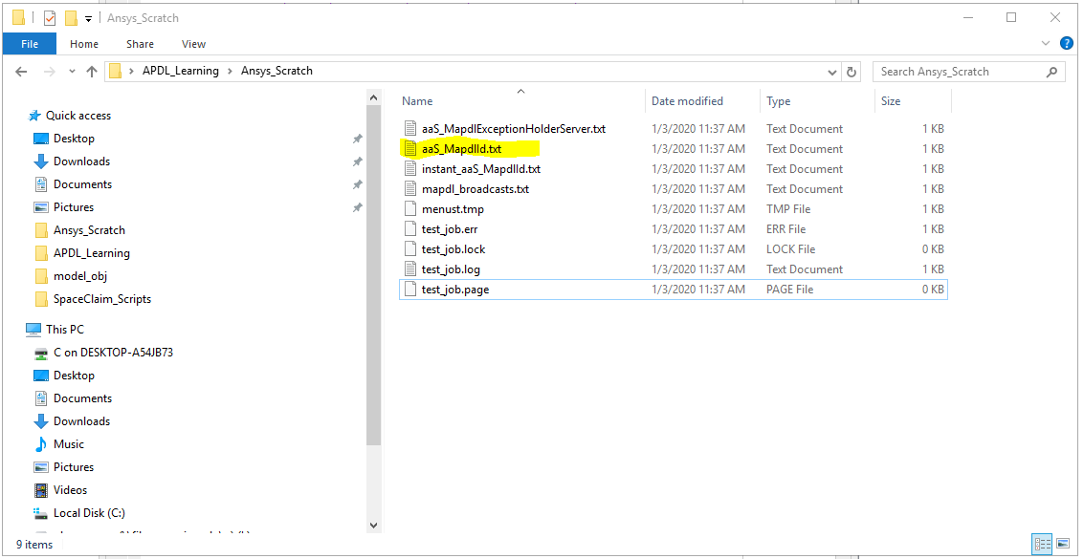

The working directory and job name specified earlier are important because they are also needed by Matlab in order to connect to the server. The screenshot below shows how the path and job name are entered in the AnsysMech tool in eMach:

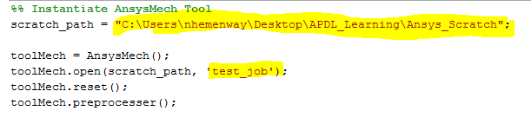

As far as I am aware, when ANSYS APDL runs in server mode, it is not possible to have the GUI open. Because of this, we cannot see the cross section that is drawn or any of the analysis results. To make sure everything is working correct, we can save the cross section out as a ‘.iges’ file which can then be opened in any CAD software. The image below shows how this is done in the code.

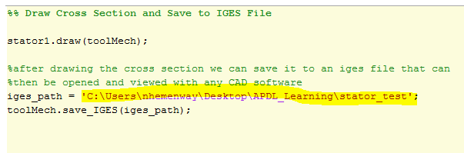

At this point, everything is set to run the AnsysMechExample.m file. Upon running the example, the ‘.iges’ file is created. The image below shows the cross section that was created after opening it in Solidworks.

