**BACHELOR OF COMPUTER SCIENCE**

**FACULTY/SCHOOL OF SCHOOL OF COMPUTER SCIENCE**

**BINA NUSANTARA UNIVERSITY**

**JAKARTA**

**ASSESSMENT FORM**

**Course: COMP6048001 - Data Structure**

**Method of Assessment:** **Case Study**

**Semester/Academic Year : 2/2021-2022**

**Name of Lecturer : Yulianto, S.Kom., M.Kom**

**Date : ………………………**

**Class : LA20**

**Topic : Review II**

**Nama : Valentino Marcell**

**NIM : 2602084104**

No 1

Print After Inserting [E, I, L, G, X]

Deleting O

Deleting T

Deleting D

Deleting P

Deleting X

Deleting S

Deleting I

Deleting C

Deleting M

Deleting K

Deleting E

No 2  
After Inserting 41, 22, 5, 51, 48, 29,18, 21, 45, 3

InOrder Traversal

No 3

Inserting 6

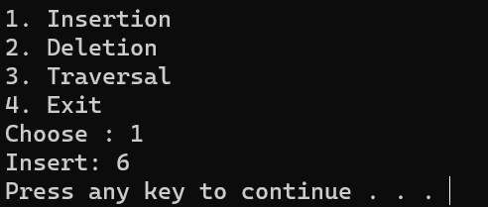

Inserting 27

Inserting 19

Inserting 11

Inserting 36

Inserting 14

Inserting 81

Inserting 63

Inserting 75

Display Data

Delete data

Deleting 14

After Deleting 75

Deleting 36

Deleting 19

Deleting 11

