**JumperDude**

Hamza Unsal

Sevinj Abdullayeva

***Software Technology and GUI Design***

**Description**

**CONCEPT**

The aim of our Jumper Dude project is to produce fun and addictive. As we could imagine from the name, there is a main character. This main character’s main job is trying to catch the notes and bonuses. In the game, there is notes/gold/coins, which are stabile on and around the bricks and there is magic-gold, which give 5 points. The character of the game JumperDude should get the necessary 50 points in 60 seconds in order to finish game with pass otherwise he gets fail.

When we thought about our project, we planned to make some extra “obstacles”. So, in our game also have obstacles - “snowballs”. If the character touches the snowball and cannot get enough notes in the time, then there will be trouble for the character and the game will be over with fail.

The game’s purpose is very simple. When you start the game, there are plenty of coins/gold and less obstacle around. Collect the necessary points which is minimum 50 and you have to get rid of the snowballs. You can collect the “magic-gold” as well in order to get 5 points.

Once the player reach the limit of points, the game is getting harder. Bricks and gold are sparse to the character. In this way, the game purpose is getting harder to get enough notes to pass.

**What will be in the game?**

The jumper Dude game is a point-based game. Therefore, we have a counter for points. We have also a target point area. This means, if the user would like to be successful, should reach to target, otherwise fails.

**MAIN CHARACTER**

There will be the main character called Jumper Dude. There is a colorful background with Obuda University’s logo that shows the main attraction of the game.

**SCORES**

There are notes (gold/coins) around which Jumper Dude should collect. These notes, magic-gold and snowballs are stabile on and around the bricks. During the gameplay, the score indicates at the top right of the screen and increases as the Jumper Dude progresses further.

If the user fails or touches the snowballs, the screen appears as GAME OVER with fail/pass. If the user reaches the goal, we will be able to see how many seconds and how many points.

**OBSTACLES**

**Snowballs** -If the player touches one of the snowballs and cannot get enough notes in the time then the character will be fail and sent to the game over screen. However, if the player touches one of the snowballs and already got at least 50 points in the time then the character will be sent to the “game over” screen with pass.

**MAGIC GOLD**

**Magic gold** -It gives 5 points if the player collects the big magic gold.

**IMPLEMENTATION**

Our game include main background images and sixteen different sprites for the player, each of which performs a different animation for the player. Every sprite is transparent. Because WPF supports transparency far better than Windows Forms, it is far preferable to do more advanced game development programming for this game.

We have several different still images of the running image. When they are loaded in sequence, they will appear to be animated.

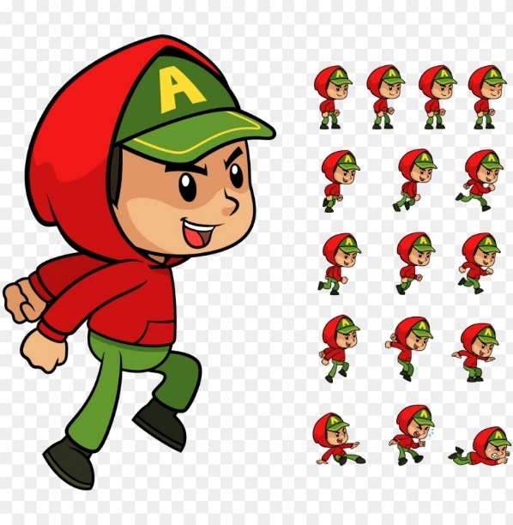

**Screens:**

There are three screens in game.

1. Title Screen
2. PlayGround Screen
3. GameEnd Screen

**Animations:**

Three kind of animations are handling in the game

1. Coin Animation
2. Player Animation
3. Background Animation

There is animation class where animation logic is implemented which uses the images from resources folder and create the animation on screen.

**UIEffect:**

There is UIEffect class where background image movement is handling in function IngameScreenBackground_5

**Player Movement:**

There is PlayerMovement class where is the PlayerDirectionX function is for handling the x direction of player and PlayerDirectionY is for handling the y direction of player.

**Generate Level:**

There is LevelGenerator class where the GenerateLevel function implemented which is using the random function method which generate the levels in game.

**Collision:**

There is Collision class which is used for detecting the collision of player object with the coin and obstacle object. X and y axis are checked for detecting the collision.

**USER GUIDE**

**Instructions:**

The main character Jumper Dude

* Runs forward with the letter d and back with a.
* He can jump by pressing w key.
* In order to pass he has to collect at least 50 points.
* If you lose, you can restart by clicking on the restart button.
* He has to overcome the obstacles by jumping.
* He can get 5 points by collecting the big magic gold.

