**Implementing Cryptography**

**A)ENCRYPT AND DECRYPT A SENSITIVE FILE USING BOTH AES (SYMMETRIC ENCRYPTION)**

* **Symmetric Encryption:**It uses the same secret key for both encryption and decryption, requiring both sender and receiver to securely share the key.

**Step 1:** Navigate to the directory containing the file

**Step 2:** Create or verify the content of the file

**Step 3:** Use the OpenSSL command to encrypt the file and output the result

**Step 4:** Open the cy149-encrypted.txt file to check that the content is encrypted

**Step 5:** Use OpenSSL to decrypt cy149-encrypted.txt back to its original form

**Step 6:** Use the cat command to check that cy149-decrypted.txt contains the original content

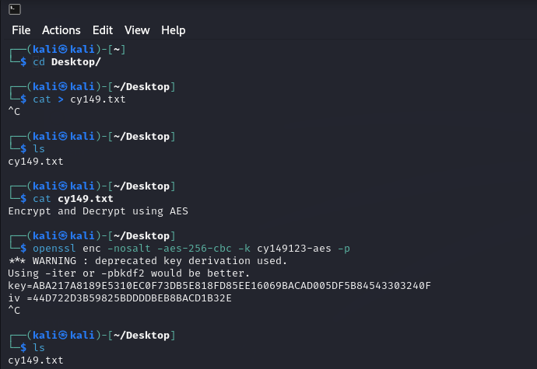

**Step 7:**Use the OpenSSL command to encrypt cy149.txt and save the output in encrypt.txt

**Step 8**: Run the ls command to confirm that encrypt.txt exists

**Step 9:** To keep only the encrypted file, you can delete the original file

**Step 10:** Run the ls command again to check the current files in the directory

**Step 11**: Use the cat command to view the Base64-encoded encrypted content in encrypt.txt

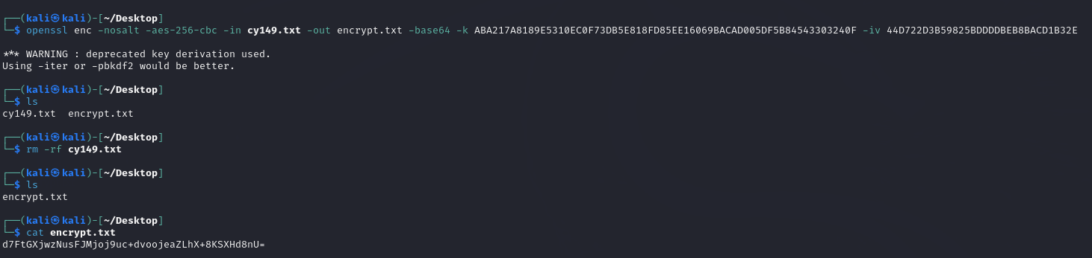

**Step 12:**Use the OpenSSL command to decrypt the file (encrypt.txt) and save the output as decrypt.txt

**Step 13:** Run the ls command to confirm the presence of decrypt.txt

**Step 14:** Use the cat command to view the content of decrypt.txt

