BGInfo for Linux

by [Vikram Khatri](https://www.zinox.com/archives/author/vikram-khatri) | May 9, 2012

<https://www.zinox.com/archives/170>

If you are spoiled using BGInfo of Windows to show some useful information on your desktop, you may try this poorly written but working script that does the same thing.

This was written for SuSe Linux but can be adapted for other distribution. If you happen to make enhancements to this script, please do send me a copy to keep it here so that it is useful to others as well.

## Install ImageMagick Utilities

Install ImageMagick utilities.

Install procinfo

## Set a background image

Right click on your Linux desktop and select Change Desktop Background.

Select an image of your choice or copy the image to the /usr/share/backgrounds folder. It may be different on other distributions.

Make a copy of this image and keep it somewhere so that the script uses the original image.

## Use the script attached

## Download script [here](https://www.zinox.com/wp-content/uploads/liinfo.txt)

#!/bin/bash

# Author : Vikram Khatri vikram@zinox.com

#

# Purpose: Add BGInfo like information on Linux Desktop

# File name: liinfo

SCHOME=/root/bin/backup

BGFILE=$SCHOME/sys.info

BG=$SCHOME/bg.png ### This is a generated image with sys information

WALL=/usr/share/backgrounds/backup/wall.png ### This is your original background image

NEWWALL=/usr/share/backgrounds/wall.png ### This is the new background image that you will use

> $BGFILE

A_UPTIME=" Uptime : "

A_HOSTNAME=" Host Name : "

A_USERNAME=" User Name : "

A_NUMCPU=" Num of CPU : "

A_CPUMODEL=" CPU Model : "

A_MEMTOTAL=" Total Memory : "

A_OSVERSION=" OS Version : "

A_IPADDRESS=" IP Address : "

A_DNSSERVER=" DNS Server : "

A_GATEWAY=" Gateway : "

A_FREEDISK=" Disk Free Space : "

A_SOFTWAR1=" DB2 10.1"

A_SOFTWAR2=" Optim Performanace Manager 5.1.1"

A_SOFTWAR3=" Data Studio 3.1.1"

B_UPTIME=`procinfo | grep uptime | awk '{print $2}'`

B_HOSTNAME=`hostname`

B_USERNAME=`whoami`

B_NUMCPU=`cat /proc/cpuinfo | grep processor | wc -l`

B_CPUMODEL=`cat /proc/cpuinfo | grep "model name" | awk -F":" '{print $2}' | head -1 | sed -e 's/^ *//'`

B_MEMTOTAL=`cat /proc/meminfo | grep MemTotal | sed -e 's/^ *//' | awk -F":" '{print $2}'`

B_OSVERSION=`uname -srm`

B_IPADDRESS=`/sbin/ifconfig | grep "inet addr" | grep -v 127.0.0.1 | awk '{print $2}' | awk -F":" '{print $2}'`

B_DNSSERVER=`grep ^nameserver /etc/resolv.conf | awk '{print $2}'`

B_GATEWAY=`netstat -rn | grep UG | awk '{print $2}'`

B_FREEDISK=`df -k | grep ^/dev | awk '{print $1" "$4" KB Available"}'`

echo "$A_UPTIME" $B_UPTIME >> $BGFILE

echo "$A_HOSTNAME" $B_HOSTNAME >> $BGFILE

echo "$A_USERNAME" $B_USERNAME >> $BGFILE

echo "$A_OSVERSION" $B_OSVERSION >> $BGFILE

echo "$A_IPADDRESS" $B_IPADDRESS >> $BGFILE

echo "$A_NUMCPU" $B_NUMCPU >> $BGFILE

echo "$A_DNSSERVER" $B_DNSSERVER >> $BGFILE

echo "$A_CPUMODEL" $B_CPUMODEL >> $BGFILE

echo "$A_MEMTOTAL" $B_MEMTOTAL >> $BGFILE

echo "$A_GATEWAY" $B_GATEWAY >> $BGFILE

echo " " >> $BGFILE

echo "$A_SOFTWARE" >> $BGFILE

echo "$A_SOFTWAR1" >> $BGFILE

echo "$A_SOFTWAR2" >> $BGFILE

echo "$A_SOFTWAR3" >> $BGFILE

### The following ImageMagick utility generates an image with the

### transparent background from the file $BGFILE

cat $BGFILE | \

convert -font Courier-Bold -pointsize 30 \

-background none \

-fill white \

label:@- $BG

### This utility combines two images and creates a new image

composite -gravity south $BG $WALL $NEWWALL

## Add script to run at boot time

These instructions are for SuSe Linux and it may be different on other Linux distributions.

Create a file liinfi in /etc/init.d

chmod +x liinfo

Add folowing entries

#!/bin/bash

### BEGIN INIT INFO

# Provides: liinfo

# Required-Start: $network

# Required-Stop:

# Default-Start: 3 5

# Default-Stop: 0 1 2 6

# Description: Set BGInfo like info on your desktop

### END INIT INFO

/root/bin/liinfo

Run chkconfig -a liinfo

## Add Crontab Entry to refresh

Optionally, if you want your image to be refreshed every 15 minutes, add a crontab entry as shown:

# crontab -e

and add

*/15 * * * * /root/bin/liinfo

and save the file.

### **How it may look?**

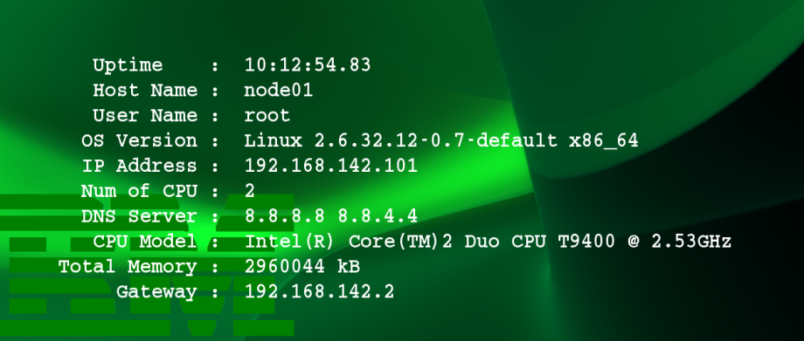

## ImageMagick operation not authorized

Solution

Since ImageMagick is sometimes used on web servers to operate on images for users, it has security checks on certain operations.

Option 1:

sudo rm /etc/ImageMagick-6/policy.xml

Option 2:

sudo mv /etc/ImageMagick-6/policy.xml /etc/ImageMagick-6/policy.xml.off

When done, you can restore the original with

sudo mv /etc/ImageMagick-6/policy.xml.off /etc/ImageMagick-6/policy.xml

Option 3:

Edit the Imagemagick policy.xml file to uncomment this line:

<!-- <policy domain="module" rights="none" pattern="{PS,PDF,XPS}" /> -->

And change it from rights="none" to rights="read|write"

<policy domain="module" rights="read|write" pattern="{PS,PDF,XPS}" />

## Bulk patching using Ansible

When managing a lot of applications, it might be a worth considering something like [Ansible](https://www.ansible.com/) to quickly set-up, manage and patch all of your servers.

Ansible playbook to apply the above fix. It deals with the different ImageMagick directories as well!

---

- name: Find ImageMagick directories

find:

paths: /etc

pattern: "ImageMagick(?:-\\d)"

file_type: directory

use_regex: yes

register: imagemagick_directories

- name: Allow ImageMagick coder to read and write

lineinfile:

dest: "{{ item.path }}/policy.xml"

regexp: '\s*<policy domain="coder" rights="none" pattern="PDF" />'

line: ' <policy domain="coder" rights="read|write" pattern="PDF" />'

backrefs: yes

with_items: "{{ imagemagick_directories.files }}"