IE2080

2nd Year 1st Semester

Assignment

Submitted to

Sri Lanka Institute of Information Technology (SLIIT)

Y2S1-WD-CSNE- 1.1 MAIN GROUP

Submitted by IT22320728

Sewmina Maduranga Ranawaka

**Task 01**

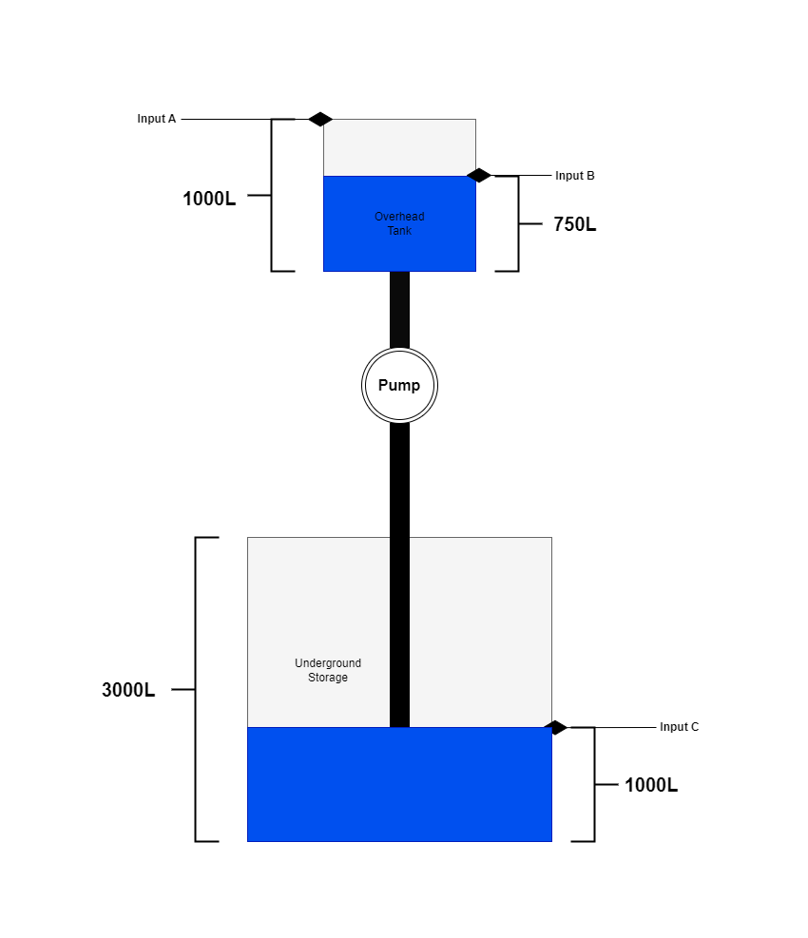

* A household contains two tanks. The overhead tank is the main supply and the underground tank acts as a backup if the water level of the overhead tank falls beyond a certain point. Going into detail there are two sensors placed in the overhead tank to determine the maximum water level(1000L) and another sensor to activate the pump to fill the overhead tank when the water level falls beyond some point(750L) from the underground storage.
* In addition, a separate sensor is placed in the underground storage to avoid pumping water from it to the overhead tank if the water level of the underground storage is under a certain limit(1000L).

**Task 02**

* Sensor A is programed to turn on when the water level touches the sensor.
* Sensor B is turned on when the water stops to be in contact with the sensor.
* Sensor C is turned on when the water stops to be in contact with the sensor.

Turn On – 1

Turn Off – 0

|  |  |  |  |
| --- | --- | --- | --- |
| Sensor A | Sensor B | Sensor C | F |
| 0 | 0 | 0 | 0 |
| 0 | 0 | 1 | 0 |
| 0 | 1 | 0 | 1 |
| 0 | 1 | 1 | 0 |
| 1 | 0 | 0 | 0 |
| 1 | 0 | 1 | 0 |
| 1 | 1 | 0 | X |
| 1 | 1 | 1 | x |

**Task 03**

Using K-Map :

**F = (A’BC’)**

**Task 04**

**Task 05**

* The storage could be refilled manually and apart from that adding a sensor would increase the complexity of the circuit.
* Since the underground storage is not dependent on another supply of water which is activated automatically a sensor is not required.
* Cost efficiency could be taken into consideration too.

