Sri Lanka Institute of Information Technology

Software Architecture

Assignment 1- SE3030



Group Details : Y3S1.20(WD) – **Group_28**

|  |  |
| --- | --- |
| Registration Number | Name |
| IT18153828 | Dahanayake H.Y.D |
| IT18040654 | Wickramasinghe S.P |
| IT18111170 | Silva S.H.I |

Supermarket service

a) Explain the Scenario using a diagram

It is a retail situation in which cashier and manager operate together to sell their products to their clients. Two consumers and one producer is present in this situation where it has Manager consumer and Cashier consumer. Then Manager consumer will add goods to supermarkets and offer discounts on goods. The final measured bill will be displayed by the Cashier consumer.  To achieve best practices of OSGI we expose the producer service interfaces only not the implementations. Consumers can work through the interfaces.

figure[01]

The following diagram is workflow of supermarket manager consumer. There are 6 options of add item, update, delete, search Items and manger can exit by pressing 6 when necessary. In the process of adding new item to item list, Manager has to input name, price, discount which are then save to list. If manager input any other input rather than mention options system notify to enter valid input. Then the auto generated id and final price will be calculated by system.

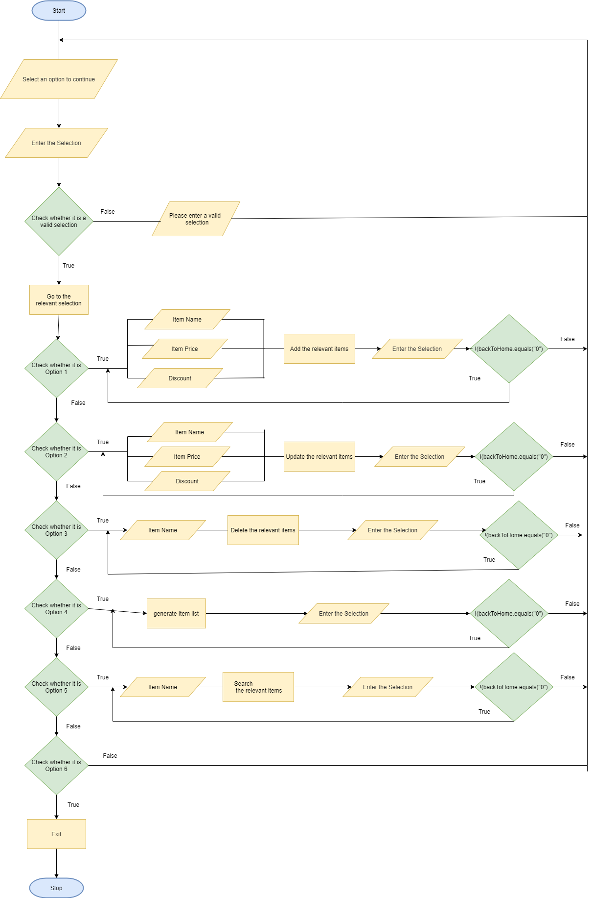

figure[02]

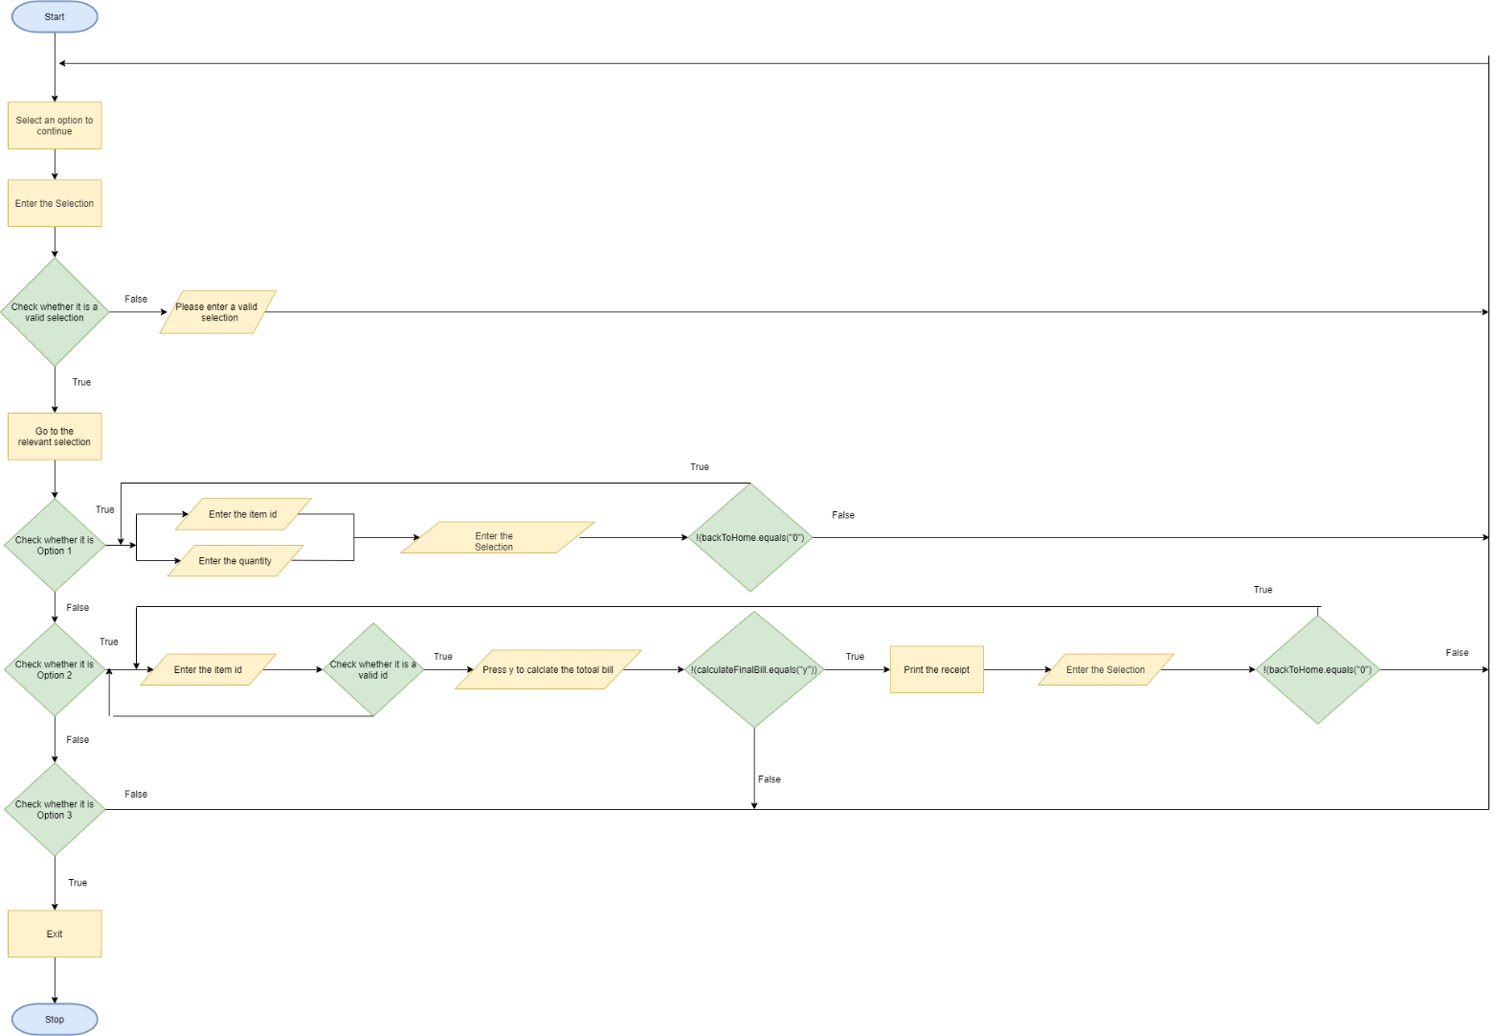

This is the part of the workflow of consumer cashier side. Option 1 describes the view of list items by pressing 1. then by pressing 2 ask cashier to enter quantity then user can generate the bill which gives the total final price to user. User can iterate the process, in the end calculated final bill will be display. If the user wants to exit it can proceed by pressing 3 if option is not related to this, then it shows the notification to enter a valid selection.

b)Manifest implementation

**Cashier Consumer Manifest**

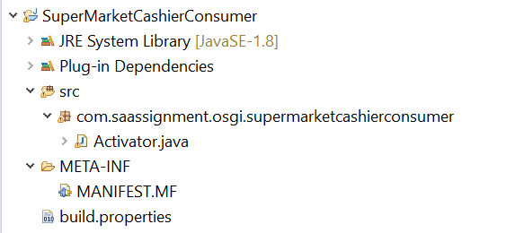

End user of system who are cashier consumers will display the bill using the method of cashier service impl . This bill then prints and present it to the client. Cashier can also view the item list.

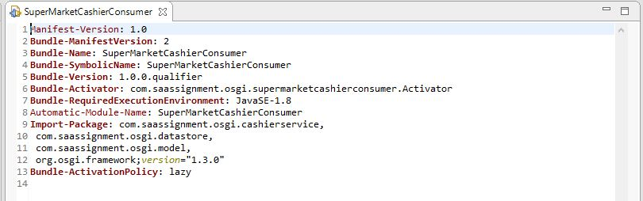

This is the manifest file of cashier consumer Here, imported packages from com.saassignment.osgi.cashierservice, com.saassignment.osgi.datastore, com.saassignment.osgi.model framework and version from this we achieve the services provided by cashier producer.

We run this activator after running all of the bundles.

**Manager Consumer Manifest**

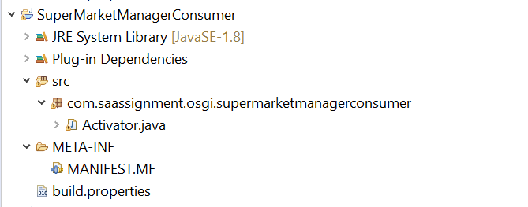

Manager of the supermarket add items and have the privileged to manage the items and they can make discount to relevant items those details will be stored in datastore ItemList in producer.

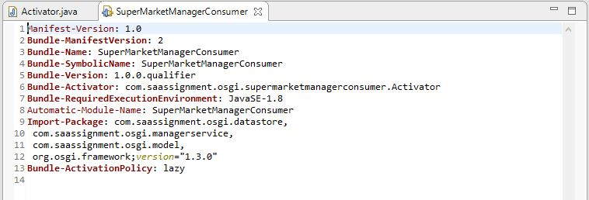

In this manager consumer manifest file, Imported the com.saassignment.osgi.datastore, com.saassignment.osgi.managerservice, com.saassignment.osgi.model, org.osgi.framework from producer.

We run this activator class after running the producer

**Service Producer Manifest**

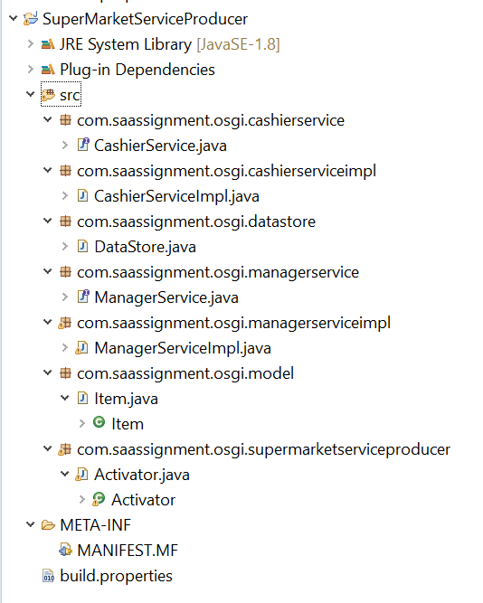

This is the producer part of the system. There are two of them which are cashier service and manager service.

In cashier service,

Cashier service is the interface. service impl is the implementation of the interface. It has the calculation algorithms of the bill and implementation of viewing the item list. Cashier service will be export from the bundle. Then supermarket cashier consumer can use that services to do his tasks

In manager service,

Manger service is the interface and have the CRUD operations to manipulate items The impl class of manager service will implement the services in manager services. Manager service interface will export as a package. Then supermarket manager consumer can use that services to do his tasks.

In the manifest file it imported the osgi framework package and exported the com.saassignment.osgi.cashierservice, com.saassignment.osgi.datastore, com.saassignment.osgi.managerservice, com.saassignment.osgi.model.

.

Activator has the List of items that’s add by the manager. It has the shared data between the consumer and producer. Data add by the manager can be view by the cashier.

Model has the item class which stores the item details.

In the supermarket service producer activator class register the cashier service and manager service

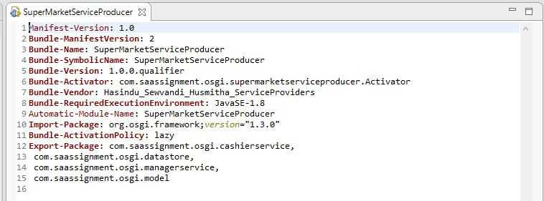

c)All commands of bundle install and run in OSGi framework.

Manager Consumer Stopped

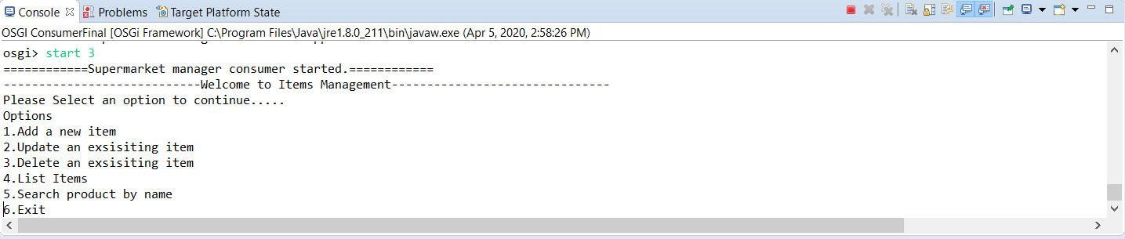

Manager Consumer Started

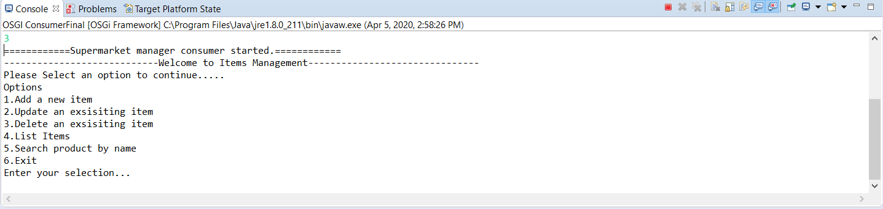

Start cashier consumer

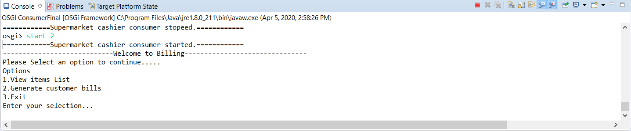

Stop cashier consumer

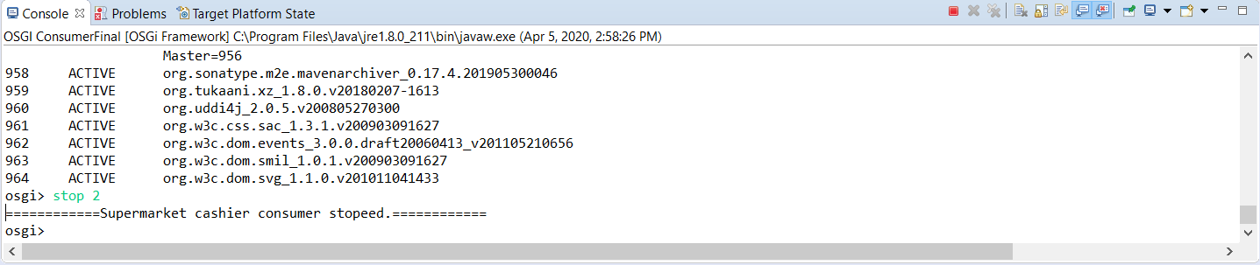

Super Market Service Started

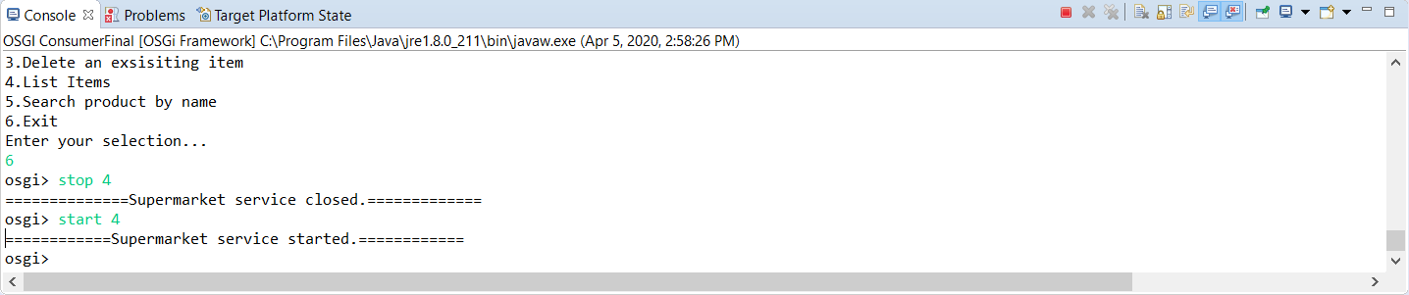

Super Market Service Closed

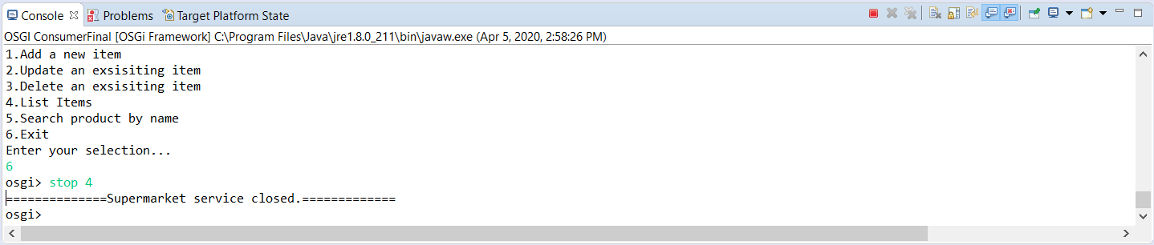

Listing bundles

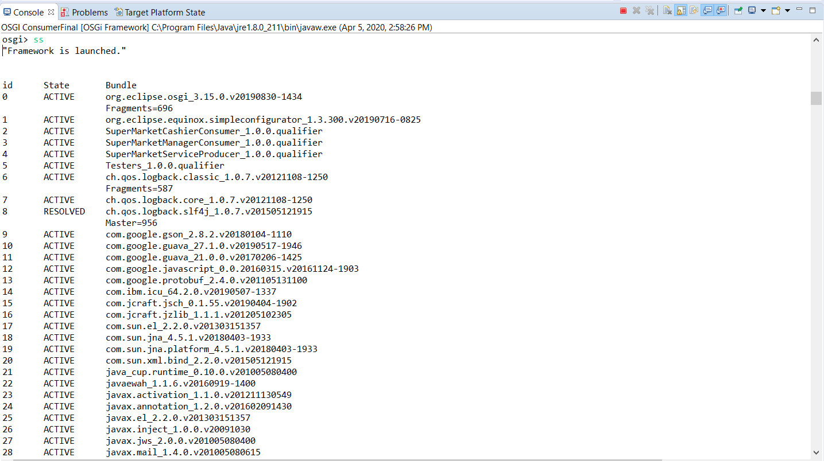

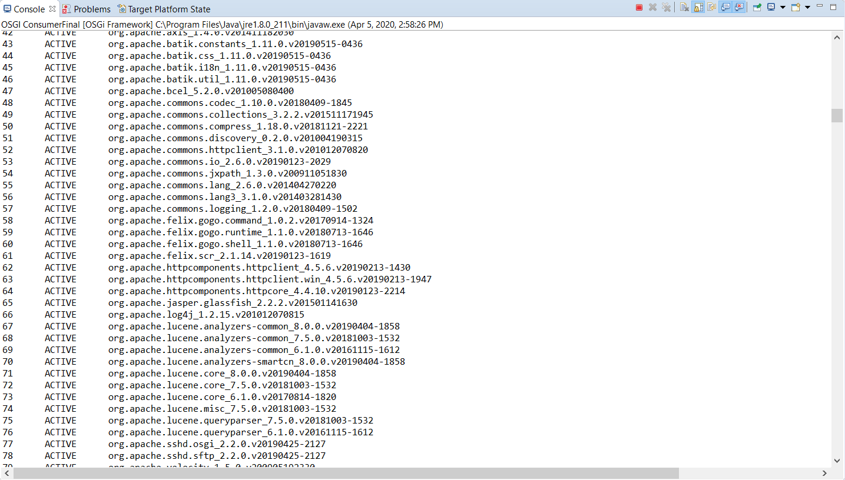

Uninstall Cashier Consumer

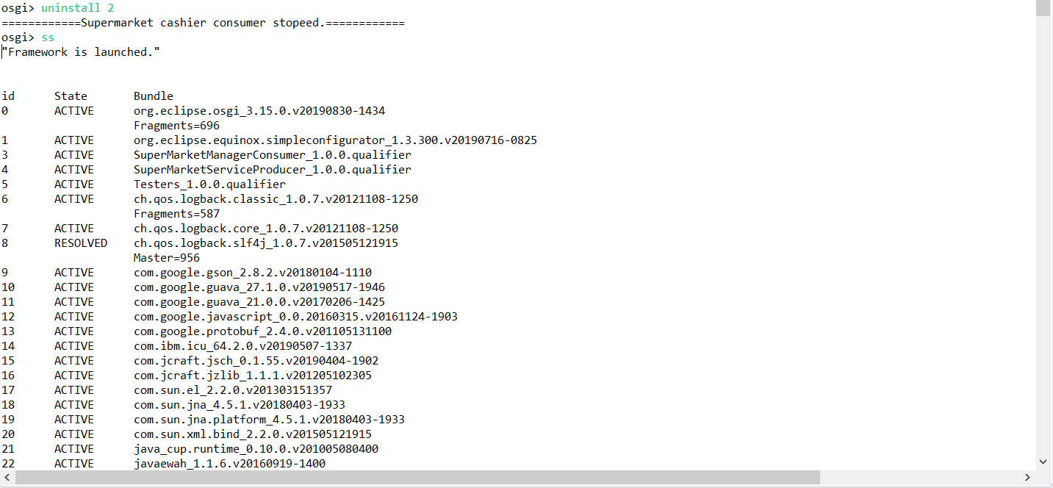

Uninstall manager Consumer

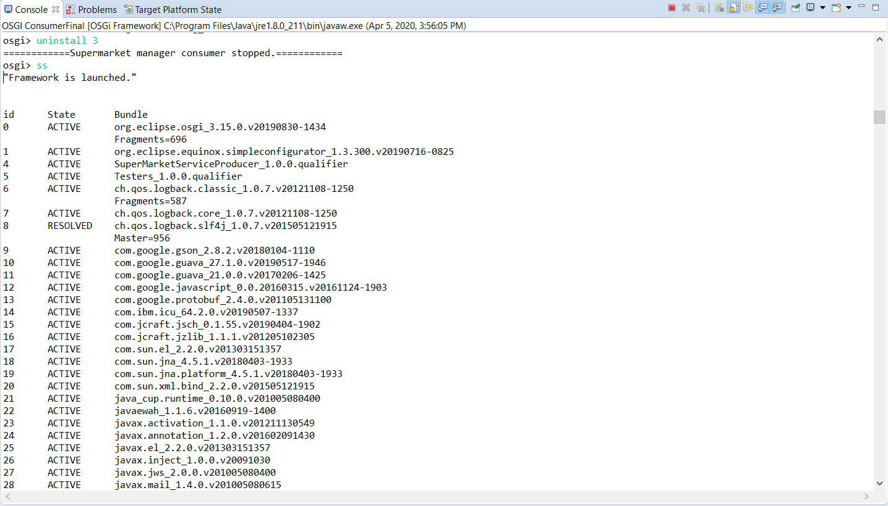

Uninstall Supermarket Producer

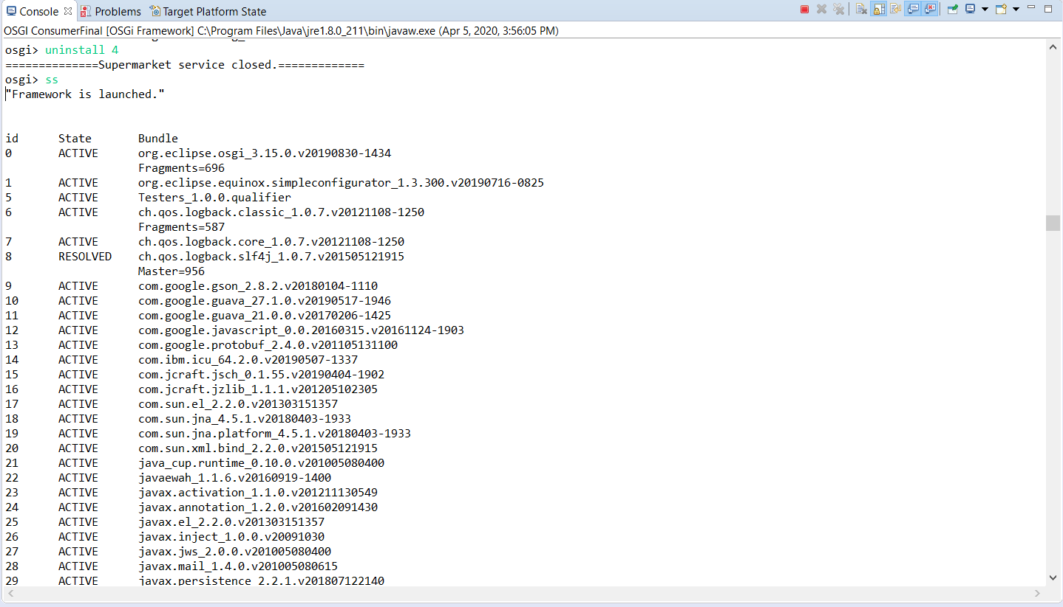

d)Sample screenshots of its behavior & outputs.

**Add item 1**

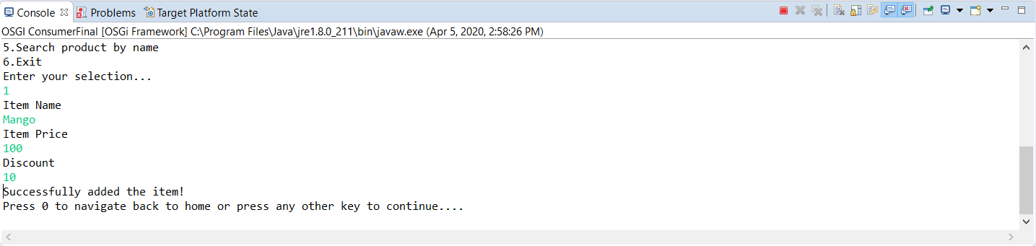Supermarket Manger consumer add item by selecting number 1

**Add item 2**

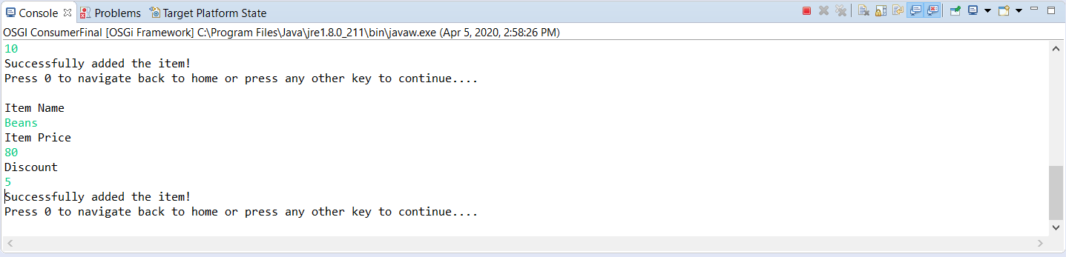

Supermarket Manger consumer add another item by selecting number 1

**Update Item 1**

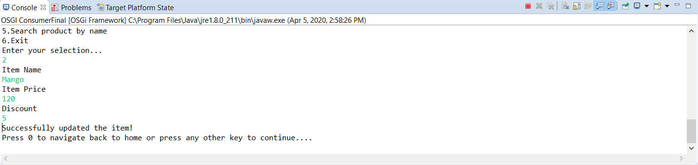

Manager consumer can update the existing item by selecting number 2

**Delete Item 1**

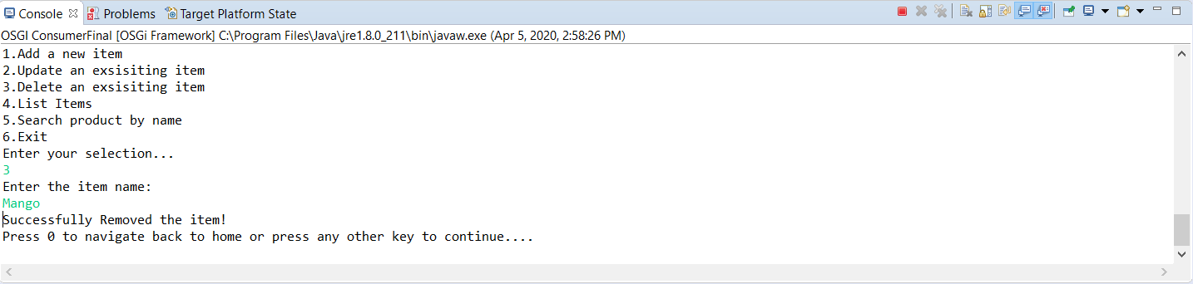

Manager consumer can delete the existing item by selecting number 3

**List Items**

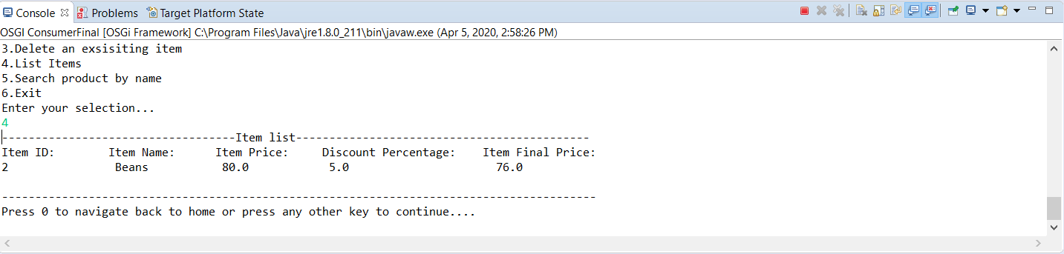

Manger can view the item list by selecting number 4

**Search by product name**

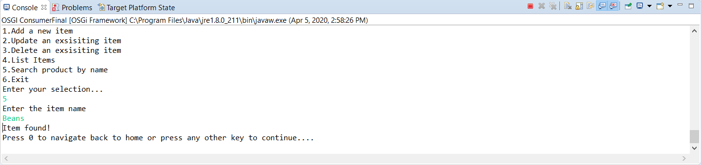

Manage consumer can search the added items by pressing number 5

**Select an option**

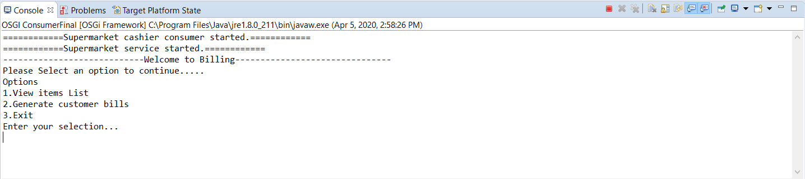

**Cashier Item List**

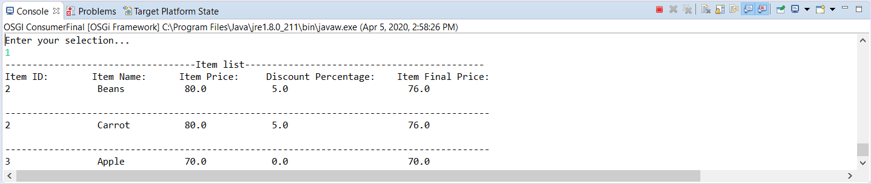

likewise we added 2 more products Product Id - 2,3

**Billing Item**

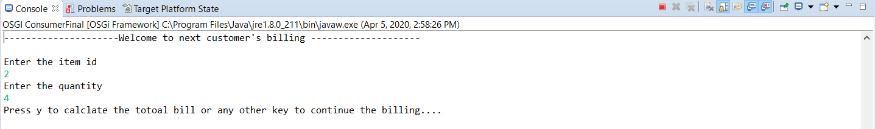

Cashier can enter quantity and item id to calculate bill.

**Continue Billing**

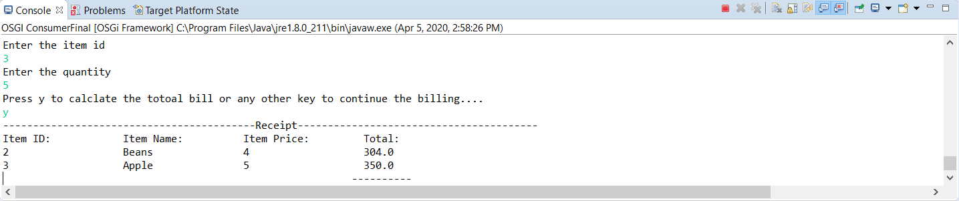

When we press y it proceed to next step of billing.

**Total bill**

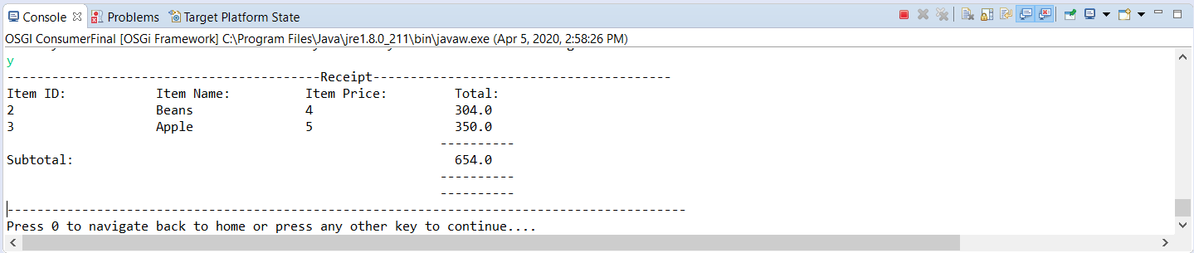

Cashier will get the calculated total bill.

**Exit Cashier**

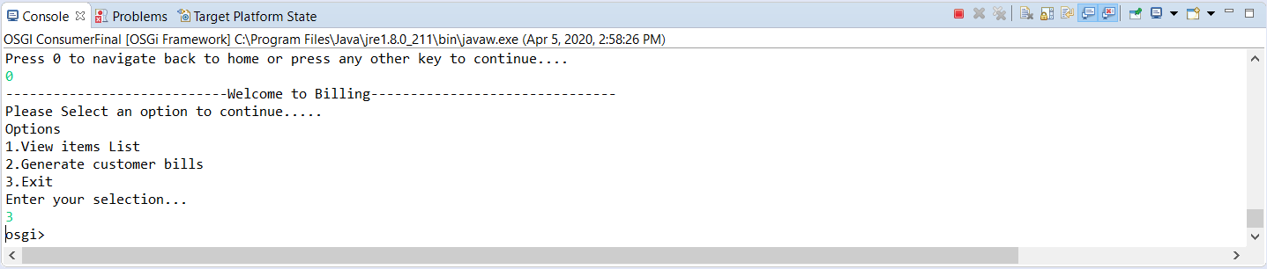

Cashier can exit the programme by pressing number 3.