Deep Learning - Lab sheet 2

**IT20657864-A.D.S.Dodanthenna**

01)

No of iterations-100

No of iterations-500

No of iterations-800

No of iterations-1000

No of iterations-2500

If we increase the number of iterations the output, getting closed to desired output and the error getting decreased.

02)

a. What happens when the number of hidden nodes increase?

02)

b) Can you explain the pattern of the accuracy when the hidden nodes increase?

When the no of hidden nodes is very low the accuracy is also becoming very low. But if we increase the hidden nodes the accuracy became high. If we increase the hidden nodes up to 100 the accuracy became nearly 95%. Finally, it became like constant.

03 a)

Epochs=3

Epochs=5

Epochs=8

Epochs=12

Epochs=25

02)

b) Add L1 and L2 regularization terms to the model and retrain the model.

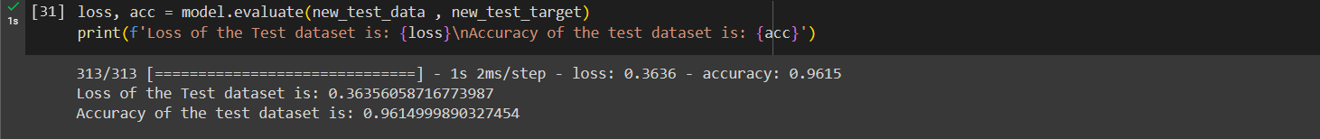

03

c) Visualize class-wise test dataset performance using a confusion matrix.

