Pre- and Post-Test

1 point per question.

**Topic Area 1: Biology 2**

Area 1: Cancer biology and cell lines 2

Area 2: Sex Chromosomes 2

Area 3: RNA and RNA-seq 2

Area 4: Gene expression 2

Area 5: X Chromosome Inactivation 3

**Topic Area 2: Coding 3**

Area 1: R and R markdown 3

Area 2: R data frames 3

Area 3: R functions and loops 4

Area 4: R if statements 4

Area 5: Linux command line 4

**Topic Area 3: Professional Development 5**

Area 1: Authorship 5

Area 2: Reading a scientific paper 5

Area 3: Writing a scientific paper 5

Area 4: Searching for coding solutions 6

Area 5: Interpreting plots 6

**Topic Area 4: Personal Feelings 7**

Question 1: Unix 7

Question 2: R 8

Question 3: Programming 8

Question 4: Collaboration 9

Question 5: Reading/Interpreting Literature 9

Question 6: Writing 9

Question 7: Research Experience 10

**Post-CURE Survey questions 10**

# Topic Area 1: Biology

### Area 1: Cancer biology and cell lines

1. Tumors produce all the oxygen and nutrients they need to grow larger [FALSE]
2. Malignant tumors can develop the ability to spread into other regions of the body [TRUE]
3. The Cancer Cell Line Encyclopedia is a collection of cell lines derived from human tumors. [TRUE]
4. A cell line is used as a model system for laboratory research because they show some genetic similarities to the tumor type they were derived from [TRUE]

### Area 2: Sex Chromosomes

1. Individuals with XX genotype will typically develop male reproductive organs. [FALSE]
2. Sex chromosomes do not have an effect on cancer susceptibility or progression. [FALSE]
3. The Y chromosome is much shorter than the X chromosome. [TRUE]
4. XY individuals can lose their Y chromosome in their cells over time as they age. [TRUE]

### Area 3: RNA and RNA-seq

1. RNA is reverse transcribed into cDNA prior to Illumina sequencing. [TRUE]
2. RNA sequencing results provide a snapshot of the genes expressed in specific cells in specific conditions. [TRUE]
3. The sequencing reads of a gene in an RNA-seq experiment represent a proportion of the reads from that gene relative to all the RNA in the sample. [TRUE]
4. The sequencing reads of a gene in an RNA-seq experiment represent an absolute quantification of all the RNA expressed from that gene in the sample. [FALSE]

### Area 4: Gene expression

1. All genes are encoded by DNA in chromosomes and are expressed in every cell of the body. [FALSE]
2. Gene expression can vary with age, sex, growth factors, and environmental stimuli. [TRUE]
3. There are several algorithms (software tools) available to align RNA sequencing reads to a reference genome or reference transcriptome. [TRUE]
4. Gene expression is typically measured as the average number of reads mapping to a specific gene’s coordinates in the genome. [FALSE]

### Area 5: X Chromosome Inactivation

1. Suppression of one X chromosome’s gene expression in XX females is called X chromosome inactivation. [TRUE]
2. XIST is a long non-coding RNA that blocks X chromosome inactivation in humans. [FALSE]
3. Inactive X chromosomes in XX female cells can be reactivated in cancer. [TRUE]
4. Inactive X chromosomes in XX female cells can be reactivated when forming a cell line. [TRUE]

# Topic Area 2: Coding

### Area 1: R and R markdown

1. Code written in R is easy to read so you do not need to spend much time adding descriptive comments to your scripts. [FALSE]
2. Saving R scripts with the data you produced or analyzed allows you to easily reproduce, modify, and share your protocols for future work. [TRUE]
3. You can print an R Markdown as a report with nicely formatted text, code, and plots. [TRUE]
4. R Markdown is integrated into RStudio to make it easier to work with R code. [TRUE]

### Area 2: R data frames

1. In the following R data frame called employees, subset(employees, sex == “Male”) gives you a data frame with 2 rows and 5 columns [TRUE]

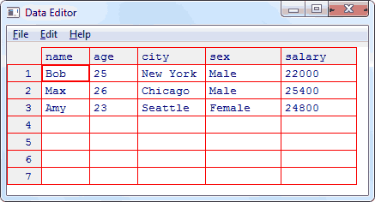

1. In the employees data frame above, length(levels(factor(employees$city))) would equal 3 [TRUE]
2. In the employees data frame above, employees$age would be the same as employees[2] [TRUE]
3. In the employees data frame above, employees$Bob would equal [“Bob”,25,”New York”,”Male”,22000] [FALSE]

### Area 3: R functions and loops

1. When a variable is created inside a function, it can and should be referenced outside of the body of that function [FALSE]
2. Once a function is written, any variable that contains data in the expected format can be passed in as input [TRUE]
3. A for loop is used to iterate through a list of values performing some manipulation or function [TRUE]
4. The value of squared at the end of this loop is 6. [FALSE]

for (i in 1:3){

squared = i ^ 2

}

### Area 4: R if statements

1. The if statement can be used to make a choice based on the value of some variable [TRUE]
2. Multiple if statements can not be nested together; a separate if statement has to be written for each variable [FALSE]
3. If A = TRUE and B = FALSE, then A || B = FALSE [FALSE]
4. The value of sex after this code is executed is “male” [TRUE]

chrY_expression = 15

threshold = 10

if (chrY_expression > threshold) {

sex = "male"

} else {

sex = “female”

### Area 5: Linux command line

1. These Linux commands will create a new subdirectory called ‘project’ inside the `placenta’ directory: mkdir project/placenta [FALSE]
2. This Linux command will copy all text files to a ‘code’ directory from a project directory called ‘RNA-seq’ : cp /home/user/code/*.txt /data/project/placenta/RNA-seq/ [FALSE]
3. This Linux command will rename cancer.txt to CCLE_IDs.txt:

mv cancer.txt CCLE_IDs.txt [TRUE]

1. This Linux command will delete all text files in the CCLE_code directory:

del CCLE_code/*.txt [FALSE]

# Topic Area 3: Professional Development

### Area 1: Authorship

1. Authorship order when publishing a paper describing scientific research typically reflects the amount of creativity, work, and leadership given to the project [TRUE]
2. The status of corresponding author of a publication is important because it states who conducted all the correspondence with the journal’s editorial team before publication [FALSE]
3. The first author of a publication is a coveted distinction that indicates that that author contributed to primary analysis, troubleshooting, writing, and finalizing of all components of the manuscript [TRUE]
4. The principal investigator of the laboratory where the work for a publication was done is typically listed last on the author list [TRUE]

### Area 2: Reading a scientific paper

1. When reading a scientific paper, it is not important to read the methods of the paper since the results section details the conclusions that the authors reached [FALSE]
2. The abstract of a scientific paper is a concise summary of the problem being addressed, the results attained, and the significance of the conclusions drawn [TRUE]
3. Figures in a scientific paper show the evidence used to make specific conclusions [TRUE]
4. The results and discussion sections of a paper must include a detailed background of previously published work that lead to the proposed experiments from which conclusions were drawn [FALSE]

### Area 3: Writing a scientific paper

1. The introduction of a scientific paper includes all of the learning you have done while working on the project being published. [FALSE]
2. When choosing figures to go into a publication, you should choose solely based on which ones look the most impressive and colorful to attract the reader’s attention. [FALSE]
3. When writing the methods section of a scientific paper, you do not need to include the versions of any software used because one can expect a more recent version to give the same results as the versions available at the time of publication. [FALSE]
4. When writing the discussion section of a scientific paper, it is important to state how the results of the paper are filling a gap in what is currently known about the topic. [TRUE]

### 

### Area 4: Searching for coding solutions

1. When tasked with a programming a solution to a specific data analysis problem, you should not look up solutions on the internet because no one else has had your exact problem [FALSE]
2. To compose a search for how to solve a coding problem, we should include the programming language and the words to indicate the coding problem. [TRUE]
3. When interacting with other scientists in a scientific laboratory, it is best to only speak when spoken to [FALSE]
4. If you find code online that seems to exactly address the problem you are trying to solve, you can expect it to work by copying and pasting it directly into your R script [FALSE]

### Area 5: Interpreting plots

The following questions will refer to this plot which shows the expression of a specific gene *PNG* in skin samples taken from three types of penguins:

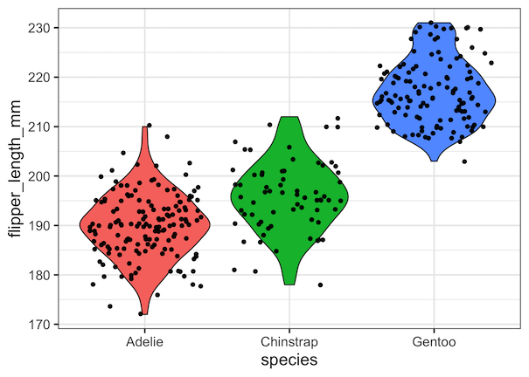[

1. *PNG* expression is distinctly higher in Gentoo penguins. [TRUE]
2. Average expression of *PNG* in Chinstrap penguins is 215 [FALSE]
3. The high end of *PNG* expression observed in Adelie penguins is the low end of *PNG* expression observed in Gentoo penguins [TRUE]
4. More measurements of *PNG* were taken for Adelie and Gentoo penguins than for Chinstrap penguins [TRUE]

# Topic Area 4: Personal Feelings

### Question 1: Unix

**Points**: 1

**Type**: Survey

**Question**: How would you describe your comfort level with using a command line interface to interact with a Linux/Unix command-line style environment?

1. Very uncomfortable
2. Uncomfortable
3. Slightly uncomfortable
4. Slightly comfortable
5. Comfortable
6. Very comfortable

**Answer**: All answers accepted.

### Question 2: R

**Points**: 1

**Type**: Survey

**Question**: How would you describe your comfort level with programming in R?

1. Very uncomfortable
2. Uncomfortable
3. Slightly uncomfortable
4. Slightly comfortable
5. Comfortable
6. Very comfortable

**Answer**: All answers accepted.

### Question 3: Programming

**Points**: 1

**Type**: Survey

**Question**: How would you describe your level of coding expertise using any programming language?

1. No experience
2. Beginner
3. Advanced beginner
4. Competent
5. Proficient
6. Expert

**Answer**: All answers accepted.

### Question 4: Collaboration

**Points**: 1

**Type**: Survey

**Question**: How comfortable are you asking your peers coding questions in an open class forum?

1. Very uncomfortable
2. Uncomfortable
3. Slightly uncomfortable
4. Slightly comfortable
5. Comfortable
6. Very comfortable

**Answer**: All answers accepted.

### Question 5: Reading/Interpreting Literature

**Points**: 1

**Type**: Survey

**Question**: How comfortable are you reading and interpreting a scientific paper?

1. Very uncomfortable
2. Uncomfortable
3. Slightly uncomfortable
4. Slightly comfortable
5. Comfortable
6. Very comfortable

**Answer**: All answers accepted.

### Question 6: Writing

**Points**: 1

**Type**: Survey

**Question**: How comfortable are you in writing a scientific paper?

1. Very uncomfortable
2. Uncomfortable
3. Slightly uncomfortable
4. Slightly comfortable
5. Comfortable
6. Very comfortable

**Answer**: All answers accepted.