Cross-Dataset Robustness of Bangla Handwritten Text Recognition
Reproducible preliminary manuscript and dataset-analysis report

Abstract
This manuscript documents the reproducible setup for a thesis on Bangla handwritten text recognition robustness. The current stage verifies BN-HTRd dataset archives, profiles sample line/word images, runs preprocessing diagnostics, and defines the controlled evaluation path needed to measure cross-dataset performance drop.

Research Question
How robust are Bangla HTR models trained on BN-HTRd when evaluated outside their original benchmark distribution?
- Measure the gap between benchmark and real-world handwriting.
- Keep the external dataset separate from training and tuning.
- Analyze failure modes by skew, noise, lighting, stroke density, and segmentation quality.

Methods
- Verify all downloaded dataset archives with SHA-256.
- Build archive and sample-level inventories.
- Profile sample image quality with width, height, contrast, blur proxy, and ink fraction.
- Run preprocessing diagnostics using denoising, CLAHE, and adaptive thresholding.
- Prepare writer-safe split planning and an external annotation protocol.

Dataset Inventory
Archive | Members | JPG | TXT | XML
Automatic_Annotation.zip | 154374 | 121572 | 15694 | 0
BN-HTR_Dataset.zip | 185856 | 137721 | 16256 | 15168
Sample_Small.zip | 4378 | 3225 | 387 | 360

Computed Preliminary Results
- Sample files extracted/profiled: 3,985.
- Sample JPEG images: 3,225.
- Ground-truth words in sample documents: 2,363.
- Line/word images profiled: 359.
- Images preprocessed for comparison: 120.
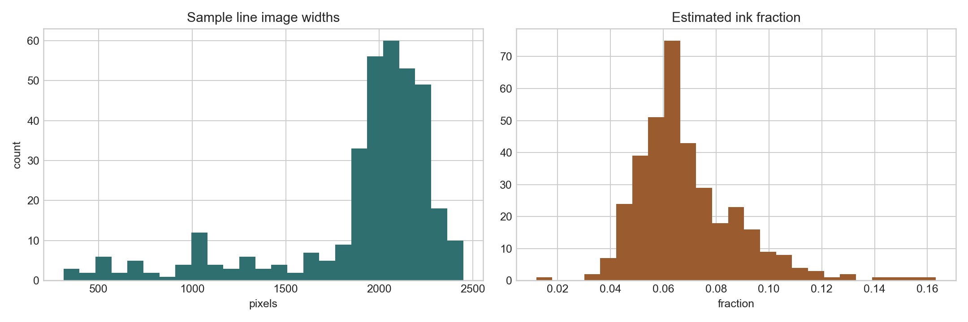
Figure 1. Sample image dimensions and estimated ink-density distributions.
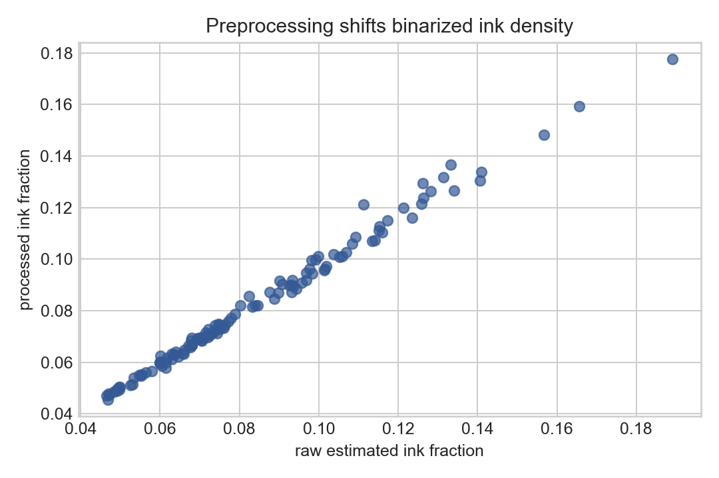
Figure 2. Ink-density shift after preprocessing.

Access and Reproducibility Notes
Hugging Face split status: blocked. Reason: 403 GatedRepoError: token account is not authorized for BN-HTRd_Split.zip Next action: Visit https://huggingface.co/datasets/shaoncsecu/BN-HTRd_Splitted and request access, or continue with verified Mendeley v4 archives.
The final CER/WER phase requires either authorized access to the Hugging Face split or a local full extraction plus line-level label conversion. This manuscript records computed preliminary results only and does not claim final OCR accuracy.

