

Innovation and market report
  - Offline relief coordination for Bangladesh

BANGLADESH INNOVATION FAIR 2026

Innovate to Market
Touhidul Alam Seyam
BGC Trust University Bangladesh
4 September 2026 / Editorial edition
AI-generated concept artwork. The project is a software demonstration with simulated environmental and vehicle data.

02 / THE OPPORTUNITY

Executive perspective
Digital Delta preserves relief requests and delivery records on field phones when commercial internet is unavailable.
Field teams need their records to survive a disconnected interval.
The proposed product  A clinic creates an urgent supply request. Trusted nearby phones carry an encrypted message toward its recipient. The receiving phone can calculate a route, expose a deadline conflict and record a signed handoff. An optional laptop shows the mission, while the field phones retain their own records and decision tools.  The evidence today  All eight software module paths have implementation and automated evidence. The recorded local gate passed the same 60 Android journeys on Android 15 and Android 16 emulators. Screenshots show actual application states, including visibly simulated missions. Physical three-phone relay, camera trials and operator validation remain open. | The commercial proposition  The recommended first offer is a supervised preparedness exercise for a district or relief organization. The sponsor receives configured devices, offline maps, role provisioning, bilingual training and an evidence review. Recurring support could cover seasonal readiness, credential administration and approved integrations. Customer demand and willingness to pay still need interviews.  The decision sought  Identify one operational sponsor willing to define a controlled exercise and its acceptance criteria. The next investment should establish whether the system works with real radios, real operators and an agreed response procedure.

Reading the evidence
Implemented software, emulator evidence, physical acceptance and market hypotheses are different stages. This report labels each where it affects a decision.
Repository R01–R08. Market recommendation is an assessment, not a signed commercial commitment.

03 / THE OPPORTUNITY

A guide to the report
The report connects the disaster response problem to the product, its engineering evidence and a credible first deployment.
Pages | What you will find
04–12 | Problem context, buyers, competition, business model and validation
13–26 | Product overview and annotated Bangla and English screenshots
27–34 | Architecture, privacy, evaluation and operational risk
35–38 | Pilot milestones, impact measurement, demonstration and partnership
39–40 | External references and repository evidence


AI-generated concept illustration of a clinic logistics workflow. It does not depict a project deployment.

How the walkthrough works
The delivery narrative connects the modules conceptually. Individual screenshots come from separate recorded drills and may show different mission destinations or states. Full captures preserve context. Enlarged details highlight the decision being explained.

04 / THE OPPORTUNITY

The Bangladesh use case
Relief coordination becomes harder when disrupted transport coincides with power and telecommunications failures.
7.2 million  Affected people in nine districts  June 2022 response plan [S01] | 3.74 million  Affected people in six districts  June 2024 assessment [S03]
Different events and assessment areas. These figures are not a trend series and should not be added.

Documented exposure
The UN Bangladesh response plan estimated 7.2 million people affected across nine northeastern districts in June 2022. The June 2024 assessment reported 3.74 million affected people across six districts. These are event-specific estimates with different dates and coverage. They should not be added or treated as a trend series. [S01, S03]

A continuity problem
The 19 June 2022 situation update described power shutdowns for safety, difficult mobile communication, submerged highways and limited boat availability. That combination motivates keeping essential operational records on devices that can continue working through disconnected periods. [S02]

Product implication
A relief team needs more than a map. It needs a durable record of what was requested, who may approve a change, which transport mode remains feasible and who accepted custody. Digital Delta combines those steps in one demonstrable field workflow.

Scope of the opportunity
Flood exposure establishes a public need. It does not establish product demand, willingness to pay or measured impact. Those questions require a controlled exercise with the organizations that own relief operations.
S01, S02 and S03. Counts are affected people, not customers or displaced-population totals.

05 / THE OPPORTUNITY

The delivery journey
One urgent delivery crosses several organizational and physical boundaries.
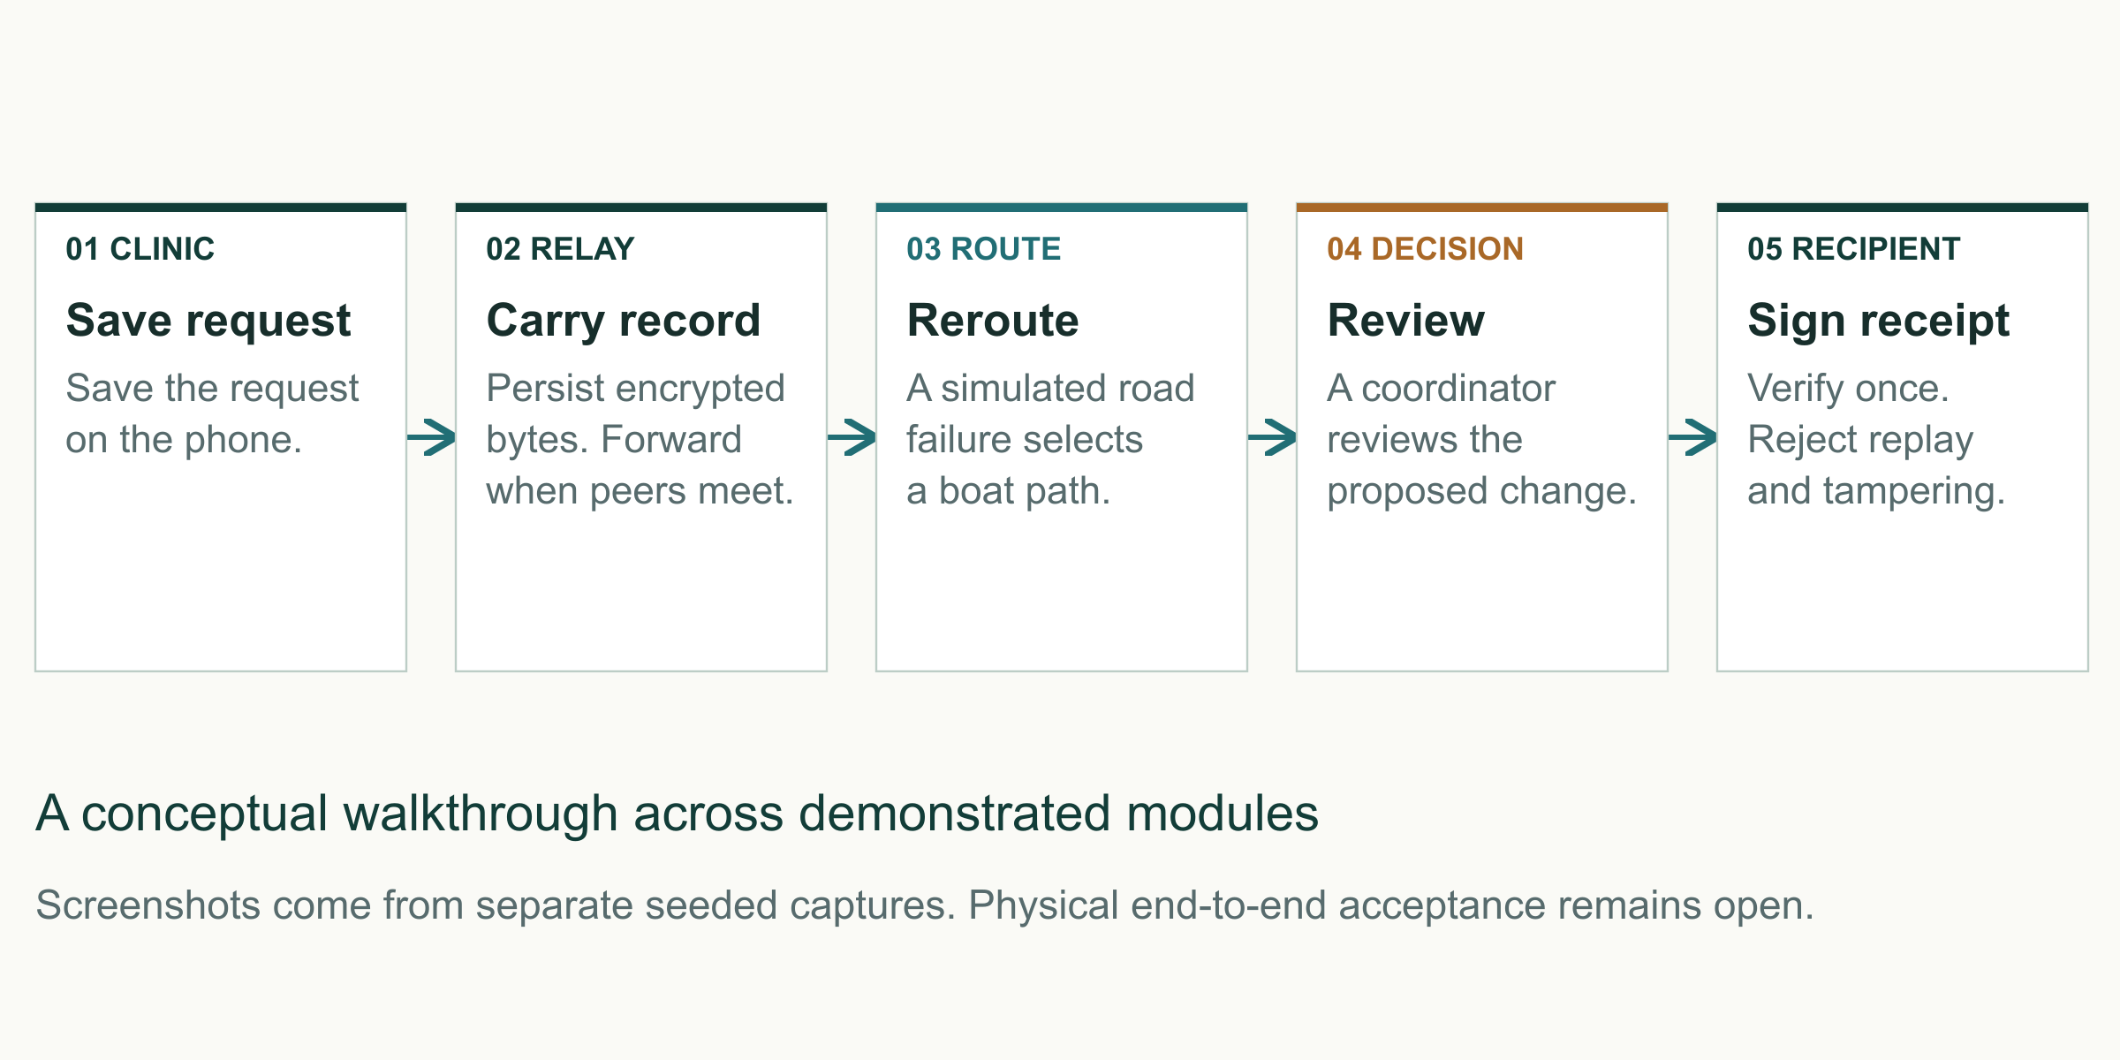
Original explanatory diagram. Editable source supplied in the design asset pack.
A representative mission  A clinic requests urgent cargo. A coordinator validates the request and assigns transport. A boat operator receives the job after a truck route becomes unavailable. The receiving hospital verifies the delivery. Volunteers may carry encrypted messages between contacts without gaining access to medical or cargo contents.  Human authority  An authorized coordinator confirms priority changes and unsafe conflict resolutions. Operators remain responsible for judging actual route safety. The fair model proposes actions within a simulation and cannot substitute for official incident command. | What is uncertain during an outage  A sender can know that a request is stored locally without knowing that a recipient has accepted it. A relay can acknowledge durable storage without becoming the custodian of the supplies. The interface and audit trail must preserve those distinctions.
R01, R05, R08. Mission is a representative demonstration scenario, not a recorded field deployment.

06 / THE OPPORTUNITY

Who uses buys and owns the system
The likely customer is an institution that can sustain a deployment between emergencies.
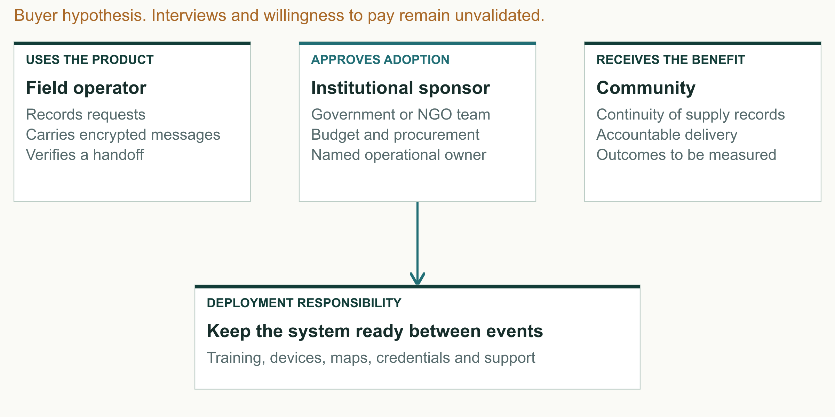
Original explanatory diagram. Editable source supplied in the design asset pack.
Initial buyer hypothesis  A district administration, humanitarian organization or health logistics partner could sponsor the first deployment. Each has a different approval chain. Discovery must establish who controls budget, who owns response procedures and who accepts responsibility for devices and credentials.  Beneficiary relationship  Affected households benefit from better coordination if the pilot eventually demonstrates it. They are not the default paying customer. The proposed model avoids charging per emergency request or monetizing sensitive recipient data. | Operational ownership  A deployment needs an administrator before the first emergency. Someone must issue and revoke identities, select supported phones, update offline maps, train new staff and run readiness exercises. A technically capable prototype without that owner is unlikely to become a maintained service.
Buyer roles are hypotheses derived from the project workflow. No endorsement or partnership is implied.

07 / THE OPPORTUNITY

Competitive landscape
Existing platforms solve important parts of disaster coordination. Digital Delta must prove the value of joining the field steps.
Platform | Documented strength | Relationship to Digital Delta
Sahana Eden [S06] | Inventory, requests, assets and mapping | Closest relief domain analogue; integrate where useful
KoboCollect [S07] | Offline Android forms after setup | Potential assessment input; server upload follows collection
Ushahidi [S08] | Crowdsourced reports and mapping | Potential reporting and situational-awareness partner
Briar [S09] | Encrypted sync over Bluetooth and Wi-Fi | Proves adjacent communication concepts
Meshtastic [S10] | Off-grid LoRa mesh communication | Uses separate radio hardware beyond this fair scope
Paper and radio | Familiar local procedures | Pilot baseline and operational fallback

A careful comparison  The comparison uses first-party product documentation. “Not established” means the reviewed source does not document the exact integrated workflow. It does not mean a competitor cannot implement it. Sahana’s cited page is explicitly a legacy archive. | The position worth testing  Digital Delta focuses on an encrypted phone relay feeding route decisions, priority review and signed custody in a bundled bilingual app. Its value depends on whether this integration reduces operational effort compared with a trained team using its current tools.
S06–S10. Comparison is scoped to reviewed documentation, not an exhaustive product audit.

08 / THE OPPORTUNITY

The first reachable market
Count operational deployments rather than affected people, mobile subscriptions or national resilience funding.
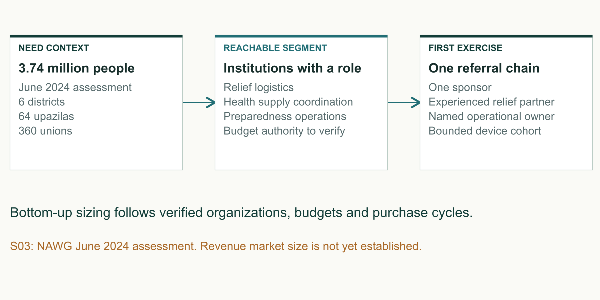
Original explanatory diagram. Editable source supplied in the design asset pack.
Total addressable need  The appropriate unit is a team or institution with recurring preparedness and disconnected logistics work. A validated registry would count potential deployment owners, remove overlap between agencies and identify existing systems. No verified national revenue market is available in the evidence package.  Obtainable first deployment  A reasonable initial test involves one sponsor, one health referral chain and one experienced relief partner. Its size should follow supervision capacity. The proposed 12-week exercise plan later in this report is an assumption to discuss with that sponsor. | Serviceable starting area  The June 2024 assessment covered six northeastern districts, 64 upazilas and 360 unions. This is a documented geographic frame for investigation, not a claim that all of those institutions are reachable customers. Device readiness and institutional consent will reduce the serviceable subset. [S03]  Institutional spending signal  The World Bank approved US$270 million for Bangladesh flood recovery and resilience in May 2025. The program includes infrastructure, livelihoods and preparedness. It demonstrates investment in resilience, but none of that total can be booked as Digital Delta’s addressable software revenue. [S04]
S03 and S04. No TAM revenue estimate or sales forecast is asserted.

09 / THE OPPORTUNITY

The service around the software
Sell readiness and accountable deployment support around an offline field tool.
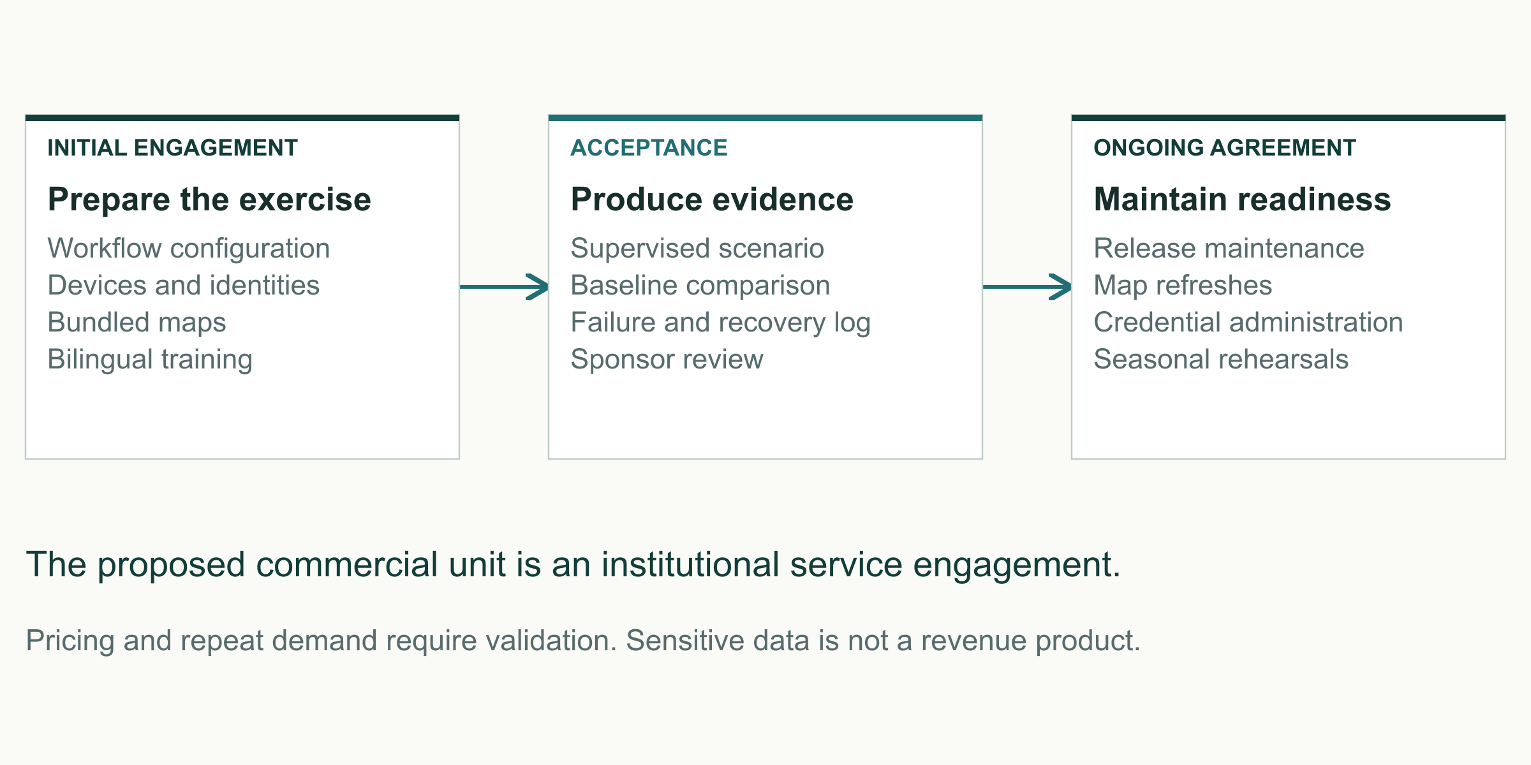
Original explanatory diagram. Editable source supplied in the design asset pack.
A first offer  Package a bounded preparedness exercise: workflow mapping, a configured APK, trusted identities, reviewed offline maps, training, observed test sessions and an evidence report. This is easier to scope and evaluate than an open-ended national platform purchase.  Pricing logic  Price against the real cost of delivery and the sponsor’s procurement process. Discovery should compare fixed exercise fees, annual deployment support and partner-funded implementation. Avoid per-relief-request pricing, which would penalize use when needs increase. | A recurring service hypothesis  After a successful exercise, annual support could include credential administration, supported-device checks, seasonal refresher training, map updates, release maintenance and incident support. Integration work should be separately scoped because partner systems and governance vary.  Defensibility  The potential advantage is accumulated operational knowledge: a tested-device matrix, clear failure behavior, trusted local delivery partners, maintainable policies and evidence from repeated exercises. The present prototype does not establish a patent moat or exclusive technical invention.
Commercial options are recommendations. Pricing, licenses, sales and partnerships remain unvalidated.

10 / THE OPPORTUNITY

Illustrative pilot cost model
A transparent planning budget helps a sponsor judge the scale of a controlled exercise.
BDT 517,500
Illustrative 12-week pilot total including 15% contingency
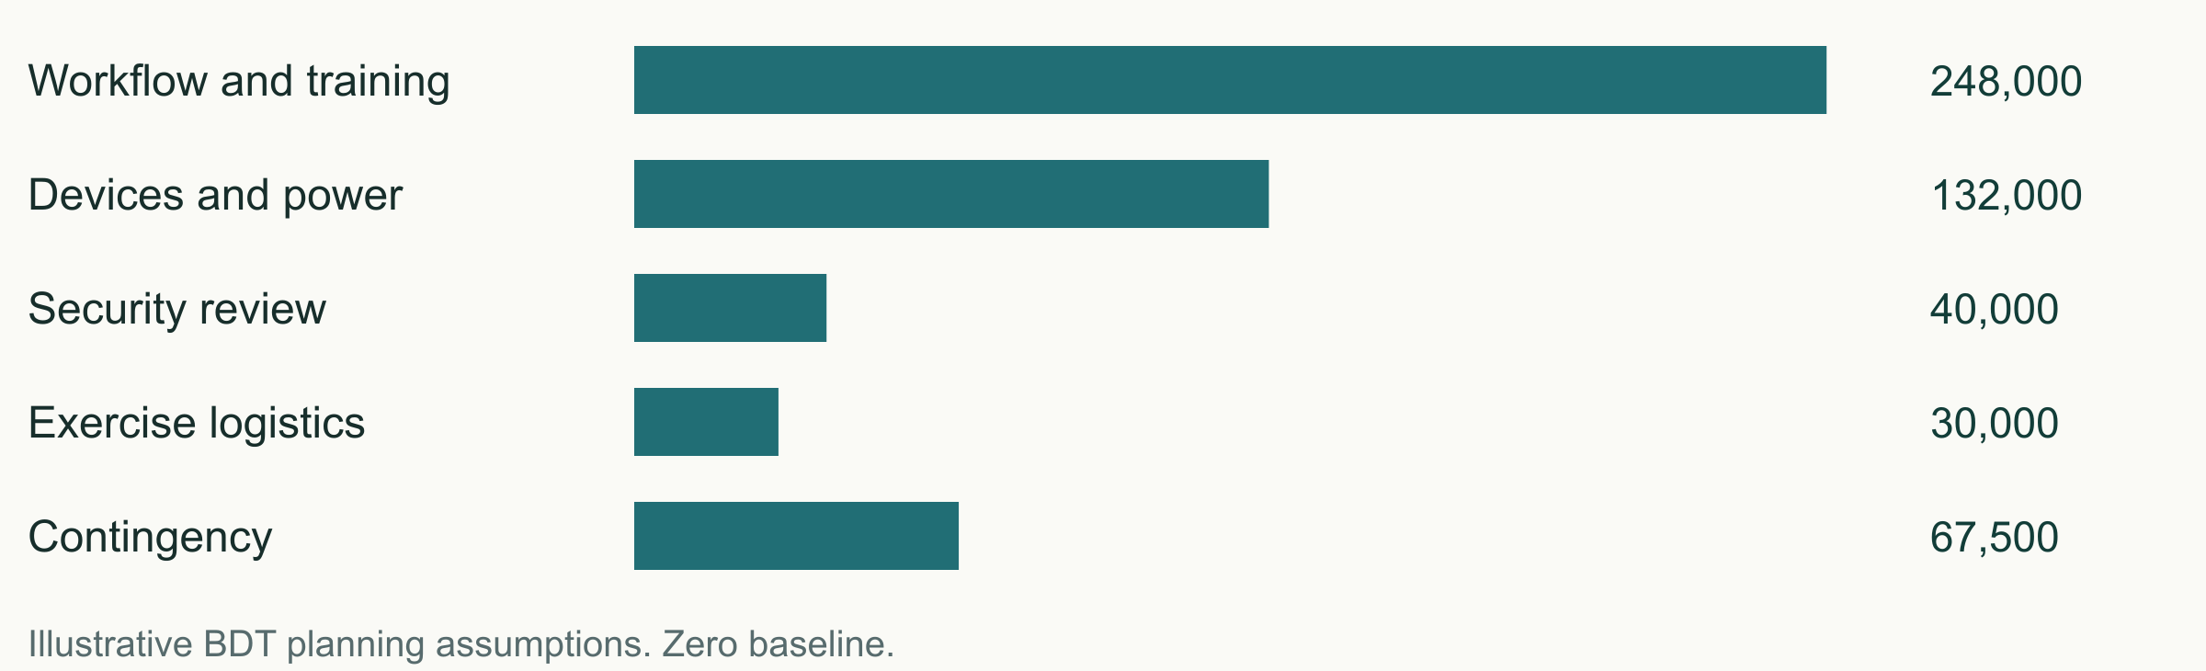
Cost item | Illustrative calculation | BDT
Workflow and engineering | 40 days × 5,000 | 200,000
Training and field facilitation | 12 days × 4,000 | 48,000
Independent security review | 5 days × 8,000 | 40,000
Exercise phones | 6 × 18,000 | 108,000
Power and protective accessories | 6 × 4,000 | 24,000
Travel and exercise logistics | Assumed allowance | 30,000
Subtotal |  | 450,000
Contingency | 15% of subtotal | 67,500
Illustrative total |  | 517,500

One sponsor, twelve weeks and six exercise phones. Invented planning rates, not supplier quotations or actual expenditure. Excludes taxes, long-term salaries, emergency transport and ongoing production support. Replace assumptions with local quotes and an agreed staffing plan.
Planning model created for this report. All inputs require validation. Total = 450,000 × 1.15.

11 / THE OPPORTUNITY

The adoption journey
The innovation fair should open a supervised pilot conversation with an operational owner.
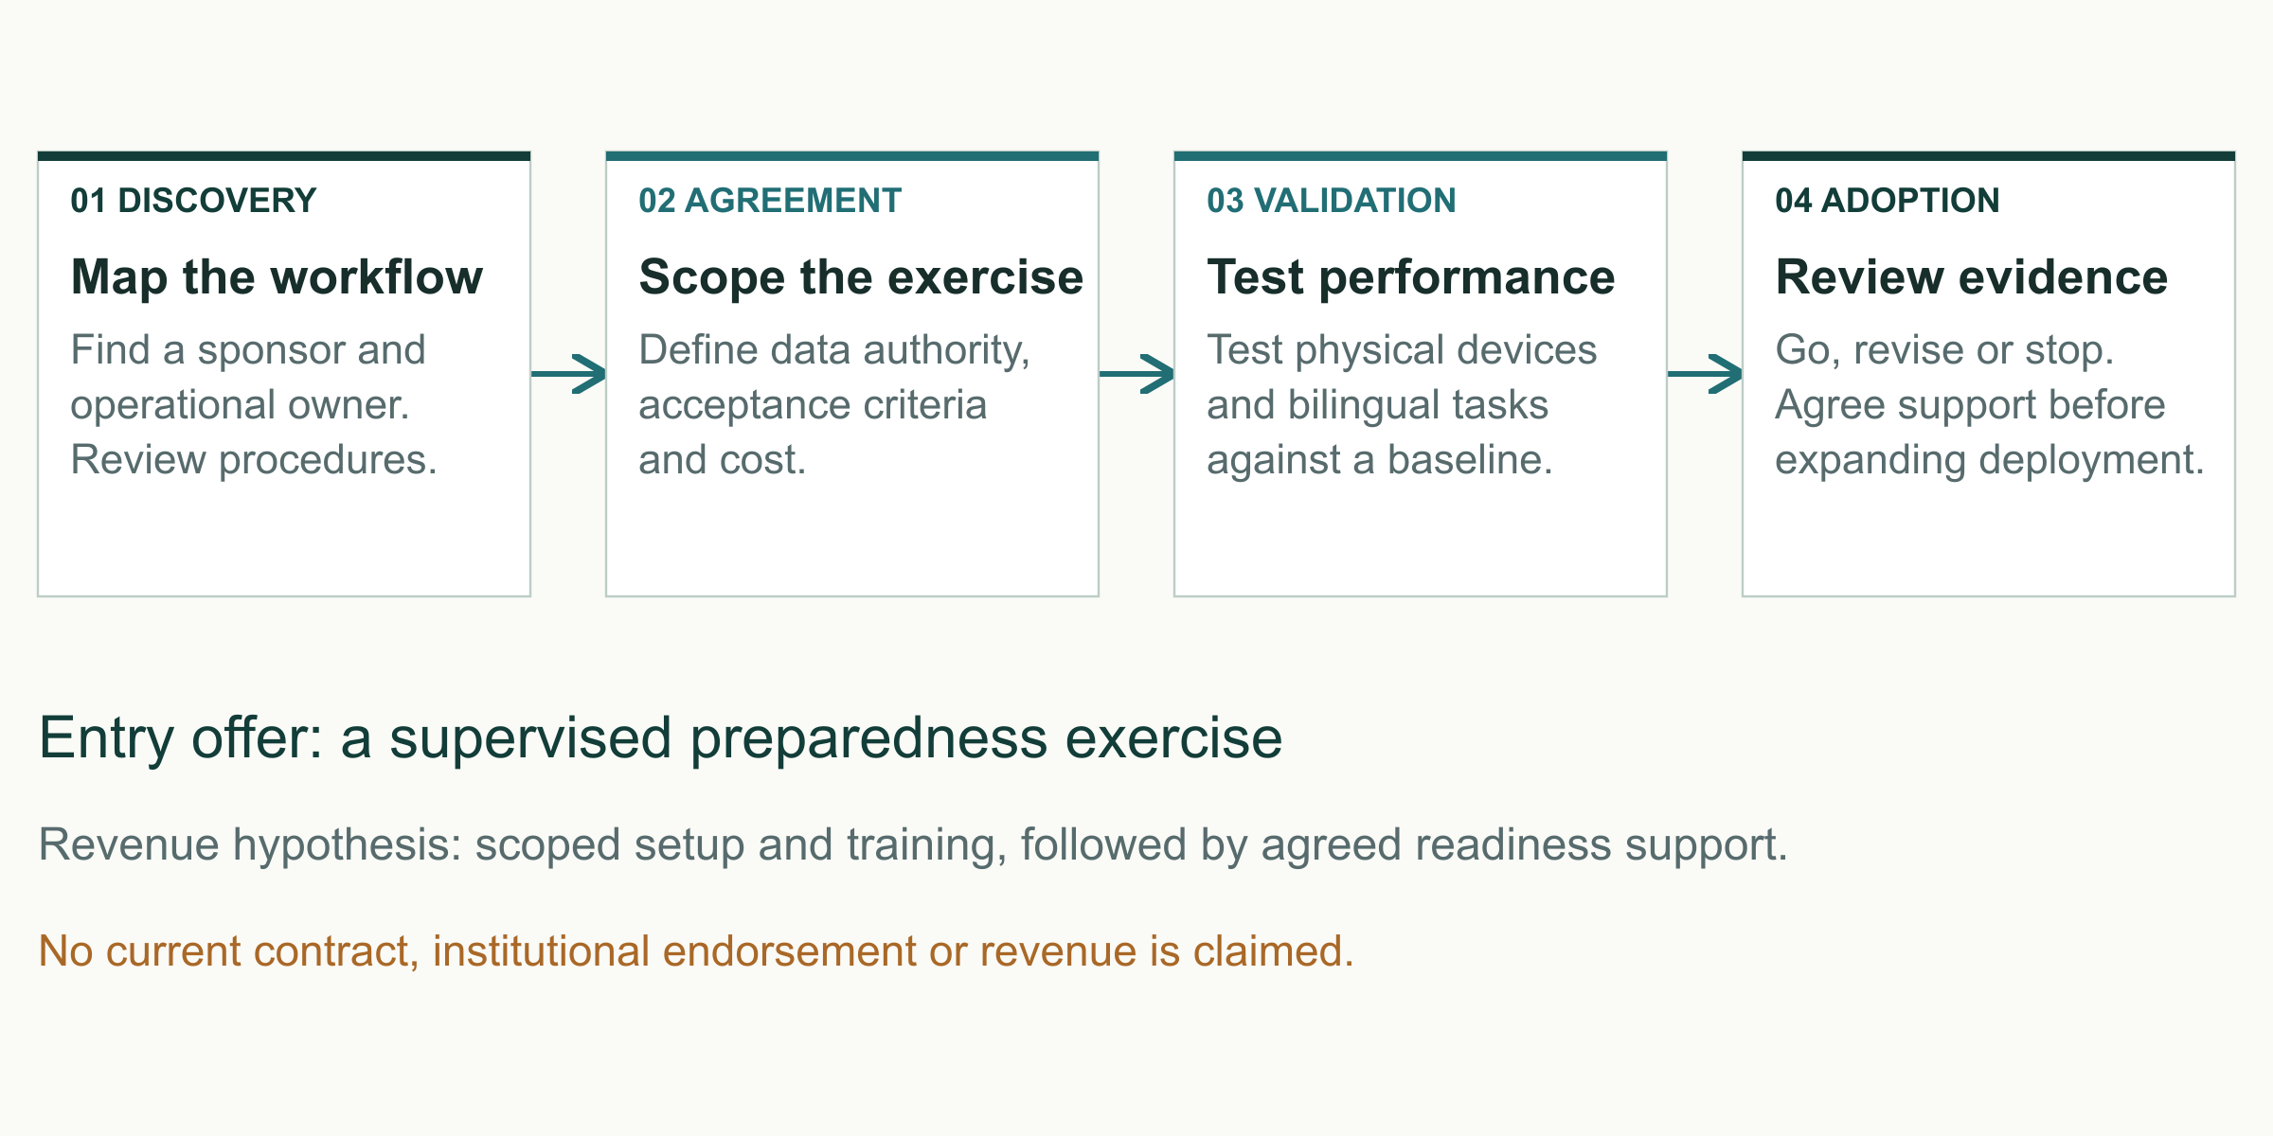
Original explanatory diagram. Editable source supplied in the design asset pack.
Fair conversation  Show the offline workflow and its failure handling. Ask interested organizations to identify the person who owns logistics procedures and can approve a controlled exercise. Record the workflow problem and follow-up owner only with consent. A booth conversation is a lead, not validated demand.  Exercise proposal  Agree a scenario, participant roster, tested phones, map area, acceptance thresholds and stop conditions. Existing approved procedures stay authoritative. The app records events and recommendations in shadow mode so the team can compare logs safely. | Discovery and qualification  Interview logistics coordinators, health-facility staff, volunteer supervisors and procurement owners. Map one current workflow, its failure points and its record requirements. Qualify the sponsor’s capacity to provision identities and maintain devices before proposing deployment.  Adoption decision  Review the exercise against measurable outcomes. If the system adds work or creates ambiguous state, improve the workflow before expansion. If it passes, negotiate a bounded support agreement and an integration review. Scale one repeatable deployment pattern at a time.
Go-to-market recommendation aligned with the fair’s Innovate to Market theme [S05]. No organizer-specific judging rubric is assumed.

12 / THE OPPORTUNITY

Customer validation plan
The first research should challenge the assumptions most likely to prevent adoption.
Hypothesis | Method | Disconfirming signal
Offline continuity matters | Reconstruct past incidents | Current procedure already solves it
The interface is learnable | Observed bilingual tasks | Repeated critical errors
An institution will own it | Budget and procedure interviews | No administrator or sponsor
Integrated workflow saves effort | Compare complete task sequence | More work than the baseline

Research design  Conduct approximately 12 semi-structured interviews across operational leads, clinic or hospital staff, volunteer supervisors and budget owners. This is a proposed sample, not completed research. Ask participants to reconstruct a recent coordination episode before showing the app.  Observed task test  After consent and a short briefing, ask participants to create a request, interpret queued versus received status, resolve a conflict and verify a handoff. Record task completion, time, help requests and critical mistakes in Bangla and English. Use test identities and synthetic cargo only. | Questions worth answering  Which records are lost or duplicated? How long can teams be out of contact? Who may redirect cargo? What devices and power arrangements exist? What is the current paper or radio fallback? Who would pay for training and seasonal readiness? Ask for examples rather than general enthusiasm.  Decision criteria  Before research starts, define what would justify stopping or changing the product. Examples include no identifiable owner, unacceptable training burden, unreliable supported phones or a preference for a simpler existing tool. A useful result may narrow the scope.
Proposed primary research. No interviews, survey percentages or testimonials have been fabricated.

13 / THE DELIVERY JOURNEY

The product at a glance
Eight module paths share the same local event and trust model.
Module | Capability | Visible evidence
M1 | Offline identity and role enforcement | Trust and denied-action screens
M2 | Conflict-aware local records | Conflict review and resolution
M3 | Encrypted store-and-forward relay | Nearby service and durable queue
M4 | Multimodal route search | Truck failure and boat fallback
M5 | Signed proof of delivery | Accepted, replay and tamper states
M6 | Priority preemption | SLA warning and confirmed decision
M7 | On-device route-risk model | Labelled synthetic input and reroute
M8 | Hybrid fleet rendezvous | Simulated delay and custody transfer

One continuous workflow  Identity controls who can act. Local storage preserves the action. Relay carries it to another phone. Routing and risk help explain transport choices. Priority review records a human decision. Signed custody closes the handoff. The project’s central technical idea is that these steps can share a durable offline record. | Demonstration boundary  Truck, boat and drone movement is simulated. Environmental inputs and route failures are simulated. No sensor, IoT device or physical drone is required or controlled. The Android UI, local storage, cryptographic operations and bundled inference are actual software paths with recorded test evidence.
R01, R02, R05, R06. Working module paths do not mean every physical acceptance gate is complete.

14 / THE DELIVERY JOURNEY

Two languages one mission
Bangla and English ship together and retain the same operational meaning.
FULL CAPTURES  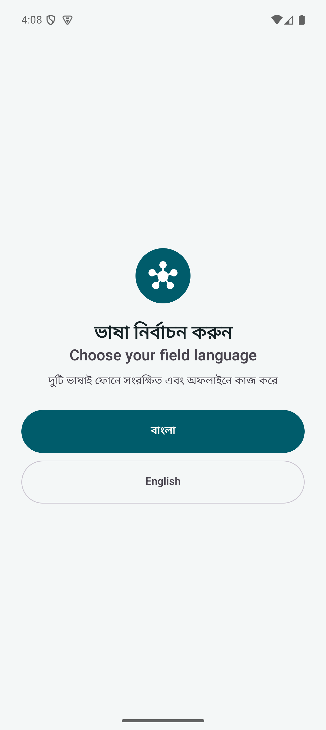 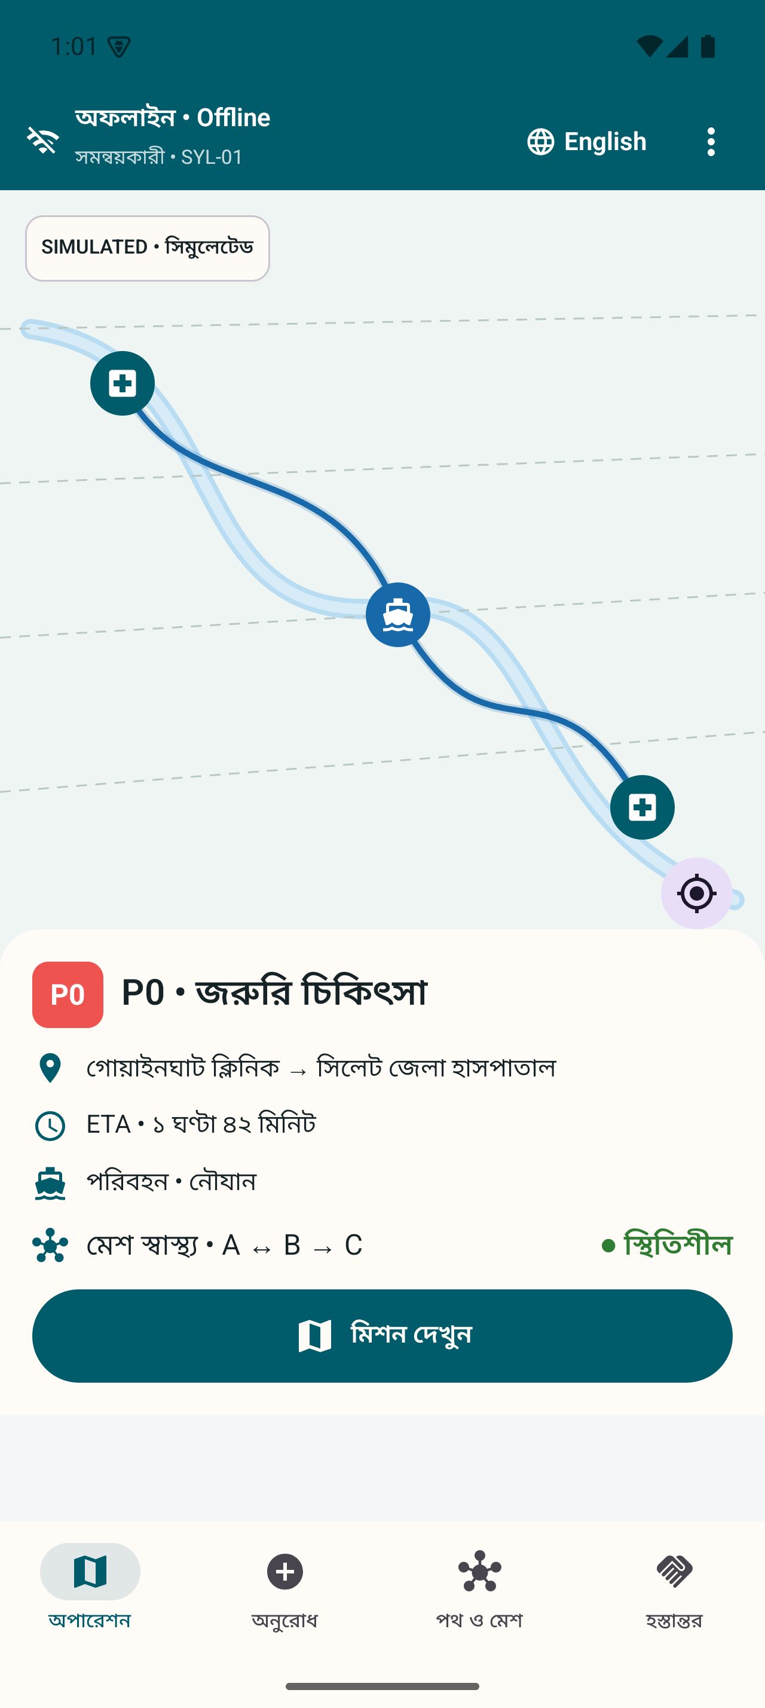 | ENLARGED DETAIL  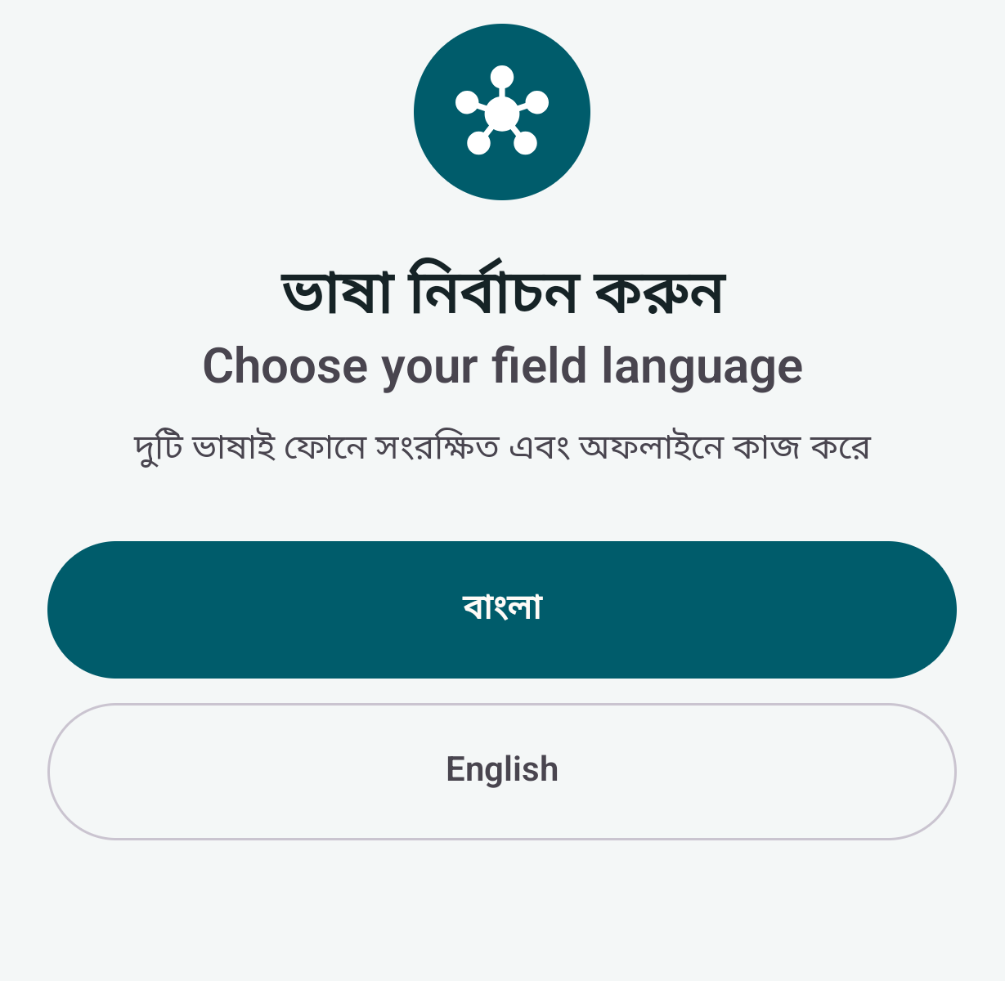  Detail crop. Full source context appears alongside.
01 Language choice  Both interfaces ship with the app. Switching language does not replace the mission record. | 02 Shared semantics  Stable domain codes support the same decisions in Bangla and English.
01 First-run language choice. Both interfaces are bundled.
02 Bangla field home with an offline operational context.
Design purpose  Field teams should not need internet to download a language pack. Domain codes remain language neutral so a Bangla request and an English receiver can represent the same mission state. Switching the interface must not reset a form or create a different event. | What remains to test  Automated string parity and emulator journeys support implementation coverage. Human review still needs to test comprehension, wrapping, TalkBack, low literacy and task completion on the actual phones.
R01, R02, R06. Actual application captures. Human inclusion outcomes remain unmeasured.

15 / THE DELIVERY JOURNEY

Offline identity and authority
A selected profile cannot grant itself permission to act.
FULL CAPTURES  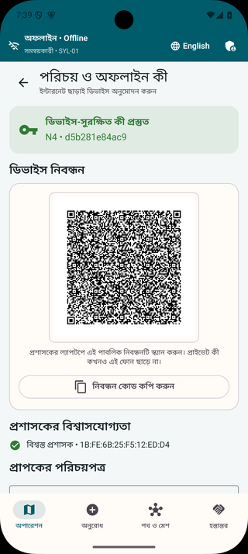 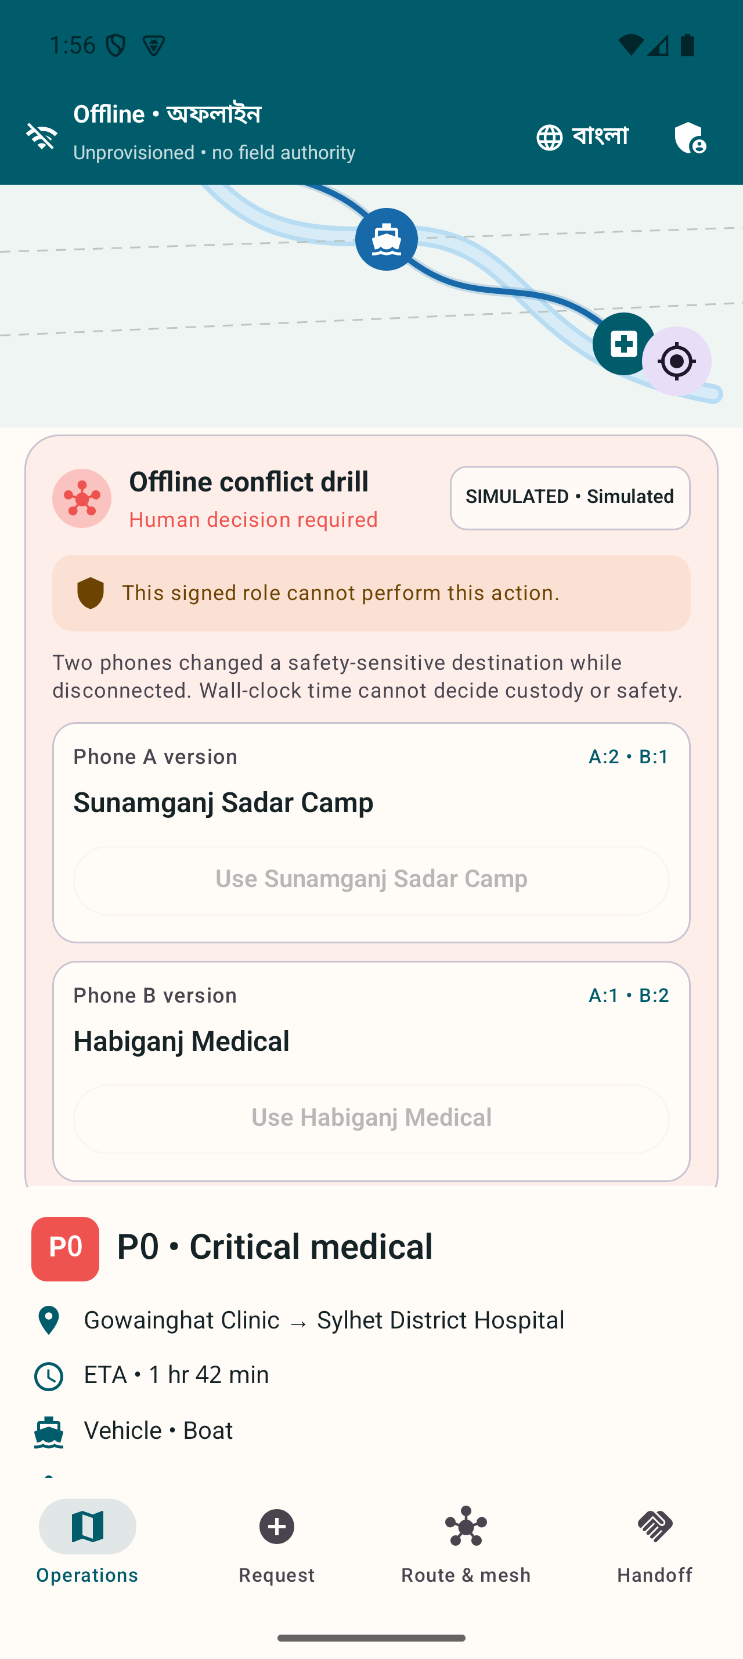 | ENLARGED DETAIL  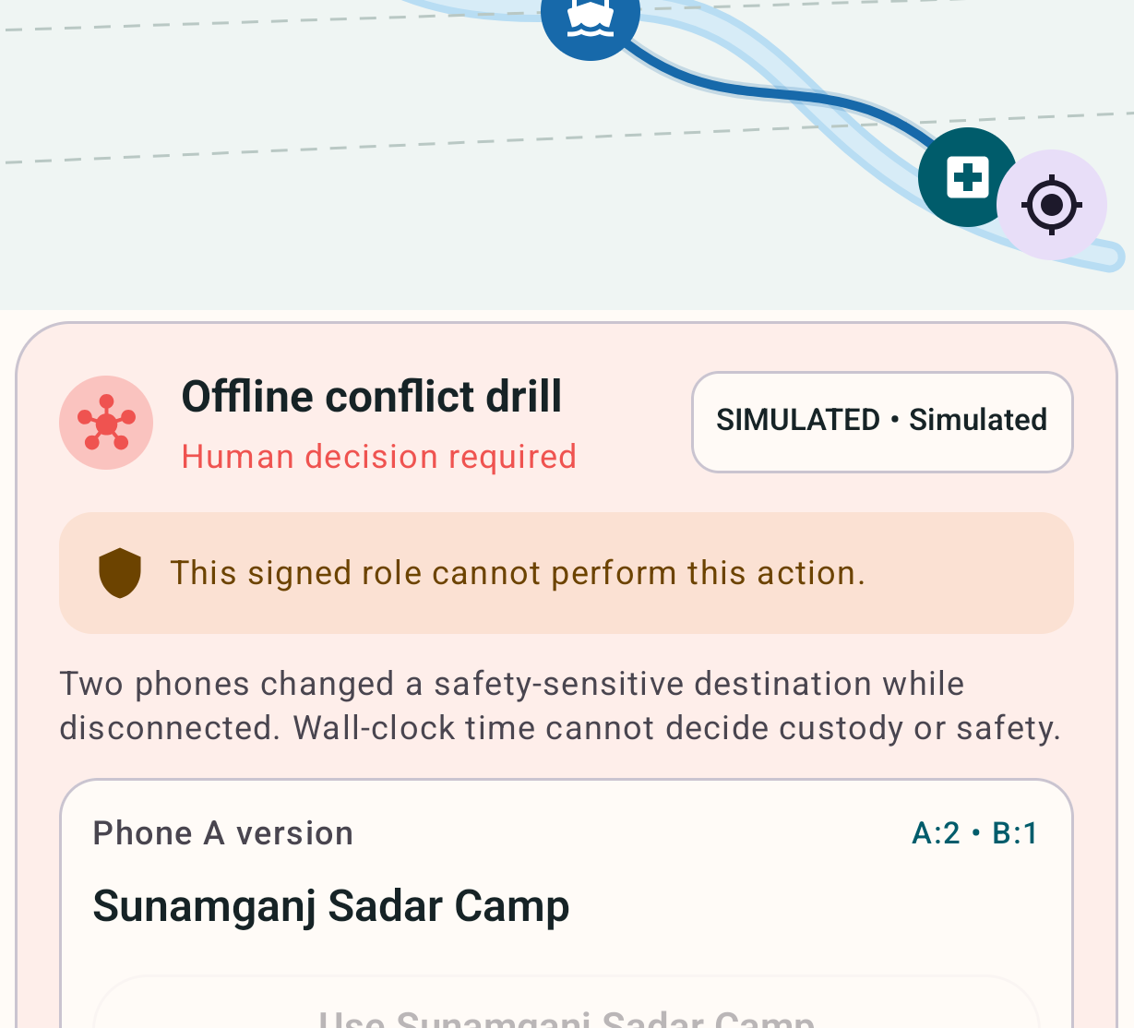  Detail crop. Full source context appears alongside.
01 Authority is explicit  A trusted credential binds a device identity to a role. | 02 Denial is visible  The app explains when the current role cannot perform an action.
01 Bangla provisioning state after trusted credential installation.
02 English role denial. Unauthorized activity remains blocked.
Trust model  A phone needs an administrator-signed credential bound to its node, role and Keystore keys. Offline PIN unlock controls local access. The app checks authorization again at the action boundary, so hiding a button is not the only defense. | Evidence and limit  The screenshots show trusted provisioning and a refused role action. Recorded tests cover invalid role bindings and related trust checks. Physical QR provisioning and hostile-phone exchange still need real-device trials.
M1. R01, R02, R05, R06, R07.

16 / THE DELIVERY JOURNEY

An urgent request stored locally
The sender commits the request before attempting transfer.
FULL CAPTURES  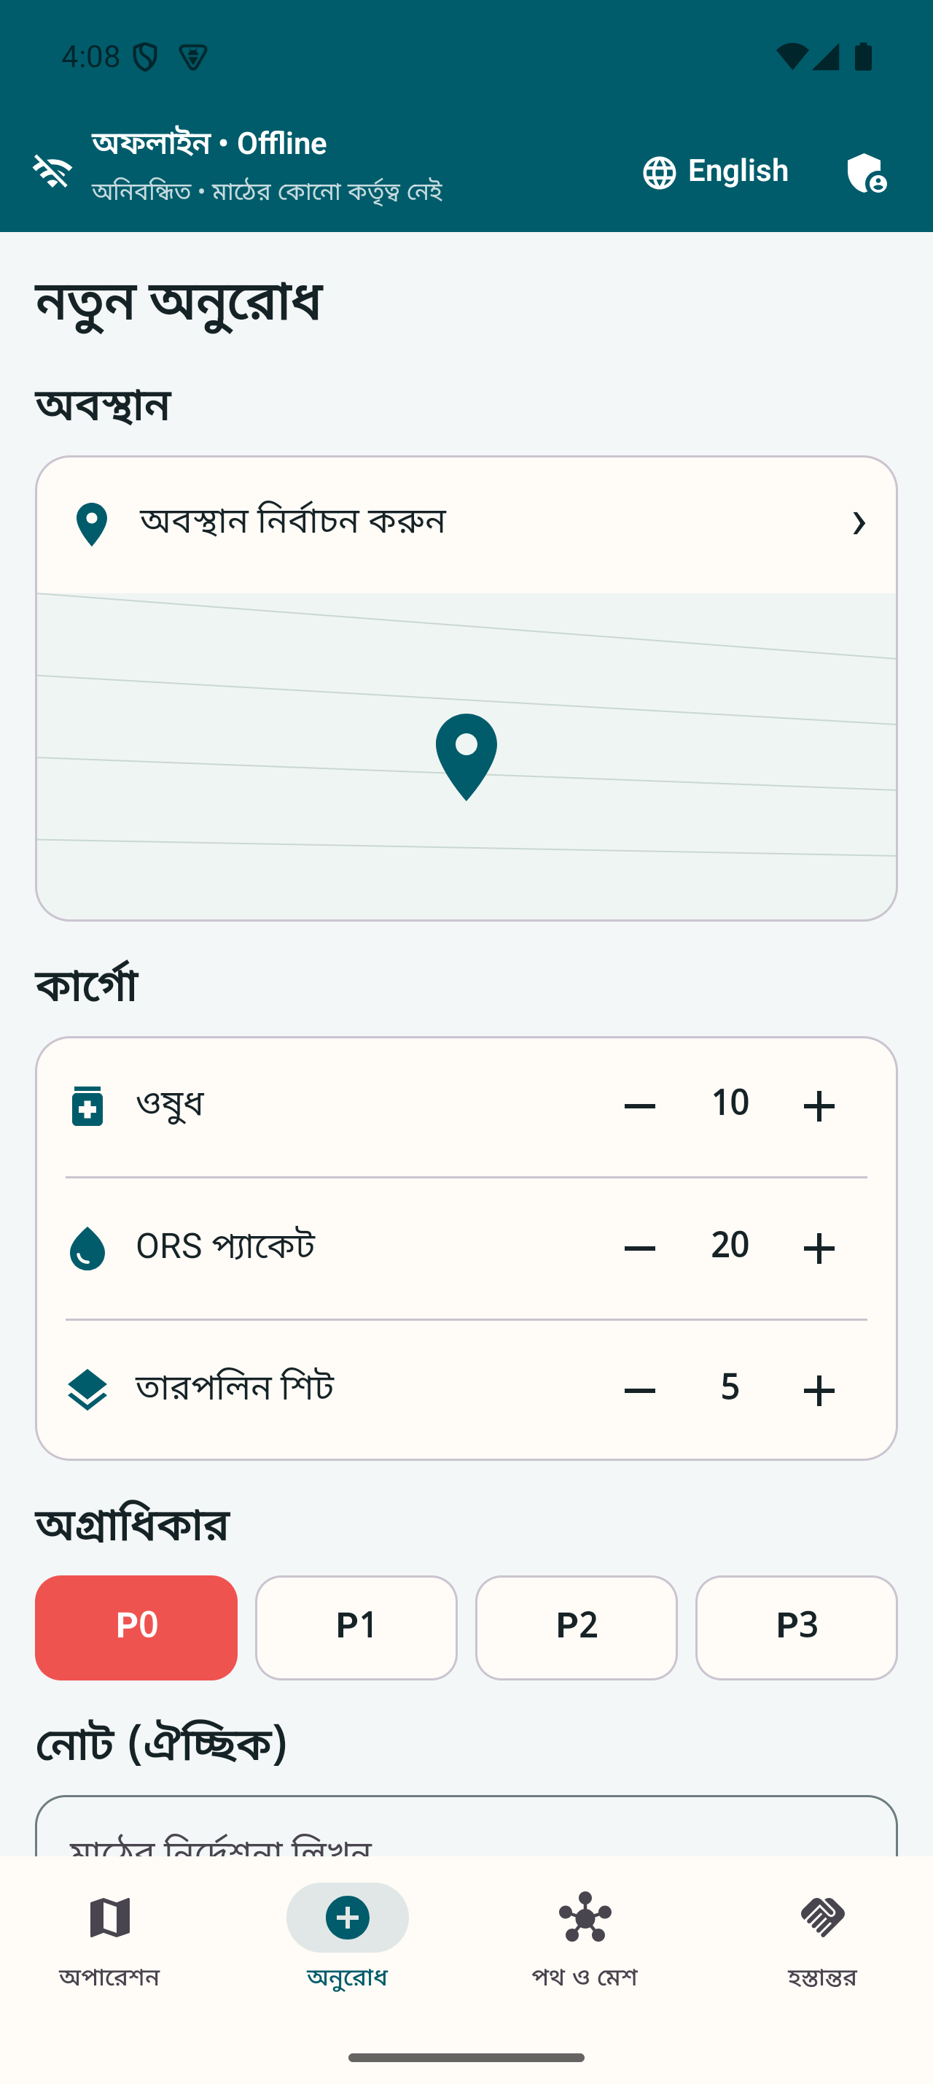 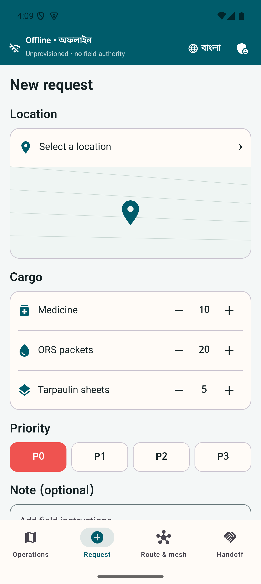 | ENLARGED DETAIL  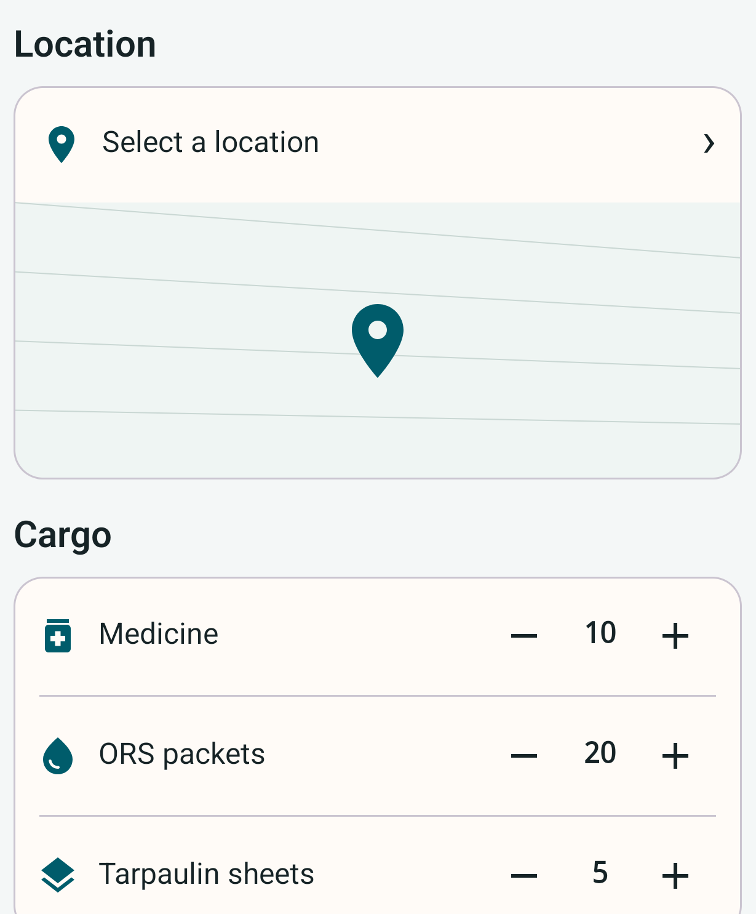  Detail crop. Full source context appears alongside.
01 The request has structure  Location, cargo and priority become fields that can be stored locally. | 02 Queue state has meaning  A locally saved request still needs transfer and recipient acceptance.
01 Bangla urgent request in the field application.
02 Equivalent English request workflow and priority context.
What happens  The form becomes a language-neutral Protobuf event. The app encrypts the delivery payload for the intended recipient and atomically stores the operation and envelope in its local outbox. A queued request remains visible when a network transfer cannot proceed. | Why it matters  Queued does not mean delivered. The operator needs to distinguish saved, relayed and accepted states. Recipient-only decryption has connected-test evidence. The physical end-to-end radio journey remains an open gate.
M1–M3. R01, R02, R05, R06. Test and demo identities only.

17 / THE DELIVERY JOURNEY

Nearby encrypted relay
Phones store and carry envelopes until another trusted peer becomes reachable.
FULL CAPTURES  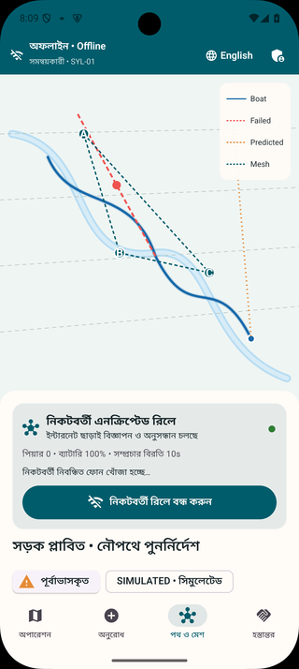 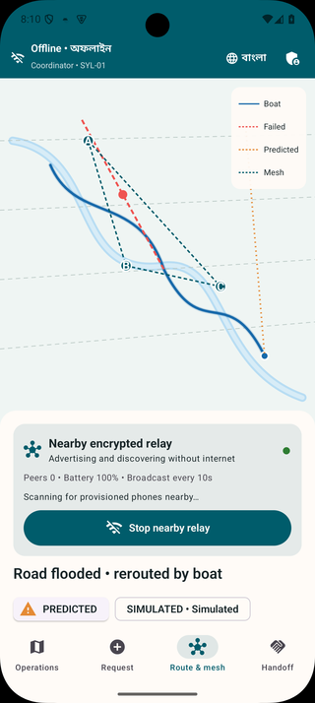 | ENLARGED DETAIL  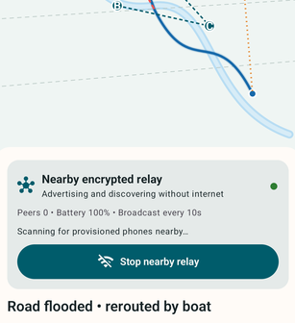  Detail crop. Full source context appears alongside.
01 The radio has a visible state  The user starts and stops the foreground relay session. | 02 Persistence precedes transfer  An encrypted envelope can wait for the next authenticated peer.
01 Bangla relay session with explicit active-state information.
02 English relay view from the same evidence family.
Active relay behavior  Nearby Connections uses a visible Android foreground service for discovery and transfer. Human comparison digits and signed peer challenges establish trust before message acceptance. Durable queues, acknowledgements, expiry, hop limits and duplicate rejection belong to the application layer. | Evidence boundary  These captures show the service active on an emulator. They establish UI and single-device lifecycle behavior. They do not establish range or a successful A-to-B-to-C physical radio exchange.
M3. R01, R02, R05, R06. Radio distance and real-phone delivery rates are not claimed.

18 / THE DELIVERY JOURNEY

Conflicts receive a human decision
Concurrent safety-sensitive edits remain visible until an authorized coordinator resolves them.
FULL CAPTURES  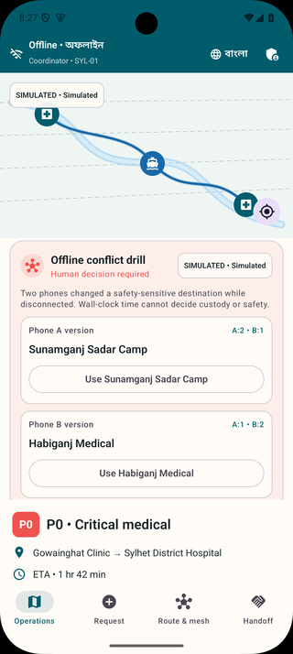 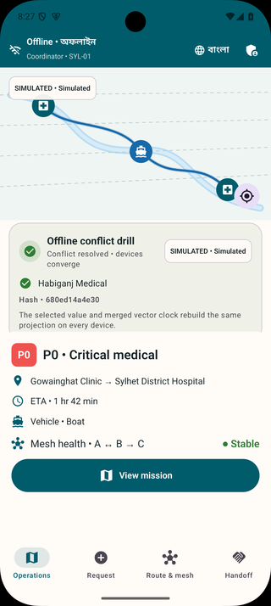 | ENLARGED DETAIL  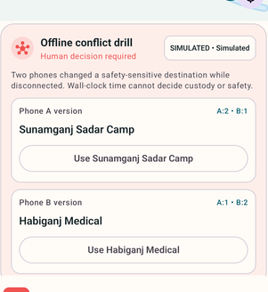  Detail crop. Full source context appears alongside.
01 Conflicting destinations stay visible  The review shows both versions instead of silently choosing the latest clock time. | 02 The decision becomes evidence  The accepted value retains policy and convergence information.
01 Two destination versions await a coordinator’s decision.
02 Resolved state records the choice and convergence evidence.
Concurrent does not mean latest  Two disconnected devices may change the same destination. Wall-clock time cannot establish which instruction is correct. Vector clocks expose concurrency, while the resolver records the selected value, merged clock, policy version and convergence hash. | Safe convergence  The implementation uses different merge rules for sets, inventory counters and unsafe field conflicts. The screenshots show an actual simulated conflict and its resolution. Physical two-phone convergence remains part of acceptance.
M2. R01, R05, R06. The conflict inputs are a labelled disconnected-edit drill.

19 / THE DELIVERY JOURNEY

Route failure and boat fallback
A confirmed failed edge removes the truck path and the phone searches valid alternatives.
FULL CAPTURES  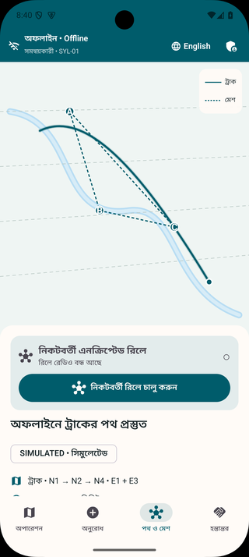 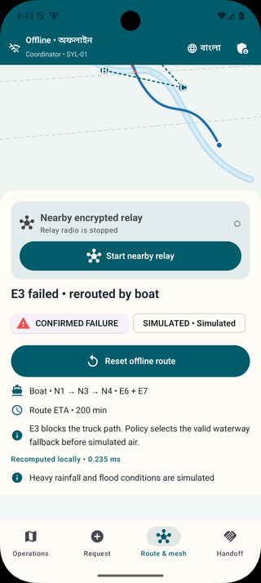 | ENLARGED DETAIL  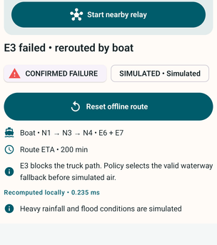  Detail crop. Full source context appears alongside.
01 The failed road changes feasibility  The simulated E3 failure removes the truck option. | 02 The phone selects a boat path  The result exposes the selected mode and edges E6 and E7.
01 Initial truck route in the Bangla interface.
02 English view after the simulated failure selects a boat route.
The seeded route  The initial truck route uses E1 and E3. Simulating an E3 failure causes the routing engine to select the policy-ordered boat alternative E6 and E7. Mode constraints filter the graph before deterministic route search. | What the user should understand  A feasible graph path is not proof of physical safety. A real deployment needs maintained map and closure information, a human override and named target-phone latency measurements. The fair route and vehicle movement are simulated.
M4. R01, R05, R06. Under-two-second performance remains a target-phone acceptance measurement.

20 / THE DELIVERY JOURNEY

Priority changes need confirmation
The app exposes a predicted deadline breach and records the coordinator’s response.
FULL CAPTURES  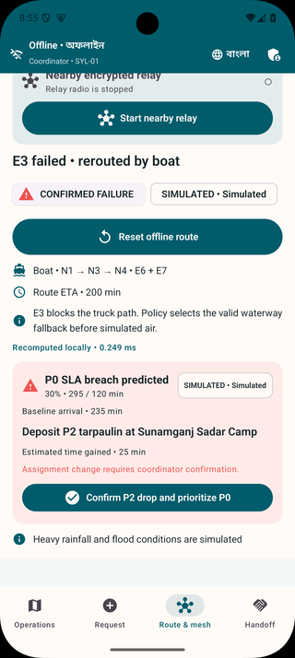 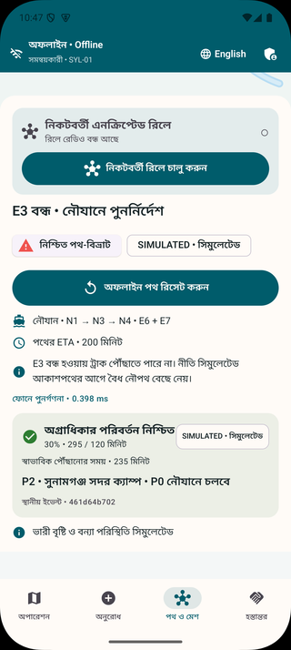 | ENLARGED DETAIL  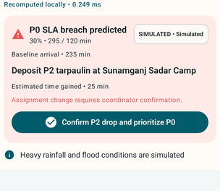  Detail crop. Full source context appears alongside.
01 The proposal explains the tradeoff  A longer boat route threatens the urgent cargo deadline. | 02 A person confirms the change  The decision records a safe waypoint, reason and affected cargo.
01 A preemption proposal explains the simulated SLA problem.
02 Bangla confirmed state retains the decision in the mission.
Decision logic  The triage engine considers the cargo SLA, route ETA, a 30 percent slowdown scenario and a safe drop waypoint. In the drill, the longer boat route threatens P0 cargo and prompts a proposal involving P2 cargo. It does not automatically transfer authority or supplies. | Guardrails  The policy rejects stale estimates older than five minutes, requires a safe waypoint and records the confirmer, affected cargo and reason. Competing urgent cargo remains visible. The term triage here refers to logistics priority, not diagnosis or clinical decision making.
M6. R01, R02, R05, R06. Operator confirmation is required.

21 / THE DELIVERY JOURNEY

On-device route risk
A small bundled model demonstrates how a prediction can influence routing offline.
FULL CAPTURES  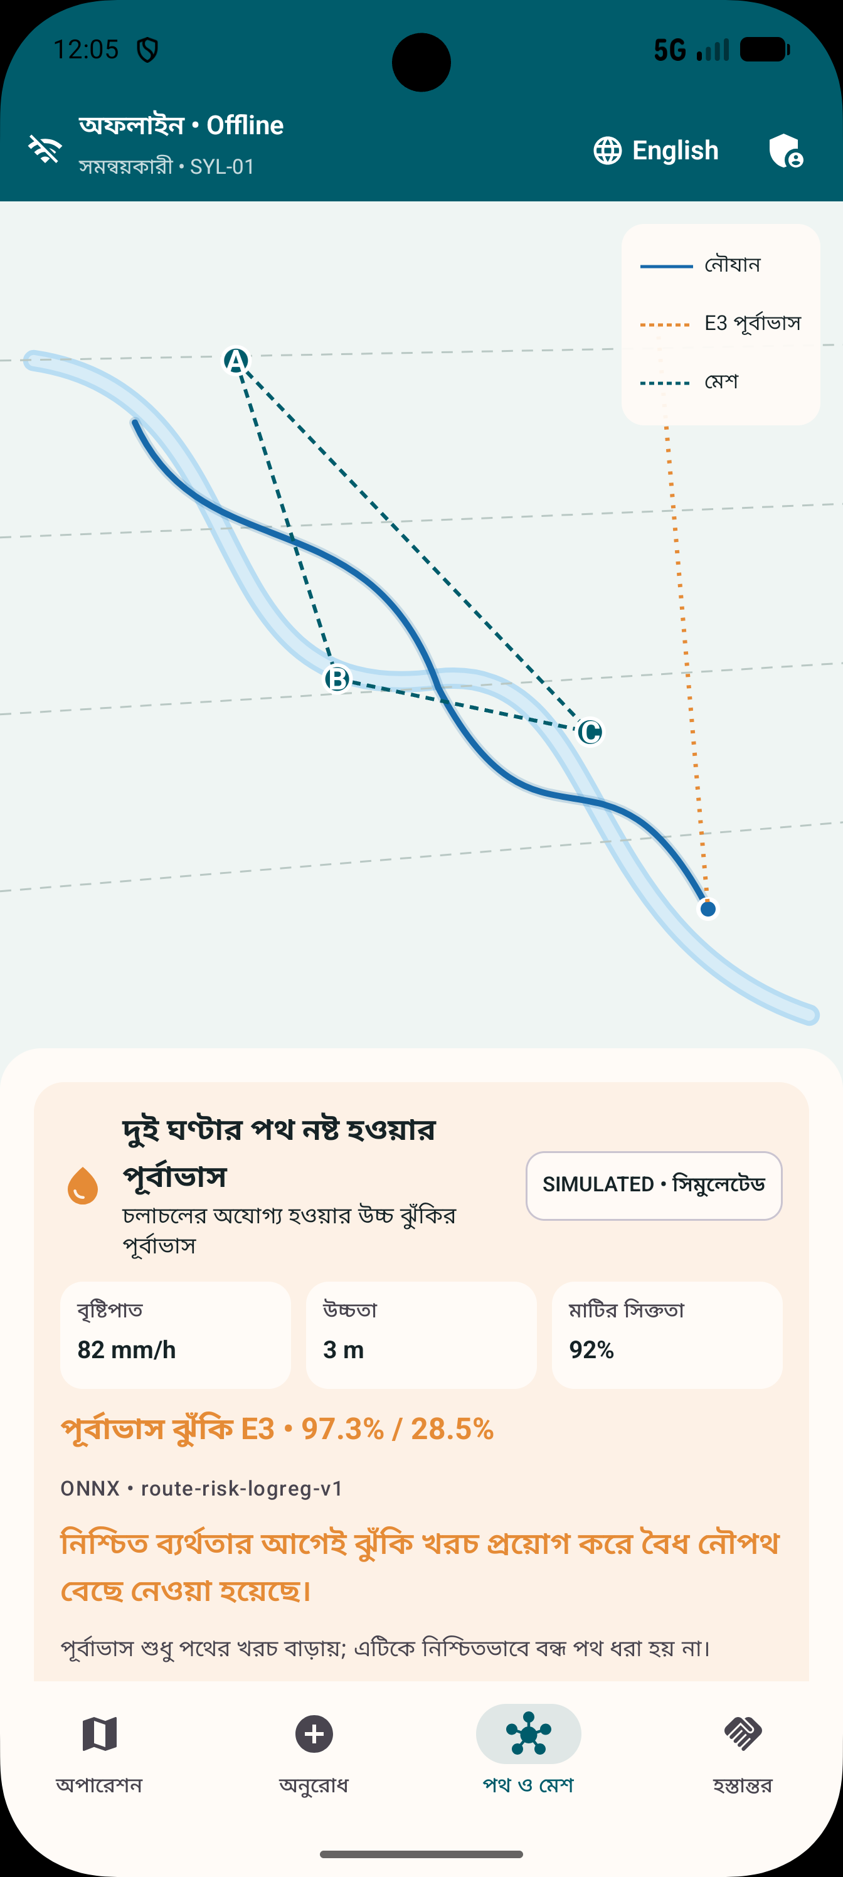 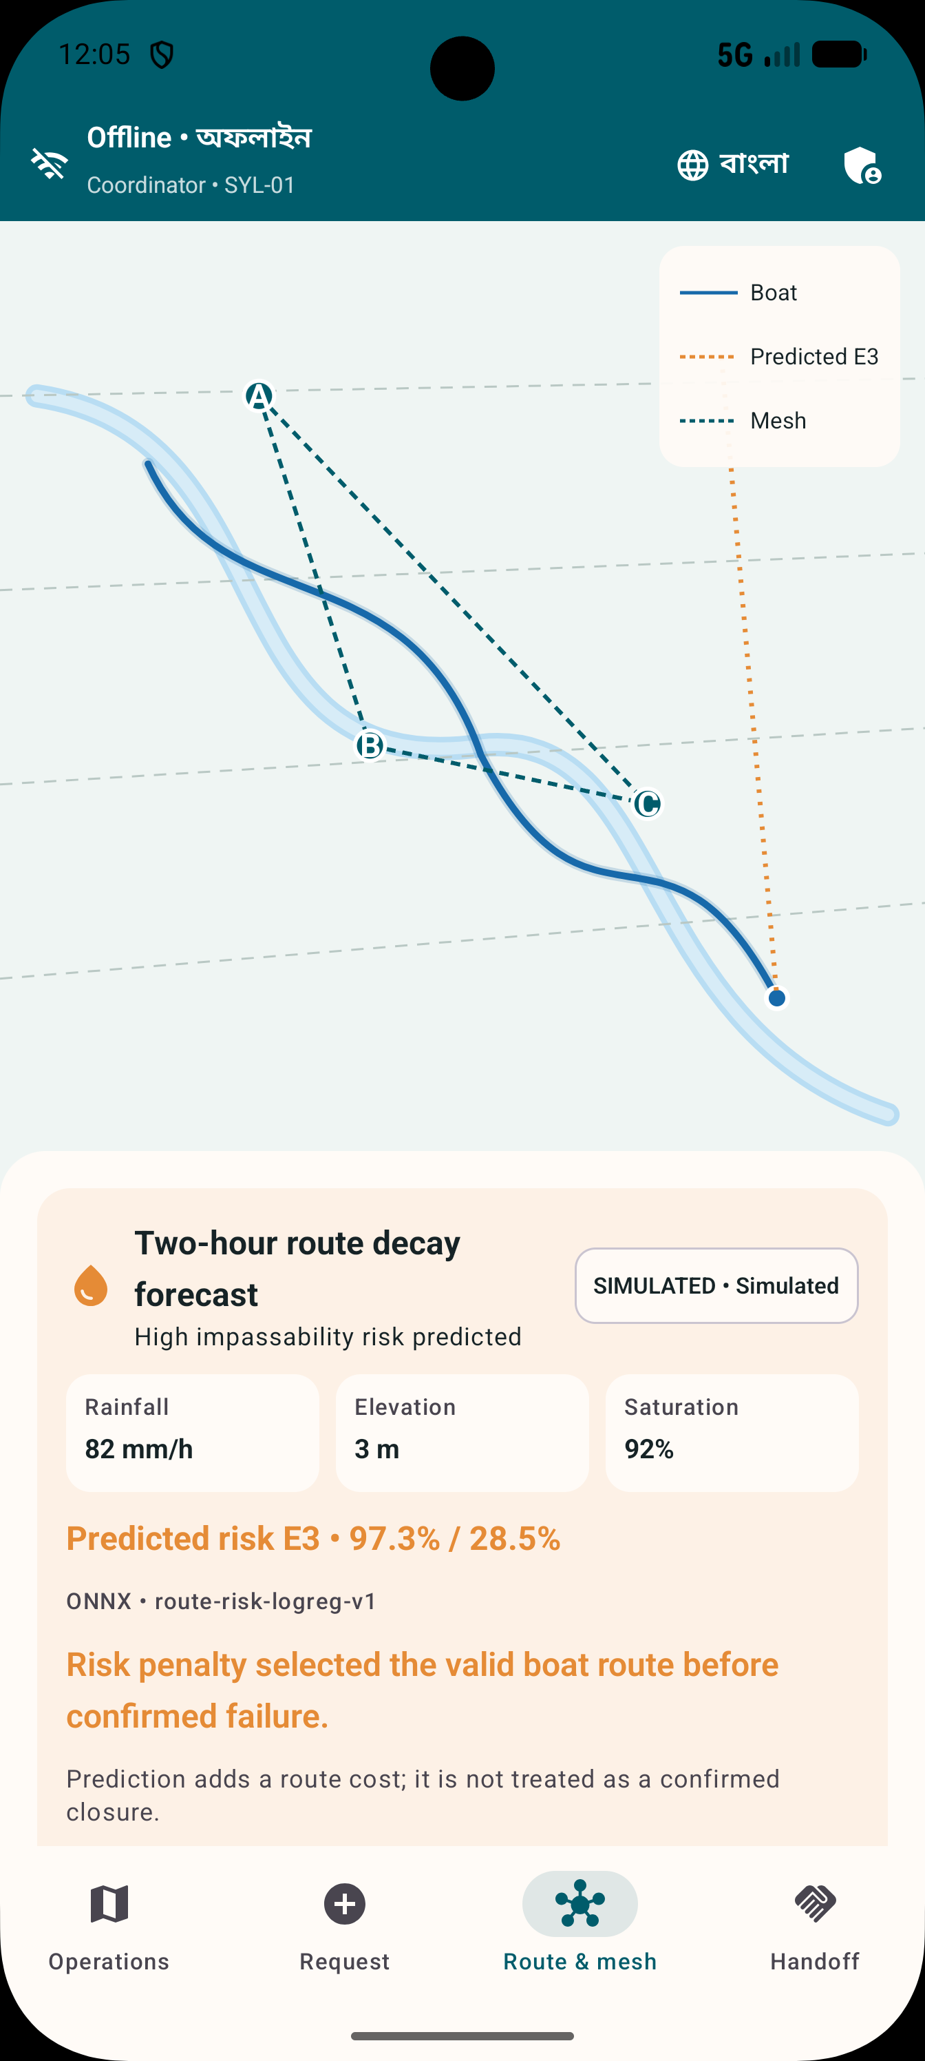 | ENLARGED DETAIL  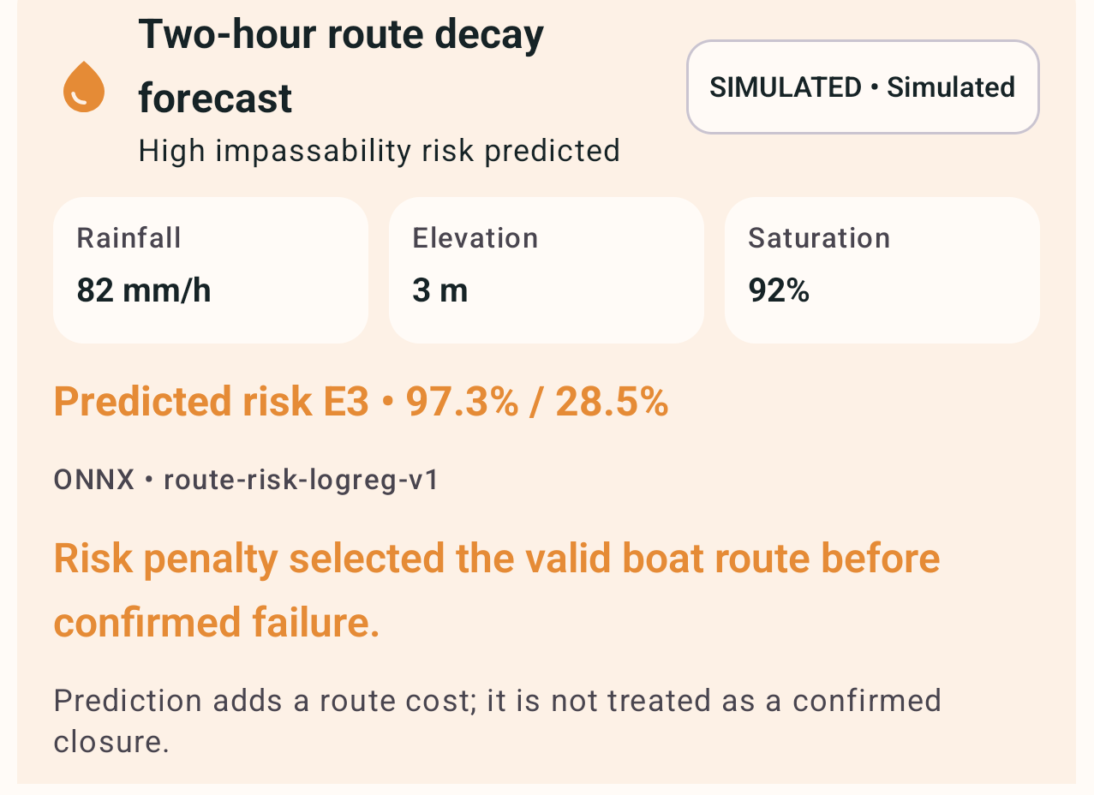  Detail crop. Full source context appears alongside.
01 Inputs stay labelled  Rainfall, elevation and saturation belong to the synthetic exercise. | 02 Risk affects route cost  The model output is advisory and does not create a confirmed closure.
01 Bangla model output with visible simulation labelling.
02 English risk interpretation and proactive route result.
Model behavior  The ONNX classifier consumes simulated rainfall, elevation and soil saturation. Crossing its configured probability threshold adds a cost to an edge. A prediction does not become a confirmed closure. The UI exposes the simulated inputs and the resulting route choice. | Research boundary  Training and evaluation use deterministic synthetic labels. These screenshots prove the integration path, not Bangladesh flood forecast accuracy. A field model would require real observations, time and location holdouts, calibration and operational review.
M7. R02, R04, R05, R06. No live sensor feed or live weather service is used.

22 / THE DELIVERY JOURNEY

Signed proof of delivery
The receiver verifies the offer and accepts custody once.
FULL CAPTURES  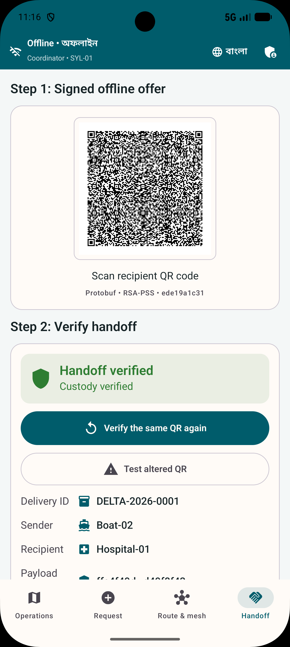 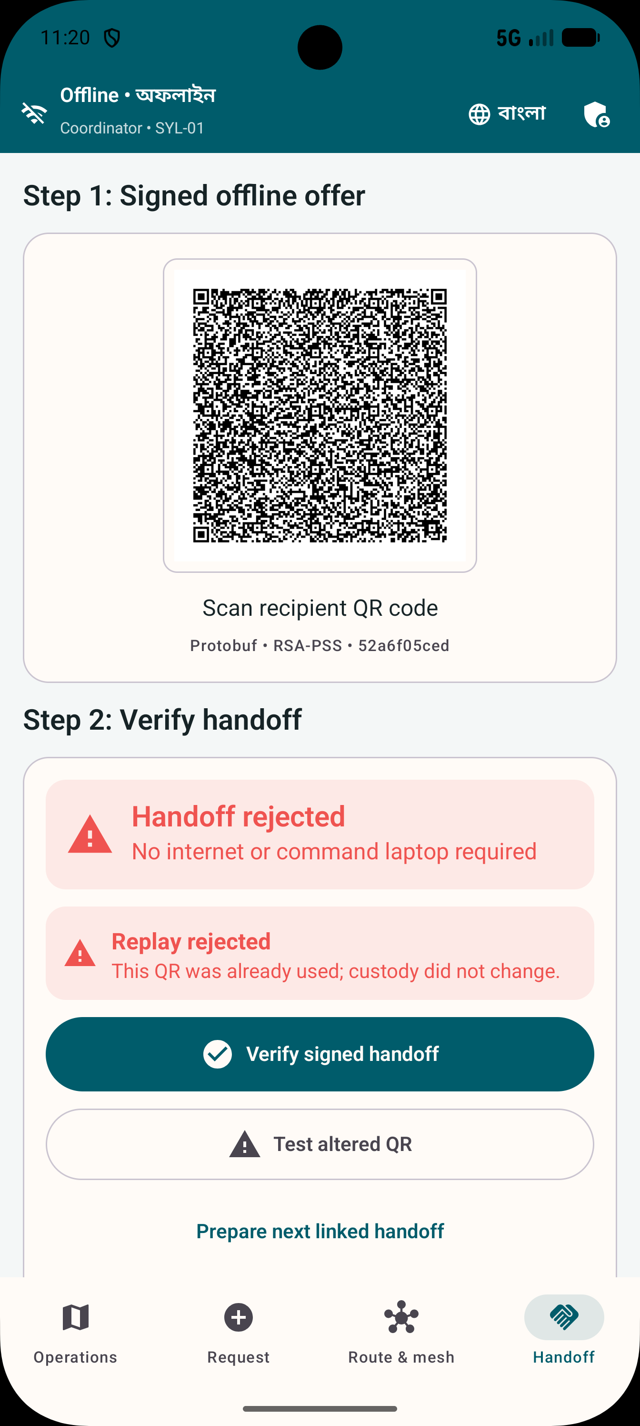 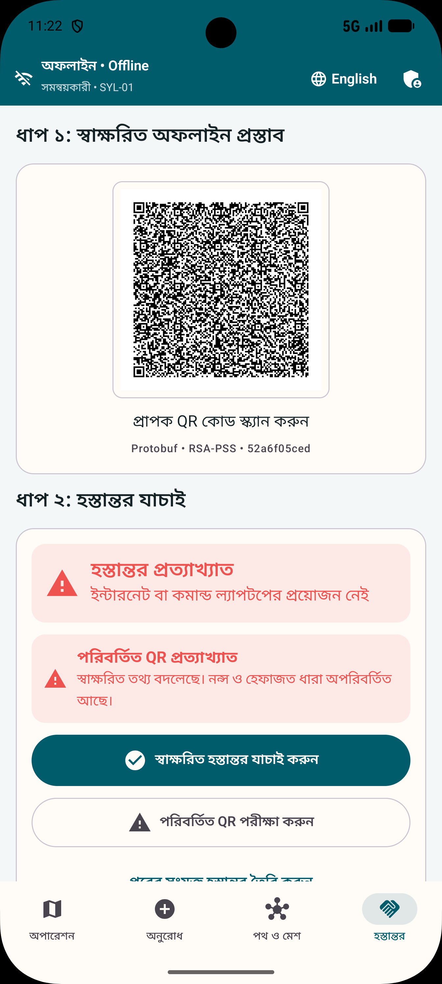 | ENLARGED DETAIL  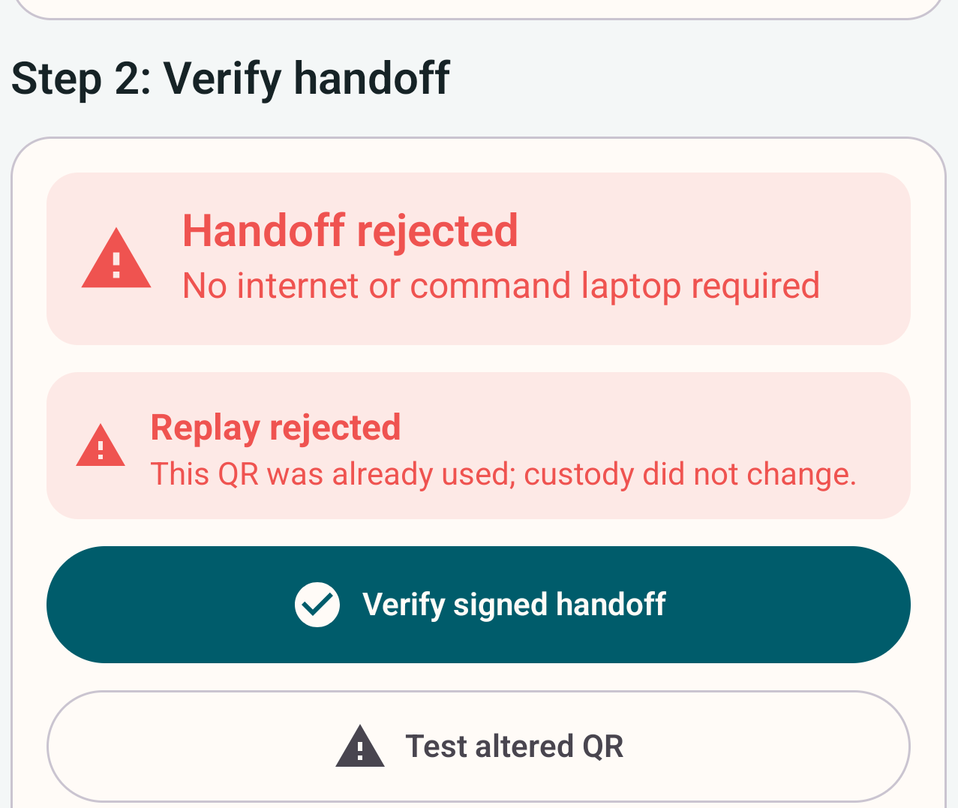  Detail crop. Full source context appears alongside.
01 A replay must fail  Reusing an accepted offer cannot create a second custody transition. | 02 Tampering must fail  Altered trusted fields produce a visible rejection.
01 Signed receipt accepted.
02 Repeated offer rejected.
03 Altered offer rejected in Bangla.
Acceptance and rejection  A signed Protobuf QR binds the mission, delivery, sender, recipient, payload hash and nonce. The receiver verifies trust and signatures, atomically claims the nonce and writes a linked two-party receipt. Replaying the offer or altering trusted fields must fail without a second custody change. | Evidence boundary  The software uses actual Android Keystore signing and local verification. The pictured cargo and handoff belong to the simulated rehearsal. Real-camera scanning between phones in airplane mode remains an acceptance gate.
M5. R01, R02, R05, R06, R07.

23 / THE DELIVERY JOURNEY

Hybrid fleet rendezvous
A simulated boat delay changes where the next handoff should occur.
FULL CAPTURES  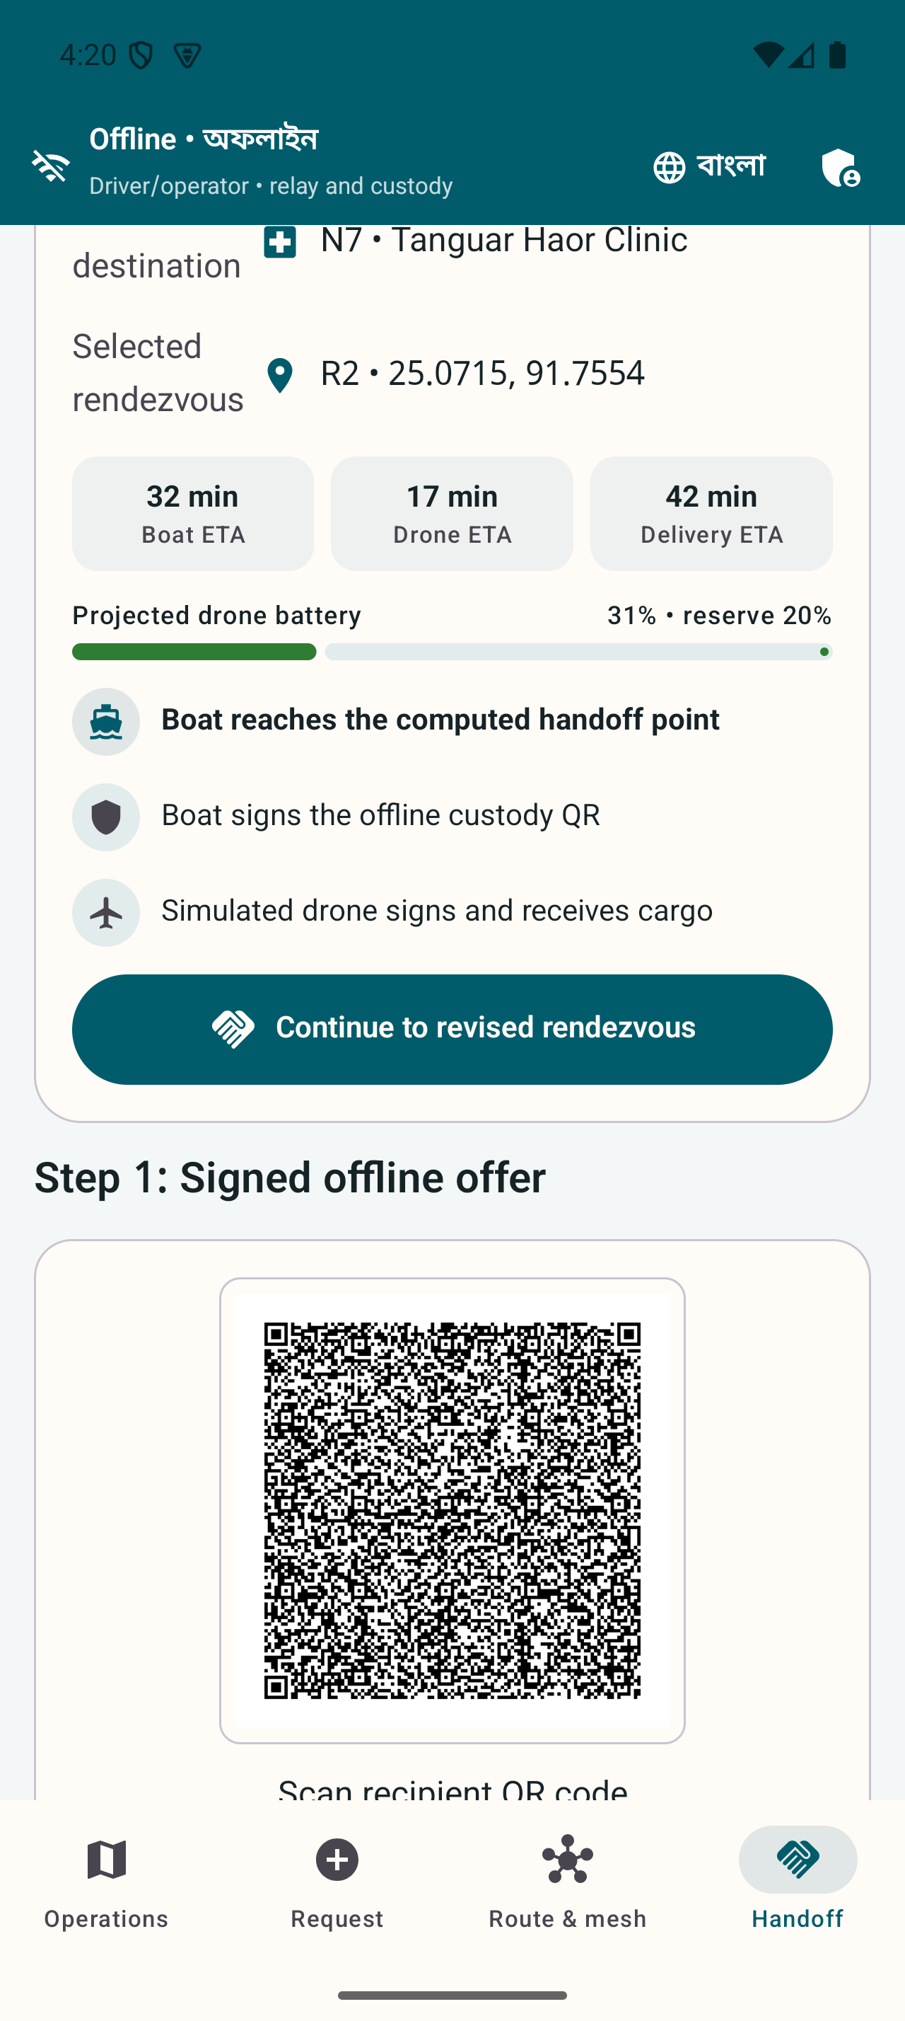 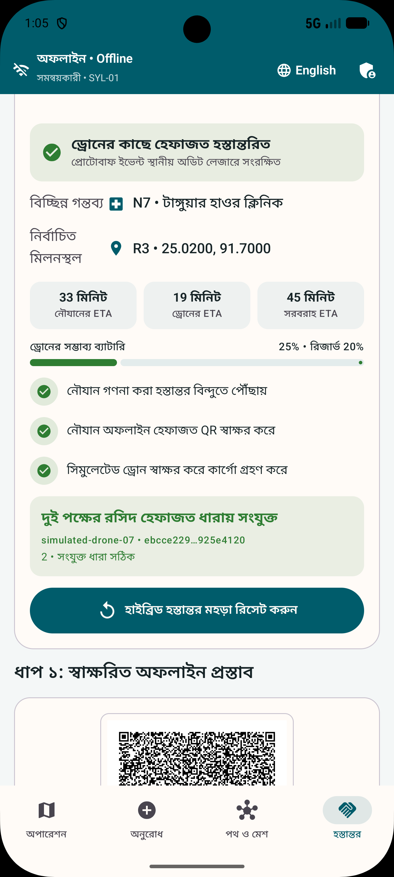 | ENLARGED DETAIL  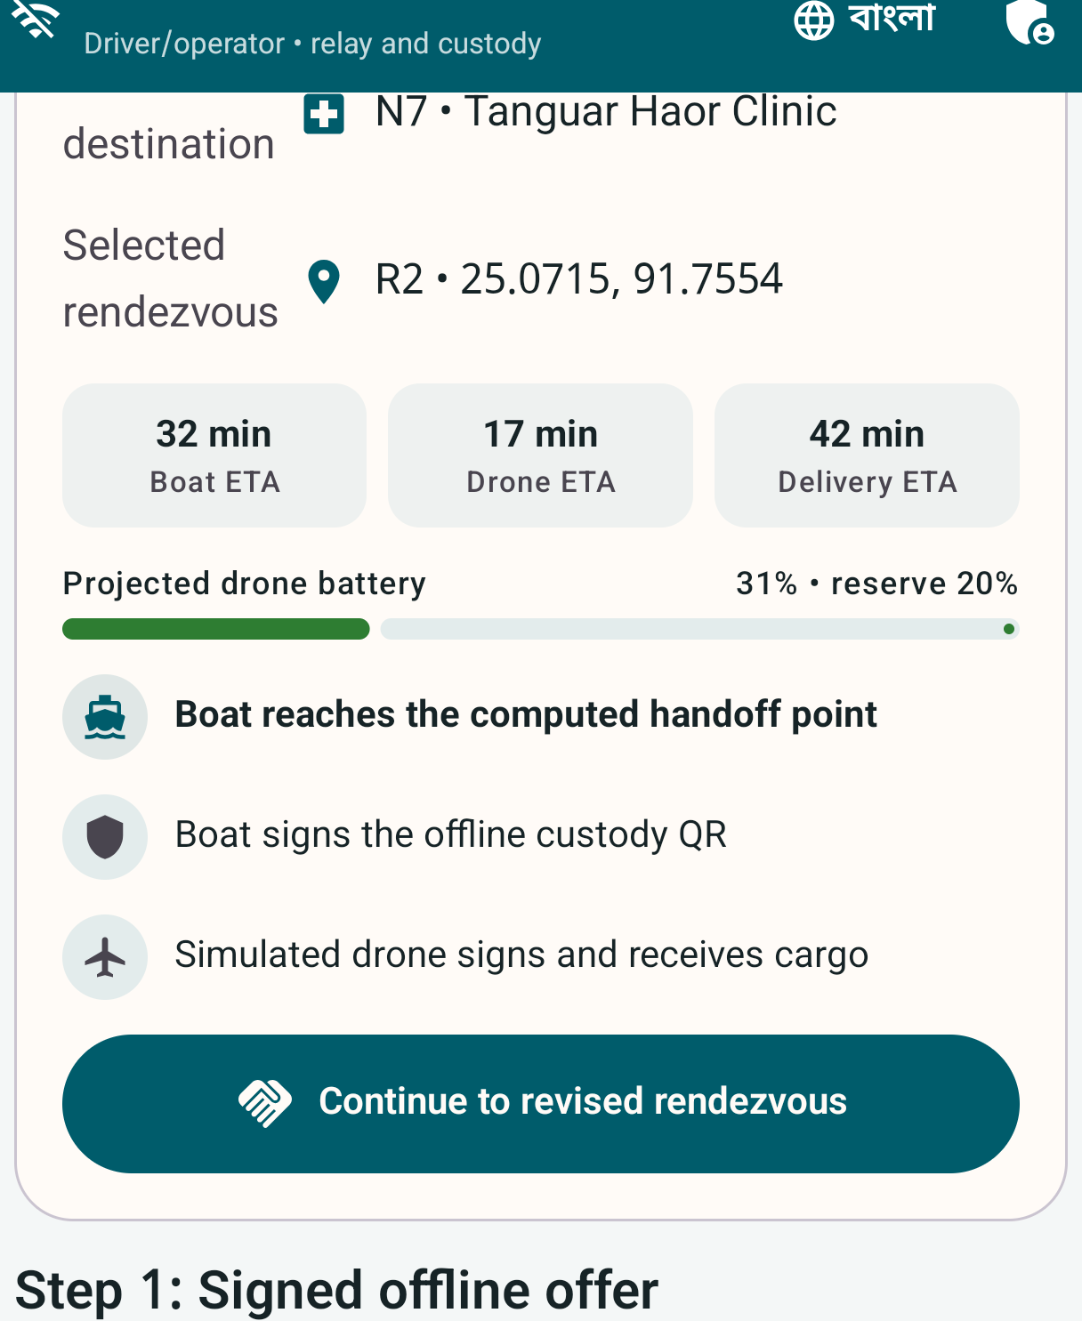  Detail crop. Full source context appears alongside.
01 A delay changes the meeting point  An 18-minute simulated boat delay replans R3 to R2. | 02 Custody stays accountable  A linked receipt records the simulated vehicle handoff.
01 Delayed boat state triggers a revised meeting point.
02 Bangla transfer state records linked custody evidence.
Rendezvous calculation  The graph marks an air-only destination as drone-required. The engine compares candidate meeting points and enforces a 20 percent battery reserve. In the drill, an 18-minute boat delay causes the plan to move from R3 to R2. | Custody remains explicit  The recalculated plan and vehicle state become Protobuf events before the handoff advances. The boat and simulated drone sign a receipt. The demonstration does not operate a drone or include a physical vehicle control interface.
M8. R01, R02, R05, R06. All vehicles and their telemetry are simulated.

24 / THE DELIVERY JOURNEY

Geography stays on the device
Bundled maps support the display even when commercial map services cannot be reached.
FULL CAPTURES  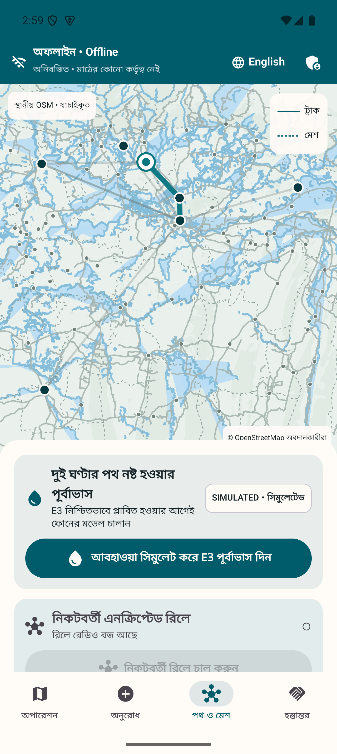 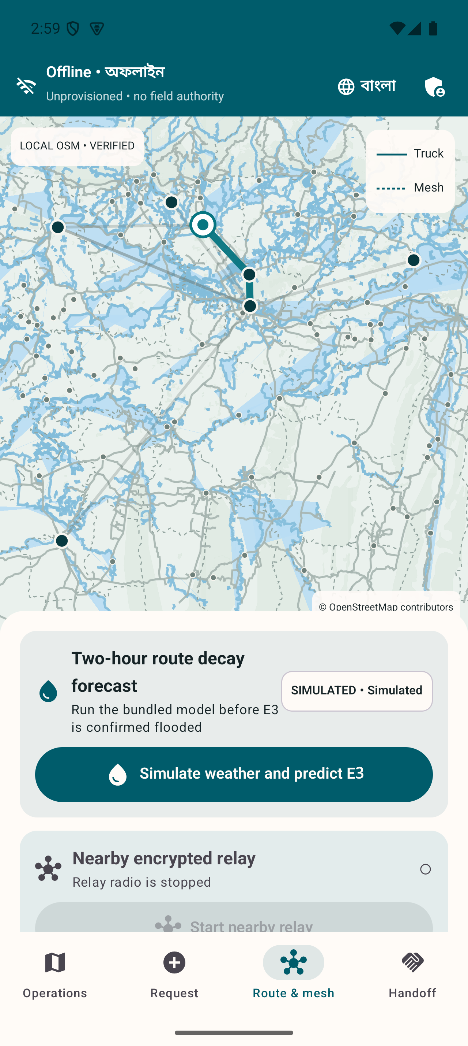 | ENLARGED DETAIL  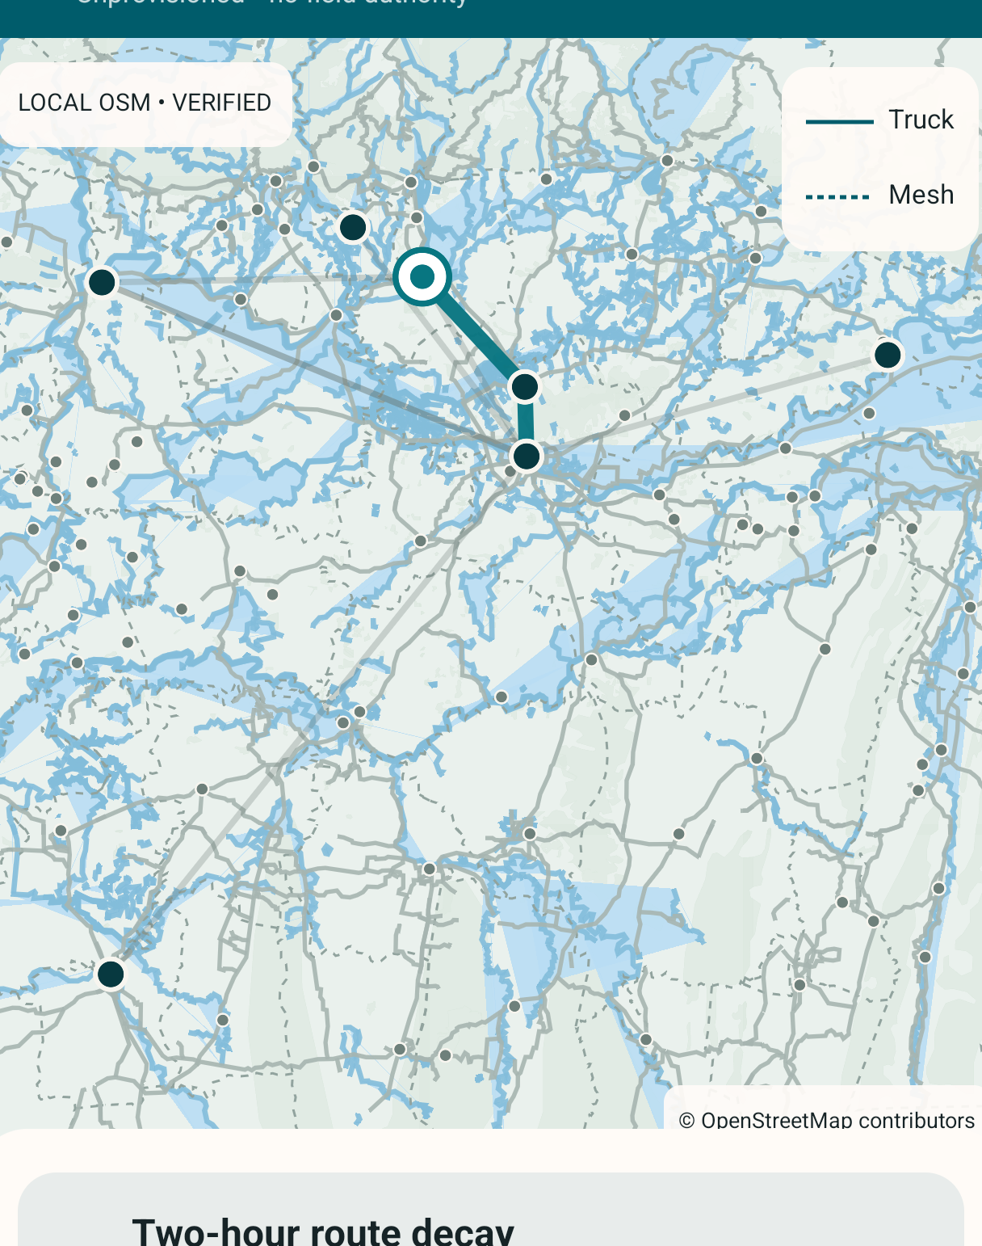  Detail crop. Full source context appears alongside.
01 The basemap lives locally  A reviewed geographic extract supplies the map without a download. | 02 Provenance stays visible  OSM attribution and simulated mission overlays have separate meanings.
01 Bangla map renderer with local geography and mission overlays.
02 English renderer using the same offline source boundary.
Provenance and separation  The Android extract derives from the reviewed OpenStreetMap-based PMTiles archive used by the projector. Checksums pin both assets. Basemap geography and simulated mission overlays remain separate sources, with map attribution visible. | Operational limit  An offline map can become stale. A deployment owner must review geography, distribute updates and decide how verified closures enter the graph. The included geography is a demonstration asset, not a guarantee of navigation suitability.
R01, R02, R05, R06. Map attribution belongs to OpenStreetMap contributors.

25 / THE DELIVERY JOURNEY

Delta Command overview
The projector gives observers a shared view without owning field operations.
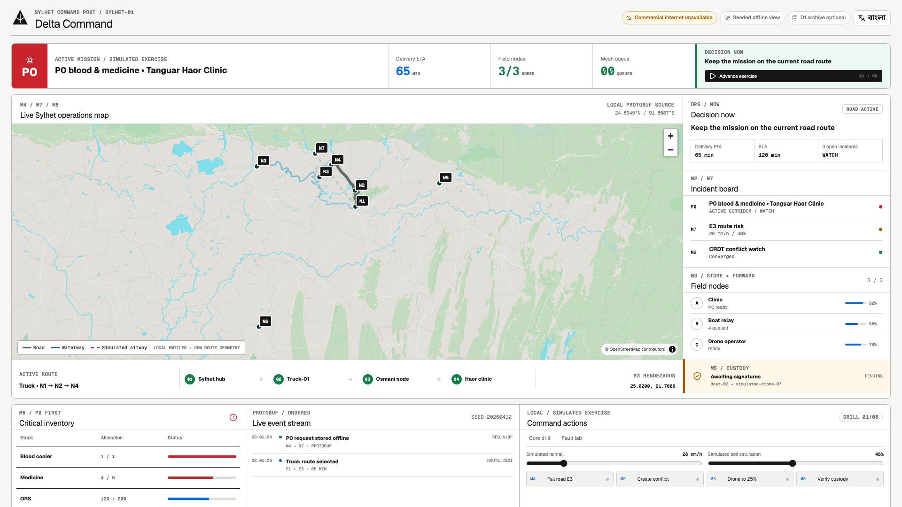
Full English dashboard capture. OpenStreetMap contributors.
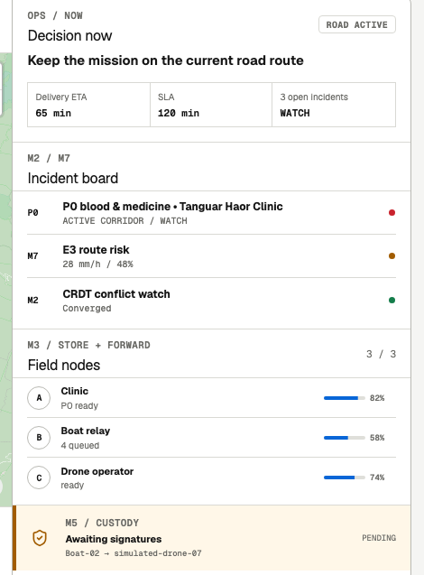 | 01 The mission summary frames the screen  Urgency, ETA and next decision provide the overview.  02 The observer shows field evidence  Routes, incidents, custody and event history support explanation.  Field authority  The laptop presents an optional view. Identity, routing, priority and custody remain phone responsibilities.
R01, R02, R06. Public presentation: digital-delta-headquarters.vercel.app.

26 / THE DELIVERY JOURNEY

Bilingual headquarters and recovery
The dashboard can change language and recover a missed event interval.
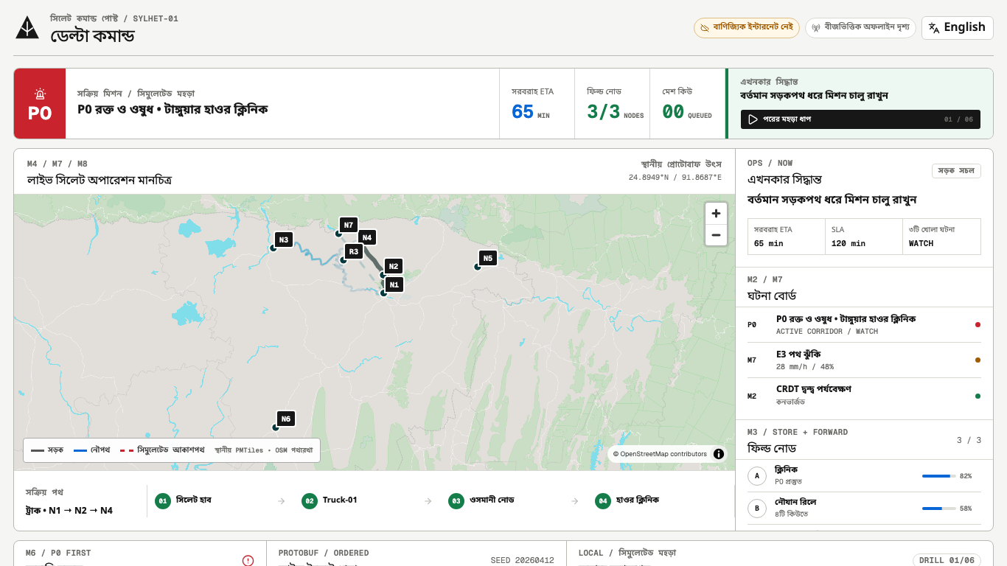  Bangla overview at the 1366 × 768 projector target. | 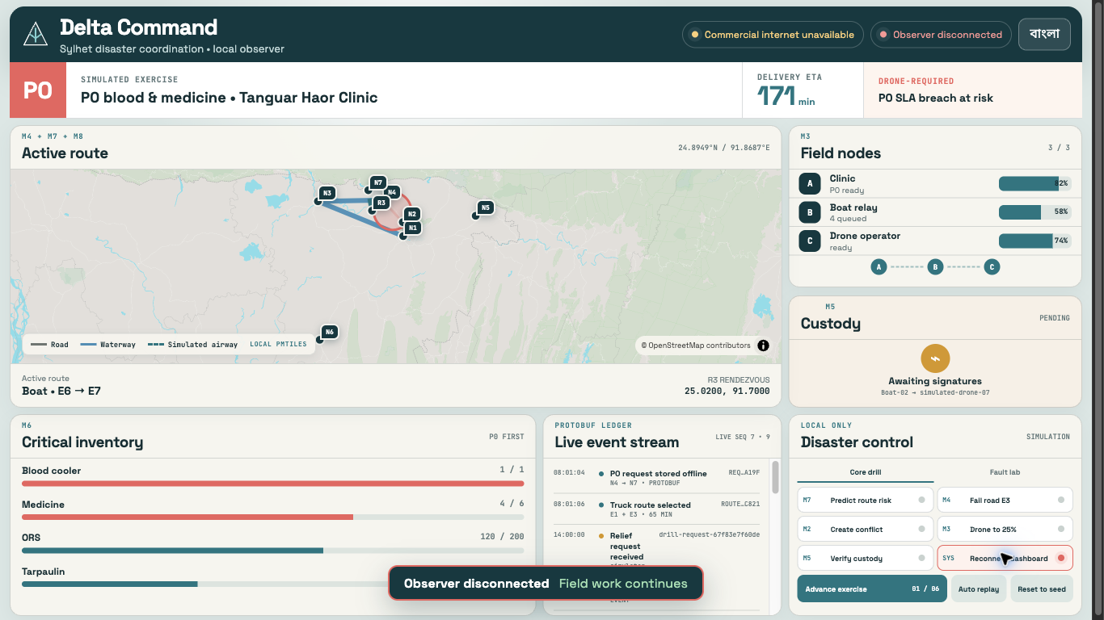  Disconnected English observer state explains the connection loss.
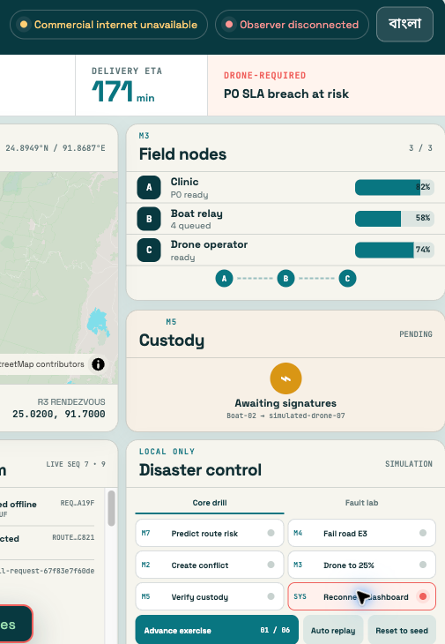
01 Disconnection has a visible state  The observer explains the lost connection instead of implying fresh data. | 02 Reconnection replays the gap  The recorded exercise recovers events 8 through 14 after sequence 7.

Projection recovery
The recorded local disconnect exercise closed the projector at sequence 7, published events 8 through 14 while it was absent and replayed the gap after reconnection. That demonstrates observer recovery on the laptop. Physical phone continuity with the command laptop powered off still needs its own live proof.
R01, R05, R06 and artifacts/reports/fault-injection/2026-09-04-dashboard-disconnect.md.

27 / THE ENGINEERING

Field authority and observation
The authoritative field path runs between phones. Headquarters receives an optional projection.
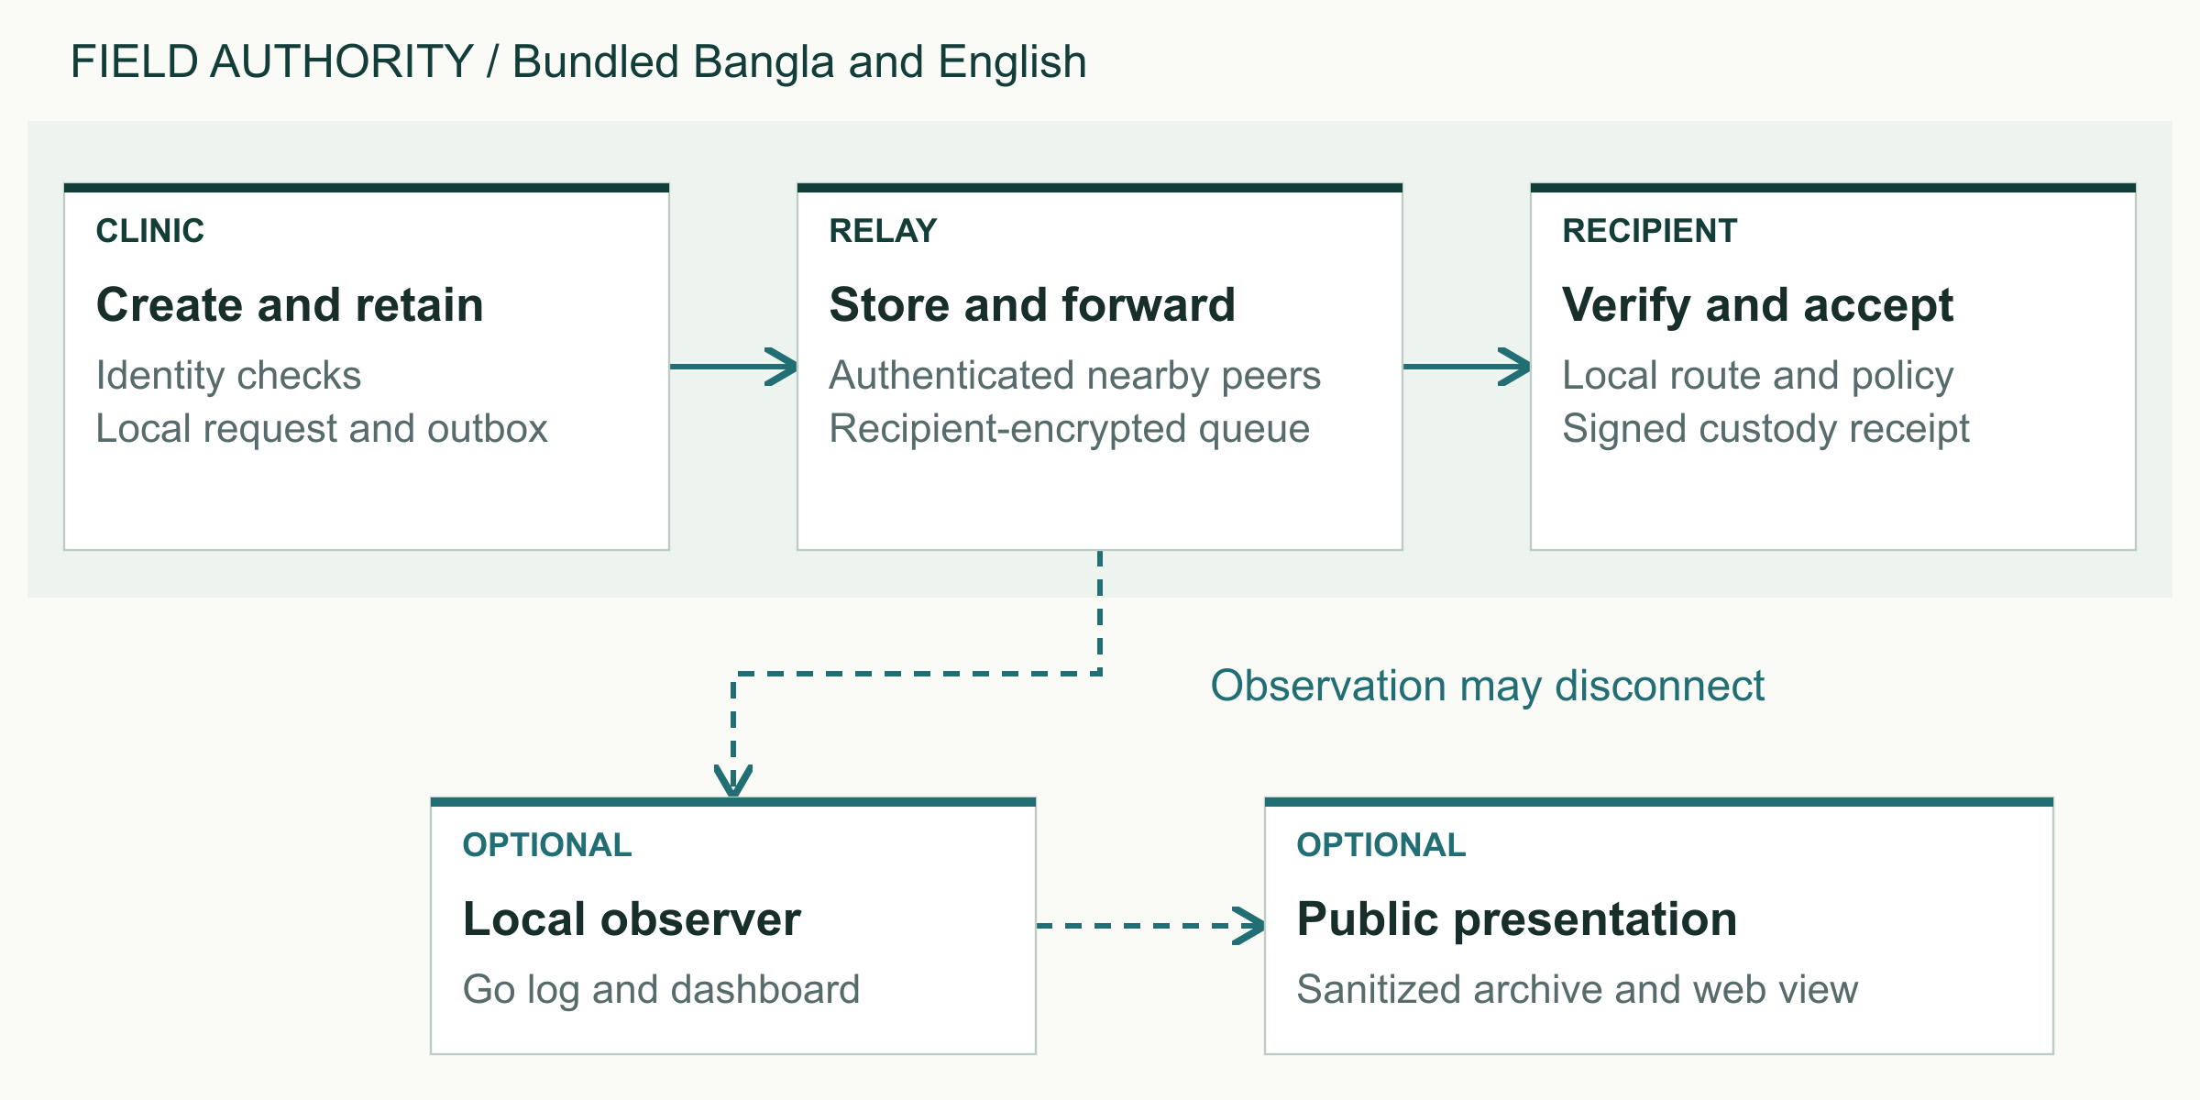
Original explanatory diagram. Editable source supplied in the design asset pack.
The field boundary  Each Android phone owns its identity checks, Room database, route search, triage and custody verification. Nearby links move encrypted Protobuf envelopes between authenticated peers. A relay forwards encrypted bytes and cannot read the recipient’s domain payload.  Transport accuracy  gRPC applies to supported IP links. The Android nearby path carries framed Protobuf over the radio adapter. The browser uses an allow-listed SSE JSON presentation object. JSON is excluded from mesh domain payloads. | Optional services  The Go node and local dashboard support observation and engineering exercises. The Vercel presentation and sanitized Cloudflare D1 archive add optional visibility. None sits between the field phones or becomes a source of custody authority.
Architecture figure 1. Derived from R01 and docs/ARCHITECTURE.md. Dashed links indicate optional observation.

28 / THE ENGINEERING

Inside a field phone
The interface reads local state while repositories coordinate durable storage and domain rules.
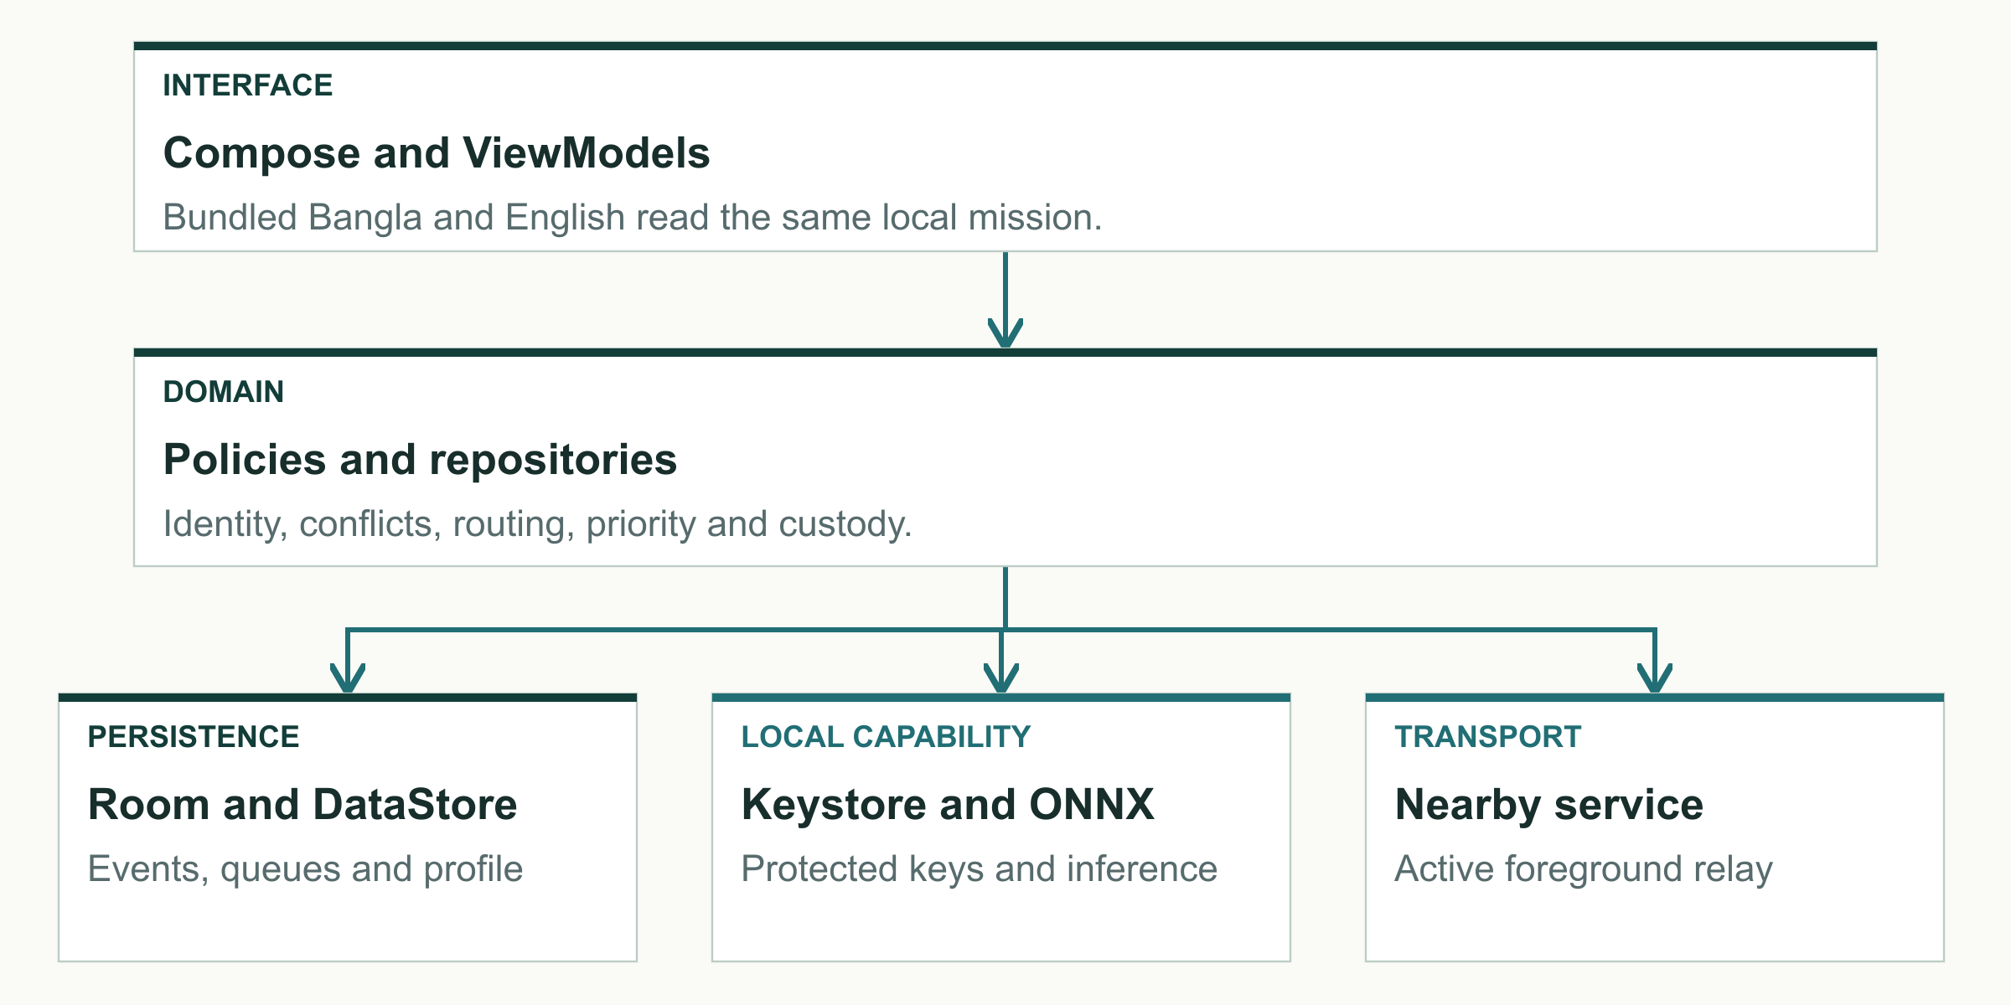
Original explanatory diagram. Editable source supplied in the design asset pack.
Interface and domain separation  Kotlin, Compose and ViewModels present immutable screen state. Language-neutral domain rules handle authorization, conflicts, routing and custody. Repositories coordinate those rules with Room, cryptography and transport so the field workflow can remain local.  Service lifetime  An Android foreground service owns active Nearby discovery and relay. WorkManager performs bounded deferred inbox application and maintenance. It does not substitute for a continuously active radio service. | Storage before transfer  Room stores operation bytes, queues and projections. Proto DataStore stores language and selected device profile. Android Keystore protects non-exportable private keys. Database migrations must preserve event bytes required for signature verification.
Architecture figure 2. R01. Diagram summarizes responsibilities rather than exact source-directory structure.

29 / THE ENGINEERING

Privacy and message acceptance
A durable relay acknowledgement and final domain acceptance are different events.
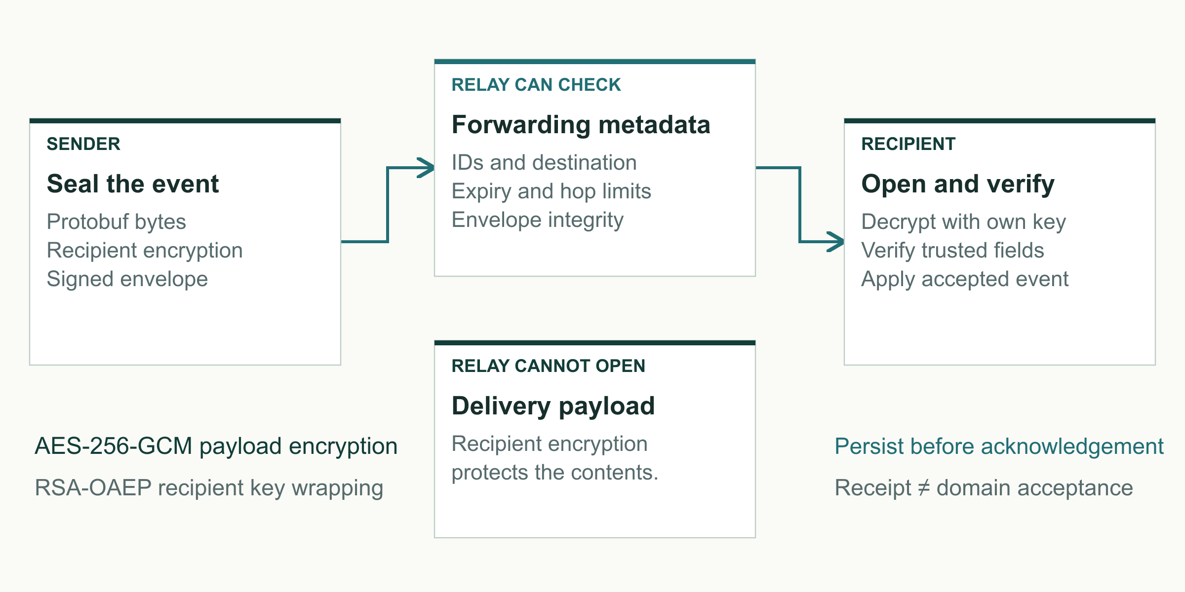
Original explanatory diagram. Editable source supplied in the design asset pack.
Sending and receiving  The sender prepares language-neutral Protobuf bytes, signs the appropriate data and encrypts the payload for the intended recipient. Relays can validate routing and integrity fields, persist the envelope and forward it. Only the recipient opens the protected delivery contents and applies accepted events.  Failure semantics  A lost acknowledgement can trigger a retry, so message IDs and nonces prevent duplicate effects. Expiry and hop limits bound delayed propagation. Acknowledgement validation rejects the wrong node, unknown or revoked keys and altered receipt fields. | Cryptographic building blocks  The implementation uses AES-256-GCM payload encryption, RSA-OAEP recipient key wrapping and RSA-2048-PSS signatures through JCA/JCE and Android Keystore. Signed provisioning credentials bind device keys and roles to a trusted administrator.
The design asset pack also includes the separate message lifecycle figure covering persistence, acknowledgement, verification and local acceptance.
Architecture figure 3. R01 and R07. Metadata visible for forwarding is not equivalent to payload confidentiality.

30 / THE ENGINEERING

Event records and conflict policy
Devices converge by policy and accepted events rather than by trusting the latest wall-clock timestamp.
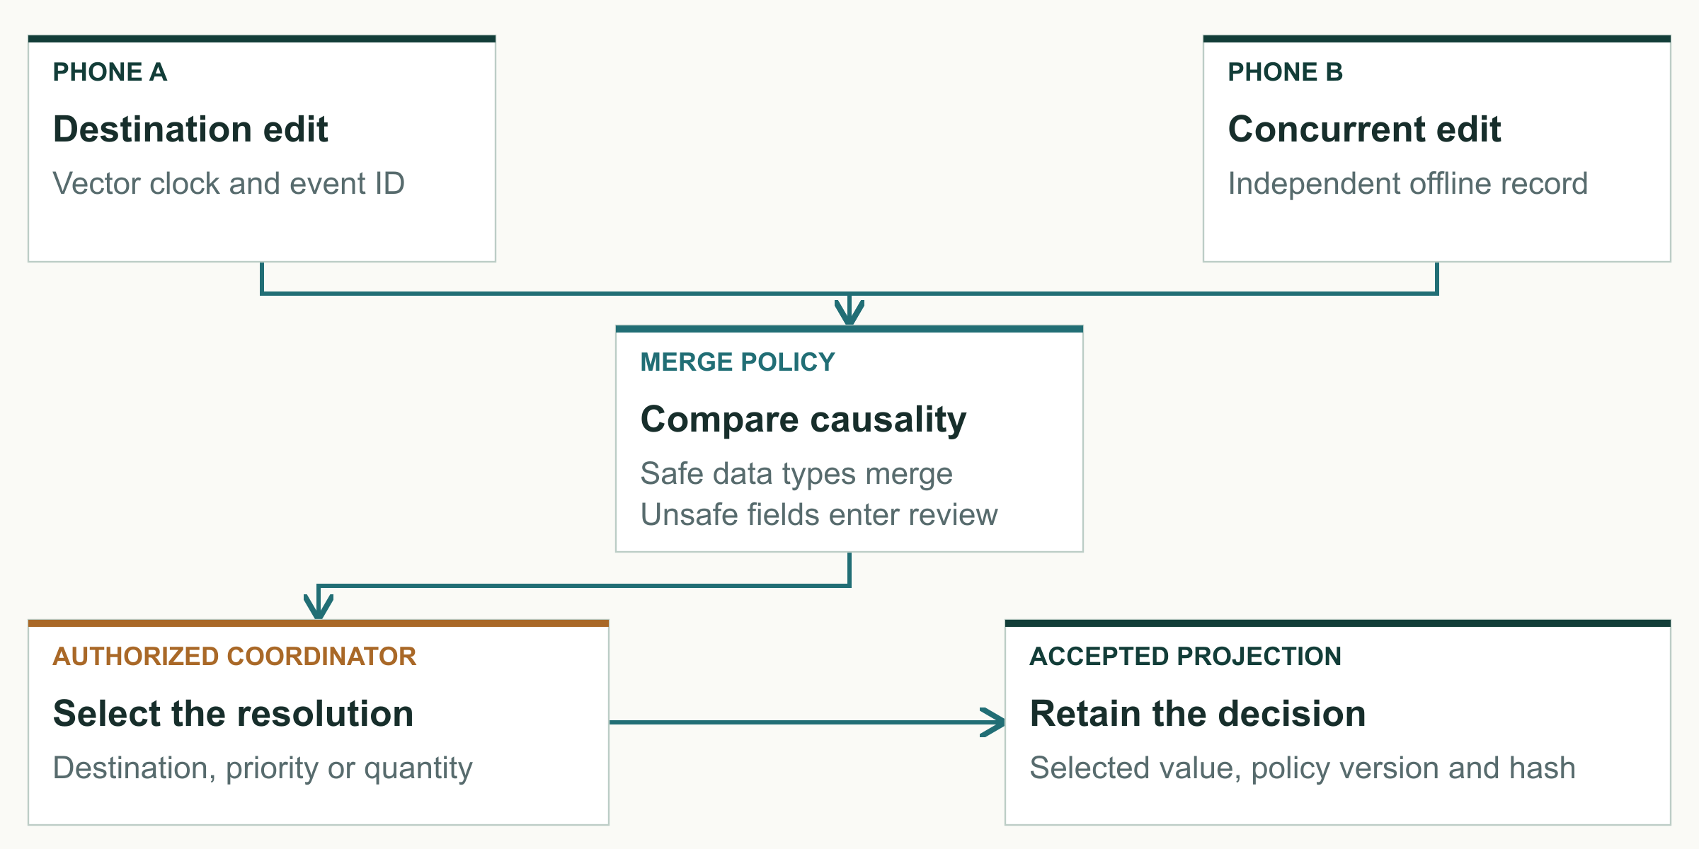
Original explanatory diagram. Editable source supplied in the design asset pack.
Policy by data type  Grow-only sets suit receipt and audit identifiers. Inventory uses per-replica counters. Assignment removal needs observed operation tags and tombstones. Safety-sensitive destination, priority and medical-quantity conflicts require a human resolution.  Important boundary  The repository includes tests and emulator evidence for the conflict drill. Real multi-phone convergence and full operational assignment behavior still require the documented physical acceptance work. This diagram describes the intended invariant and implemented test seams. | Rebuildable views  An append-only operation log feeds local projections. Equal accepted event sets and policy versions should produce equal convergence hashes. Restart and out-of-order delivery must not cause a previously removed assignment to return unexpectedly.
Architecture figure 4. R01 and R05. The event log remains distinct from the disposable headquarters projection.

31 / THE ENGINEERING

Routing risk and priority decisions
Confirmed closures constrain the graph. Predictions influence cost. People confirm cargo changes.
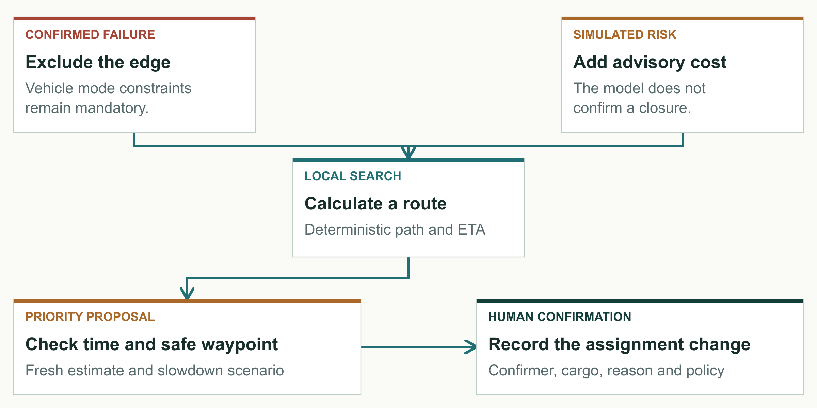
Original explanatory diagram. Editable source supplied in the design asset pack.
Route policy  The deterministic graph search filters edges by truck, boat or simulated drone capability. A confirmed failed edge becomes unavailable. Advisory model risk adds a cost rather than silently changing the edge into a closure.  Tradeoff  Combining routing and priority makes the demonstration coherent, but it can amplify stale inputs. The interface must expose why the route changed and allow an authorized person to reject the recommendation. Real-world route quality is not established by a correct graph algorithm alone. | Priority policy  The resulting ETA feeds the SLA engine, including a 30 percent slowdown case. The policy validates estimate age, cargo priority and safe waypoint availability before proposing a change. Confirmation records a durable reason and assignment update.
Architecture figure 5. M4, M6 and M7. R01, R04, R05. Simulated environmental and vehicle inputs only.

32 / THE ENGINEERING

Model evaluation and limitations
The model demonstrates offline integration and a measurable recall tradeoff on synthetic data.
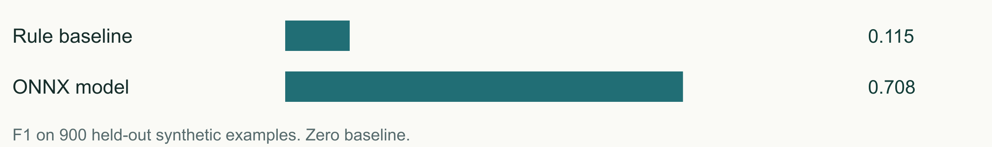
Held-out test metric | Model | Rule baseline
Precision | 0.612766 | 0.954545
Recall | 0.837209 | 0.061047
F1 | 0.707617 | 0.114754
ONNX parity maximum error | 8.94 × 10⁻⁸ | Not applicable

Experiment design  The dataset contains 6,000 synthetic examples: 4,200 training, 900 validation and 900 held-out test rows. A standardized logistic regression exports to ONNX. The 0.285 decision threshold was selected on validation data, then the held-out split measured performance.  Next research step  Collect properly governed observations of route status, timing and environmental conditions. Use time and location holdouts, report calibration and assess false-negative costs with domain experts. Until then, the output is a synthetic demonstration signal. | Interpretation  The model identifies more synthetic positive cases than the simple rule baseline, at the cost of additional false positives. The test confusion matrix contains 374 true negatives, 182 false positives, 56 false negatives and 288 true positives. False alarms can produce unnecessary reroutes.
R02 and R04. These are not real flood prediction accuracy figures. All 900 held-out labels are synthetic.

33 / THE ENGINEERING

Verification results and open gates
The local evidence supports software behavior while leaving real-device performance explicit.
Result | Recorded evidence | Boundary
60 journeys per emulator | Android 15 and Android 16 passed | Virtual devices
10,000 streams | Loopback durable acknowledgements | No lossy radio or encryption load
17 dashboard tests | Next.js local gate | Browser software behavior
3 archive tests | Sanitized ingestion validation | Optional public archive
Physical readiness | Open acceptance sheet | Not yet verified

Recorded software gate  The 4 September 2026 report records scripts/verify-local.sh --connected passing Android builds and tests, schema checks, model parity, map integrity, Go checks, dashboard build/tests and archive validation. The same 60 connected journeys passed on each of two Android emulators.  What the fair package still needs  Three physical phones must demonstrate relay interruption and recovery, camera scanning in airplane mode and continued field work with the laptop off. Target-phone battery, memory and latency, human accessibility review and repeated rehearsals remain required. | Load result in context  The local Go harness retained 10,000 independent acknowledged streams on loopback. Its p95 acknowledgement latency was 57.645 seconds and peak server RSS was approximately 1.19 GiB. This is connection-capacity evidence. It does not establish handset mesh throughput or acceptable operational latency.
R02, R03 and R05. Results are cited from existing dated evidence; this report does not claim a new test run.

34 / THE ENGINEERING

Security and operational risk
The most important risks cross software, people and deployment ownership.
Risk | Current mitigation | Next evidence
Lost or compromised phone | PIN, Keystore, signed roles | Recovery and revocation drill
Malicious or replayed message | Peer proof, nonce and signature checks | Hostile physical peer tests
Long disconnected interval | Durable queue, TTL and expiry | Radio and battery measurements
Unsafe route suggestion | Mode rules and human confirmation | Domain review with real data
Single maintainer dependence | Source and runbooks | Support and succession owner

Design posture  Encryption protects delivery contents in transit. Credentials and role checks limit who can act. Replay defenses protect custody transitions. These mechanisms reduce specific risks but do not establish that the whole system has passed an independent security audit.  Sensitive data  Use synthetic or minimized data during demonstrations and research. A production data plan must specify lawful authority, consent where appropriate, access, retention, incident response and deletion. The proposed public archive accepts only sanitized presentation metadata. | Operational accountability  A pilot must define how lost phones are reported, who revokes credentials, how long records remain available and who can export summaries. Offline revocation propagates only when contact occurs, so stale trust is an operational risk that needs an agreed response.
R01, R05, R07. Risk register is an engineering assessment, not legal advice or certification.

35 / ADOPTION AND EVIDENCE

Proposed twelve week pilot
A staged exercise should earn permission to expand through observable results.
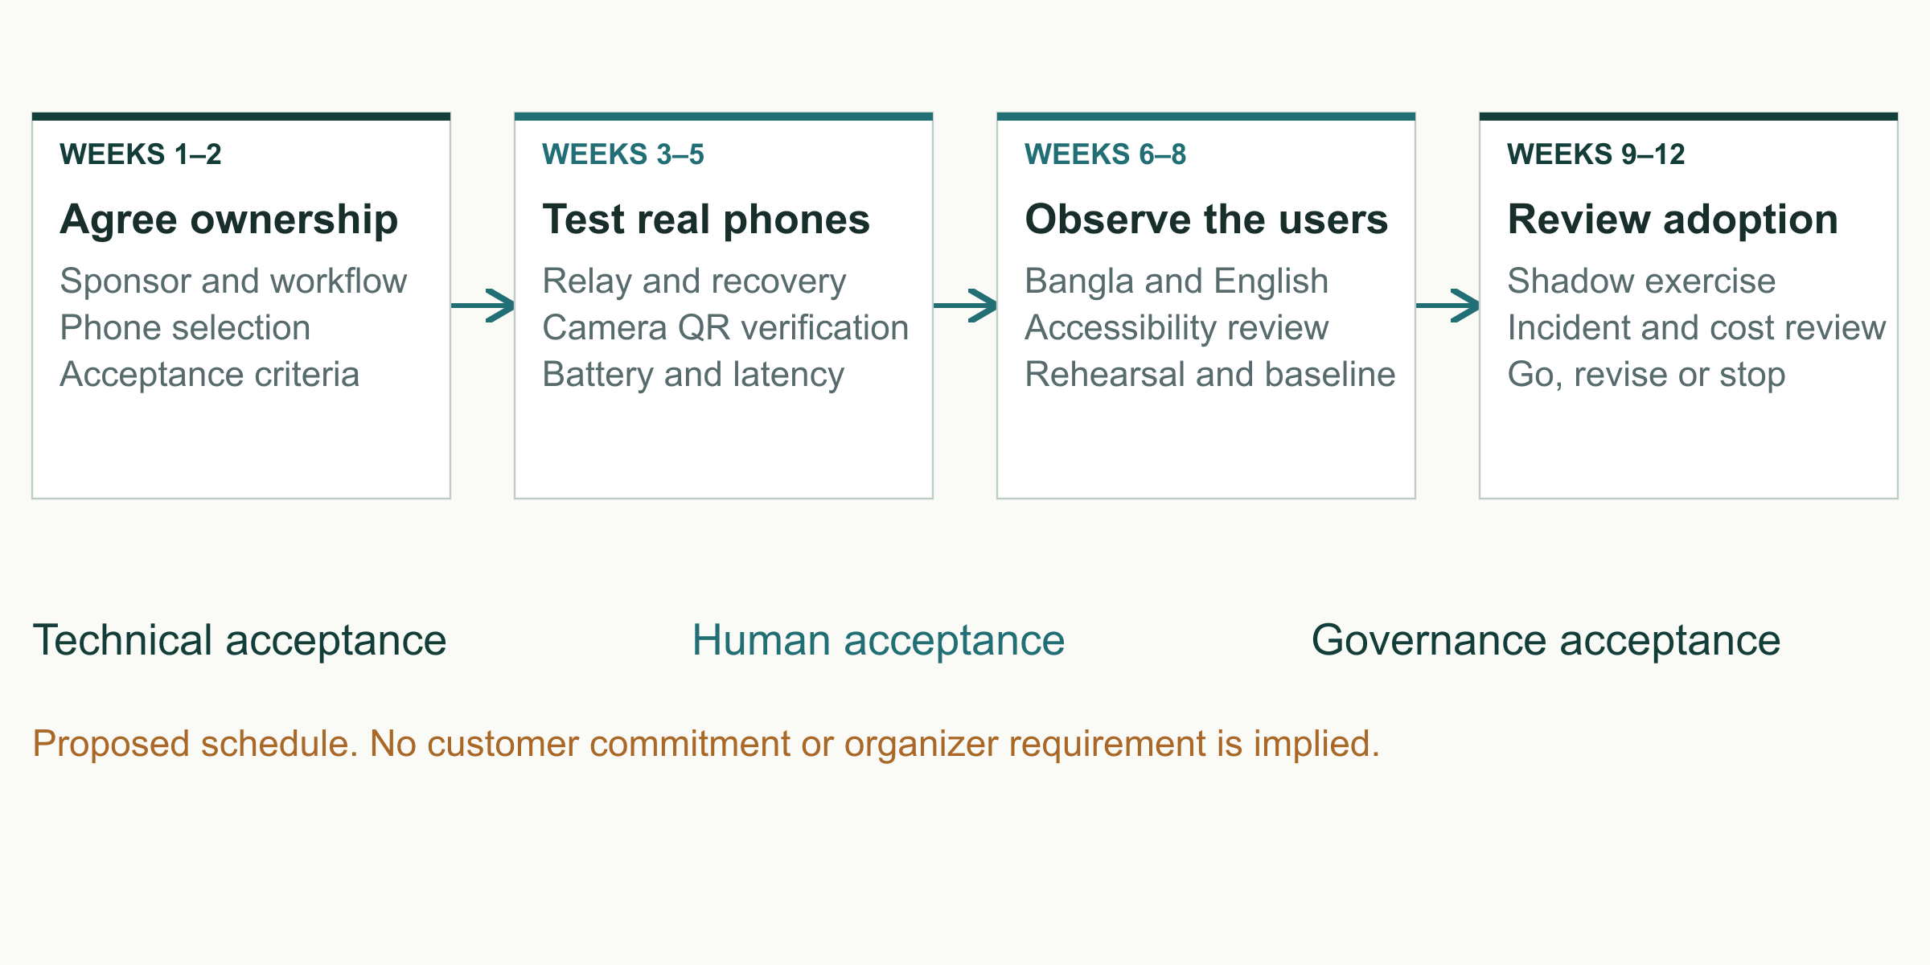
Original explanatory diagram. Editable source supplied in the design asset pack.
Weeks 1 to 2  Agree the sponsor, workflow and data owner. Select the test phones and participants. Document the existing procedure, define stop conditions and obtain any necessary organizational approval for the controlled exercise.  Weeks 6 to 8  Observe bilingual task completion and accessibility with participants. Rehearse on the intended devices, power setup and venue. Compare the digital event trail with a paper or radio baseline using synthetic cargo. | Weeks 3 to 5  Provision devices, test offline maps and measure the physical radio and camera paths. Run interruption, restart, duplicate and revocation cases. Publish the tested-device list and fix failures before inviting broader use.  Weeks 9 to 12  Conduct a supervised shadow exercise, review incidents and support effort, then make a go, revise or stop decision. Discuss a maintenance agreement only if the sponsor accepts the evidence and has an operational owner.
Proposed duration and activities. This schedule is not an organizer requirement or committed customer project.

36 / ADOPTION AND EVIDENCE

Impact and inclusion measurement
A credible impact claim starts with a measured change in the delivery workflow.
Outcome | Pilot measure
Record continuity | Requests recovered after restart / requests created
Delivery accountability | Complete receipt chains / attempted handoffs
Usability | Unassisted task success and critical-error count
Reliability | Median and p95 latency by tested device
Support burden | Staff hours per exercise and incident

What to measure  Compare time from request creation to assignment and verified receipt. Track missing requests, duplicate effects, unresolved conflicts and incomplete custody chains. Record human overrides and whether participants understand the difference between queued and accepted states.  Inclusion  Bundled Bangla and English remove one download and language barrier. They do not establish accessibility by themselves. Include people with disabilities, older responders and participants with limited smartphone experience in a consented study, and adapt the interface to observed problems. | Operational denominators  Report successful handoffs as a fraction of attempted handoffs. Separate planned disconnections from unexpected failures. Break task results down by device model, language and participant experience. Do not present a mean alone when a small number of severe failures determine usability.  Longer-term contribution  Reliable coordination could support health logistics, disaster preparedness and accountable delivery, connecting the project to SDGs 3, 9, 11, 13 and 16. Lives saved, carbon savings and cost reductions remain unmeasured and must not be claimed from the prototype.
Proposed evaluation framework. No field impact results are reported.

37 / ADOPTION AND EVIDENCE

Innovation fair demonstration
A short connected story can show the product and its limits clearly.
Suggested core pitch | Focus
0:00–1:00 | Problem and offline request
1:00–3:00 | Route failure and human priority decision
3:00–4:00 | Signed delivery and rejection proof
4:00–5:00 | Evidence limits and pilot request

Opening minute  Show that the field app has bundled languages and offline state. Explain the clinic-to-hospital mission and identify every simulated environmental and vehicle input. Present a saved urgent request and its local queue.  Closing proof  Accept a signed handoff once, reject its replay and show a tampered offer failing. Summarize the physical gates still ahead and ask the audience for a sponsored controlled exercise. Deeper technical slides can answer questions after the core pitch. | Middle sequence  Show a role denial, route failure, boat fallback and a priority proposal. Explain one architectural point: the phone owns the record and can calculate locally. Use the projector as an observer, then demonstrate its disconnect recovery with the appropriate evidence boundary.  Booth preparation  Use the documented reset and deterministic seed. Prepare the exact phones, local power, projector, offline assets and backup demonstration material. Organizer confirmation of stall, schedule and equipment remains separate from software readiness.
Suggested five-minute narrative. Actual speaking time and booth requirements require organizer confirmation [S05, R08].

38 / ADOPTION AND EVIDENCE

Team and partnership request
The next milestone is a jointly owned exercise with real operators and phones.

AI-generated concept illustration. No actual deployment is depicted.
Project lead  Touhidul Alam Seyam of BGC Trust University Bangladesh leads the individual project. The repository describes work across Android, Go services, the command interface, cryptographic integration, routing, model integration and evidence capture. No additional team member is recorded for the exhibition.  What Digital Delta brings  The current package includes implemented field workflows, an optional command dashboard, local verification scripts, synthetic scenarios, paired screenshots and documented open gates. It provides a concrete starting point for a controlled exercise. | What a partner can contribute  An operational sponsor can identify one meaningful supply workflow and the person authorized to own it. A logistics partner can provide experienced operators and a baseline procedure. A technical or academic reviewer can challenge the security, data, accessibility and evaluation design.  The request  Agree a discovery meeting and nominate an operational owner. Define a supervised three-phone test before discussing wider deployment. Market readiness will depend on measured reliability, training burden and sustained ownership.
R01 and R08. No customer, institutional endorsement, award or funding commitment is claimed.

39 / ADOPTION AND EVIDENCE

Research source register
Primary sources support the problem framing and product comparison.
S01 United Nations Bangladesh
Flash Floods Humanitarian Response Plan 2022 Open source
27 June 2022
S02 UN Resident Coordinator Bangladesh
Severe Flash Floods Situation Update 1 Open source
19 June 2022
S03 Needs Assessment Working Group
Rapid Assessment of Northeastern Flood 2024 Open source
28 June 2024
S04 World Bank
Bangladesh flood risk reduction and recovery financing Open source
14 May 2025
S05 Bangladesh Innovation Fair
Innovate to Market and exhibitor information Open source
Accessed 4 September 2026
S06 Sahana Software Foundation
Eden Legacy Archive and documented capabilities Open source
Accessed 4 September 2026
S07 KoboToolbox
Collecting data using KoboCollect Open source
Updated 17 July 2026
S08 Ushahidi
Platform features and enterprise deployments Open source
Accessed 4 September 2026
S09 Briar Project
How it works Open source
Accessed 4 September 2026
S10 Meshtastic
Introduction to off grid mesh communication Open source
Accessed 4 September 2026

40 / ADOPTION AND EVIDENCE

Evidence and illustration register
Repository evidence supports implementation claims and identifies the remaining release work.
R01 Digital Delta
README and technical architecture Open source
Repository evidence reviewed 4 September 2026
R02 Digital Delta
Final local verification gate
artifacts/reports/verification/2026-09-04-final-local-gate.md
R03 Digital Delta
Go 10000 connection load evidence
artifacts/reports/load/2026-09-04-go-10000.md
R04 Digital Delta
Route risk model card
models/route-decay/MODEL_CARD.md
R05 Digital Delta
Testing strategy and physical device gates
docs/TESTING.md and docs/PHYSICAL_DEVICE_TEST.md
R06 Digital Delta
Bilingual screenshot evidence
artifacts/screenshots/field-bn, field-en, command-bn, command-en
R07 Digital Delta
Security model and public claim audit
docs/SECURITY.md and artifacts/reports/claim-audit/2026-09-04.md
R08 Digital Delta
Product requirements and fair research
docs/PRD.md and research/innovation-fair-fit.md

Illustration and diagram provenance
Three AI-generated concept illustrations appear in this edition. They are not documentary photographs. Full product screenshots remain unaltered. Enlarged details are explicitly labelled crops of those source captures. Twelve original vector figures and a river-branch logo are supplied as editable design assets. Basemap attribution belongs to OpenStreetMap contributors.

Evidence reading order
Read the dated local verification and claim-audit reports first. No new software or physical acceptance run was performed solely to create this report. Proposed budgets, interviews and pilot activities are assumptions or future work.

