ROOT

0/1 0/10 0/11 0/15 0/17 0/18 0/20 1/5 1/8 2/3 2/7 2/10 2/16 3/3 3/14 4/2 7/5 15/19 19/38

1/1 1/4 2/11 2/12 1/16 4/11 5/3 8/3

2/1 2/6 2/13

5/15 5/16

9/6 10/3

3/1 3/5 4/5 4/14 5/12 3/6 10/10 11/5 11/9 12/4 14/6

4/1 4/3 9/11

12/3 14/4

15/9 15/10 15/11

5/1 5/7 5/8

11/18 15/26

13/4 14/8

16/18 16/19 17/13 17/14 20/19

6/1 6/11 6/6 8/7

13/21 14/18

14/7 18/9

18/13 18/14 19/15 19/17

7/1 7/3 7/13 7/10 15/18 15/29 19/31

8/1 8/12 8/14 9/3

16/24 17/20 17/21 19/20

16/44 24/20

9/1 9/4 9/5 9/13 9/14

18/20 18/22 18/23

20/27 21/19

17/38 17/48

10/1 10/2 10/4 10/5

19/22 19/23 20/28

23/12 23/13

18/45 18/47 19/37

11/10 11/12 11/13 11/17 11/21 11/23 12/1 12/8 13/27 20/40 21/32 21/33

12/6 12/7 14/16 16/47

13/1 13/2

22/21 22/24

13/10 13/13 13/14 13/15 13/18 13/19 15/12

17/45 17/46 18/48 19/44

14/1 16/9 18/6

23/18 24/17

14/10 14/11 14/12 14/15

19/43 21/38

20/41 21/37 23/20

20/45 20/46

15/1 15/2 15/5 16/3 16/6

25/15 25/16 25/17 25/18 25/20

15/13 15/14 15/17 19/19 15/15 15/20 15/24 16/28 18/27

22/25 23/24

21/34 21/36

16/2 16/10 16/12 17/7 18/1 16/5 19/3

17/3 17/15 18/10

26/9 26/13 26/10 26/11 26/16 27/19 27/20 28/13

20/21 20/24

16/20 16/27 16/31 16/33 16/34 16/39 16/41 16/46 18/38

16/32 17/32

24/18 25/19

17/2 17/8 17/10 17/12

20/3 20/14 20/15 20/18

18/3 18/11

27/14 27/15 27/16 27/18

21/17 23/9

17/17 17/27 17/31 17/41 17/42 17/43 17/23 17/25

17/29 17/37

17/30 17/33 18/34

19/36 21/29

18/2 18/5 18/7

21/3 24/6

19/8 19/11 19/13 20/13 21/12 22/2 22/7

24/9 24/10

18/35 18/46 19/18 19/33 21/23 21/31

18/24 20/25 18/32 20/29 19/27 20/32

22/17 22/19

19/1 19/9

19/6 20/6

22/3 25/3

23/8 25/1

20/22 20/30 20/34 23/10

22/20 23/17

21/27 23/16

20/1 20/4 21/4

20/10 20/12 21/13

23/3 23/5

26/1 27/5

21/20 21/22 22/12

25/14 26/8

21/5 21/6 21/7 21/11 22/1

24/2 24/4

27/3 28/1 28/2

23/11 23/14 23/15

27/13 27/22

22/9 23/4

24/11 24/12 24/13 24/14

28/7 28/8 28/11

24/5 24/8

25/5 26/5 26/7 28/5 25/11 26/4 25/10 25/12

30/4 32/5 29/10 29/11 31/4

25/2 25/4

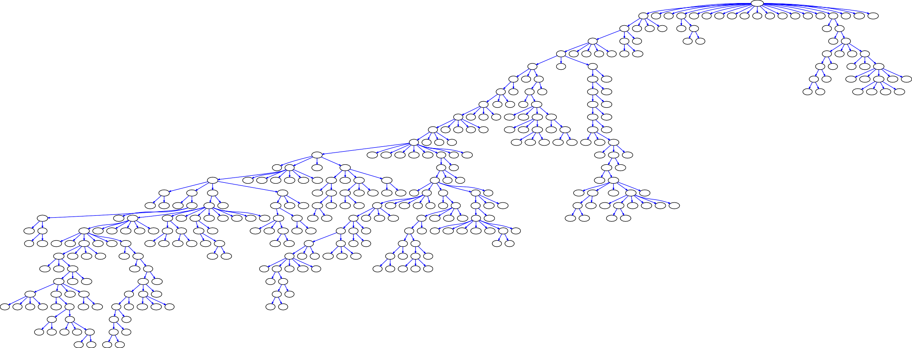

28/3 28/4 31/2 31/3

29/3 30/1 29/5 29/6 31/1 33/2 33/4

32/1 33/1 34/1 35/1